

SOFTWARE REQUIREMENTS SPECIFICATION (SRS)

TeaMart – WebApp

GHETIYA VASU (25SOEIT13006)
GHODASARA SHREYU (25SOEIT13007)
DESAI SUJAL (25SOEIT13004)

This is to certify that the above statement made by the student(s) is correct to the best of my knowledge.

Department of Computer Engineering RK. University, Rajkot – Gujarat

Academic Year: 2026

SCHOOL OF ENGINEERING, RK UNIVERSITY, RAJKOT

Description

- TeaMart is a comprehensive mobile ordering system designed to streamline the browsing and purchasing of tea, coffee, and related refreshments. The client-facing application provides a modern onboarding flow alongside secure authentication, including registration, login, and password recovery modules. Through an intuitive catalogue interface, customers can explore categorized beverages, discover top-rated brews, place orders, and monitor active or completed transactions in real time. Dedicated profile management further allows users to oversee personal delivery details and preferences effortlessly.

- The platform integrates a centralized Admin Management Portal to optimize daily store operations and inventory oversight. The administrative dashboard delivers live operational insights, detailing daily revenue, total order volumes, and recent sales activities at a glance. Additionally, administrators can manage registered customer profiles, track order fulfillment, and update the catalog dynamically through dedicated modules for adding, modifying, and pricing products. This dual-module setup ensures efficient transaction processing and seamless inventory maintenance.

Functional Requirement Summary

User Side

- Splash Screen & Branding
- Onboarding Feature Walkthrough
- User Registration
- User Login
- Admin Login Redirection
- Forgot Password Request
- Password Reset
- Personalized Home Greeting
- Promotional Banners Display
- Beverage Category Exploration
- Top Rated Brews Listing
- Product Catalog & Shop Browsing
- Ongoing Orders Tracking
- Completed Orders History
- User Profile Management
- Delivery Addresses Management
- Payment Methods Configuration
- Account Settings & Privacy

Admin Side
- Admin Registration
- Admin Authentication & Login
- Revenue Analytics & Metrics
- Order & User Statistics Dashboard
- Recent Orders Overview
- Registered User Management & Listing
- Customer Details View & Actions
- Store Orders Listing & Itemization
- Order Tracking & Fulfillment
- Inventory & Current Stock Listing
- Add New Product Module
- Product Image Upload
- Edit Product Details & Pricing
- Delete Product from Catalog
- Delete user

App UI

- Splash Screen



The Splash Screen serves as the initial launch interface to establish brand identity using a warm, minimalist aesthetic. It prominently displays a steaming traditional clay cup alongside the official TeaMart logo and the tagline "Fresh Tea, Delivered to Your Door". The screen automatically transitions the user to the onboarding walkthrough once core application resources have loaded.

- Visit Screens

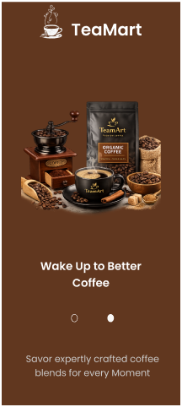

The Visit (Onboarding) walkthrough introduces first-time users to the application through a three-step visual carousel showcasing premium teas, artisanal coffees, and warm community moments. Each slide combines high-resolution product imagery with dot navigation indicators to demonstrate the core value propositions of TeaMart. The final screen features a prominent "Get Started..." call-to-action button that transitions the user directly to the registration and login flows.

- Login & Registration

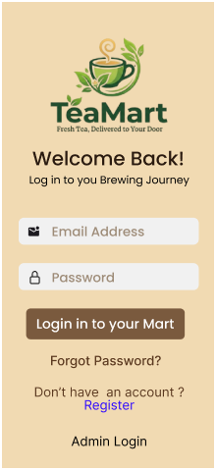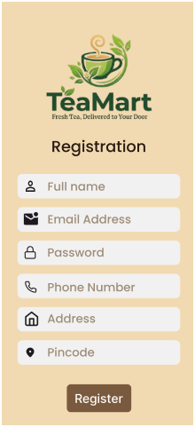

The Registration screen enables new customers to create an account by capturing essential credentials including full name, email address, password, contact number, delivery address, and Pin code. Complementing this, the Login screen provides secure authentication via registered email and password, featuring navigation paths for password recovery, new user signup, and direct redirection to the admin login portal. Together, both screens establish secure access control while maintaining a consistent visual branding identity across the onboarding flow.

- Forgot Password & Reset Password

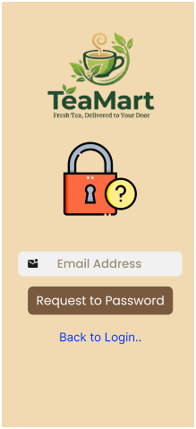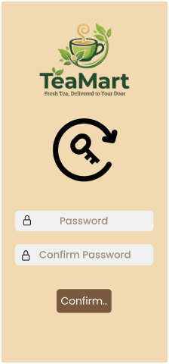

The Forgot Password screen allows users to initiate credential recovery by entering their registered email address to receive reset instructions, alongside a direct return link to the login page. Subsequently, the Reset Password screen prompts the user to enter and confirm their new password to securely update their account credentials. Together, these screens ensure seamless, self-service account recovery while maintaining user security and visual design consistency.

- Home

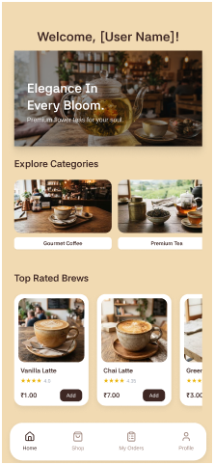

The Home Screen serves as the primary dashboard for authenticated users, greeting them with a personalized header and a prominent promotional showcase banner. It facilitates seamless product discovery through dedicated visual sections for "Explore Categories" (such as Gourmet Coffee and Premium Tea) and a horizontally scrollable "Top Rated Brews" catalog displaying item ratings, prices, and direct "Add" actions. A persistent bottom navigation bar provides instant access across key app modules, including Home, Shop, My Orders, and Profile.

- Shop page

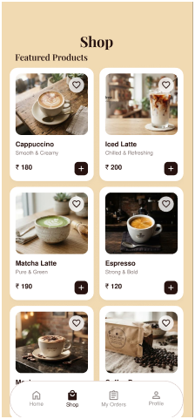

The Shop screen presents a comprehensive catalog of featured beverages and items arranged in a clean two-column grid layout. Each product card displays a high-quality image, product title, brief description, pricing in INR, a Wishlist favourite icon, and a quick-action '+' button to add items directly to the cart. The interface includes the persistent bottom navigation bar, ensuring smooth switching between the Home, Shop, My Orders, and Profile sections.

- Cart & Checkout page

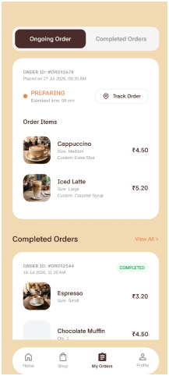

The Orders screen provides real-time tracking and comprehensive history of customer purchases through dedicated tabs for "Ongoing Order" and "Completed Orders". It displays active orders with real-time preparation status, estimated delivery times, order item breakdowns with customizations, and a direct "Track Order" button. The lower section lists past completed orders with itemized pricing, order IDs, and timestamps, allowing customers to easily review their previous transactions.

- Profile

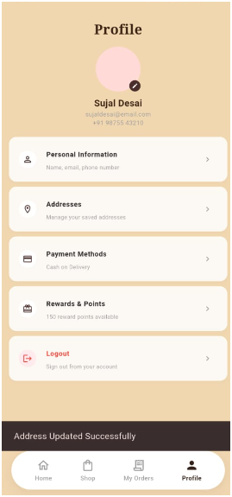

The Profile Screen allows users to access and manage their personal and donor-related information. It displays the user's name and location and provides options for Edit Profile, Donation History, and Donor Details. It also includes a Logout option.

- Edit Profile



The Personal Information and Saved Address screens allow authenticated users to view and update their profile credentials and delivery locations. The Personal Information interface provides editable fields for the user's full name, email address, and contact number with a "Save Changes" action. The Saved Address screen features a dedicated text area to update the active shipping address and postal details via the "Update Address" button, ensuring accurate order delivery.

- Payment method & Reward points

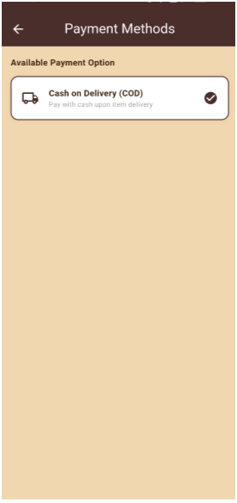

The Payment Methods screen enables users to manage their preferred transaction mode, featuring options like "Cash on Delivery (COD)" with clear delivery payment instructions. Alongside this, the Rewards & Points screen showcases the user's loyalty progress—highlighting accrued points (e.g., 150 Points) and tier status such as "Gold Member". It also features a "Redeemable Rewards" section where customers can directly redeem earned points for perks like a "Free Kulhad Chai" via a dedicated "Redeem" action button.

- Admin Login & Registration

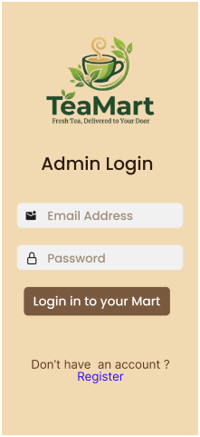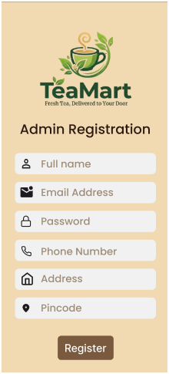

The Admin Registration and Admin Login screens provide a dedicated, secure authentication portal for authorized store personnel and managers. The Admin Registration screen captures essential administrative details including full name, email address, password, phone number, operational address, and pin code to create authorized management accounts. Complementing this, the Admin Login screen facilitates secure access using registered email credentials and a password, while providing an integrated navigation link to the registration flow for new administrators.

- Admin Dashboard

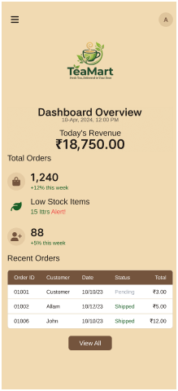

The Dashboard Overview serves as the central administrative hub, delivering real-time business insights including daily earnings (Today's Revenue), total order volume, critical low-stock alerts, and user growth metrics. It also features a "Recent Orders" summary table displaying key fulfillment details—such as Order ID, Customer Name, Date, Status (e.g., Pending, Shipped), and Total Amount—along with a "View All" action for comprehensive order monitoring. In addition, the screen provides top navigation with a hamburger menu and admin profile access for effortless system control.

- User Management

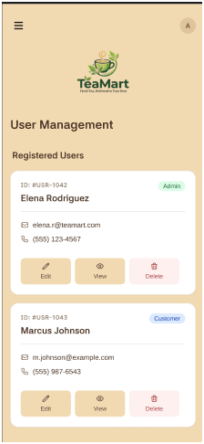

The User Management screen displays a structured list of all registered accounts as individual user cards, presenting essential details including User ID, Full Name, Email Address, Contact Number, and assigned role badges such as "Admin" or "Customer". Each card is equipped with dedicated action buttons—Edit, View, and Delete—enabling administrators to update account information, review user profiles, or remove accounts from the platform. The top app bar features the TeaMart logo alongside a drawer menu icon and an admin profile avatar for seamless navigation across administrative modules.

- Order details

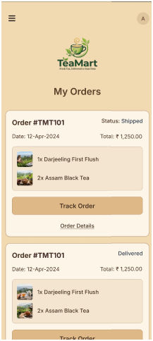

The My Orders screen provides users with an itemized overview of their purchases and live fulfillment status. Each order card highlights the unique Order ID (e.g., #TMT101), order date, total payable amount, current status (such as Shipped or Delivered), and a itemized list of purchased items with quantities and thumbnail previews. Dedicated action buttons, including Track Order and Order Details, allow customers to monitor real-time shipping updates or access comprehensive invoice records.

- Products & Add Products & Edit Product

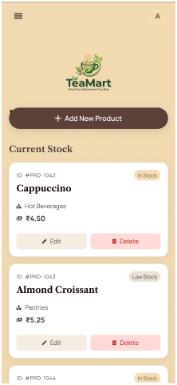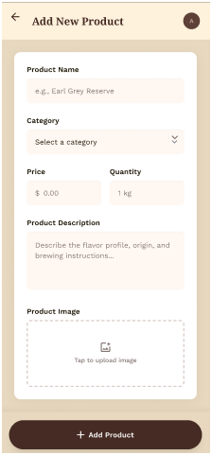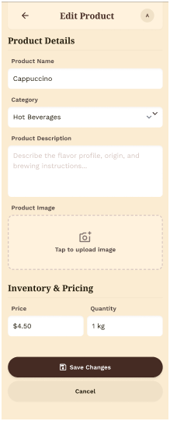

Products (Products Screen): Displays active catalogue items with details including Product ID, item name, category, price, and stock indicators (e.g., In Stock, Low Stock), alongside dedicated Edit and Delete action buttons for each record.

Add New Product Screen: Provides an input form to create menu items by specifying product name, category selection, price, inventory quantity, description, and an image upload picker via a primary Add Product action.

Edit Product Screen: Allows managers to modify existing item attributes—including title, category, descriptive details, cover image, and updated inventory pricing—with Save Changes and Cancel controls to keep the digital catalogue up to date.

