FarmSense360
Submitted Towards the Partial Fulfillment of the Requirements for the Award of the Degree of
Bachelors in Technology
by
Inkulu Lokesh Kumar Gupta (20124040)
Gangavath Surya Kiran (20124030)
Kumkapalla Chidvilas (20124052)
Swetha (20124103)

Under the Mentorship of
Dr Naveen Kumar Gupta

Department of Information Technology
Dr B R Ambedkar National Institute of Technology
Jalandhar-144008, Punjab (INDIA)
May 2024
Undertaking
We declare that the project work presented in this report entitled FarmSense360, submitted to the Department of Information Technology, Dr B R Ambedkar National Institute of Technology Jalandhar, for the award of the Bachelor of Technology degree in Information Technology, is our original work. We have not plagiarized or submitted the same work for the award of any other degree. In case this undertaking is found incorrect, we accept that our degree may be unconditionally withdrawn

Inkulu Lokesh Kumar Gupta (20124040)

Gangavath Surya Kiran (20124030)

Kumkapalla Chidvilas (20124052)

Swetha (20124103)

Department of Information Technology
Dr B R Ambedkar National Institute of Technology Jalandhar
Jalandhar, Punjab, India
May 2024

Certificate
This is to certify that the project report entitled FarmSense360 submitted by Inkulu Lokesh Kumar Gupta (20124040), Gangavath Surya Kiran (20124030), Kumkapalla Chidvilas (20124052), Swetha (20124103) to the Dr B R Ambedkar National Institute of Technology Jalandhar, in partial fulfillment for the award of the degree of B. Tech in Information Technology has been carried out under our supervision and that this work has not been submitted elsewhere for a degree.

Dr Naveen Kumar Gupta
Assistant Professor
Department of Information Technology,
Dr B R Ambedkar National Institute of Technology Jalandhar
Jalandhar, Punjab, India
May 2024

Contents Pg
- Introduction……………………………………………………. 1

1.1 Purpose……………………………………………….. 2

1.1.1 Primary Objectives…………………………….. 2

1.2 Scope ………………………………………………… 2
1.3 Backdrop……………………………………………… 3
1.3.1 Highlights of Union budget 2023-2024 ……… 3
1.3.2 Highlights of Union Budget 2024-2025 ……… 4
- Existing work…………………………………………………… 6

2.1 Existing work ………………………………………… 6

2.2 Limitations……………………………………………. 6
- Model……………………………………………………………. 8

3.1 Methodology …………………………………………… 8
3.2 Algorithmic Framework………………………………… 10
- Proposed work…………………………………………………… 13
4.1 Crop Recommendation Module………………………… 13
4.2 Price Prediction ………………………………………… 15
4.3 Community …………………………………………….. 18
4.4 Government Initiatives Navigator………………………. 20
- Expected outcomes………………………………………………. 24
5.1 Crop Prediction System ……………………………….. 24
5.2 Modern Practices Info ………………………………… 24
5.3 Government Initiatives ………………………………... 24
5.4 Soil Types ……………………………………………… 24
5.5 Doubt Posting & Blogs………………………………… 25
5.6 Alternative Farming Methods………………………… 25
- Conclusion ………………………………………………………. 26
6.1 conclusion …………………………………………….. 26
6.2 Future Work…………………………………………… 27
- References………………………………………………………… 29

List of Figures

Figure | Caption | Page no.
1.1 | Highlights of Union budget 2023-2024 in Agriculture Sector | 3
1.2 | Highlights of Union budget 2024-2025 in Agriculture Sector | 5
3.1 | Process Flow Diagram (PFD) | 9
3.2 | Scatter plot of temperature vs humidity | 10
3.3 | Algorithm Training and recommendation model | 11
3.4 | Support Vector Machine Algorithm | 11
3.5 | Pair plot for different types of crops | 12
4.1 | Showing Users can input their location details, including district, state, and Crop Season | 13
4.2 | Showing Recommended Crop | 14
4.3 | Graph showing the rainfall level of particular over 60 Years | 15
4.4 | Showing Interface to explore particular crop | 16
4.5 | Showing current crop price per quintal, prime cultivation locations & brief Forecast | 16
4.6 | Representing offering insights into price trends and fluctuations | 17
4.7 | Representing top list of crops with their prices per quintal and their rank in terms of yield and profitability | 17
4.8 | Representing loss list of crops with their prices per quintal | 18
4.9 | Showing Asking Questions with Name and phone | 19
4.10 | About post Info | 19
4.11 | Showing how to answer question | 20
4.12 | Government Initiatives Navigator includes the following key functionalities | 21
4.13 | Sowing Scheme Coverage | 22
4.14 | Latest Farming News in India | 23
6.1 | Achieved Goals | 26

Chapter 1: Introduction

Agriculture stands as a cornerstone of our nation's economy, supporting a significant portion of the population. However, the sector grapples with challenges such as low income, farmer suicides, and the migration of younger generations away from farming. Critical among these challenges is the issue of crop selection, where farmers often lack the necessary information to make informed decisions, leading to decreased yields and financial instability. Recognizing these pressing issues, FarmSense360 emerges as a beacon of innovation, dedicated to transforming farming practices through technological advancements and a comprehensive approach. This report delves into the core objectives of FarmSense360, elucidating how its features are meticulously crafted to address the multifaceted needs of farmers and drive towards the overarching goal of bolstering agricultural sustainability and productivity.
FarmSense360 empower farmers by providing precise insights, actionable recommendations, and fostering a supportive community where experiences and insights can be shared. Moreover, FarmSense360's scope extends across various dimensions of agriculture, leveraging advanced technologies like machine learning to offer predictive insights on crop sustainability and recommendations tailored to specific soil conditions and climatic variations. By amalgamating cutting-edge technologies with agricultural expertise.
FarmSense360 a pioneering platform in the agricultural landscape, embodies a commitment to revolutionizing farming practices through technological innovation and a holistic approach. This report to illuminate the primary objectives of FarmSense360, delineating how these objectives drive the platform's features and contribute to the overarching goal of enhancing agricultural sustainability and productivity.
FarmSense360, in response to the challenges outlined in Maharashtra's onion price fluctuations, to mitigate the risks associated with crop selection through data-driven insights and predictive analytics. The scenario in Maharashtra underscores the inherent uncertainty and risks farmers face when deciding which crops to cultivate, often leading to significant economic repercussions for both farmers and consumers. FarmSense360 recognizes the gravity of these decisions and aims to provide farmers with the tools and knowledge necessary to make informed choices that align with market demands and environmental conditions [9]. By leveraging advanced algorithms and machine learning models, FarmSense360 analyzes various factors such as environmental parameters and soil characteristics to recommend the most suitable crops for cultivation.
FarmSense360 seeks to mitigate the adverse effects of uninformed decisions on farmers' livelihoods and contribute to the overall stability and sustainability of agricultural systems in India. This emerges as a proactive solution aimed at providing predictive insights to empower Indian farmers as well as Retailers and common people through its robust features and innovative strategies, FarmSense360 to revolutionize farming practices, foster community engagement, and contribute to the modernization and efficiency of agricultural on a global scale.

1.1 Purpose
FarmSense360 seeks to empower farmers by providing precise insights and actionable recommendations, leveraging advanced technologies to optimize crop management. The primary purpose of this report is to offer a comprehensive exploration of FarmSense360, dissecting its functionalities and demonstrating how they align with the platform's objectives. By doing so, we aim to provide a nuanced understanding of how FarmSense360 contributes to the modernization and efficiency of agricultural practices.
    - Primary Objectives:
The primary objectives of implementing this agricultural predictive system are as follows:
1. Precision Agriculture Implementation - FarmSense360 aims to bring precision agriculture to the forefront by providing farmers with accurate and timely information for informed decision-making. This includes precise crop predictions and soil-specific recommendations tailored to individual farming plots
2. Real-Time Support and Accessibility - The platform strives to offer instant assistance through a chatbot, ensuring that farmers can access help promptly, thereby enhancing the efficiency of problem resolution and decision-making processes.
3. Knowledge Dissemination - FarmSense360 serves as a comprehensive knowledge hub, disseminating information on modern farming techniques, tools, organic fertilizers, and alternative farming options. The objective is to educate farmers and promote the adoption of sustainable and innovative practices.

4. Community Building - The platform aims to foster a sense of community among farmers through features like blog posting and Q/A sessions. This cultivates an environment where farmers can share experiences, insights, and collectively work towards addressing challenges and finding innovative solutions.

1.2 Scope
The scope of FarmSense360 encompasses a comprehensive solution tailored to address the multifaceted challenges encountered in agriculture. Leveraging advanced technologies and a holistic approach, FarmSense360 extends its reach across various facets of farming, including precision agriculture implementation, real-time support and accessibility, knowledge dissemination, and community building. By offering precise insights and actionable recommendations, FarmSense360 aims to empower farmers with the tools and resources necessary for informed decision-making, thereby optimizing crop management and enhancing agricultural sustainability and productivity. Furthermore, FarmSense360's scope transcends geographical boundaries, catering to the diverse needs of farmers across different regions and agricultural practices. Through its robust features and innovative strategies, FarmSense360 endeavours to revolutionize farming practices, foster community engagement, and contribute to the modernization and efficiency of agricultural endeavours on a global scale.
1.3 Backdrop

The Crop price prediction model is designed to provide farmers with valuable insights into future crop prices, facilitating informed decision-making and strategic planning for their agricultural activities. Leveraging historical data and employing the Decision tree regressor algorithm, the model considers factors such as climate conditions, market demand, and past pricing trends to generate accurate predictions for the upcoming year.
The Decision tree regressor, chosen for its ability to capture non-linear relationships, is then employed to train the model. This algorithm recursively splits the dataset based on feature values, creating a tree structure that captures complex patterns in the historical data. The dataset is split into training and testing sets for evaluation, with the Mean Absolute Error (MAE) serving as a metric for assessing the accuracy of predictions.
1.3.1 Highlights of Union budget 2023-2024 in Agriculture Sector

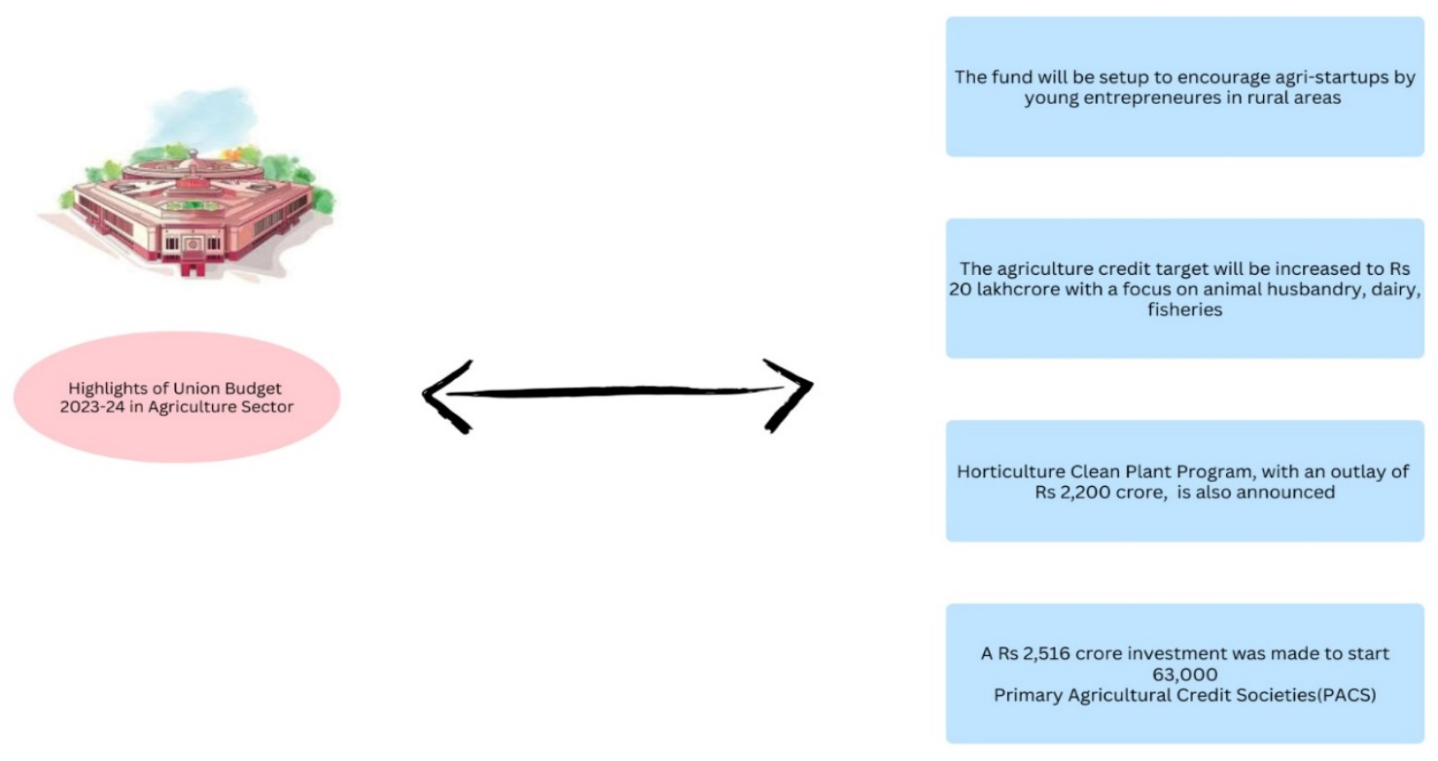
Fig. 1.1 Highlights of Union budget 2023-2024 in Agriculture Sector
The Union Budget 2023-24 for the Agriculture Sector unfolds a series of pivotal measures aimed at catalysing rural development. A notable initiative is the establishment of a dedicated fund designed to bolster Agri-startups led by young [18].
Simultaneously, the budget underscores a substantial increase in the agriculture credit target, soaring to Rs 20 lakh crore, with a targeted focus on sectors pivotal to rural livelihoods such as animal husbandry, dairy, and fisheries. The introduction of the Horticulture Clean Plant Program, backed by a substantial outlay of Rs 2,200 crore, signifies a commitment to sustainable horticultural practices. Further, a new sub-scheme under the PM Matsya Sampada Yojana, accompanied by a significant investment of Rs 6,000 crore, is unveiled to fortify the fisheries sector. In a bid to enhance financial support, the allocation of Rs 2,516 crore is earmarked for the establishment of 63,000 Primary Agricultural Credit Societies (PACS). Fig 3.1 highlights the union budget in agricultural sector for the timespan between 2023-2024. Noteworthy is the government's ambitious goal to facilitate the transition of 10 million farmers to natural farming over the next three years, thereby contributing to the growth of the organic farming sector.

- Launch of Agriculture Accelerator Fund to support Agri-startups by young entrepreneurs.
- Agricultural credit increased to Rs.20 trillion, focusing on dairy, fisheries, and animal husbandry [14].
- New sub-scheme under PM Matsya Sampada Yojana with Rs.6,000 crore investment to support fish vendors, fishermen, and small businesses.
- Empowerment of 10 million farmers to switch to natural farming.
- Establishment of decentralized storage capacity to assist farmers in storing produce and obtaining fair prices.
- Creation of a Digital Public Infrastructure for Agriculture to increase access to farm inputs, market intelligence, and support for Agri-startups [22].
- Introduction of PM PRANAM to encourage the use of alternative fertilizers by states and Union Territories [26].
- Rs.2,516 crore investment for computerizing 63,000 Primary Agricultural Credit Societies (PACS).
- Support for the Indian Institute of Millet Research, Hyderabad, as the Centre of Excellence to make India a global hub for "Shree Anna" [25].

1.3.2 Highlights of Interim Union Budget 2024-2025 on Agriculture Sector
- The government aims to encourage both private and public investment in post-harvest activities.
- The application of Nano-DAP will be extended to cover all agro-climatic zones. A strategic plan under the Atmanirbhar Oilseeds Abhiyaan will be devised to attain self-sufficiency in oilseeds production.
- Additionally, a comprehensive program for the development of the dairy sector will be formulated.
- Efforts will be intensified to implement the Pradhan Mantri Matsya Sampada Yojana, aimed at enhancing aquaculture productivity, doubling exports, and creating more job opportunities.
- There will be an increased allocation of funds for the Blue Revolution, totaling up to Rs.2,352 crore.
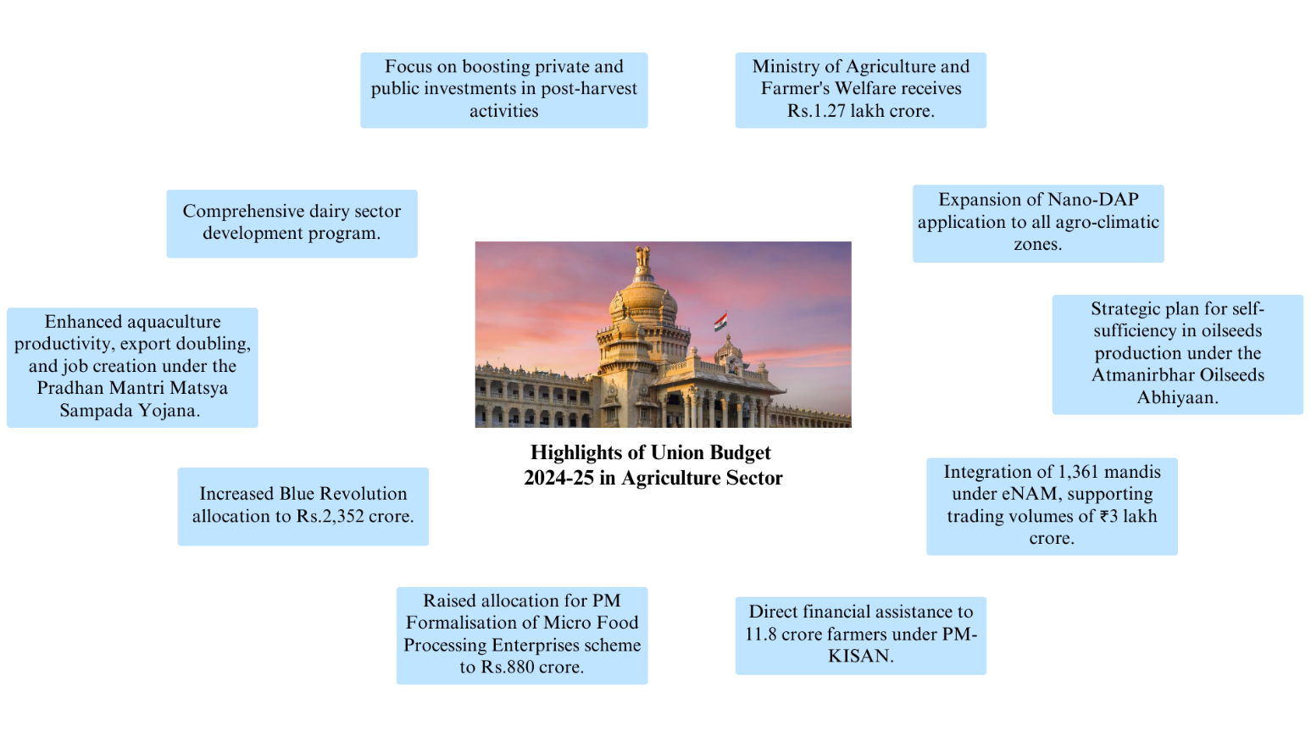
Fig. 1.2 Highlights of Union budget 2024-2025 in Agriculture Sector
- Similarly, the allocation for the PM Formalisation of Micro Food Processing Enterprises scheme will be raised to Rs.880 crore [13].
- The Ministry of Agriculture and Farmer's Welfare has been allocated a budget of Rs.1.27 lakh crore.
- Direct financial assistance will be provided to 11.8 crore farmers under the PM-KISAN scheme.
- Additionally, crop insurance coverage will be extended to 4 crore farmers through the PM Fasal Bima Yojana.
- Furthermore, the integration of 1,361 mandis under eNAM will support trading volumes amounting to ₹3 lakh crore [18].

Chapter 2: Existing work with limitations

2.1 Existing work
The existing work in agricultural technology tends to focus on individual features and operates within the confines of single modules. These systems, while often effective in their specialized functions, fall short of providing comprehensive support to farmers. The limitation lies in their segmented approach, where predictive analytics, soil recommendations, or instant assistance are treated as isolated components rather than integrated elements within a unified platform. This lack of cohesion hampers efficiency and may require farmers to navigate between multiple tools to address different aspects of their agricultural needs. The Existing Work concentrate on individual features and limited to single module, lacking efficiency in providing comprehensive support to farmers
In contrast, the proposed system, FarmSense360, distinguishes itself by presenting a unified and integrated platform that incorporates multiple critical aspects of agriculture. Rather than compartmentalizing features, the proposed system takes a holistic approach, recognizing the interconnected nature of various agricultural processes. By offering a wide array of features under one umbrella, FarmSense360 aims to provide farmers with a more efficient and seamless experience. This integrated system ensures that farmers can access predictive analytics, soil-specific recommendations, instant assistance, and a wealth of information on modern farming techniques all within a single platform.
The primary goal of this proposed system is to empower farmers by consolidating diverse functionalities into one comprehensive resource. Beyond individual decision-making support, the system emphasizes sustainable practices and community collaboration. It recognizes that farmers are part of a larger ecosystem that includes both fellow farmers and retailers. By fostering collaboration and knowledge exchange among these stakeholders, the proposed system seeks to create a robust agricultural community that can collectively contribute to the success and sustainability of farming practices.

2.2 Limitations

Existing crop recommendation and price prediction systems have several limitations that can impact their accuracy, reliability, and usability
1. Price Volatility:
Price volatility poses a significant challenge, particularly for small-scale farmers who are more vulnerable to market fluctuations. Sudden drops in prices can lead to income instability and reduced profits, impacting the financial sustainability of small farmers. The lack of effective risk management strategies exacerbates the impact of price volatility on agricultural communities.

2. Poor Adoption of Mechanization & Limited Access to Technology:
Despite technological advancements, a considerable portion of agricultural operations is still reliant on manual Labor. In regions like India, where mechanization levels hover around 60-70% for tasks like Ploughing, harvesting, threshing, and irrigation, there is a need for broader adoption of technology. Limited access to modern farming equipment and technology hampers efficiency, making it challenging for farmers to keep pace with evolving agricultural practices.
3. Inadequate Access to Crop Insurance Schemes:
Farmers face persistent challenges with crop insurance schemes, including a lack of awareness, difficulties in assessing the extent of damages caused by crop losses, insufficient coverage, and delays or non-payment of claims. The absence of a robust and accessible crop insurance system leaves farmers exposed to risks associated with unpredictable weather patterns and other natural disasters, jeopardizing their financial stability.
- Lack of Inquiry Insights:
Current farming practices often lack comprehensive insights and inquiry mechanisms. Farmers may face challenges in accessing real-time information about their crops, soil conditions, and best practices. The absence of a structured inquiry system hinders farmers from making informed decisions, optimizing their agricultural processes, and addressing challenges promptly.
- Soil Fertility Depletion:
Post the Green Revolution, the increased use of chemical fertilizers has led to soil fertility depletion. Excessive and indiscriminate use of chemical fertilizers contributes to reduced organic matter and humus content in the soil. This degradation impacts soil health, reducing its ability to support robust plant growth. Sustainable soil management practices are essential to address this issue and promote long-term agricultural productivity.

Chapter 3: Model

3.1 Methodology
About: Provides general information about the system, its objectives, and the technology used. Introduces users to the various modules and features available.
Modern Farming: Offers insights into contemporary farming practices, including tools, techniques, and sustainable methods. Features educational content to keep users updated on the latest advancements in agriculture.
Crop Suggest: Utilizes the crop prediction model to suggest suitable crops based on historical data and current conditions. Guides farmers in making informed decisions about crop selection for optimal yields.
Schemes: Offers information on government initiatives, subsidies, welfare programs, and loans available to farmers. Provides a user-friendly interface for farmers to explore and apply for relevant schemes.
Shop: Integrates a marketplace where farmers can access and purchase agricultural tools, seeds, and other necessities. Facilitates a convenient platform for farmers to acquire resources for implementing modern farming practices
Community: Enables farmers to engage in discussions, post doubts, and share experiences. Features a blog section with contributions from experts and fellow farmers, fostering a collaborative community.
The system provides an overarching view encompassing its objectives, technology employed, and the assortment of modules and features at users' disposal. It serves as a gateway for users, acquainting them with the spectrum of functionalities available. Modern Farming serves as an educational hub, delivering insights into contemporary agricultural practices, tools, and sustainable methodologies.
Through curated content, users stay abreast of the latest advancements in agriculture. Crop Suggest employs a sophisticated prediction model to recommend suitable crops, drawing from historical data and prevailing conditions. By offering tailored suggestions, it empowers farmers to make informed decisions, optimizing yields and profitability. Schemes furnishes comprehensive information on governmental initiatives, subsidies, and financial assistance programs.
With a user-friendly interface, farmers navigate through available schemes, facilitating seamless access and application processes. The integrated Shop feature streamlines procurement, providing a marketplace for agricultural essentials like tools and seeds.

Process Flow Diagram (PFD)

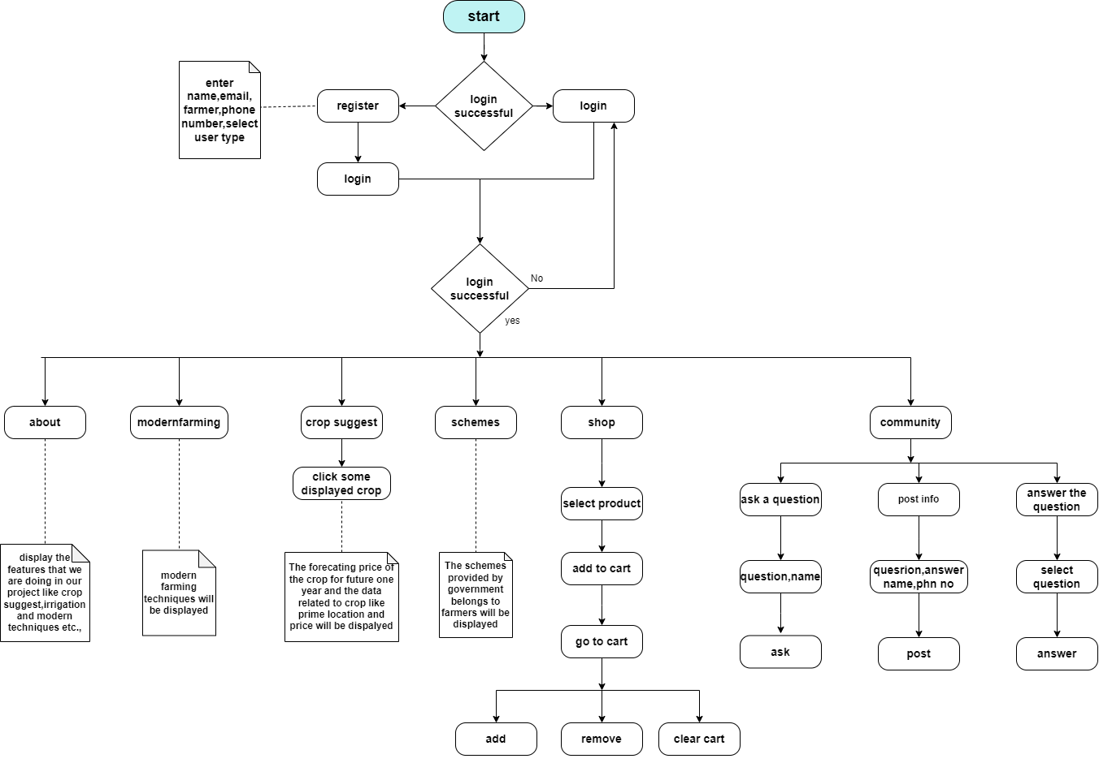
Fig.3.1 Process Flow Diagram (PFD)
This holistic system design aims to provide farmers with a comprehensive platform that not only offers predictive insights but also encompasses modern farming practices, government initiatives, a marketplace, and a collaborative community for shared learning and support. Fig.3.3 shows how the process flows if user interacts with the website.

3.2 Algorithmic Framework
The algorithms are employed across different modules of the platform to enhance decision-making and optimize agricultural practices. Below is a detailed overview of the algorithms used in Farmsence360
Decision Tree:
Decision trees are used for classification and regression tasks. They recursively split the data based on features to create a tree-like structure that predicts the target variable. For instance, a decision tree model could classify crops based on features like soil type, climate conditions, and historical yield data to recommend suitable crops for cultivation as shown in Fig. 3.2.
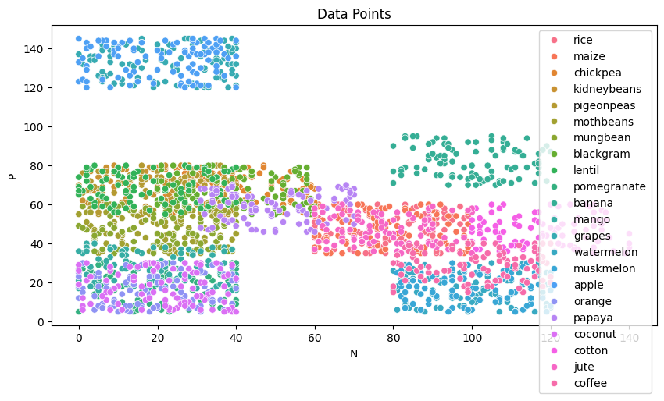
Fig.3.2 Scatter plot of temperature vs humidity
Logistic Regression:
Logistic regression is a classification algorithm used to model the probability of a binary outcome based on one or more predictor variables. In Farmsence360, logistic regression could be utilized for tasks such as predicting the likelihood of a particular crop being affected by a disease or pest based on environmental factors. It could also be used for sentiment analysis in the Community Component Module to classify user comments as positive or negative.

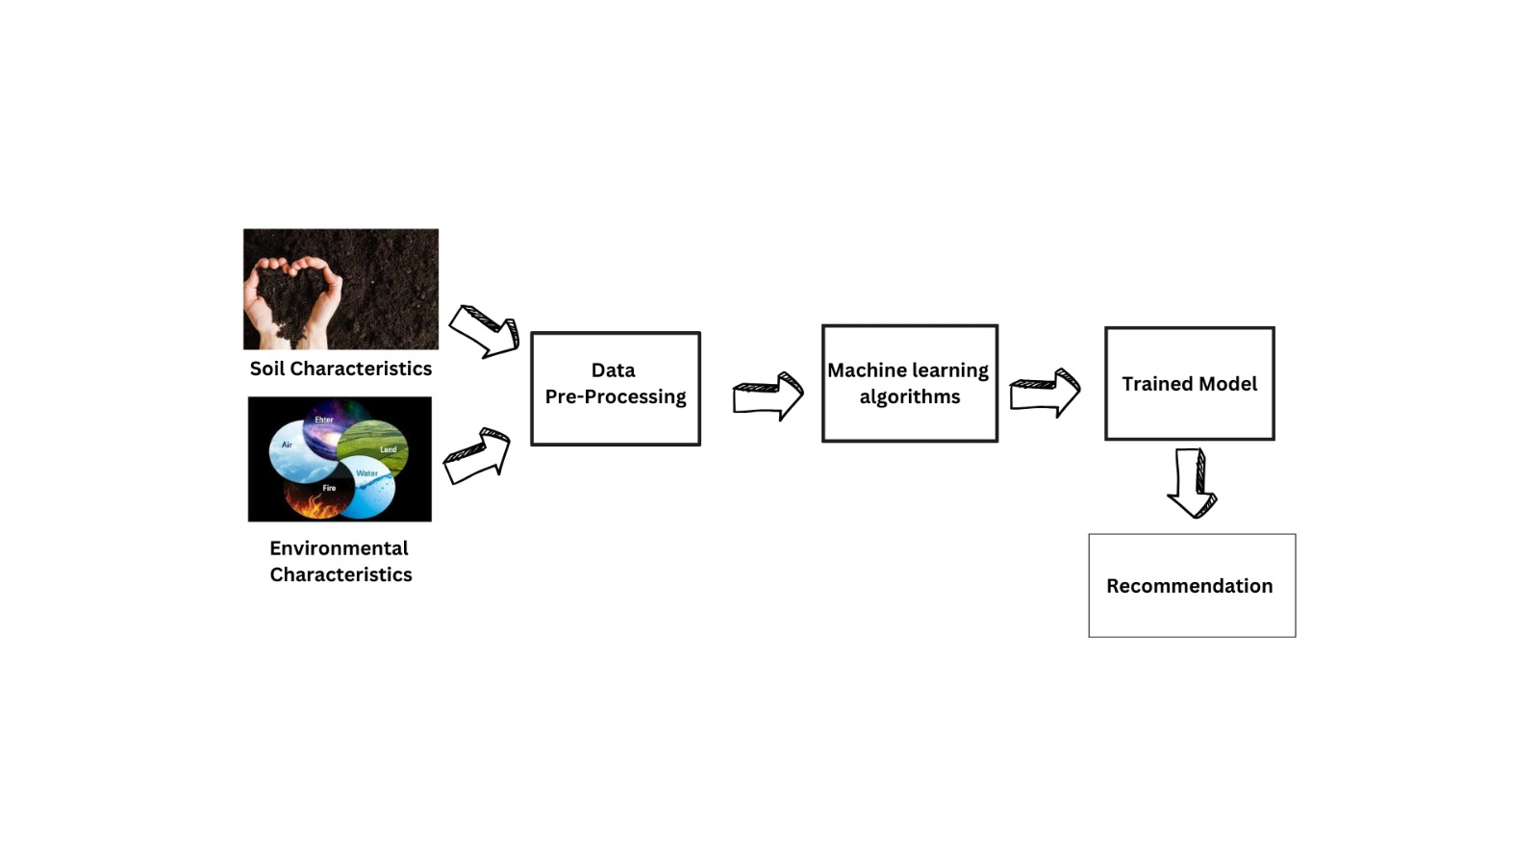
Fig 3.3 Algorithm Training and recommendation model
Support Vector Machine (SVM):
SVM is a powerful supervised learning algorithm used for classification and regression tasks. It finds the hyperplane that best separates classes in a high-dimensional space.
In Farmsence360, SVM could be utilized for tasks such as v
\+8++ on symptom patterns or predicting crop yield based on various environmental factors. SVM could also be employed for image recognition tasks, such as identifying crop pests or diseases from images captured by farmers
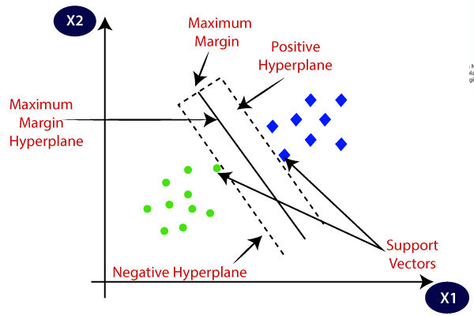
Fig 3.4 Support Vector Machine Algorithm
K-Nearest neighbour (KNN):
KNN is a simple and effective classification and regression algorithm that works by finding the k-nearest neighbour of a data point and making predictions based on their labels or values. Application: KNN could be used in Farmsence360 for tasks such as recommending agricultural practices or inputs based on the practices of similar farms in the vicinity. For example, KNN could be employed to recommend fertilizer types and quantities based on the practices of neighbour farms with similar soil and climate conditions Fig. 3.5.
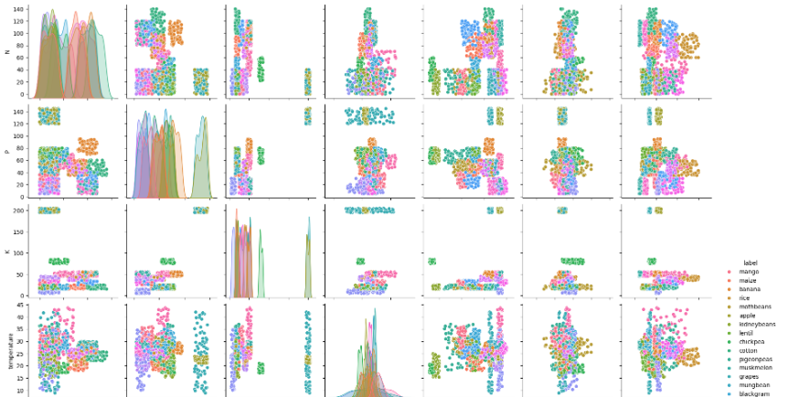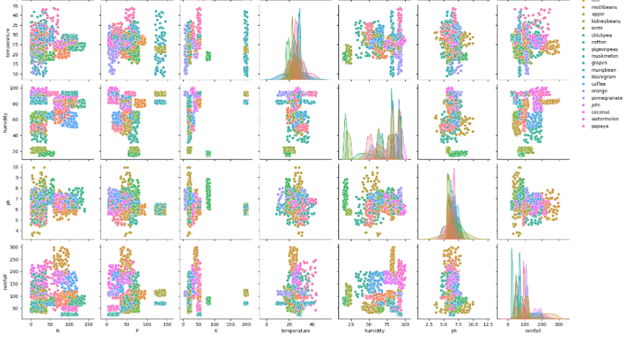
Fig 3.5 Pair plot for different types of crops
Chapter 4: Proposed Work
The FarmSense360, aims to build upon the existing integrated platform by introducing novel features that further enhance the user experience and address specific challenges faced by the agricultural community. FarmSense360 seeks to expand the scope of the platform by incorporating the following innovations
4.1 Crop Recommendation Module:
The Crop Recommendation Module is an additional feature integrated into our existing platform to provide farmers with valuable insights and recommendations for crop cultivation. This module utilizes dynamic APIs to fetch real-time data and manual datasets comprising over 200 varieties of crops. The primary objective is to assist farmers in making informed decisions regarding crop selection based on various environmental factors such as nitrogen, phosphorus, potassium, temperature, humidity, rainfall, and pH values. Fig. 3.4 is the page where user can fill the parameters and get the crop recommendation according to the parameters entered.
Input Parameters: Users can input their location details, including district, state, and city.
Data Retrieval: The module fetches relevant data from dynamic APIs, including environmental factors and soil conditions.
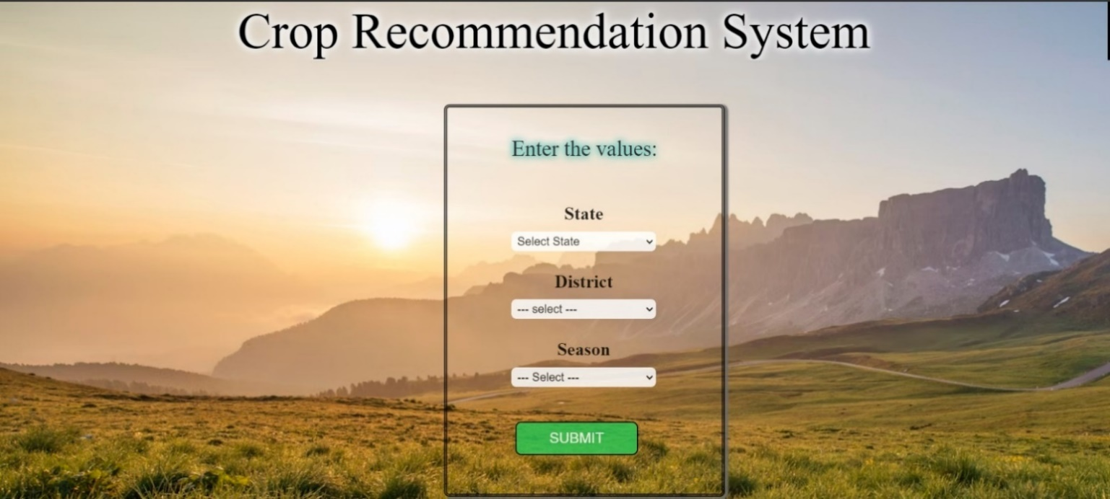
Fig 4.1 Showing Users can input their location details, including district, state, and Crop Season
Recommendation Algorithm: Based on the input parameters and retrieved data, the module employs a Decision tree, KNN, SVC, Logistic algorithm to suggest suitable crops for cultivation.
Crop Database: A comprehensive database containing information on over 200 crop varieties, categorized into different types such as rice, pulses, cash crops, millets, oilseeds, cotton, woods, fruits, leafy vegetables, nuts, and flowers [7].
User Interface: A user-friendly interface to display the recommended crops along with relevant details such as growth requirements, optimal conditions, and potential yields.
The Crop Recommendation Module is a valuable addition to our platform, aimed at empowering farmers with actionable insights and recommendations for crop cultivation. By leveraging dynamic APIs and comprehensive datasets, the module facilitates informed decision-making and helps optimize agricultural practices for improved productivity and sustainability. We believe that this feature will significantly benefit farmers and contribute to the advancement of agriculture in the region.Fig.3.5 is the output page displayed to the user after entering the parameters in the crop recommendation page

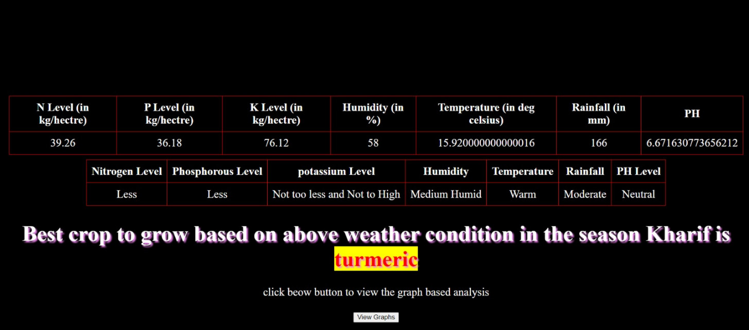
Fig.4.2 showing Recommended Crop

Long-Term Rainfall Analysis:
Within the Crop Recommendation Module of Farmsense360, an additional feature is being integrated. This feature will present graphical representations depicting rainfall levels spanning over 60 years for specific regions. Such data aids farmers in making informed decisions regarding suitable crop selections and anticipated climatic variations. This section will be accessible subsequent to the crop recommendation process, with the graphs becoming visible upon clicking the designated "View Graphs" button.

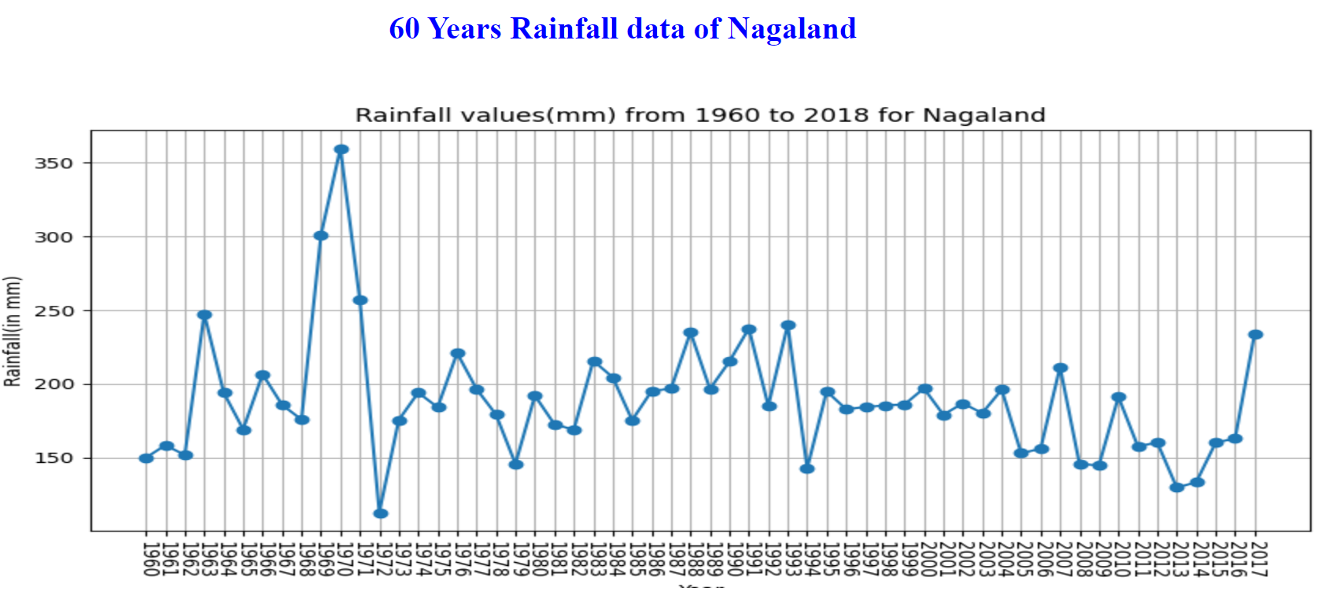
Fig 4.3 Graph showing the rainfall level of particular over 60 Years
4.2 Price Prediction
The Crop Price Prediction Module is a crucial feature integrated into the Farmsence360 website, designed to provide accurate forecasts of crop prices for farmers and agricultural stakeholders. This module fetches data from a comprehensive database and utilizes advanced forecasting algorithms to predict crop prices for the upcoming year. By offering insights into price trends and fluctuations, this module enables farmers to make informed decisions regarding crop selection, planting schedules, and marketing strategies The scope of the Crop Price Prediction Module encompasses the following key functionalities, Decision tree, KNN, are employed to predict future crop prices based on historical data and market dynamics.
User Authentication: Users are required to log in to the Farmsence360 website before accessing the price forecaster module.
Commodity Selection: Users can select a specific crop (commodity) for which they wish to obtain price predictions.
Data Retrieval: The module fetches relevant data from the database, including historical crop prices, market trends, and other pertinent information.
Price Forecasting: Advanced forecasting algorithms analyzes historical data and market trends to predict future crop prices for the selected commodity.Fig.3.6 is the interface for exploring the price forecast of particular crop.
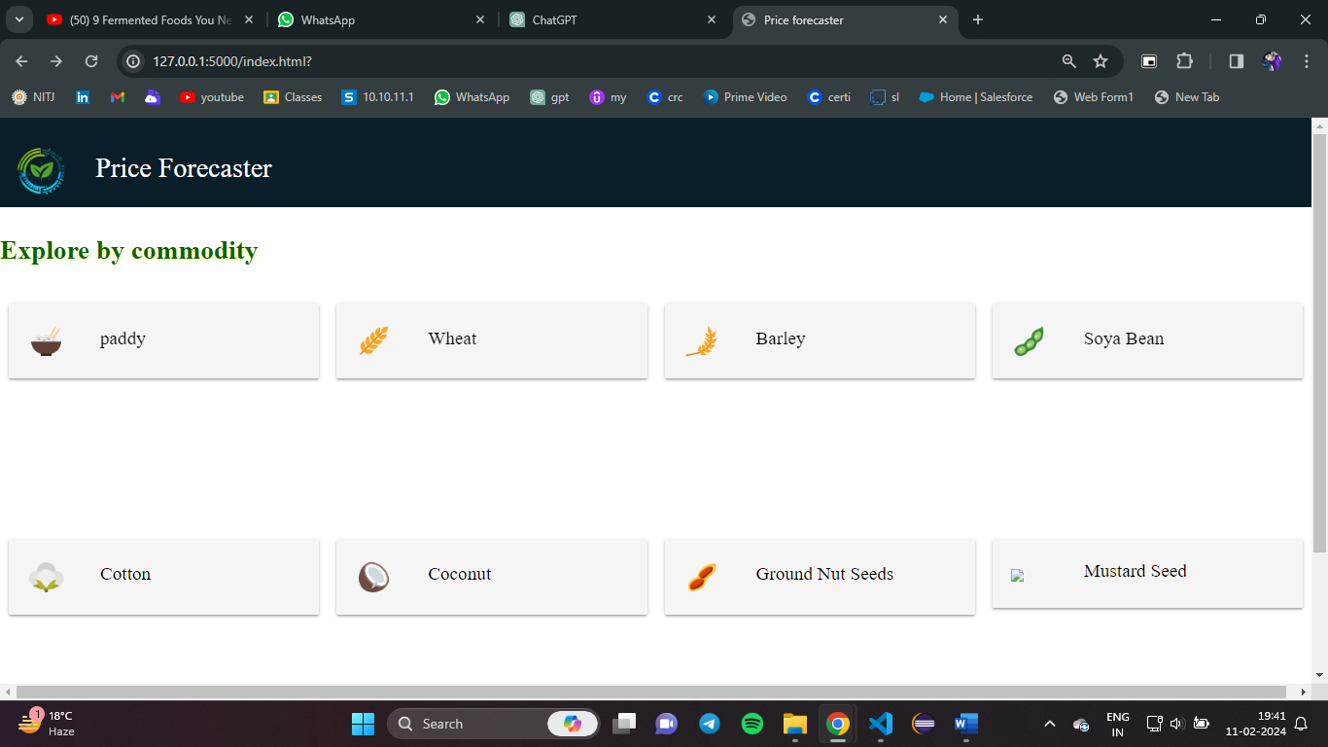
Fig.4.4 showing Interface to explore particular crop

Information Display: The module presents various information related to the selected crop, including current price per quintal, prime cultivation locations (states), crop types (Rabi, Kharif), major export countries, brief forecast (minimum and maximum crop prices), and forecast trends (monthly price fluctuations and changes).
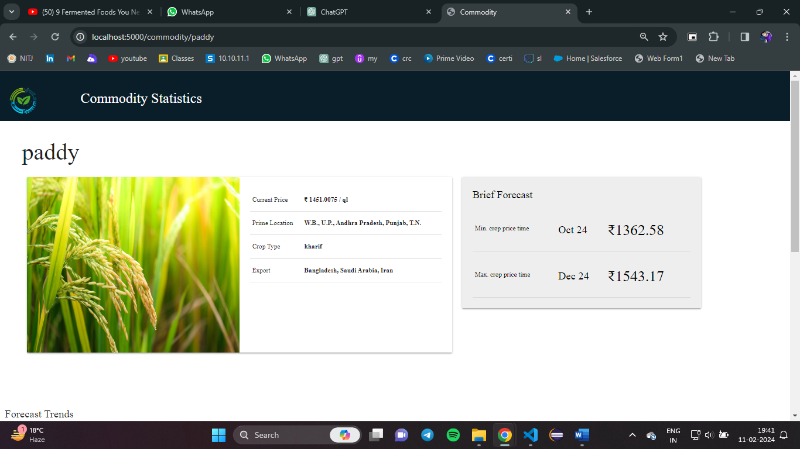
Fig.4.5 Showing current crop price per quintal, prime cultivation locations & brief Forecast
User Interface: A user-friendly interface is provided to display the forecasted crop prices and associated information in a clear and accessible manner.
Recommendation Algorithm: Based on the input parameters and retrieved data, the module employs a Decision tree, KNN to suggest suitable crops for cultivation.
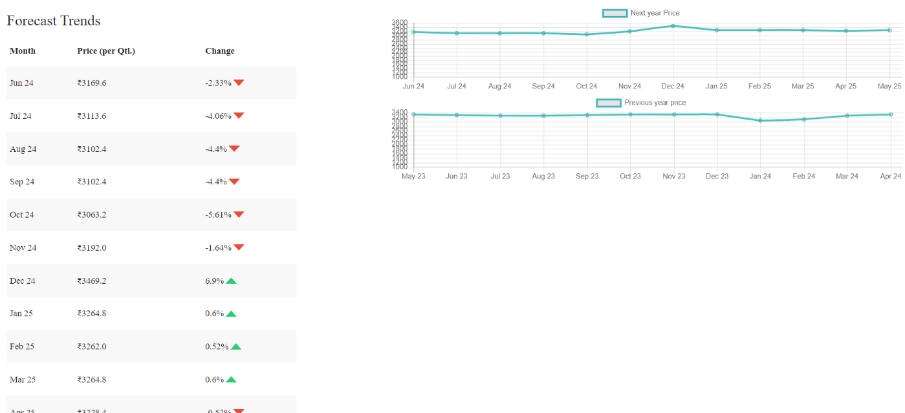
Fig.4.6 Representing offering insights into price trends and fluctuations
Current Trends:Within the Price Prediction Module, an additional feature is being incorporated to enhance its functionality. This feature will provide insights into current market trends, specifically focusing on two key metrics: the top gainers and top losers.
Top Gainers: This section will display a comprehensive list of crops alongside their respective prices per quintal and their percentile rank in terms of yield and profitability. This ranking will facilitate easy comprehension for farmers, showcasing which crops have achieved the highest ranks in terms of yield and profit gain. The presentation will be structured in an ascending order, from the top-ranked crop to the lowest-ranked, enabling users to discern the leading performers effortlessly.
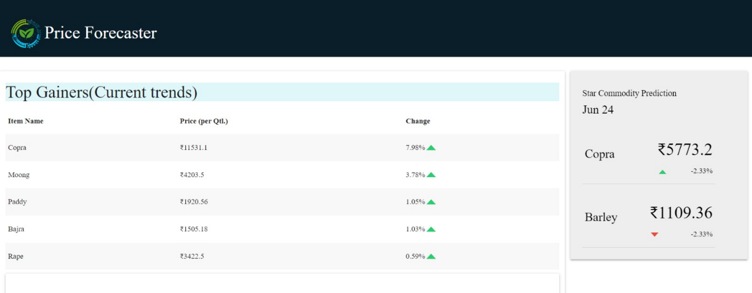
Fig.4.7 Representing top list of crops with their prices per quintal and their rank in terms of yield and profitability
Top Losers: Conversely, this segment will furnish farmers with information regarding crops that have incurred the greatest losses. It will exhibit a catalog of crops, their corresponding prices per quintal, and their percentile rank, indicating their position in terms of low yields and losses. The arrangement will be presented in descending order, illustrating the crops with the highest losses and lowest ranks, thereby aiding farmers in identifying crops with diminished profitability.
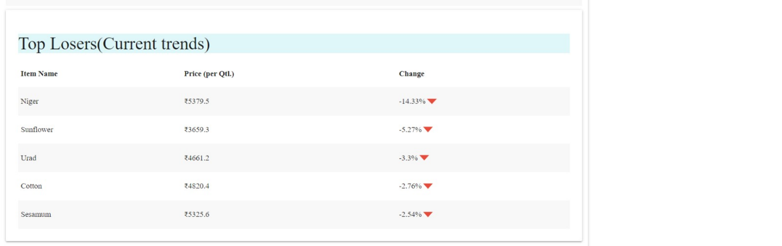
Fig. 4.8 Representing loss list of crops with their prices per quintal
The Crop Price Prediction Module is a valuable addition to the Farmsence360 website, offering farmers and agricultural stakeholder's valuable insights and forecasts for crop prices. By leveraging advanced forecasting algorithms and comprehensive data analysis, this module facilitates informed decision-making, risk mitigation, and enhanced planning, ultimately contributing to the success and sustainability of agricultural operations. Fig3.7 and Fig3.8 pictures is the webpage of particular crop. We believe that this feature will significantly benefit farmers and contribute to the growth and development of the agricultural sector.
4.3 Community
The Community Component Module is an essential feature integrated into the Farmsence360 platform, designed to foster communication and collaboration among users within the agricultural community. This module comprises three main functionalities: Ask Questions, Post Info, and Answer a Question. Users can interact with each other by asking questions, sharing information, and providing answers, thereby creating a supportive and informative environment for agricultural discussions.
Ask Questions: Users can ask questions anonymously or with their name and phone number. These questions are displayed on the community page for other users to view and answer. See
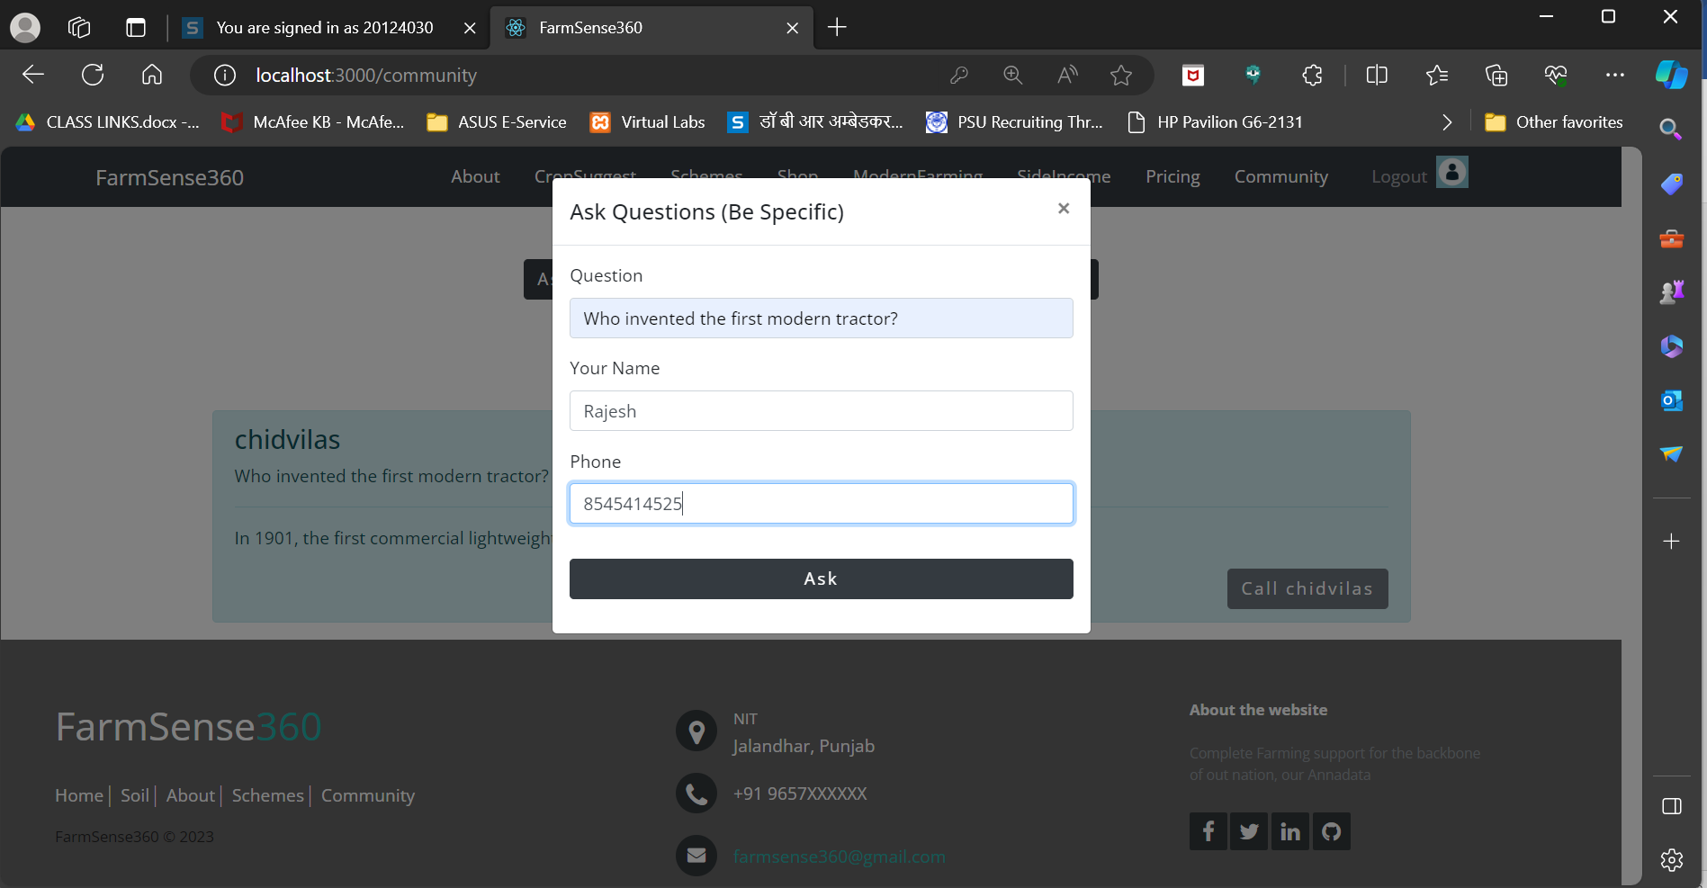
Fig. 4.9 Showing Asking Questions with Name and phone
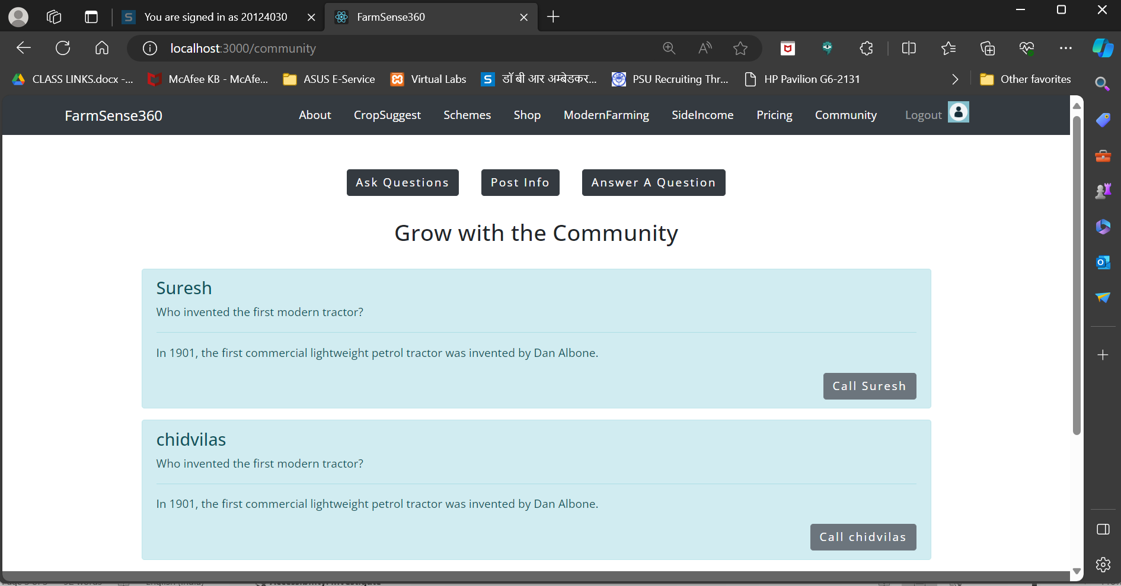
Fig. 4.10 About post Info
Post Info: Users can share information by filling out a form and submitting it. The posted information is displayed on the community page, allowing other users to access and engage with it. Fig. 3.10 is the page where the info that are posted are displayed.
Answer a Question: Users can view questions posted by other users and provide answers by clicking on the "Answer Now" button. The answers are displayed on the community page along with the name of the user who provided the answer. Fig. 3.11 is the prompt shown when answer a question is clicked.
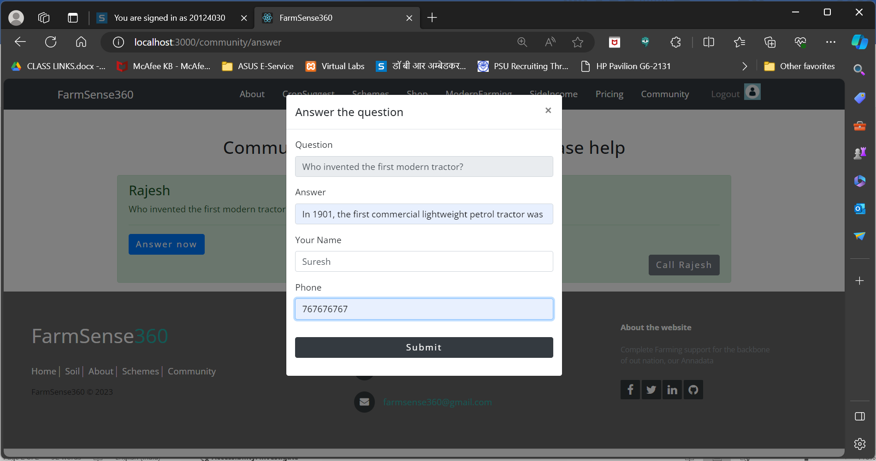
Fig.4.11 showing how to answer question
User Authentication: Access to the community section is restricted to logged-in users. Users must log in to the Farmsence360 platform to access the Ask Questions, Post Info, and Answer a Question functionalities.
Contact Feature: Users can contact other users who have posted questions or provided answers by tapping on the "Call {username}" button. This feature directs users to the relevant application to facilitate communication.
The Community Component Module is a valuable addition to the Farmsence360 platform, enabling users to interact, share information, and seek assistance within the agricultural community. By leveraging MongoDB for data storage and user authentication, this module provides a secure and efficient platform for users to engage in meaningful discussions and collaboration. We believe that this feature will enhance user experience and contribute to the growth and development of the agricultural community within the Farmsence360 platform.

4.4 Government Initiatives Navigator
The Government Initiatives [1] Navigator is a dedicated section within the Farmsence360 platform designed to provide farmers with comprehensive information on various government initiatives related to agriculture in India. This feature aims to streamline access to crucial information about subsidy programs, grants, and policy changes, enabling farmers to take advantage of the support available to them. By centralizing this information and providing direct links to relevant government websites, Farmsence360 seeks to simplify the process of accessing government assistance and reduce bureaucratic hurdles for farmers.
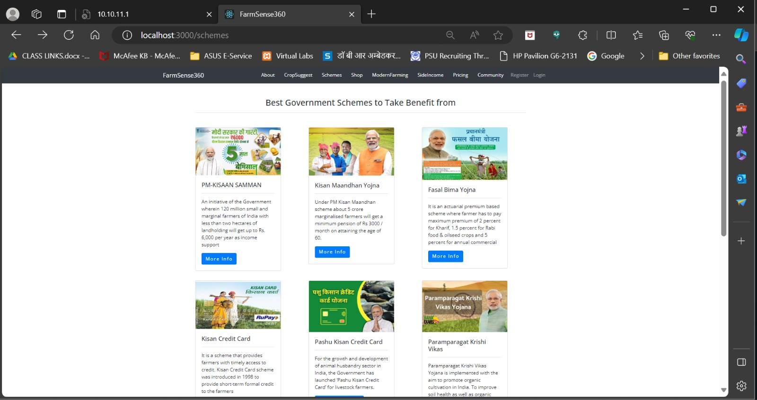Fig.4.12 Government Initiatives Navigator includes the following key functionalities
Scheme Coverage: The navigator covers a range of government schemes, including but not limited to
- PM-KISAAN SAMMAN
- Soil Health Card Scheme
- National Agriculture Market
- Pradhan Krishi Sinchai
- Paramparagat Krishi Vikas
- Pashu Kisan Credit Card
- Kisan Credit Card
- Fasal Bima Yojna
- Kisan Maandhan Yojna
All these schemes are displayed in webpage as shown in Fig .3.12 and Fig .3.13
Comprehensive Guide: The navigator provides detailed information on Indian government schemes related to agriculture, including their objectives, eligibility criteria, features, and benefits to farmers.
Up-to-Date Information: The navigator ensures that information on government initiatives is kept up to date, reflecting any policy changes or updates in subsidy programs or grants
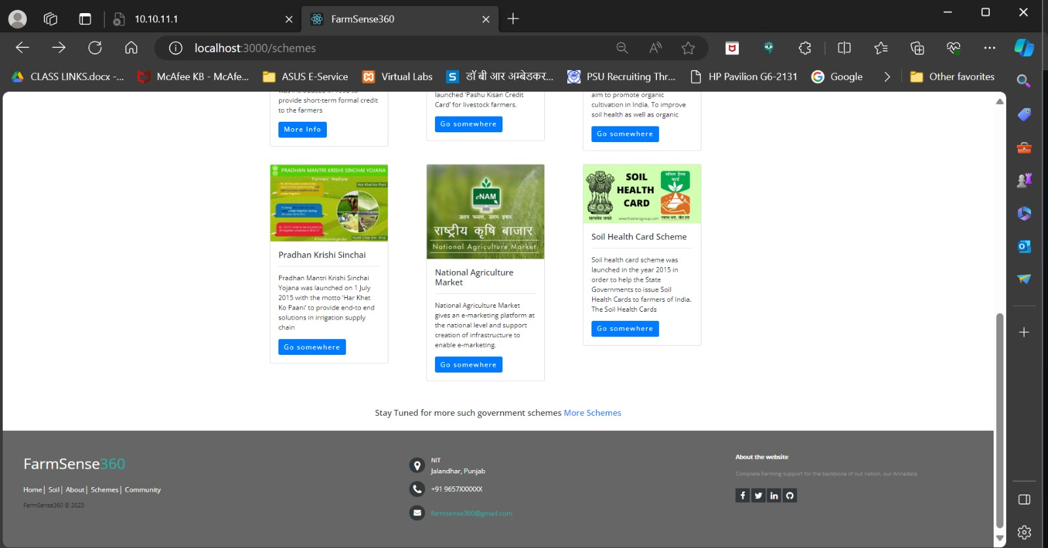
Fig.4.13 Sowing Scheme Coverage
Direct Links: Users can access direct links to the official websites of government schemes, allowing them to apply for farmer applications or gather further information about specific initiatives.
The Government Initiatives Navigator is a valuable addition to the Farmsence360 platform, providing farmers with easy access to comprehensive information about government schemes and initiatives related to agriculture in India. By centralizing this information and providing direct links to relevant government websites, Farmsence360 aims to empower farmers and streamline the process of accessing government assistance, ultimately contributing to the growth and development of the agricultural sector.
Current Affairs in Agriculture:
Farmsense360 will also integrate a module designed to deliver the latest farming news, ensuring that farmers remain abreast of current affairs pertinent to the agricultural sector. This module will encompass a spectrum of topics including updates on farming practices, loan availability, subsidies, fertilizer costs, and new regulations governing agricultural activities. By providing access to this comprehensive repository of information, Farmsense360 aims to empower farmers with the knowledge necessary to make informed decisions and adapt effectively to evolving industry dynamics.
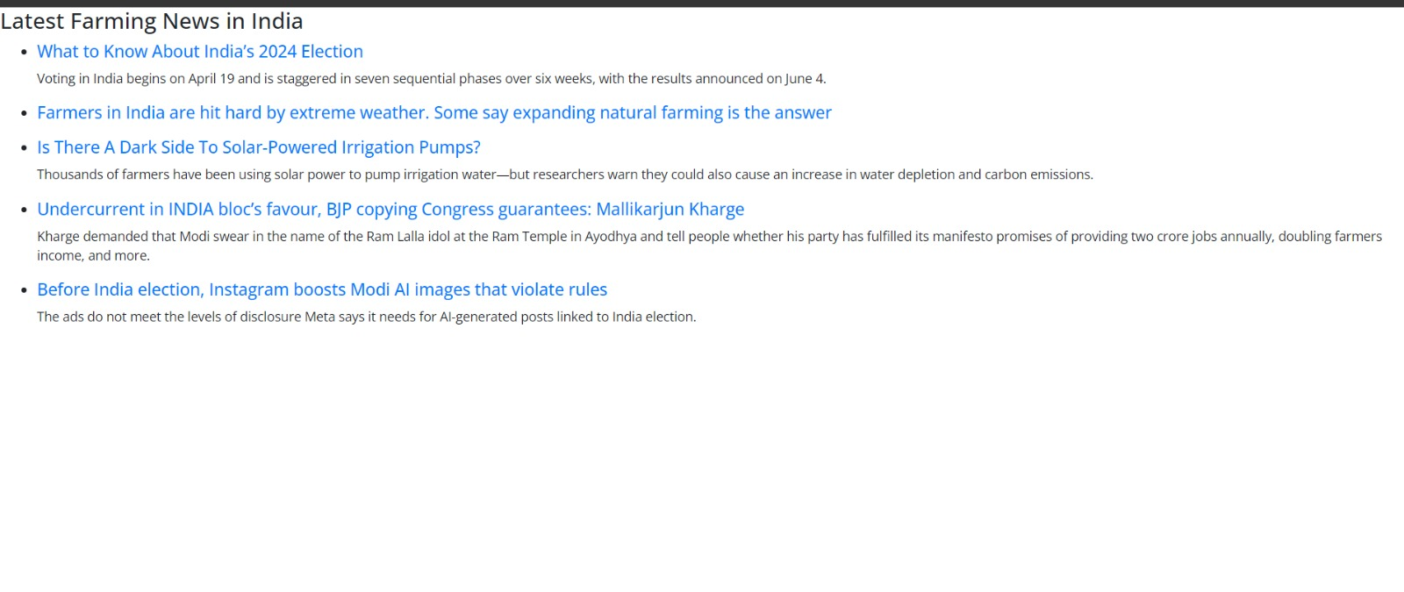
Fig.4.14 Latest Farming News in India

Chapter 5: Expected Outcomes
Expected Outcomes from the Proposed Features:
  - Crop Prediction System (Price Forecast up to 1 year):

- Improved Decision-Making: Farmers will benefit from accurate and reliable price predictions, allowing them to plan their agricultural activities more effectively. With insights into future crop prices, farmers can make informed decisions on crop selection, timing of planting, and harvesting, optimizing their yield and financial returns.
- Risk Mitigation: The ability to anticipate price fluctuations up to a year in advance provides farmers with a valuable tool for risk management. By understanding potential market trends, farmers can navigate price volatility and make strategic choices to protect their income and profitability.
5.2 Modern Practices Info (Includes Tools & Techniques):
- Enhanced Efficiency: Farmers will gain access to information on cutting-edge tools and techniques, promoting the adoption of modern farming practices. This knowledge transfer can lead to increased efficiency in various agricultural operations, such as planting, irrigation, and harvesting.
- Productivity Boost: The incorporation of modern practices aims to improve overall productivity. By adopting advanced tools and techniques, farmers can potentially enhance their output, contributing to increased yields and sustainability.
5.3 Government Initiatives Information Interface :
- Increased Access to Support: Farmers will have comprehensive information on government initiatives, schemes, subsidies, welfare programs, and loans. This facilitates easier access to crucial resources and financial support, empowering farmers to leverage available assistance for the development and enhancement of their agricultural practices.
- Financial Sustainability: Awareness of available government support can contribute to the financial sustainability of farmers. Access to subsidies and loans enables farmers to invest in necessary resources and technologies, fostering growth and resilience.
5.4 Soil Types – Suitable Crops:
- Informed Crop Selection: Farmers will receive insights into different soil types, helping them make informed decisions about suitable crops based on the specific characteristics of their soil. This tailored approach can lead to better crop yields and resource utilization, aligning agricultural practices with the natural conditions of the land.
- Resource Optimization: Understanding soil characteristics supports the optimization of resources such as fertilizers and irrigation, reducing waste and promoting sustainable farming practices.

5.5 Doubt Posting & Blogs:
- Community Collaboration: The doubt posting feature fosters a collaborative community where farmers can share experiences, seek advice, and collectively address challenges. This communal exchange of knowledge creates a supportive environment for continuous learning and problem-solving.
- Expert Insights: Blogs contributed by experts and fellow farmers provide valuable insights and real-world experiences. This platform offers a space for the dissemination of expert knowledge, contributing to the ongoing education and improvement of farming practices.
5.6 Alternative Farming Methods:
- Diversification Opportunities: Farmers will have information on alternative farming methods, opening up opportunities for diversification. Exploring alternative crops or farming practices can provide resilience against environmental factors and market uncertainties, potentially leading to more stable and diversified income sources.
- Sustainability Focus: Alternative farming methods often emphasize sustainable and eco-friendly practices. The adoption of these methods contributes to environmental conservation and aligns with the growing demand for sustainable agriculture.

Chapter 6: Conclusion & Future Work
6.1 Conclusion
Farmsence360 has successfully achieved its goals by integrating advanced technology and comprehensive features to support the agricultural community. The platform offers precise crop recommendations, accurate price predictions, and educational content on modern farming practices. It provides easy access to government initiatives and fosters community collaboration. These innovations enhance decision-making, risk management, efficiency, and financial sustainability for farmers. Overall, Farmsence360 significantly contributes to the advancement and resilience of agriculture through informed and sustainable practices Fig. 6.1.

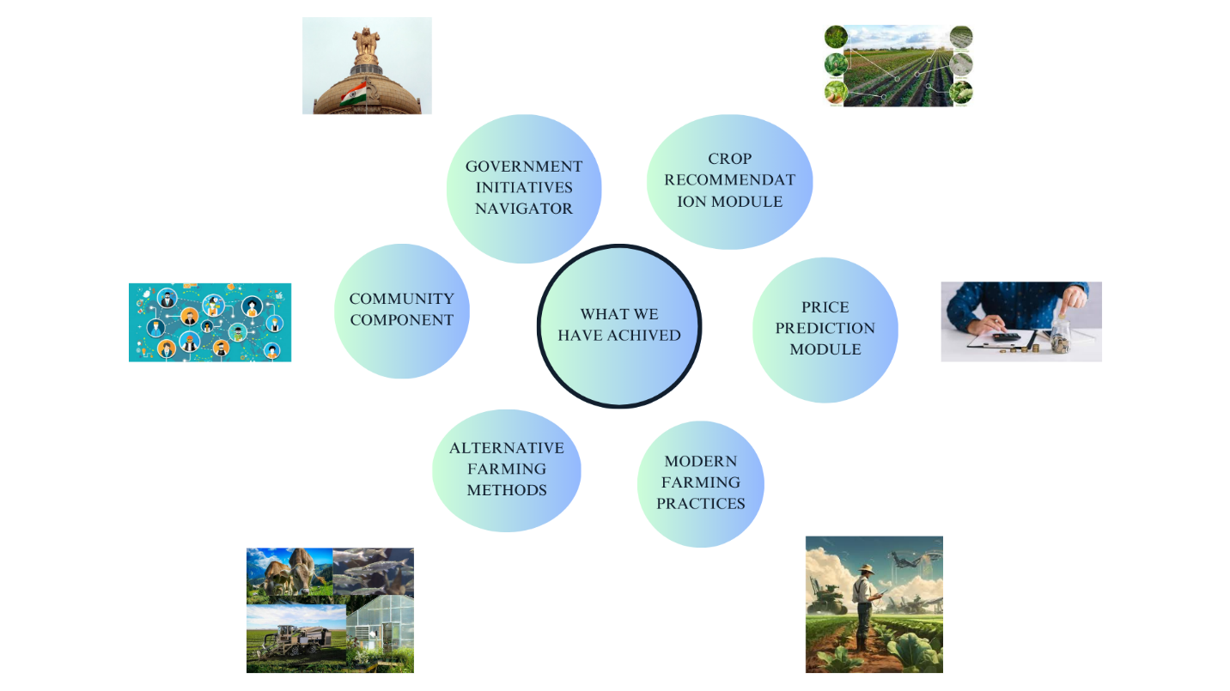
Fig.6.1 Achieved Goals
:
- Improved Decision-Making: Through features like Crop Recommendation and Price Prediction, farmers will be empowered to make informed decisions regarding crop selection, planting schedules, and marketing strategies.
- Increased Efficiency and Productivity: Access to information on modern farming practices, tools, and techniques will equip farmers to optimize their operations and potentially achieve higher yields.
- Enhanced Risk Mitigation: Price forecasts and insights into market trends will enable farmers to navigate market fluctuations and protect their profitability.
- Financial Sustainability: The Government Initiatives Navigator will streamline access to crucial information on government schemes, subsidies, and loans, empowering farmers to leverage financial support for agricultural development.
- Sustainable Practices: Information on alternative farming methods and soil suitability will encourage the adoption of sustainable practices that are not only environmentally conscious but also promote resource optimization.
- Community Collaboration: The doubt posting and blog features will foster a collaborative community where farmers can share knowledge, experiences, and best practices, fostering continuous learning and problem-solving.
The proposed enhancements and new features aim to make Farmsense360 a more powerful and user-friendly platform for farmers. By leveraging advanced technologies, expanding data sources, and fostering community engagement, Farmsense360 will provide even more valuable insights and support to the agricultural community, ultimately contributing to the growth and sustainability of the sector.
6.2 Future Work
Building on the existing capabilities of Farmsense360, the proposed future work aims to introduce new functionalities that will further enhance the platform's value to the agricultural community. These future enhancements will focus on integrating advanced technologies and new services, including chatbots, e-commerce, weather data, soil testing, and more.
Chatbot Integration & AI-Powered Chatbot
To provide farmers with instant support and personalized assistance, an AI-powered chatbot will be integrated into the Farmsense360 platform. This chatbot will offer:
- 24/7 Customer Support: Available round-the-clock to answer queries related to crop recommendations, government schemes, marketplace transactions, and more.
- Interactive Problem Solving: Capable of diagnosing common issues based on user inputs and providing step-by-step solutions.
- Personalized Assistance: Utilize machine learning to tailor responses based on user history and preferences, improving the relevance and accuracy of the assistance provided.
E-Commerce and Shopping Tools
The existing Shop module will be expanded into a comprehensive e-commerce platform, providing farmers with a seamless shopping experience for agricultural tools and supplies:
- Wide Product Range: Offer an extensive catalog of products including seeds, fertilizers, tools, machinery, and more.
- User Reviews and Ratings: Implement a review and rating system to help farmers make informed purchasing decisions based on peer feedback.
- Discounts and Offers: Provide information on discounts, offers, and bulk purchase benefits to help farmers save on essential supplies.
Weather Data Integration
Integrate advanced weather forecasting services to provide real-time weather data and alerts to farmers:
- Localized Weather Reports: Deliver accurate, location-specific weather forecasts including temperature, humidity, rainfall, and wind speed.
- Weather Alerts: Send timely alerts about extreme weather conditions such as storms, droughts, and heavy rainfall to help farmers take preventive measures.
- Historical Weather Data: Provide access to historical weather data to help farmers analyzes climate patterns and make informed decisions.
Soil Testing and Analysis
Introduce a comprehensive soil testing and analysis module to help farmers understand their soil health and optimize crop cultivation:
- At-Home Soil Testing Kits: Offer affordable and easy-to-use soil testing kits that farmers can use to collect samples and receive analysis results.
- Professional Soil Testing: Partner with agricultural laboratories to provide detailed soil analysis services, including nutrient content, pH levels, and contamination reports.
- Soil Health Reports: Generate detailed reports with recommendations on soil amendments, fertilizer usage, and suitable crop types based on the test results.

References

- Ray, Rakesh Kumar, Saneev Kumar Das, and Sujata Chakravarty. "Smart crop recommender system-a machine learning approach." 2022 12th International Conference on Cloud Computing, Data Science & Engineering (Confluence). IEEE, 2022.
- Cheung, L., Wang, Y., Lau, A.S. and Chan, R.M., 2023. Using a novel clustered 3D-CNN model for improving crop future price prediction. Knowledge-Based Systems, 260, p.110133.
- S. Kavitha and N. Anandaraja, "Constraints and Suggestions as Percived by the Kisan Call Center Beneficiaries", International Journal of Pure and Applied Bioscience, July 2017 .
- AMMY XU 10 JUL 2023 Spatial Data Makes AI Crop-Yield Predictions Better Climate change has made the need for accurate predictions more urgent than ever.
- Ghutake, Ishita, et al. "An intelligent crop price prediction using suitable machine learning algorithm." ITM web of conferences. Vol. 40. EDP Sciences, 2021.
- Samuel, Pandit, et al. "Crop price prediction system using machine learning algorithms." Quest Journals Journal of Software Engineering and Simulation (2020).
- Patel, Shrikant, et al. "Mongodb versus mysql: A comparative study of two python login systems based on data fetching time." Research in Intelligent and Computing in Engineering: Select Proceedings of RICE 2020. Springer Singapore, 2021.
- Boduch, Adam. React material-ui cookbook: build captivating user experiences using react and material-ui. Packt Publishing Ltd, 2019.
- Singh, Pankaj, and Gaurav Agrawal. "Development, present status and performance analysis of agriculture insurance schemes in India: Review of evidence." International Journal of Social Economics 47.4 (2020): 461-481.
- Bathla, Seema, and Siraj Hussain. "Structural reforms and governance issues in Indian agriculture." Indian agriculture towards 2030 (2022): 251-296.
- https://www.frost.com/uncategorized/budget-2023-2024-analysis-agriculture/
- https://www.bankbazaar.com/tax/union-budget-agriculture-sector.html.
- Boduch, A., & Derks, R. (2020). React and React Native: A complete hands-on guide to modern web and mobile development with React. js. Packt Publishing Ltd.
- Jaskani, Muhammad Jafar, and Iqrar Ahmad Khan. "Horticulture: An Overview." University of Agriculture Faisalabad (2021).
- Juárez-Hernández, Sergio, and Claudia Sheinbaum Pardo. "Assessing the potential of alternative farming practices for sustainable energy and water use and GHG mitigation in conventional maize systems." Environment, development and sustainability 22.8 (2020): 8029-8059.
- Manida, M., & Ganeshan, M. K. (2021). New agriculture technology in modern farming. In 2nd International Multidisciplinary Conference on Information Science, Management Research and Social Sciences (ICISMRSS–2021).
- https://pib.gov.in/PressReleaseIframePage.aspx?PRID=2002012 [Schemes for Welfare of Farmers [02 FEB 2024].
- Rao, Madhuri Shripathi, et al. "Crop prediction using machine learning." Journal of Physics: Conference Series. Vol. 2161. No. 1. IOP Publishing, 2022.
- Karthikeya, H. K., K. Sudarshan, and Disha S. Shetty. "Prediction of agricultural crops using KNN algorithm." Int. J. Innov. Sci. Res. Technol 5.5 (2020): 1422-1424.
- Fegade, Tanuja K., and B. V. Pawar. "Crop prediction using artificial neural network and support vector machine." Data Management, Analytics and Innovation: Proceedings of ICDMAI 2019, Volume 2. Springer Singapore, 2020.
- Aditya Shastry, K., H. A. Sanjay, and M. C. Sajini. "Decision tree based crop yield prediction using agro-climatic parameters." Emerging Research in Computing, Information, Communication and Applications: ERCICA 2020, Volume 1. Springer Singapore, 2022.
- Doshi RT, Doshi S, Shah V (2023) City farming – the natural alternative, experiences in India. Urban Agric Mag 10:18–19 .
- Rohit Kumar Rajak, Ankit Pawar, Mitalee Pendke, Pooja Shinde, Suresh Rathod and Avinash Devare, "Crop Recommendation System to Maximize Crop Yield using Machine Learning Technique", International Research Journal of Engineering and Technology (IRJET), 2017.
- P. A, S. Chakraborty, A. Kumar and O. R. Pooniwala, "Intelligent Crop Recommendation System using Machine Learning," 2021 5th International Conference on Computing Methodologies and Communication (ICCMC), Erode, India, 2020 .
- C. V. Neha Niharika, K. Mothish Kumar, K. Harika, V. Venkatesh, A. Yasmine Begum, "Crop Recommendation with IOT and ML", 2023 4th International Conference for Emerging Technology (INCET), pp.1-5, 2023.
- Mayur Desai, Namrata Ansari, "An Innovative Method to Increase Agricultural Productivity using Machine Learning-based Crop Recommendation Systems", 2023 Second International Conference on Augmented Intelligence and Sustainable Systems (ICAISS), pp.645-651, 2023.
- K. R. S. Sravanth and N. Sundaram, "Agricultural Crisis and Farmers Suicides in India," International Journal of Innovative Technology and Exploring Engineering (IJITEE), vol. 8, no. 11, Sep. 2019.

