What are the main assumptions of Linear regresssion? (IMP Qsn Interviews)
1. Linearity
The relationship between input (X) and output (Y) should be linear. Means: change in X leads to proportional change in Y
2. Independence of Errors
The errors (residuals) should be independent of each other
- The error of one data point should not depend on another
- Important in time-series data
3. Homoscedasticity (Constant Variance)
The variance of errors should be constant
- Errors should spread evenly
- Not like a funnel shape
4. Normality of Errors
The Errors should follow a normal distribution (bell-shaped curve or symmetrically distributed)
- Helps in statistical inference (confidence intervals, p-values)
5. No Multicollinearity
Independent variables should not be highly correlated with each other
- If X variables are strongly related → model gets confused
6. No Autocorrelation
Errors should not be correlated over time
- Common issue in time-series data
LINEAR
- L → Linearity
- I → Independent errors
- N → Normal errors
- E → Equal variance
- A → Absence of multicollinearity
- R → Residual independence (no autocorrelation)

VIF (Variance Inflation Factor)?
VIF is a metric used in linear regression to detect multicollinearity (when independent variables are highly correlated with each other).
If the VIF value is high, it indicates multicollinearity, so we should remove the corresponding feature. Features should be removed one by one instead of all at once, because after each removal we need to recheck VIF and model performance, since removing one feature can change the relationships among the remaining features.
Remove VIF>5
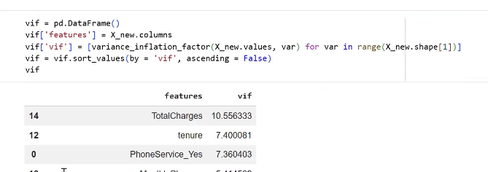
RFE is a feature selection technique used in machine learning to choose the most important input variables by recursively removing the least important ones.

What are the Three methds to perform Linear Regression ?
  - Sklearn – Lin Reg
  - StatModel- OLS
  - Sklearn SGD Reg = Suitable for Complex Dataset

What is RFE (Recursive Feature Elimination)
- RFE is a feature selection technique that recursively removes the least important features to select the most relevant ones.
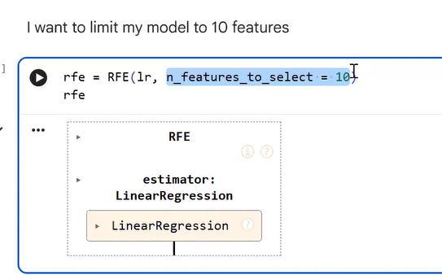

    - We Cannot remove any feature from the dataset untill and unless we observed , Removal of that particular feature Result Improved Performance

What is ROC Curve (Receiver Operating Characteristic)
ROC curve is a graph used to evaluate classification models by plotting True Positive Rate (TPR) against False Positive Rate (FPR) at different threshold values. It shows how well the model can distinguish between classes, and a curve closer to the top-left indicates better performance.]
- If the Curve of a model is very Beyond the Min Roc Line(yellow line) It is performing very well
- Else If model curve is very near or below min line it is showing poor performance
Example :
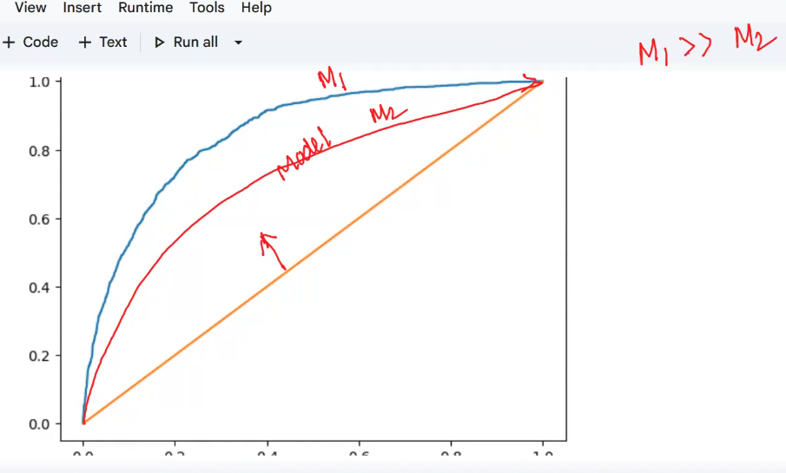

Why Logestic Regression is Suitable for only classification Tasks, we call it with “ Regression Method ” ?
Logistic Regression uses a regression-based approach (on log-odds) to solve a classification problem, which is why it is called Logistic Regression.
👉 Because its output is a probability (0 to 1)
$$p=\frac{1}{1+e^{-z}}$$
- Output is always between 0 and 1
- We apply a threshold (usually 0.5):
👉 $p≥0.5→1$
👉 $p<0.5→0$
✅ So it naturally fits binary classification

🔹 Then why is it called “Regression”?
👉 Because it performs regression on log-odds, not directly on class labels.
$$log⁡\left(\frac{p}{1-p}\right)=w_{1}x_{1}+w_{2}x_{2}+⋯+b$$
- This is a linear equation (like linear regression)
- We are estimating a continuous value (log-odds)
Key Idea (Very Important)
- Linear Regression → predicts continuous output (Y)
- Logistic Regression → predicts probability, then converts to class
👉 Internally → regression
👉 Final output → classification

What is Generalized Linear Model?
A Generalized Linear Model is a framework that extends linear regression so it can handle different types of target variables.
  - Imported using Stats Model
Feature | GLM | Logistic Regression
Type | Framework | Specific model
Output types | Continuous, binary, count | Only binary
Distribution | Many (Normal, Poisson, Binomial) | Only Binomial
Link function | Multiple | Only Logit
Flexibility | High | Limited
Examples of GLMs
- Linear Regression → Normal distribution
- Logistic Regression → Binomial
- Poisson Regression → Count data
Simple Analogy
- GLM = Toolbox 🧰
- Logistic Regression = One tool (screwdriver)

What is the kernal (parameters) in SVM?
A kernel transforms your data so that it becomes easier to separate.
Instead of manually converting features, SVM uses a kernel function to do it efficiently.
Without kernel:
- SVM can only draw a straight line (linear boundary)
With kernel:
- It can draw curves, circles, complex shapes

Kernel | Shape of Boundary | Complexity | Use Case
Linear | Straight line | Low | Simple data
Polynomial | Curved | Medium | Feature interactions
RBF | Very flexible | High | Complex data
Sigmoid | Neural-like | Rare | Experimental

What is the diffrence b/w Sampling with replacement vs without replacement:

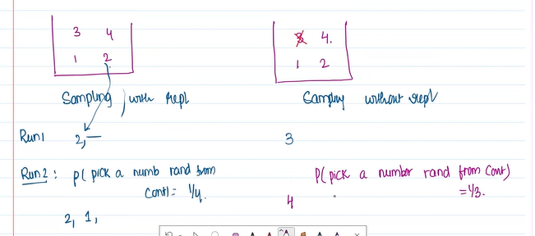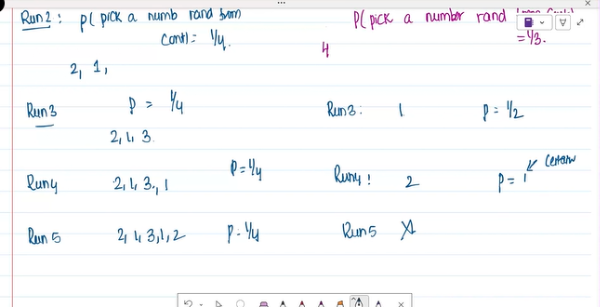

Why we consider Decision tress in Ensembles ?
  - Decision tress shows Unsteady nature [ like if you consider 4 different learners , you will get four different decision tress bcoz of unsteady nature]
  - Even though 4 different decision tress produced the performance is stable across all
  - So therefore Diversity will imporve due to this

What is limitation of Gradient boosting & what is mastering the training data, Memorizing the Decision data or overfitting
One main problem with the gradient boosting decision tree, On repetation process of boosting or addressing errors , after perioied of time it ends up with Zero error that leads to overfitting.

Main challenges of Ensembles are:
  - Training time is high
  - Testing time is high
  - Model size also High

How PCA differers from T-SNE?
PCA reduces dimensions by preserving maximum variance in linear data, while t-SNE reduces dimensions by preserving local similarities and revealing nonlinear clusters mainly for visualization.

How sequentual ensembles are different from parllel ensembles?
Sequential ensembles train models one after another, where each new model learns from the mistakes of the previous model to improve performance and mainly reduce bias, while parallel ensembles train multiple models independently at the same time and combine their predictions using voting or averaging to mainly reduce variance; examples of sequential ensembles are Boosting and XGBoost, whereas Random Forest and Bagging are examples of parallel ensembles.

Model Building
As per the assignment, implement at least 3 forecasting models.
I recommend:
- Linear Regression (Baseline)
- Random Forest Regressor
- XGBoost Regressor
This combination demonstrates:
- A simple linear model.
- A bagging-based ensemble model.
- A boosting-based ensemble model.
It also gives you good material for the Best Model Selection section later.

