Sentiment Analysis with MLflow Tracking
This project performs Sentiment Analysis on customer reviews using multiple Machine Learning models.
It integrates MLflow for experiment tracking, model comparison, and model management.
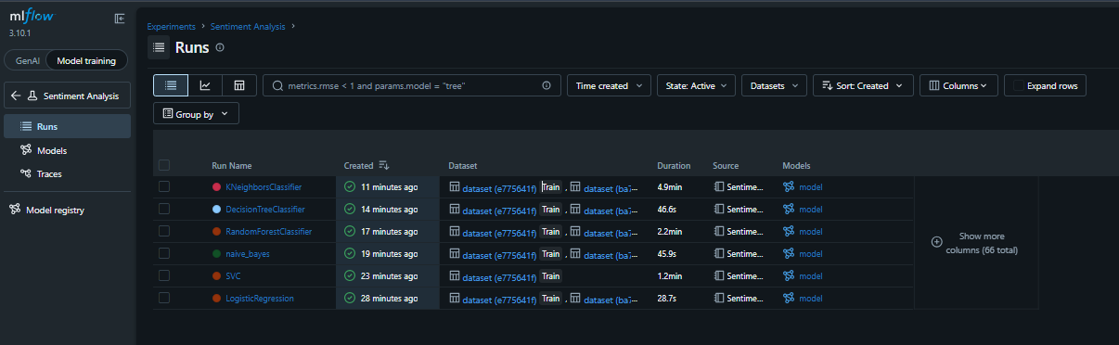
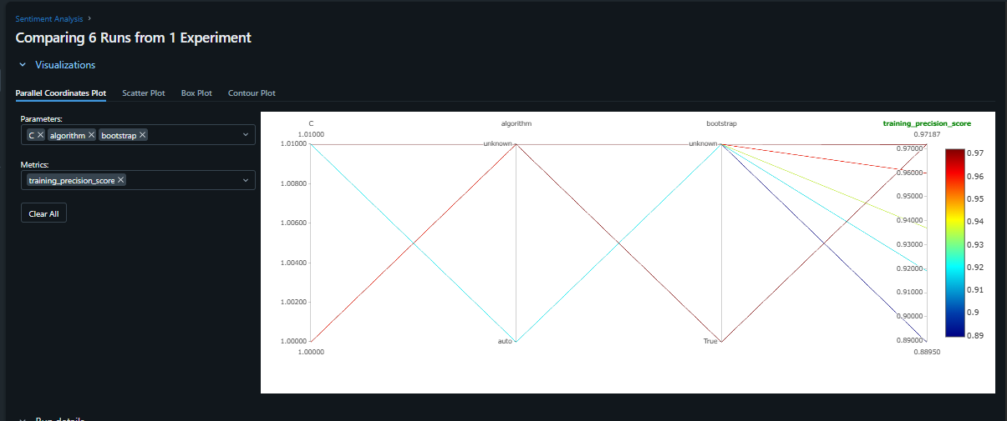
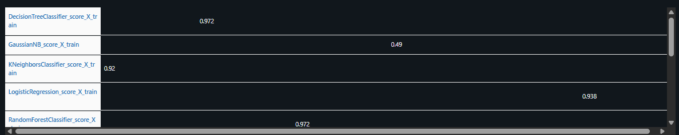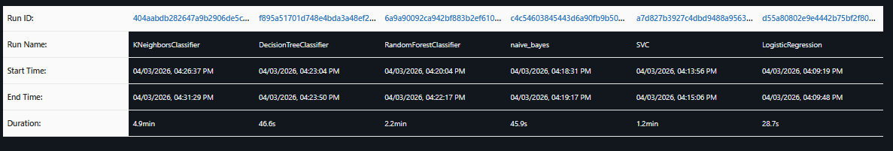
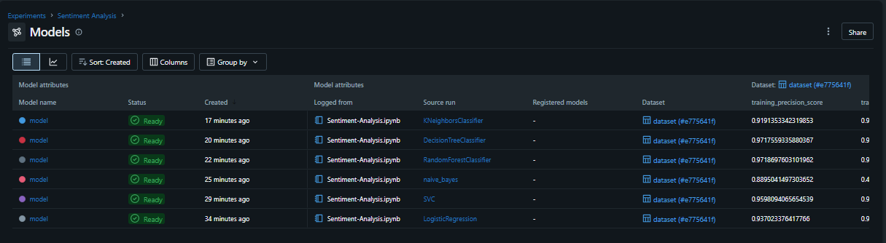
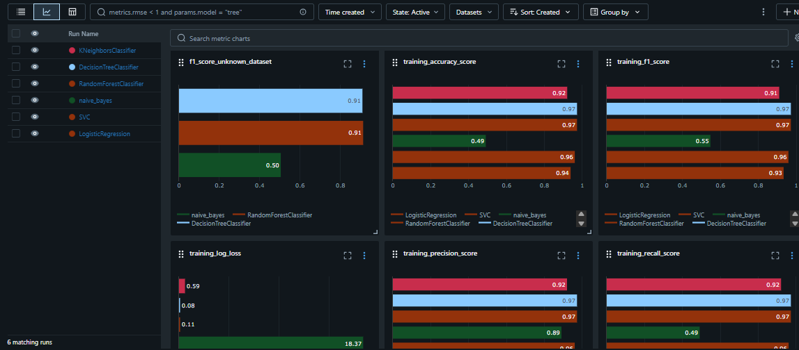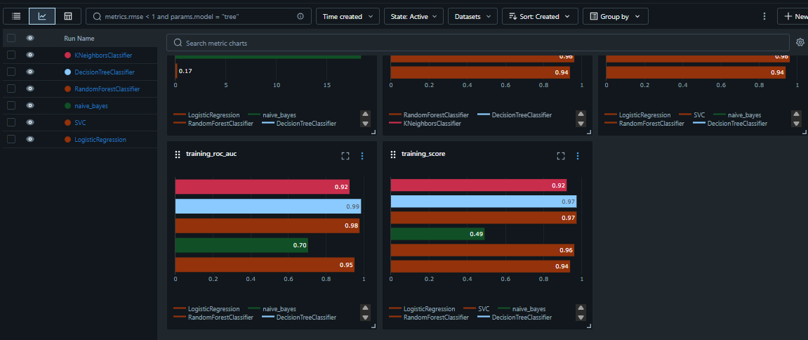
Model | Score
Logistic Regression | 0.938 (BEST)
Decision Tree | 0.972 (overfitting likely — train score)
Random Forest | 0.972 ( overfitting likely — train score)
KNN | 0.92
Naive Bayes | 0.49
Comparing two Models :
