EYE-HEALTH ANALYTICS
Exploratory Report & Data Story
Lifestyle, screen habits and vision across 10,000 respondents
Source: eye_score_cleaned.xlsx | Companion file: index.html (interactive dashboard)

1. Dataset at a glance
The analysis uses a pre-cleaned survey of 10,000 respondents described by 11 numeric attributes plus an ID. The cleaning log confirms the set is analysis-ready:
- 0 missing values and 0 duplicate rows — no imputation required.
- Float columns standardised to 4 decimals; domain ranges verified (age 5–80, screen time 0–16 h, scores 0–100).
- Ceiling values (e.g. 300 records at the 16-hour screen-time cap) were retained as valid and are disclosed.
- The set carries no date and no geographic field, so the dashboard substitutes age / screen-time ranges for a date slider and a correlation heatmap for a map.
The strongest linear relationships with the eye-health score are summarised below.
Factor | Pearson r | Reading
Glasses prescription level | −0.56 | Strongest driver; not modifiable
Age | −0.49 | Steady life-course decline; not modifiable
Daily screen time (hrs) | −0.49 | Largest MODIFIABLE risk factor
Screen brightness | −0.19 | Minor negative association
Outdoor light exposure (hrs) | +0.23 | Protective; modifiable
Exercise (hrs) | +0.24 | Protective; modifiable
Table 1. Pearson correlation of each attribute with the eye-health score (n = 10,000). Negative = score falls as the factor rises.

2. Three exploratory charts

2.1 Correlation
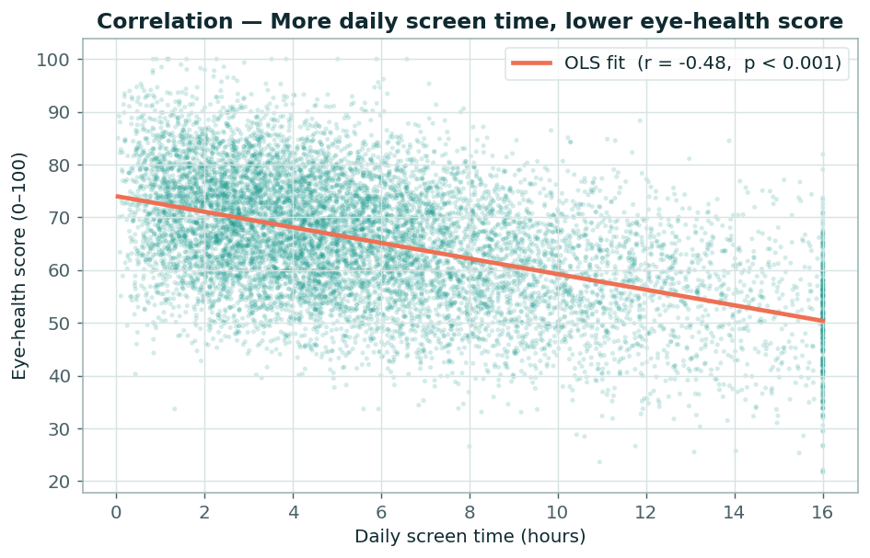
Figure 1. Each point is one respondent; the coral line is an ordinary-least-squares fit. Eye-health scores decline as daily screen time rises (r = −0.49, p < 0.001) — the clearest modifiable relationship in the data.

2.2 Distribution
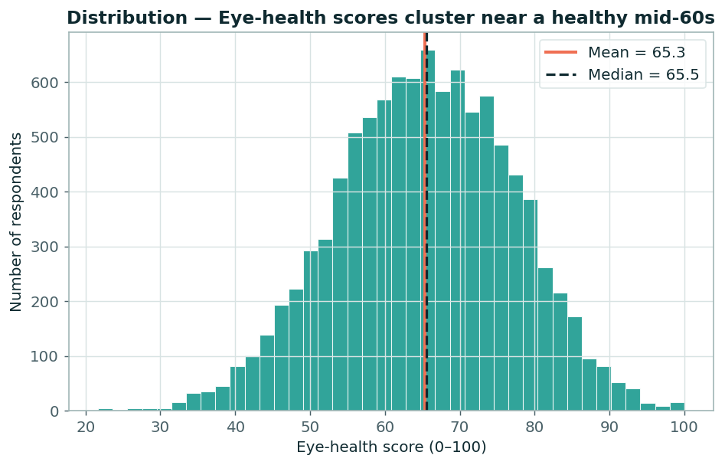
Figure 2. The eye-health score is roughly bell-shaped and centred on a mean of 65.3 (median 65.5), spanning 21.7 to the 100-point ceiling. Mean and median almost coincide, indicating little skew.

2.3 Time-series / life-course trend
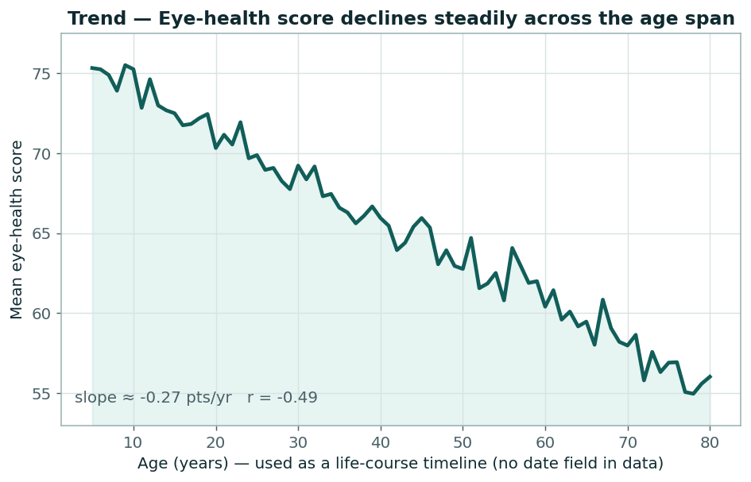
Figure 3. Mean eye-health score across age, used as a life-course timeline because the dataset has no date field. Scores fall steadily from ~75 in childhood to ~56 by age 80 (slope ≈ −0.27 points per year, r = −0.49).

3. Data Story
What protects our eyes? (286 words)
Across 10,000 complete respondents (11 attributes, zero missing or duplicate rows), the average eye-health score sits at a moderate 65.3 out of 100, with most people clustered between the mid-50s and mid-70s. That headline average, however, hides who is at risk and why.
Who this is for. The dashboard is built for digital-wellbeing and public-health communicators, and for the everyday screen user who wants to know which habits actually matter. It is exploratory, not clinical.
The single most important insight. Eye-health is shaped by two kinds of forces. The strongest correlates — prescription level (r = -0.56) and age (r = -0.49) — are largely outside a person’s control: mean scores fall from 73.6 in the under-20s to 56.5 in the over-70s. The key takeaway is the largest modifiable factor: daily screen time (r = -0.49). Heavy-screen users score roughly 20 points lower than light users, while outdoor light (+0.23) and exercise (+0.24) pull scores back up. Age sets the baseline, but daily behaviour decides where you land on it — and screen time is the lever a user can actually pull.
How bias was addressed. Because this is observational, cross-sectional data, every relationship is described as an association, never a cause. The dual-axis chart was deliberately re-based onto age, where both series genuinely move, rather than exaggerating a near-flat screen-time line through a stretched axis. Age stands in for a timeline only because the data carries no date field, and this is labelled openly. Distributions are shown in full, not just averages; group counts are always displayed; the ordinal glasses scale uses a single-hue sequence (not a rainbow) so order is not mistaken for category; and the 300 capped screen-time records are retained and disclosed.

