

THE CAESAR CIPHER

NAME: KEITH KARUNG’O

ADM. NO:230374

DIPLOMA IN CYBER SECURITY AND ETHICAL HACKING

INSTITUTE OF SOFTWARE TECHNOLOGIES

2023

DECLARATION

I Keith Karung’o registration number 230374 do hereby submit this as a substantial analysis of my first semester project . This research is my original work and has not been presented for any qualification in this or any other university or institution of learning

Sign……………………………. Date…………………………….

ACKNOWLEDGMENT

I want to express my gratitude for the support of my family and friends, as well as the resources at the Institute that made this project possible. Your contributions were essential to its success.

TABLE OF CONTENTS

THE CAESAR CIPHER.......................…....................................1
DECLARATION ................................…...............................…...2
ACKNOWLEDGMENT...........................…….................………3
TABLE OF CONTENTS ...............…….......................................4
LIST OF TABLES ..............................................................5
LIST OF FIGURES……………………………………………….6
1. CHAPTER ONE……………………………........................................………......7
1.1) Introduction......................................................................………........7
1.2) Background Of The Study ....……........................................................7
1.3)Problem Identification .........................................................................8
1.4)Objective .....................………………............…..................................8
2. CHAPTER 2 .......…………………...........………............................................10
2.1)Literature Review………………............………………..................….....…10
2.2)Introduction .............….....................………………...............................…10
2.3)Cryptography……………………………………………………………………10
2.4)Symmetric Cryptography………………………………………………………11
2.5)Caesar Cipher………………………………………………………………….12
2.6)Modular Arithmetic………………………………………………………...12-13
3. CHAPTER THREE ...….……….……….................………….………...................15
3.1) Introduction .........….……………………..............................................15
3.2) Research Design…….........……………………......................................15
3.3) Target Population .........................…....………………..................….....16
3.4)Sample Size and Sample Technique……………………………………….16
3.5)Data Collection Instrument………………….……………………………..17
4.CHAPTER FOUR……………………...………………………..17
Data Analysis and Discussion of The Results………….……17
4.1)Introduction……………...………..…………………………………..17
4.2 )Questionnaire Return Rate……………….…………...……………………………….....18
4.3)Questionnaire administered……………..…………………...…….18-19
5.CHAPTER FIVE…………………….…………………..…...….20
SUMMARY OF THE FINDINGS, CONCLUSIONS AND RECOMMENDATIONS…………………………………………………..21

5.1)Introduction ………………………..………………………………….21

5.2)Summary of Findings………..………………………………………..21
5.3)Recommendations……………………………………………………..21
6.CHAPTER SIX IMPLEMENTATION AND ANALYSIS……..22
6.1) Overview……………………………………………………..22
7. CHAPTER SEVEN SYSTEM METHODOLOGY ……24-26
7.2 Code Analysis………………………………………………….26
7.3) Function One………………………………………………………..27
7.3) Function Two………………………………………………………..28
7.3) Script Header………………………………………………………..29
7.3) REFERENCES………………………………………………………..30
LIST OF TABLES

Table 4.0 ……………………………….. Questionnaire Return Rate

LIST OF FIGURES

Figure 1.1 ……………………………….Cryptography
Figure 1.2 ……………………………….Symmetric Cryptography
Figure 1.3 ……………………………….Caesar Cipher
Figure 1.4 ……………………………….Modular Arithmetic
Figure 6.0………………………………..Caesar Cipher in work
Figure 7.1……………………………...Command line Call
Figure7.2………………………………...Shift Value
Figure7.3……………………………….. Encryption
Figure7.4………………………………..Encryption Success
Figure7.5…………………………………….Function One
Figure7.6………………………………………..Function Two
Figure7.7…………………………………...Script Header

1. CHAPTER ONE

1.1) Introduction

- The Caesar Cipher is a classical encryption method based on one of the most common types of Cryptography, The Symmetric Key. My project draws inspiration from the Roman General and Statesman Gaius Julius Caesar. During his many exploits he developed the cipher to send messages to his Generals. The cipher entailed a simple substitution where He would shift each letter of the alphabet by a certain number of positions. An example of this would be if the shift value (The Key in Cryptology terms) was the numerical value 2 the letter A would be equal to C and B would be equal to D and so on leading the alphabet to wrap . So the higher the shift value the more difficult it would be to decipher.

1.2) Background of the Study
In the realm of information security and data confidentiality, the Caesar Cipher has found renewed relevance as organizations strive to secure their sensitive communications. This project centers around enhancing the understanding of methods of Cryptography what better way than to incorporate the Caesar Cipher, An ancient simple substitution cipher within the operational framework of Stellar Security Services , a leading player in the security services sector.
Stellar Security, deals with vast amounts of sensitive information daily, ranging from client transactions to internal communications. The current mode of securing this data predominantly relies on modern encryption methods. While these methods offer the highest level of security, there is a growing recognition within the world of the need to spread awareness on Data Security and Management to do so we must start from the beginning
The Caesar Cipher, with its historical significance and simplicity, presents an intriguing option for Stellar Security . By incorporating this classical encryption technique into their existing security protocols, the organization aims to not only strengthen its defenses but also to provide a hands-on learning experience for its employees in the fundamentals of cryptography.
This project aims to not only fortify their data security but also empower their workforce with a nuanced understanding of encryption principles. The insights gained from this endeavor will not only bolster Stellar Security’s Cyber resilience but also serve as a model for other organizations seeking to balance historical encryption methods with contemporary security demands. Through this initiative, Stellar Security envisions a more robust and informed approach to safeguarding their critical information assets in an ever-evolving digital landscape.

1.3) Problem Identification

In today's world, where we share important information through digital means, keeping that information safe is really important. The Caesar Cipher, even though it's a famous historical method, faces substantial vulnerabilities when subjected to contemporary cryptographic scrutiny. It's essential to understand its weaknesses as compared to modern encryption methods because nowadays, we need much stronger ways to protect our digital messages. Regardless it is an essential encryption method that laid the foundation for many other modern encryption methods and learning about and interacting with it will with no doubt fuel a better understanding .

1.4) Objective

- The primary objective of this chapter is to provide an in-depth introduction to the Caesar Cipher. We will explore its historical significance, the fundamental principles behind its operation, and its relevance in modern cryptography. By the end of this chapter, readers will have a clear understanding of the basic workings of the Caesar Cipher and its role in the broader field of encryption

CHAPTER 2

LITERATURE REVIEW

2.1 Introduction
In this part, the writings on the concepts the Caesar Cipher is based on as recorded by other scholars and researchers will reviewed and presented according to what the investigation aims to achieve.

2.2 Cryptography
Cryptography the practice and study of secure communication in the presence of adversaries, aiming to ensure confidentiality, integrity, and authenticity of data during transmission or storage. It involves creating and deciphering codes, which allows for the secure exchange of information over unsecured channels. Based on the description above we have 3 well known types of Cryptography;
- Symmetric Key Cryptography
- Asymmetric Key Cryptography
- Hash Function Cryptography

CRYPTOGRAPHY
Encryption
Decryption
Ciphertext
Plain Text
Plain Text

Figure 1.1

2.3 Symmetric Cryptography
Also known as Secret Key Cryptography, this type of cryptography uses single key for both encryption and decryption. The same key is used for and decoding the message.
This approach relies on maintaining the secrecy of the shared key, which serves as the “pin” for securing communication. Symmetric encryption is known for its computational efficiency and speed, making it suitable for encrypting large volumes of data in real-time. One of the challenges faced by symmetric cryptography is the "inherent key distribution problem." This problem refers to the need for securely distributing the secret key between communicating parties. If an unauthorized entity gains access to the key during distribution, it can compromise the security of the entire system.
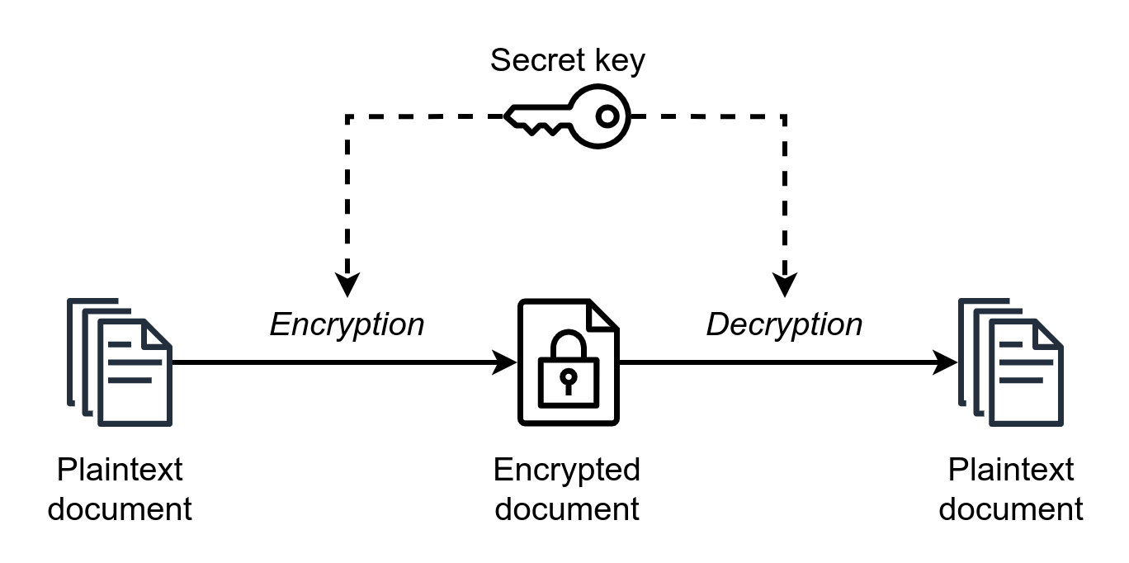

Figure 1.2

2.4 Caesar Cipher
As previously discussed this cipher is an ancient method of cryptography and is said to have been used by Julius Caesar. The Caesar cipher is based on Symmetric Encryption and involves shifting each letter of the plain text (data before encryption, often text but not always; could be media or simply a text) message by a certain number of letters

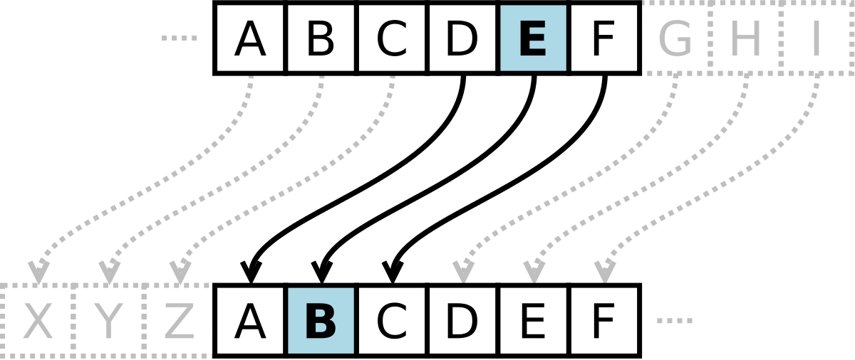

Figure 1.3

2.5 Modular Arithmetic

Modular arithmetic is the branch of arithmetic mathematics related with the “mod” functionality. Basically, modular arithmetic is related with computation of “mod” of expressions. Expressions may have digits and computational symbols of addition, subtraction, multiplication, division or any other. Here we will discuss briefly about all modular arithmetic operations.
To further our understanding of the Caesar Cipher we must understand the basics of Modular Arithmetic in which it is based on. The Caesar Cipher shifts letters in the alphabet by a fixed amount, known as the key or shift value. In modular arithmetic, numbers "wrap around" after reaching a certain value, which is known as the modulus(previously referred to as the mod). In the case of the Caesar Cipher, the modulus is the number of letters in the alphabet(26)

.
The formula of encryption is:
En (x) = (x + n) mod 26

Where
E denotes the encryption
D denotes the decryption
x denotes the letters value
n denotes the key value (shift value)

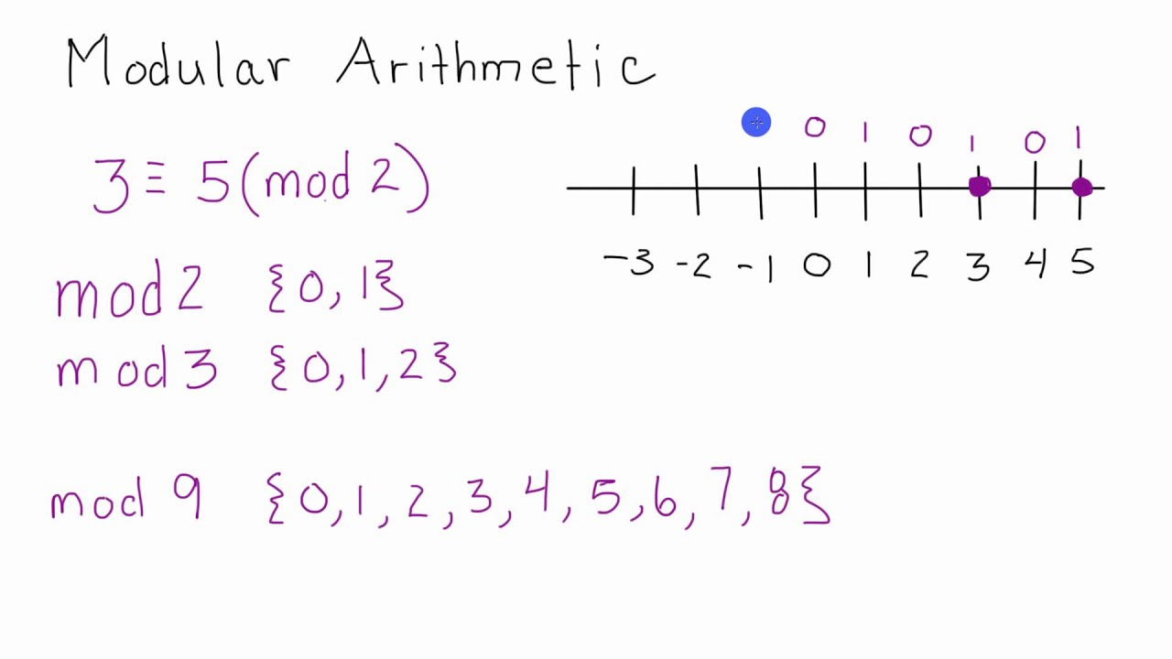
An example of mod 2 in use (Figure 1.4)

3. CHAPTER THREE

RESEARCH METHODOLOGY

3.1 Introduction
This chapter outlines the research methods that the study will deploy to achieve the study objective. The chapter present the research, research philosophy, research design, population of the study and sampling procedure. The study also presents the data collection instrument and collection, validity and reliability of the study and data analysis and processing.

3.2 Research Design
A research design is a blueprint of a study which stipulates how it should be conducted. A research design is important as logic behind every finding in the study. According to EMC Education Services (2015) a researcher can adopt three different kinds of research methods namely exploratory, descriptive and causal research. The current study will descriptive survey research design. Descriptive survey research design is a research design for conducting research that involves collecting, analyzing and integrating quantitative such as descriptive surveys and qualitative such as focus groups and interviews research .Descriptive survey research design is used at it promote collaboration of different data collected provides a better understanding of the research problem than either of each alone (Glesne, 2016). According to descriptive survey research design will help the researcher to combines elements of qualitative and quantitative research approaches such as use of qualitative and quantitative viewpoints, data collection, analysis, inference techniques for the broad purposes of breadth and depth of understanding

3.3.Target Population
Target population is the specific population about which information is desired.. Population in this study is the larger group from which the sample will be taken. The target population for the study will be 110 officers from Stellar Security Services working in different level or ranks. This will constitute the study population.

3.4 Sample Size and Sample Technique
The sample size of this study will be calculated from the Slovin’s formula given as:
n = N / [1 + N (e)²]
n = The sample size
N = Total population
e = Error tolerance
The substituted values in determining the sample size for a large population are as follows.
N= 110/1+110(0.05²⁾=85
The study will adopt stratified sampling and simple random sampling techniques to be used in selection of respondents. First, the officers in the security institutions are in different level of management which form basis for stratification. Since the respondents are classified according to their management levels, stratified random sampling method is deemed the best to use for this study.

3.5 Data Collection Instrument
The study will use primary data which will be collected using a questionnaire. Instruments are developed to collect necessary information .The methods of data collection that will be used for this study is drop and pick later technique. This method is resourceful particularly in collecting primary data. According to Plano and Ivankova (2016), the drop and pick later technique is more efficient and economical in collecting primary data. This method is suitable because respondents will have the opportunity to complete the questionnaires at their own convenience. In addition, this method is more effective in terms of cost and time.

4. CHAPTER FOUR

DATA ANALYSIS AND DISCUSSION OF THE RESULTS

4.1 Introduction
This chapter entails discussions on data presentation, analysis and interprentation of the research findings of the Caesar Cipher its historical significance, the fundamental principles behind its operation, and its relevance in modern cryptography

4.2 Questionnaire Return Rate
The questionnaires were administered to the target population of 85 employees of Stellar Security Services in Mavoko Sub County, Machakos County. The results were presented in Table 4.0.

Table 4. 0: Questionnaire Return Rate
Respondents Category | Frequency | Percent
Questionnaire filled and returned | 68 | 80%
Questionnaires not returned | 17 | 15%
Questionnaire administered | 85 | 100%
From the results in Table 1.1 indicates that a total of 85 questionnaires were administered where a total of 68 were filled returned and were found adequately completed. This constituted a 80% return rate appropriate for drawing inferences regarding the objectives of the research.
4.3 Questionnaire administered
Caesar Cipher Awareness Questionnaire
- Demographic Information:
  - Age:
  - Gender:
  - Educational Background:

- General Cryptography Awareness:
a. Have you ever heard of the term "cryptography"?
  - Yes
  - No
b. If yes, can you provide a brief definition of cryptography?
3. Knowledge of the Caesar Cipher:
a. Have you ever heard of the "Caesar cipher"?
- Yes
- No
b. If yes, can you briefly describe what the Caesar cipher is?

4. Understanding the Caesar Cipher: a. Do you know how the Caesar cipher works?
- Yes
- No
- Not sure
b. If yes, please provide a brief explanation of how the Caesar cipher functions.

5. Historical Significance:
a. Are you aware of the historical significance of the Caesar cipher and its association with Julius Caesar?
- Yes
- No
- Partially
b. If yes, please share any details you know about the historical context of the Caesar cipher.

6. Relevance in Modern Cryptology:
a. Do you think the Caesar cipher is still relevant in modern cryptology?
- Yes
- No
- Not sure
b. If yes, in what context or applications do you believe the Caesar cipher could still be relevant today?

7. Comparison with Modern Encryption: a. How do you think the Caesar cipher compares to modern encryption methods in terms of security?
- Much less secure
- Less secure
- Equally secure
- More secure
- Not sure
b. If you selected "Not sure" or any specific option, please provide a brief explanation.

8. Educational Significance: a. Do you believe understanding basic ciphers like the Caesar cipher is important for educational purposes in cryptography?
- Yes
- No
- Not sure
b. If yes, why do you think it's important?
9. Sources of Information:
I) Where did you first learn about the Caesar cipher or cryptography in general?

10. Additional Comments:
I) Please share any additional thoughts or comments you have about the Caesar cipher or cryptography.

CHAPTER 5

SUMMARY OF THE FINDINGS, CONCLUSIONS AND RECOMMENDATIONS

5.1 Introduction
This chapter describes the summary of findings from the study, conclusions, and recommendations of the study.

5.2 Summary of Findings
The administered questionnaire aimed to assess the level of understanding among individual workers at Stellar Security Company regarding cryptography, specifically focusing on their awareness of the Caesar Cipher. The findings revealed a significant gap in knowledge, with participants displaying limited familiarity with cryptographic concepts.
A notable discovery was the widespread lack of knowledge about cryptography among the surveyed workers. Many respondents admitted to being unfamiliar with the term "cryptography" and struggled to provide a precise definition. The majority had a basic awareness that cryptography related to the protection of information but lacked a deeper understanding of its principles and applications.
While the understanding of cryptography and the Caesar Cipher was notably deficient, the participants exhibited a basic familiarity with the broader concept of encryption. Many respondents acknowledged the importance of encrypting data for security purposes but lacked the depth of knowledge needed to explain encryption methods comprehensively. This indicated a surface-level awareness rather than a profound understanding.

5.3 Recommendations
The results highlight an opportunity for targeted training and educational initiatives within the organization to elevate the collective understanding of cryptographic principles among its workforce. Addressing this knowledge gap has the potential to enhance the effectiveness of Stellar Security Company's Cyber security efforts and empower its employees to navigate the intricacies of modern encryption more proficiently.

6. CHAPTER SIX
IMPLEMENTATION AND ANALYSIS

6.1) Overview
After thorough analysis of my research I came up with a innovative way to not only elevate the understanding of the Caesar Cipher but to put the practical work in by building a simple to use interactive Caesar Cipher. In this chapter I will walk you through every single step I took while working to build it

MESSAGE

“hello world”
ENCRYPTED MESSAGE
“khoor zruog”

APPLY SHIFT VALUE
“3”

Figure 6.0

- The Caesar cipher is the simplest and oldest method of cryptography. The Caesar cipher method is based on a mono-alphabetic cipher and is also called a shift cipher or additive cipher. Julius Caesar used the shift cipher (additive cipher) technique to communicate with his officers. For this reason, the shift cipher technique is called the Caesar cipher. The Caesar cipher is a kind of replacement (substitution) cipher, where all letter of plain text is replaced by another letter.
- Let's take an example to understand the Caesar cipher, suppose we are shifting with 3 as per the diagram above, then H will be replaced by K, E will be replaced by H, L will be replaced by O and this process continues until the entire plain text is finished
6.2) Advantages Of The Caesar Cipher

- Despite its vulnerabilities, the Caesar Cipher has distinct advantages, including;
- It is very easy to implement.
- This method is the simplest method of cryptography.
- Only one short key is used in its entire process.
- If a system does not use complex coding techniques, it is the best method for it.
- It requires only a few computing resources.

6.3) Disadvantages Of The Caesar Cipher

- The Caesar Cipher offers simplicity but it also poses significant disadvantages in terms of security. This chapter will outline its vulnerabilities and limitations
- Here are some of the disadvantages I managed to gather;
- Low Security: The Caesar Cipher offers weak protection and can be easily cracked.
- Small Key Space: It has a limited number of possible keys, making it vulnerable to brute force attacks.
- Frequency Patterns: It doesn't hide letter frequencies, making it susceptible to frequency analysis.
- Symmetric Key: It relies on a shared key, which can be challenging to exchange securely.
- Limited Use: It's best for basic learning and not suitable for securing sensitive data.
- Not Modern-proof: In the age of advanced cryptography, the Caesar Cipher is outdated and insecure.

7. CHAPTER SEVEN

SYSTEM METHODOLOGY

Naturally the user will interact with the program by calling on for it via the command-line where it will;

- Provide them with user-input asking them for the shift value to be used (modulo/mod) and in cryptography terms the “secret key” .
- Thereafter providing them with another user-input asking for the text that they would like to “encrypt/decrypt”.
- Lastly another user user-input is invoked where the client(user) will decide wether they want to encrypt their message or decrypt a message they have been sent .

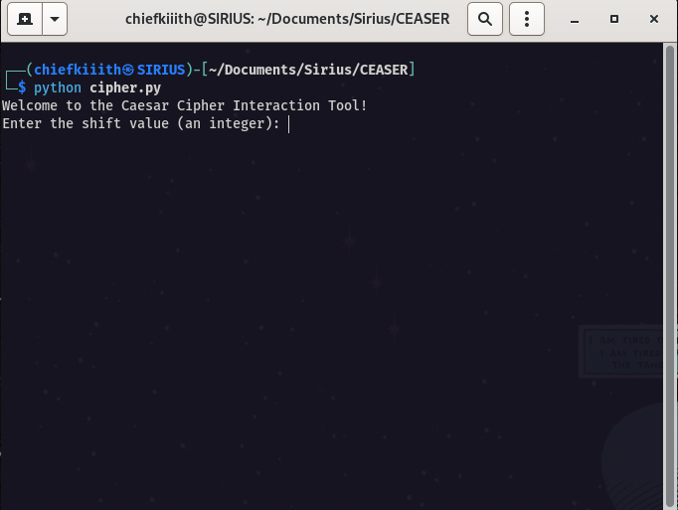

Image depicts the call of the tool on the command line(figure 7.1)

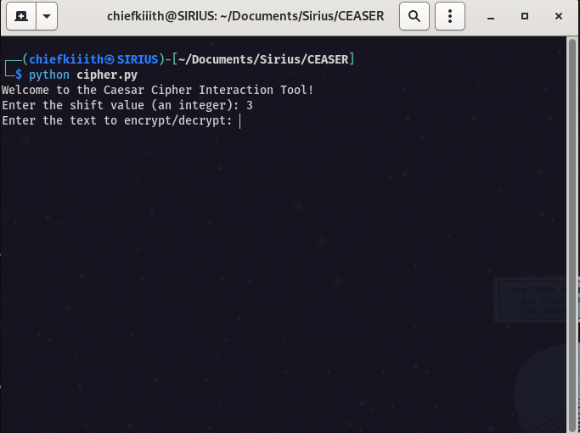
Image depicting shift value input success(fig.7.2)

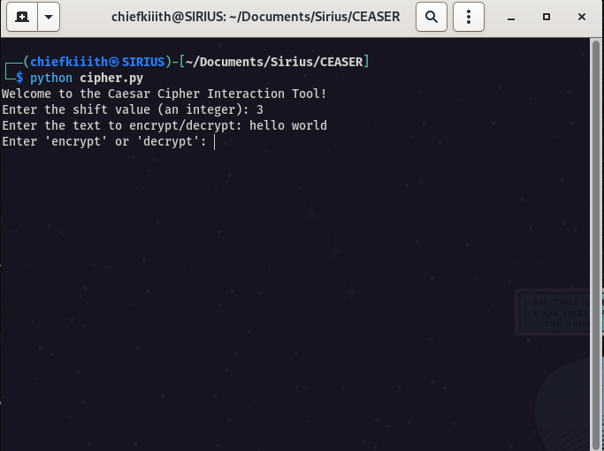

Image depicting text to be encryption(fig7.3)

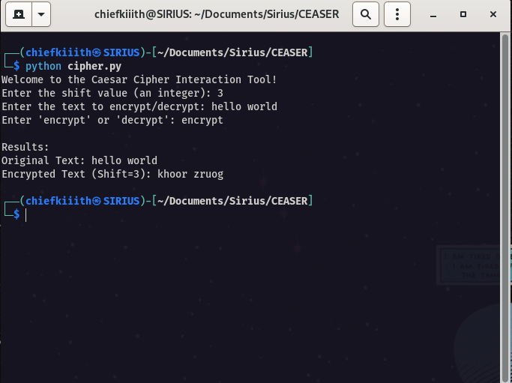

Image depicting encryption success
(fig7.4)

7.2 Code Analysis
- In this chapter I will break down the code used to build the Caesar Cipher tool. The language used for this system was Python programming language reason being was its relatively simple syntax and versatility since it can be used for a wide variety of tasks
- I broke down my code into three main bits, Two functions and the Script Header

7.3) Function One

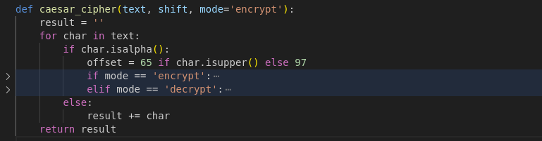
figure 7.5
- In the first function named caesar_cipher we make three arguments “text” “shift” and “mode=encrypt”
- “text” - is the string of characters that will be encrypted or decrypted,
- “shift” - is the number of places each letter in text will be shifted
- “mode” - is a string that determines whether the function will encrypt or decrypt the text (
- The function also initializes an empty string called result. This string will be used to store the encrypted or decrypted text.We then move onto a for loop which is used to repeat a specific block of code a known number of times. So we say “for char in text” Meaning for every character in text(argument from above) It will determine the offset value ( based on whether the character is uppercase or lowercase.
- For uppercase characters, the offset is 65 (the ASCII value of 'A').
- For lowercase characters, the offset is 97 (the ASCII value of 'a').

- Based on the “mode” argument, the function performs either encryption or decryption
- For encryption, the code calculates the new character position by adding the shift value to the current character's ASCII value, and then calculates the remainder of the division by 26.
- For decryption, the code calculates the new character position by subtracting the shift value from the current character's ASCII value, and then calculates the remainder of the division by 26.
- The new character position is then added to the offset value to obtain the new character coming up with our encrypted text/decrypted text
- If the character is not an alphabetic character, the code simply appends the character to the result string.
- The function returns the result string.(normally a blank)

7.4) Function Two
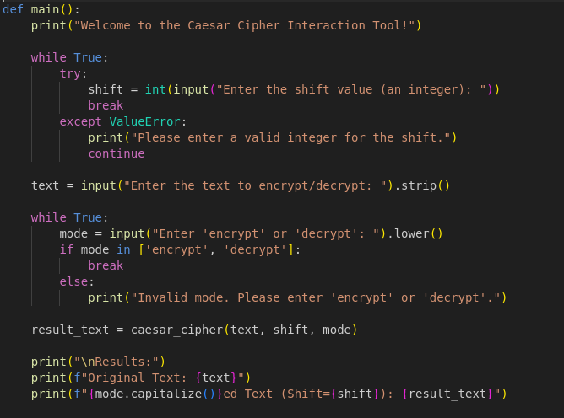

figure 7.6
- Here we have the “main” function which is the entry point of the program. It performs the following steps:
- Displays a welcome message to the user.
- Prompt the user to a shift value, and validate the input as an integer. The while loop continues until the user enters a valid integer value and if the input is not an integer, the loop prints an error message “Please enter a valid integer”
- The next prompt is a user-input where the user is asked to enter the text that is to be encrypted or decrypted.
- The strip method is called on the input to remove any leading or trailing whitespace.
- It then prompts the user to enter the mode of operation ('encrypt' or 'decrypt'). The lower method is called on the input to convert it to lowercase if typed in upper case and the while loop continues until the user enters either 'encrypt' or 'decrypt'.
- It then calls the caesar_cipher function with the user's input.
- The caesar_cipher function is called with the text, shift, and mode arguments. Display the original text and the encrypted or decrypted text. The capitalize method is called on the mode argument to capitalize the first letter and finally the original text and the encrypted or decrypted text are printed to the console.

7.5 Script Header

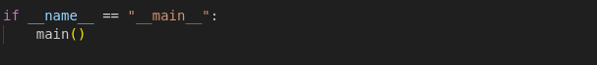
figure 7.7
This block of code is a common Python used to check whether the script is being run as the main program instead of it being imported as a module into another script.

REFERENCES

Schneier, B. (1996). Applied Cryptography: Protocols, Algorithms, and Source Code in C. John Wiley & Sons.
Slovin, E. (1960) Slovin’s Formula for Sampling Technique

