═══════════════════════════════════════
CONTENT CREATOR
COMMAND CENTER
═══════════════════════════════════════
The Ultimate Guide to Building Your Digital Empire

Your journey to content creation mastery starts here

▶  VIDEO  Production | 📊  ANALYTICS  Mastery | 💰  MONETIZE  Everything
VERSION 3.0 • JANUARY 2026 • PROFESSIONAL EDITION

📈 CHANNEL ANALYTICS DASHBOARD
Real-time performance metrics for your content empire
2.4M  SUBSCRIBERS | 847K  AVG VIEWS | 18.2%  ENGAGEMENT | $47K  MONTHLY REV
MONTHLY PERFORMANCE BREAKDOWN
PLATFORM | VIEWS | LIKES | COMMENTS | SHARES | REVENUE
▶ YouTube | 1,247,832 | 89,234 | 12,456 | 34,567 | $28,450
♪ TikTok | 3,892,156 | 456,789 | 67,890 | 123,456 | $12,890
📷 Instagram | 567,234 | 78,901 | 5,678 | 12,345 | $5,890
★ KEY INSIGHTS THIS MONTH
- TikTok short-form content outperforming long-form by 312%
- Best posting time identified: Tuesday 7PM EST
- Sponsored content CTR up 47% from last quarter
- Audience retention improved with new intro format: 78% watch past 30 seconds

📅 CONTENT CALENDAR
Strategic content planning for maximum impact
TIME | MONDAY | WEDNESDAY | FRIDAY | SATURDAY | SUNDAY
9 AM | 📹 Film Main  YouTube Video | ✏️ Script Writing | 🎙️ Podcast  Record Episode | 📸 Photo Shoot | REST
2 PM | 🎬 Edit Video | 📱 TikTok  Batch Create 5x | 📧 Emails & DMs | 🎮 LIVE  Streaming | REST
7 PM | 🚀 PUBLISH  YouTube Upload | 💬 Community | 📊 Analytics | 🎥 Behind Scenes | 📝 PLAN  Next Week
CONTENT TYPES & PRIORITIES
🔴 HIGH PRIORITY  - Main YouTube videos  - Sponsored content  - Launch announcements | 🟡 MEDIUM PRIORITY  - Shorts & Reels  - Community posts  - Story updates | 🟢 EVERGREEN  - Tutorials  - How-to guides  - Resource lists
"Consistency beats perfection. Show up every day, even when you don't feel like it."
— Every Successful Creator Ever

🎨 BRAND GUIDELINES
Your visual identity across all platforms
COLOR PALETTE
PRIMARY  #FF0000 | SECONDARY  #00A8FF | ACCENT  #9B59B6 | GOLD  #FFD700 | DARK  #1A1A2E
TYPOGRAPHY SYSTEM
STYLE | FONT DETAILS | EXAMPLE
Display Title | Impact, 36pt, Bold | MAKE IT BIG
Section Header | Arial Black, 18pt | Section Heading
Body Text | Arial, 11pt, Regular | This is the standard body text style for all content.
Quote / Emphasis | Georgia, 14pt, Italic | "Inspire with every word"
Code / Technical | Courier New, 10pt | const brand = 'awesome';
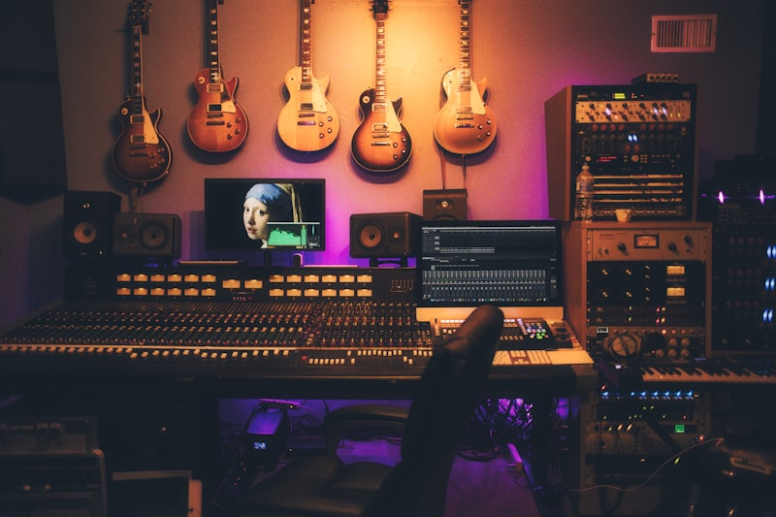
Professional studio setup following brand guidelines

💰 MONETIZATION EMPIRE
Multiple revenue streams for sustainable creator income
MONTHLY REVENUE BREAKDOWN
REVENUE SOURCE | MONTHLY | ANNUAL | % SHARE
▶ YouTube AdSense | $28,450 | $341,400 | 45%
🤝 Brand Sponsorships | $18,500 | $222,000 | 29%
📦 Merchandise & Products | $8,200 | $98,400 | 13%
🎓 Online Courses & Coaching | $5,800 | $69,600 | 9%
🔗 Affiliate Marketing | $2,500 | $30,000 | 4%
TOTAL REVENUE | $63,450 | $761,400 | 100%
BRAND PARTNERSHIP CHECKLIST
- Verify brand aligns with your audience values and demographics
- Request detailed campaign brief with deliverables and timeline
- Negotiate usage rights, exclusivity, and compensation terms
- Get everything in writing - never work on verbal agreements
- Include FTC disclosure requirements in all sponsored content
- Track performance metrics and share results with partners
═══════════════════════════════════════
★ BUILD YOUR EMPIRE ★
Content Creator Command Center © 2026
═══════════════════════════════════════

