❧ ❧ ❧ ❧ ❧ ❧ ❧ ❧ ❧ ❧ ❧ ❧ ❧ ❧ ❧
CULINARY ARTS
&
HEALTHY LIVING
❧ ❧ ❧ ❧ ❧ ❧ ❧ ❧ ❧ ❧ ❧ ❧ ❧ ❧ ❧
A Complete Guide to Nourishing Body & Soul
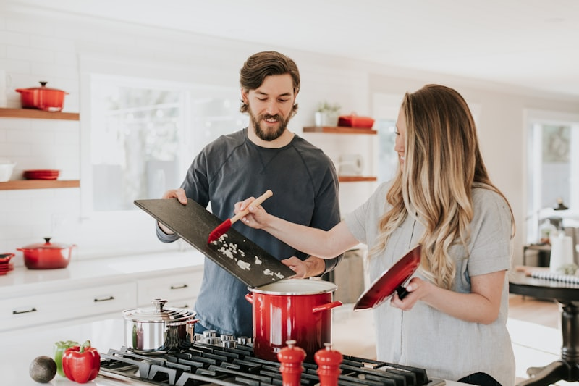
"Let food be thy medicine and medicine be thy food." — Hippocrates
WHAT'S INSIDE
🍽️  25+  Recipes | 📅  4-Week  Meal Plan | 💪  100%  Whole Foods | ⏱️  30 min  Average Cook
SPRING/SUMMER EDITION • 2026

🥙 SIGNATURE RECIPE
Mediterranean Power Bowl
⏱️ PREP  15 mins | 🔥 COOK  20 mins | 👥 SERVES  4 people | 📊 LEVEL  Easy
INGREDIENTS  Base:  - 2 cups quinoa, cooked  - 1 can chickpeas, drained  - 2 cups mixed greens  Toppings:  - 1 cucumber, diced  - 1 cup cherry tomatoes  - ½ red onion, sliced  - ½ cup feta cheese  - ¼ cup kalamata olives  Dressing:  - 3 tbsp olive oil  - 2 tbsp lemon juice  - 1 clove garlic, minced  - Fresh herbs to taste | INSTRUCTIONS  - Cook quinoa according to package directions. Fluff with fork and let cool slightly.  - Roast chickpeas at 400°F for 20 minutes until crispy. Season with cumin and paprika.  - Whisk together olive oil, lemon juice, minced garlic, salt, and oregano for dressing.  - Divide greens among 4 bowls. Top with quinoa as the base layer.  - Arrange cucumber, tomatoes, onion, feta, and olives in sections on top.  - Add crispy chickpeas and drizzle generously with lemon dressing.  - Garnish with fresh herbs and serve immediately.  👨‍🍳 CHEF'S TIP: Make extra dressing - it keeps for a week and works on any salad!
NUTRITION FACTS (per serving)
CALORIES  485 | PROTEIN  18g | CARBS  52g | FAT  22g | FIBER  9g

📅 WEEKLY MEAL PREP PLANNER
A balanced week of delicious, nutritious meals
DAY | 🌅 BREAKFAST | ☀️ LUNCH | 🌙 DINNER | CALS
MON | Greek Yogurt Parfait + Berries | Mediterranean Bowl | Grilled Salmon + Veggies | 1,650
TUE | Avocado Toast + Eggs | Quinoa Salad + Chicken | Veggie Stir-Fry + Tofu | 1,580
WED | Smoothie Bowl | Turkey Wrap + Hummus | Baked Cod + Sweet Potato | 1,520
THU | Overnight Oats + Nuts | Buddha Bowl | Chicken Breast + Quinoa | 1,690
FRI | Veggie Omelette + Toast | Lentil Soup + Salad | Grilled Shrimp Tacos | 1,610
SAT | Pancakes + Fresh Fruit | Poke Bowl | Date Night: Pasta! | 1,850
SUN | Brunch: Eggs Benedict | Light: Soup + Bread | Meal Prep Sunday! | 1,720
WEEKLY SHOPPING LIST
🥬 PRODUCE  - Mixed greens (2 bags)  - Tomatoes (1 lb)  - Cucumbers (3)  - Avocados (4)  - Berries (2 pints)  - Lemons (6) | 🥩 PROTEINS  - Salmon fillets (4)  - Chicken breast (2 lbs)  - Eggs (18)  - Greek yogurt (32 oz)  - Feta cheese (8 oz)  - Tofu (1 block) | 🌾 PANTRY  - Quinoa (2 lbs)  - Olive oil  - Chickpeas (2 cans)  - Lentils (1 bag)  - Oats (1 container)  - Mixed nuts (1 bag)

💪 HEALTH METRICS DASHBOARD
Track your wellness journey with these key indicators
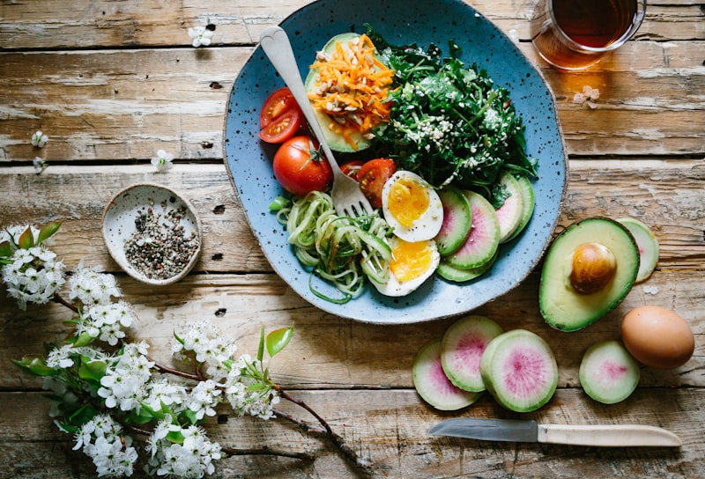
Fresh, colorful ingredients are the foundation of good health
DAILY NUTRIENT TARGETS
NUTRIENT | TARGET | YOUR INTAKE | % | STATUS
Calories | 2,000 | 1,850 | 93% | ✓ Good
Protein | 50g | 65g | 130% | ★ Great
Fiber | 25g | 18g | 72% | ↑ More
Water | 8 glasses | 6 glasses | 75% | ↑ More
Vegetables | 5 servings | 7 servings | 140% | ★ Great
WELLNESS WISDOM
- Eat the rainbow - include fruits and vegetables of every color daily
- Stay hydrated - drink water before every meal
- Practice mindful eating - chew slowly and enjoy every bite
- Prep on Sundays - success is in the planning
- Balance, not perfection - one indulgent meal won't undo progress

📖 KITCHEN REFERENCE GUIDE
Essential measurements, temperatures, and conversions
MEASUREMENT CONVERSIONS
VOLUME | WEIGHT | TEMPERATURE
1 cup = 16 tbsp  1 cup = 8 fl oz  1 tbsp = 3 tsp  1 quart = 4 cups  1 gallon = 4 quarts | 1 oz = 28g  1 lb = 454g  1 kg = 2.2 lbs  1 stick butter = 113g  1 cup flour = 125g | °F to °C: (F-32) × 5/9  325°F = 165°C  350°F = 175°C  375°F = 190°C  400°F = 200°C
🌡️ INTERNAL COOKING TEMPERATURES
FOOD | TEMP (°F) | TEMP (°C) | NOTES
🐔 Chicken/Poultry | 165°F | 74°C | Critical!
🥩 Beef (Medium-Rare) | 135°F | 57°C | Rest 3 min
🥩 Beef (Medium) | 145°F | 63°C | Rest 3 min
🐷 Pork | 145°F | 63°C | Rest 3 min
🐟 Fish/Seafood | 145°F | 63°C | Opaque center
QUICK COOKING SYMBOLS
🔥  High Heat | 🌡️  Simmer | ❄️  Refrigerate | ⏰  Rest Time | ⚠️  Caution
❧ ❧ ❧ ❧ ❧ ❧ ❧ ❧ ❧ ❧ ❧ ❧ ❧ ❧ ❧
"Good food is the foundation of genuine happiness."
— Auguste Escoffier
❧ ❧ ❧ ❧ ❧ ❧ ❧ ❧ ❧ ❧ ❧ ❧ ❧ ❧ ❧
Culinary Arts & Healthy Living © 2026 • Bon Appétit!

