🍌🍌🍌🍌🍌🍌🍌🍌🍌🍌🍌🍌🍌🍌🍌🍌🍌🍌🍌🍌🍌🍌🍌🍌🍌🍌🍌🍌🍌🍌🍌🍌🍌🍌🍌🍌🍌🍌
NANO BANANA PRO
GEMINI 3 PRO IMAGE
━━━ GOOGLE DEEPMIND'S REVOLUTIONARY AI IMAGE MODEL ━━━
🖼️  4K OUTPUT  4096x4096 max | 📝  TEXT RENDER  Multi-language | 🎨  14 IMAGES  Multi-blend input | 👥  5 PEOPLE  Subject consistency
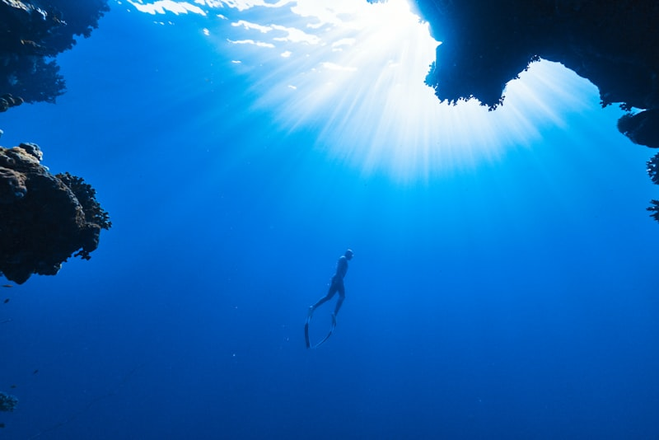  AI-Generated Photorealistic Art | 🍌 WHAT IS NANO BANANA PRO?  - Google DeepMind's latest image generation AI  - Part of Gemini 3 multimodal family  - Creates photorealistic images from text  - Advanced text rendering in images  - Multi-image blending capabilities  - Released November 2025
🍌 THE BANANA ORIGIN STORY
"Nano Banana" was the codename used during secret public testing on LMArena. The quirky name stuck after the model became a viral sensation, particularly for its photorealistic "3D figurine" images that flooded social media in late 2025.
📝 TEXT RENDERING  - Multiple fonts & styles  - 100+ languages  - Perfect kerning  - Integrated in scenes | 🎭 SUBJECT CONTROL  - Up to 5 people tracked  - Consistent across edits  - Change hairstyles  - Swap backgrounds | 🔮 RESOLUTION  - 4K (4096x4096)  - 2K standard output  - 1024x1024 free tier  - 4x vs predecessor

🎨 CAPABILITIES DEEP DIVE 🎨
FEATURE | NANO BANANA | DALL-E 3 | MIDJOURNEY 6 | FLUX 1.1
Max Resolution | 4K (4096px) | 1024px | 1792px | 2048px
Text Rendering | EXCELLENT | Good | Poor | Very Good
Multi-Image Input | 14 images | 1 image | 4 images | 1 image
Person Consistency | 5 people | Limited | 2 people | 1 person
Speed (avg) | 8-12 sec | 5-8 sec | 30-60 sec | 3-5 sec
Free Tier | 3 free/day | None | None | Limited
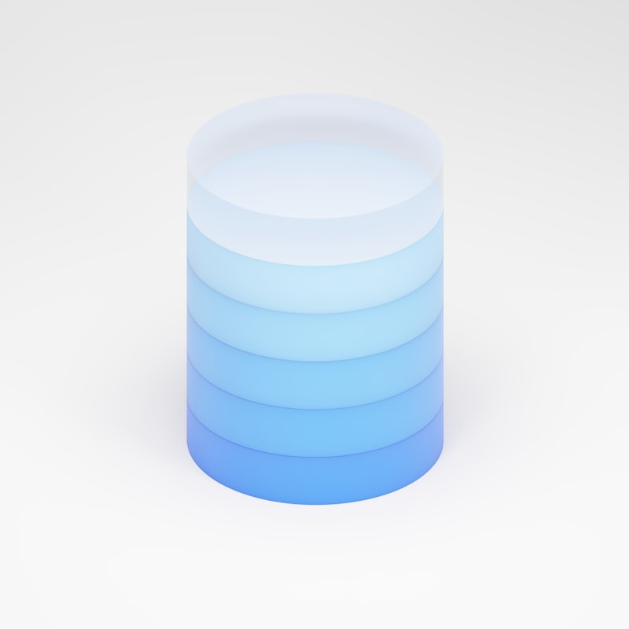  🎯 POPULAR USE CASES  - Product photography & mockups  - 3D figurine generation (viral!)  - Marketing & advertising assets  - Book covers & posters  - Social media content | 🚫 LIMITATIONS  - No explicit content generation  - Celebrity likeness restrictions  - Violence/gore blocked  - Political content filtered  - 4K requires paid tier  - Region restrictions (US/UK/etc)
🔥 VIRAL NANO BANANA TRENDS (2025)
1. 3D Figurine Boxes - Turn yourself into a collectible toy in packaging | 2. Album Cover Generator - Perfect typography for music art
3. Product Mockups - Photorealistic product shots without studio | 4. Movie Poster Style - Create cinematic posters

🚀 HOW TO USE NANO BANANA PRO 🚀
🌐 GEMINI APP  gemini.google.com  - Open Gemini app  - Type image prompt  - Click generate  3 free images/day | 💻 AI STUDIO  aistudio.google.com  - Create API key  - Select model  - Use playground  Pay-per-generation | 🔧 API ACCESS  ai.google.dev/api  - Get API key  - Install SDK  - Make API calls  ~$0.15 per 4K image
TIER | PRICE | RESOLUTION | FEATURES
🆓 FREE | $0 | 1024x1024 | 3 images/day, watermark
⭐ GEMINI ADV | $19.99/mo | 2K (2048px) | Unlimited, no watermark
👑 API PRO | Pay-per-use | 4K (4096px) | Full features, batch API
🏢 ENTERPRISE | Custom | 4K+ | SLA, priority, custom training
✨ EXAMPLE PROMPTS THAT WORK GREAT
"A 3D action figure of a software developer in a clear plastic box, professional packaging"
"Product photography of a coffee mug with 'Best Developer' text, on marble surface, studio lighting"
"Movie poster style, 'The Code Master' title text at top, cinematic, dramatic lighting, 4K"

🔬 TECHNICAL ARCHITECTURE 🔬
🧠 MODEL ARCHITECTURE  - Built on Gemini 3 foundation  - Diffusion transformer backbone  - Multimodal understanding  - Text encoder integration  - Image encoder for inputs  - Trained on filtered dataset | ⚙️ INFERENCE DETAILS  - TPU v5 inference cluster  - 8-12 seconds avg (2K)  - 15-20 seconds for 4K  - Classifier-free guidance  - Safety filtering layer  - Automatic watermarking
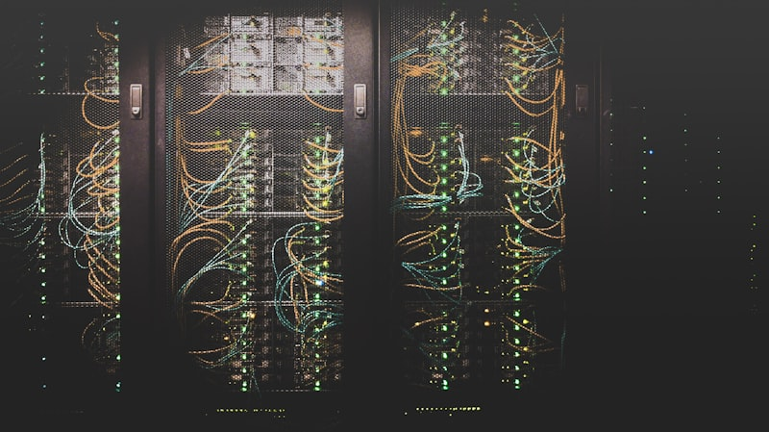
Distributed inference across Google's TPU infrastructure
📋 API CODE EXAMPLE (Python)
import google.generativeai as genai

genai.configure(api_key='YOUR_KEY')
model = genai.ImageGenerationModel('nano-banana-pro')

response = model.generate_images(
prompt='A futuristic cityscape at sunset, 4K quality',
number_of_images=4,
aspect_ratio='16:9'
)

🔮 THE FUTURE OF AI IMAGE GENERATION 🔮
Q1 2026  Video Generation  Short clips from text | Q2 2026  3D Generation  3D models from text | Q3 2026  Real-time Edit  Live image editing | 2027+  8K Resolution  Cinema quality
✅ WHY NANO BANANA PRO?  - Best text rendering in the industry  - 4K resolution output capability  - Multi-image fusion (14 inputs!)  - Subject consistency (5 people)  - Free tier for testing  - Integrated with Google ecosystem | 🎯 BEST USE CASES  - Product mockups & photography  - Marketing materials with text  - Social media content creation  - Book covers & posters  - Consistent character art  - Viral 3D figurine images
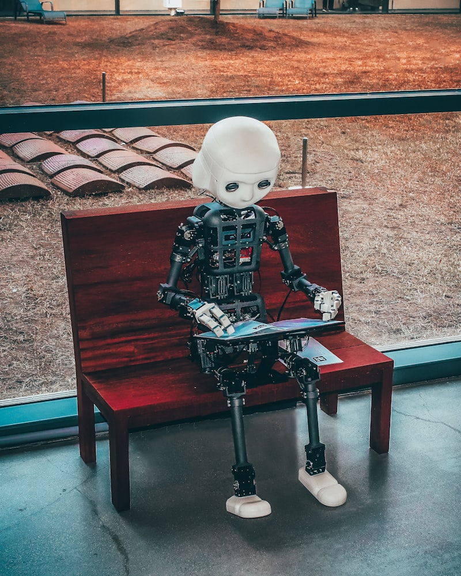
The future of creative AI is here
1B+  Images Generated | 100M+  Active Users | 195  Countries Available | #1  Text Rendering
「 IMAGINE ANYTHING. CREATE EVERYTHING. 」
🍌🍌🍌 NANO BANANA PRO © 2026 GOOGLE DEEPMIND 🍌🍌🍌

