A Microsoft Word Template for TRB Peer Review Papers

Chieh (Ross) Wang, Ph.D., Corresponding Author
Energy and Transportation Science Division, Oak Ridge National Laboratory (ORNL)
Oak Ridge, TN 37831
Email: cwang@ornl.gov
ORCiD: xxxx-xxxx-xxxx-xxxx

Word count: 1,372 words text + 2 table(s) × 250 words (each) = 1,872 words

Submission Date: July 9, 2019

This manuscript has been authored by UT-Battelle, LLC, under contract DE-AC05-00OR22725 with the US Department of Energy (DOE). The US government retains and the publisher, by accepting the article for publication, acknowledges that the US government retains a nonexclusive, paid-up, irrevocable, worldwide license to publish or reproduce the published form of this manuscript, or allow others to do so, for US government purposes. DOE will provide public access to these results of federally sponsored research in accordance with the DOE Public Access Plan (http://energy.gov/downloads/doe-public-access-plan).

Abstract
Each paper must have an abstract. The abstract must be no longer than 250 words, it must be selfcontained, and it must not require reference to the paper to be understood. The abstract should present the primary objectives and scope of the study or the reasons for writing the paper; the techniques or approaches should be described only to the extent necessary for comprehension; and findings and conclusions should be presented concisely and informatively. The abstract should not contain unfamiliar terms that are not defined, undefined acronyms, reference citations, or displayed equations or lists.

Keywords: TRB Template, MS Word, Word Counts

Introduction
Thousands of papers have been submitted to the Transportation Research Board (TRB) Annual Meeting annually; however, unlike most other journals and/or conference papers, there has yet been any official templates that help authors prepare their manuscripts. The LaTeX template originally developed by Pritchard and updated by Macfarlane and Wang (1) provides a working solution for authors intend to prepare their TRB papers using LaTeX. TRB provides a model paper (2) in Microsoft Word format that many people have been using as a template; however, this model paper is not a true template with ready-to-use styles and formatting.
This version of the TRB paper template is a non-macro document that requires the user to manually enter the number of tables/figures and update the whole document, then the number of words will be automatically counted. This template does not require any macro to be executed so it can be good for those who just want a quick template that they can work with.
As shown in Figure 1, the user is required to first enter a number in the content control (enclosed with a pair of square brackets). For example, this document contains 2 tables, so the number to be entered in the content control is 2. Then the user needs to select and update the counts.

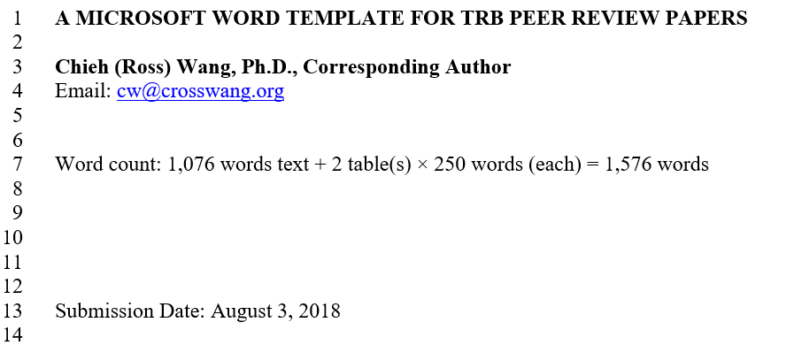
Figure 1 The user is required to enter the total number of tables/figures in the content control.

Two simple steps for updating the word count using are:
- Enter total number of tables in the content control;
- Select the entire line of the word count and press F9 on your keyboard to update the counts.

The following section describes some essential formatting rules for TRB papers, as stated in the information for authors (1).

Styles
This template defines all styles necessary for preparing a TRB paper. Useable styles for TRB papers, including Title, Normal, Heading 1, Heading 2, Heading 3, Heading 4, Heading 5, Caption, and Emphasize, are predefined in this template and can easily be applied using the “Styles” ribbon in the “Home” tab in MS Word (see Figure 2).

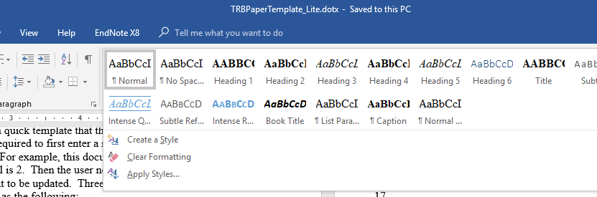
Figure 2 TRB paper styles are predefined in this template. User may select and apply styles using the “Styles” ribbon in the “Home” tab.

Intuitively Title and Headings are used for the title and different levels of headings. The Normal style is used for general texts in the paragraphs. The Emphasize style is designed to be used for author names specifically. Finally, the Caption style is used for all tables and figures. It is recommended that users utilize these predefined styles for consistency and quality.

Level 1 Header
Level 1 headers should be all capitals, boldface, on a separate line. Add a line before entering a new header of any level.

Level 2 Header
Level 2 headers should use initial capitals, boldface, on a separate line. Table titles should be inserted above the table; “TABLE” is all capitals; title is initial capitals; all type is boldface; extra space but no punctuation after number; no punctuation at end of title. Align left. Leave a line between a paragraph and a table title; leave another line after the table. Reference tables with initial capitals, e.g., Table 1, instead of all capitals.

Table 1 Example Table Caption
Column1 | Column2 | Column3 | Column4 | Column5

Level 3 Header
Level 3 headers should have initial capitals, italic, on a separate line.

Level 4 Header Initial capitals, boldface, on same line as text, with extra letter space between the subhead and text.
Table 2 shows another example table.

Table 2 Another Example Table Caption
Column1 | Column2 | Column3 | Column4 | Column5

Level 5 Header Initial capitals, italic, on same line as text, with extra letter space between the subhead and text.

It is noticed that TRB’s When including equations, please use the following format. If equations are numbered, use an Arabic numeral in parentheses, placed flush right (see Equation 1). Additional information on equation format details can be found in Preparing Papers for Peer Review and Presentation at the TRB Annual Meeting (1). No indent before equations.

(1)

Figure captions are inserted below the figure; “FIGURE” is all capitals; caption is sentence case; all type is boldface; extra space but no punctuation after number; period at end of caption. Align left. Additional lines are added before the figure and after the figure caption. Similar to tables, in-text reference for figures should use initial capitals, e.g., Figure 1, instead of all capitals.

Figure 3 This is an example figure caption.

Denote a reference at the appropriate place in the text with an italicized Arabic numeral in parentheses, e.g., (2). Do not denote text references with superscripts. List of references are placed on a new page.

Conclusions
TRB strictly enforces the word count requirement and any paper that exceeds the 7,500 words limit would not be reviewed. This document serves as a MS Word template, providing predefined styles for title, headings, and captions. It also provides semi-automatic word count that can help authors prepare their manuscripts easier. Note that users of this template should constantly update the word counts.

Acknowledgments
In a tempor mauris. Mauris congue in diam ac malesuada. Praesent sed dignissim erat. Mauris sagittis lectus nec ornare condimentum. Etiam est ante, tristique vitae tellus id, venenatis tincidunt tellus. In hac habitasse platea dictumst. Interdum et malesuada fames ac ante ipsum primis in faucibus. Donec quis pellentesque augue, ac elementum turpis. Quisque nec tristique nunc, in porttitor magna. Donec eget laoreet tortor, euismod aliquam felis.

Author Contributions
The authors confirm contribution to the paper as follows: study conception and design: X. Author, Y. Author; data collection: Y. Author; analysis and interpretation of results: X. Author, Y. Author. Z. Author; draft manuscript preparation: Y. Author. Z. Author. All authors reviewed the results and approved the final version of the manuscript.

Disclaimer
This is where a disclaimer can be added. For example, Instructions for Authors published by TRB (1) and the Sample Paper (2) provide general guidelines for authors to prepare a paper to submit. However, it is noticed that certain formatting details, e.g., page numbering, indentation, and line spacing, were left out, and the Sample Paper does not necessary reflect the provided guidelines. For example, the sample paper did not use Times Roman font throughout the paper. As a result, this template was created based on the author’s personal understanding and interpretation of the aforementioned guidelines and sample paper, and this template is provided as is.

References
- Instructions for Authors Submitting for TRB 2020 Presentation and TRR Publication Review. Transportation Research Board of the National Academies of Sciences, Engineering, and Medicine. http://onlinepubs.trb.org/am/InfoForAuthors.pdf. Accessed Jun. 25, 2019.
- Bryant, J. W., Schwartz, B., and Weeks, J. L. Sample Paper Format for TRB Peer Review Papers. Transportation Research Board of the National Academies. http://onlinepubs.trb.org/onlinepubs/dva/PaperFormatModel.docx. Accessed Aug. 24, 2016.

