A Macro-enabled Word Template for TRB Peer Review Papers

Chieh (Ross) Wang, Ph.D., Corresponding Author
E-mail: cw@crosswang.org

Word count: 1,232 words text + 8 tables/figures × 250 words (each) = 3232 words

Submission Date: June 26, 2017

Abstract
This document is a macro-enabled Microsoft Word template for TRB Annual Meeting papers. The objective of this document is to develop a ready-to-use template to help authors with their paper preparation. In this template, styles of five heading levels and captions are first set up per TRB guidelines. In addition, a macro is developed to count the number of words, figures, and tables. This template is provided as is, and users are encouraged to properly assign styles for the automatic word counting to work according to the design.

Keywords: TRB Template, Word, Macro, Visual Basic

Introduction
Thousands of papers have been submitted to the Transportation Research Board (TRB) Annual Meeting annually; however, unlike most other journals and/or conference papers, there has yet been any official templates that help authors prepare their manuscripts. The LaTeX template originally developed by Pritchard and updated by Macfarlane and Wang (1) provides a working solution for authors intend to prepare their TRB papers using LaTeX. TRB provides a model paper (2) in Microsoft Word format that many people have been using as a template; however, this model paper is not a true template with ready-to-use styles and formatting. This document serves as a macro-enabled Word template for TRB papers to help authors prepare papers and ensure the consistency of paper formatting.

The Template
This TRB paper template is a macro-enabled MS Word file that automates the process of total word counting, including texts, figures, and tables.

Development
An automated word count function has been developed to count the number of words according to TRB’s paper guidelines. As depicted in Figure 1, three fields were created in Line 10 on the title page to account for the number of text words, the number of tables and figures, and the final word count, respectively. Interested users can highlight this line and press Alt+F9 to see the detailed definition of these fields.
A Visual Basic function was then developed to automatically update the values of these three fields. The detail of this Visual Basic function is shown in Figure 2.

Figure 1 Three Fields were created to calculate the final word count.

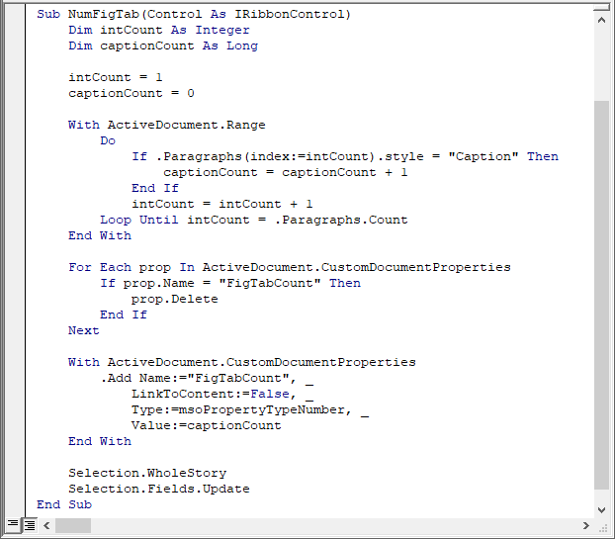
Figure 2 Screenshot of the word count macro.

Setup
Users are assumed to be familiar with how the Styles is used in Word. The Caption Style in Styles on the Home Tab (see Figure 3) is designed to be used for the caption of each figure and table. Note that only one paragraph should be used for each caption. Multiple paragraphs for a figure or table will result in overcounting.

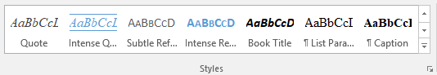
Figure 3 The Caption Style is designed for table and figure cations in this document.

Use
To use this template, open this file, enable the macro content when the security warning message is prompted (Figure 4), and save as a new Word document (.docx).

Figure 4 Enable content to allow the automated word count feature.

To execute this macro, simply go to the customized TRB tab (see Figure 5), which is the first tab next to the File tab on the ribbon, and click the Auto Word Count button. The macro function would be called and it automatically updates the fields on the title page with the most current word count information. Interested users can press Alt+F11 to open the Microsoft Visual Basic Editor to explore and modify details of this macro. The following section describes some essential formatting rules for TRB papers, as stated in the information for authors (3).

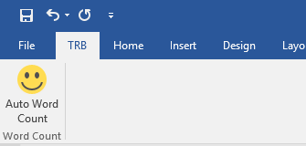
Figure 5 The customized TRB tab and the Auto Word Count Button.

Styles
This template defines all styles necessary for preparing a TRB paper. Useable styles include Title, Normal, Heading 1, Heading 2, Heading 3, Heading 4, Heading 5, Caption, and Emphasize. Intuitively Title and Headings are used for the title and different levels of headings. The Normal style is used for normal paragraphs. The Emphasize style is used for author names specifically. Finally, the Caption style is (and must be) used for all tables and figures. It is recommended that users utilize these predefined styles for consistency and quality.
Due to the fact that the macro actually counts the occurrence of the Caption style as the total number of figures and tables, successful total word count is dependent on the correct selection of style for tables and figures throughout the document.

Level 1 Header
Level 1 headers should be all capitals, boldface, on a separate line. Add a line before entering a new header of any level.

Level 2 Header
Level 2 headers should use initial capitals, boldface, on a separate line. Table titles should be inserted above the table; “Table” is all capitals; title is initial csapitals; all type is boldface; extra space but no punctuation after number; no punctuation at end of title. Align left. Leave a line between a paragraph and a table title; leave another line after the table. Reference tables with initial capitals, e.g., Table 1, instead of all capitals.

Table 1 Example Table Caption

Level 3 Header
Level 3 headers should have initial capitals, italic, on a separate line.

Level 4 Header Initial capitals, boldface, on same line as text, with extra letter space between the subhead and text.
Table 2 shows another example table.

Table 2 Another Example Table Caption

Level 5 Header Initial capitals, italic, on same line as text, with extra letter space between the subhead and text.

When including equations, please use the following format. If equations are numbered, use an Arabic numeral in parentheses, placed flush right (see Equation 1). Additional information on equation format details can be found in Preparing Papers for Peer Review and Presentation at the TRB Annual Meeting (3). No indent before equations.

(1)

Figure captions are inserted below the figure; “Figure” is all capitals; caption is sentence case; all type is boldface; extra space but no punctuation after number; period at end of caption. Align left. Additional lines are added before the figure and after the figure caption. Similar to tables, in-text reference for figures should use initial capitals, e.g., Figure 1, instead of FIGURE 1.

Figure 6 Example figure caption.

Conclusions
TRB currently accepts PDF files for the initial paper submission, but it only accepts Word files (e.g., .doc and .docx) for the final submission if your paper is selected for publication in the Transportation Research Record: Journal of the Transportation Research Board. As a result, manuscripts prepared using other office tools, such as LaTeX, may not be ideal unless you only submit papers for presentation. I hope you find this template useful, please feel free to send me your questions and feedback. If you have a better way of counting the words automatically, please do not hesitate to share.

References
- Pritchard, D., Macfarlane, G. S., and Wang, C. A LaTeX Template for Papers Submitted to the Transportation Research Board. https://github.com/chiehrosswang/TRB_LaTeX. Accessed Mar. 30, 2017.
- Bryant, J. W., Schwartz, B., and Weeks, J. L. Sample Paper Format for TRB Peer Review Papers. Transportation Research Board of the National Academies. http://onlinepubs.trb.org/onlinepubs/dva/PaperFormatModel.docx. Accessed Mar. 30, 2017.
- Preparing Papers for Peer Review and Presentation at the TRB Annual Meeting. Transportation Research Board of the National Academies. http://onlinepubs.trb.org/onlinepubs/AM/InfoForAuthors.pdf. Accessed Aug. 24, 2016.

