A Microsoft Word Template for TRB Peer Review Papers

Chieh (Ross) Wang, Corresponding Author
Georgia Institute of Technology
790 Atlantic Dr, Atlanta, GA 30332
Tel: 123-456-7890; Fax: 012-345-6789; Email: cwang325@gatech.edu

Word count: 958 words text + 4 tables/figures × 250 words (each) = 1958 words

Submission Date: August 25, 2016

Abstract
Each paper must have an abstract. The abstract must be no longer than 250 words, it must be selfcontained, and it must not require reference to the paper to be understood. The abstract should present the primary objectives and scope of the study or the reasons for writing the paper; the techniques or approaches should be described only to the extent necessary for comprehension; and findings and conclusions should be presented concisely and informatively. The abstract should not contain unfamiliar terms that are not defined, undefined acronyms, reference citations, or displayed equations or lists.

Keywords: Keyword, Keyword, Keyword, Keyword, Keyword, Keyword

Introduction
This TRB paper template is a macro-enabled MS Word file that automates the process of total word counting, including texts, figures, and tables. To execute this macro, simply press and hold “Alt” and then press “C” on your keyboard. This keyboard shortcut (Alt+C) combination will trigger the word counting macro and automatically updates the title page with the most current word count information. The detailed content of this macro is shown in Figure 1 and there is absolutely no malware in this macro. Interested users can press Alt+F11 to open the Microsoft Visual Basic Editor to explore and modify details of this macro.

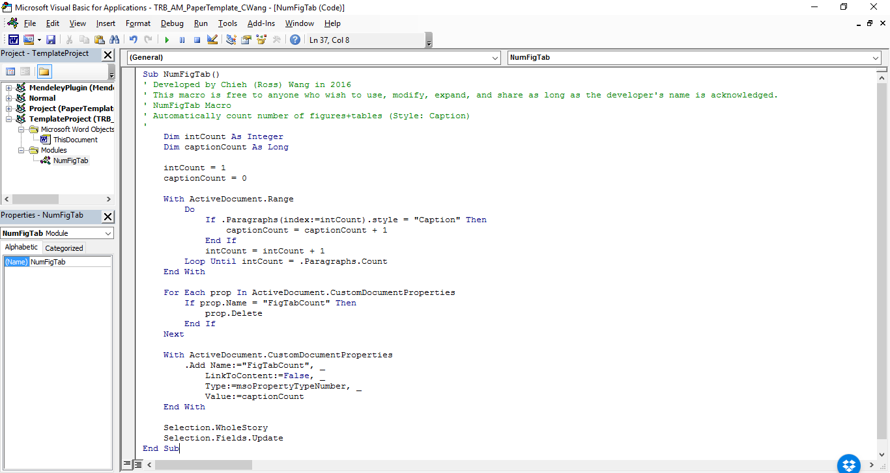
Figure 1 Screenshot of the word counting macro.

TRB currently accepts PDF files for the initial paper submission, but it only accepts Word files (e.g., .doc and .docx) for the final submission if your paper is selected for publication in the Transportation Research Record: Journal of the Transportation Research Board. As a result, manuscripts prepared using other office tools, such as LaTeX, may not be ideal unless you only submit papers for presentation. I hope you find this template useful, please feel free to send me your questions and feedback. If you have a better way of counting the words automatically, please do not hesitate to share. Below are some essential formatting rules for TRB papers, as stated in the information for authors (1).

Styles
This template defines all styles necessary for preparing a TRB paper. Useable styles include Title, Normal, Heading 1, Heading 2, Heading 3, Heading 4, Heading 5, Caption, and Emphasize. Intuitively Title and Headings are used for the title and different levels of headings. The Normal style is used for normal paragraphs. The Emphasize style is used for author names specifically. Finally, the Caption style is (and must be) used for all tables and figures. It is recommended that users utilize these predefined styles for consistency and quality.
Due to the fact that the macro actually counts the occurrence of the Caption style as the total number of figures and tables, successful total word count is dependent on the correct selection of style for tables and figures throughout the document.

Level 1 Header
Level 1 headers should be all capitals, boldface, on a separate line. Add a line before entering a new header of any level.

Level 2 Header
Level 2 headers should use initial capitals, boldface, on a separate line. Table titles should be inserted above the table; “Table” is all capitals; title is initial capitals; all type is boldface; extra space but no punctuation after number; no punctuation at end of title. Align left. Leave a line between a paragraph and a table title; leave another line after the table. Reference tables with initial capitals, e.g., Table 1, instead of all capitals.

TABLE 1 Example Table Caption
 | Test1 | 1234

Level 3 Header
Level 3 headers should have initial capitals, italic, on a separate line.

Level 4 Header Initial capitals, boldface, on same line as text, with extra letter space between the subhead and text.
Use Style Separator (Ctrl+Alt+Enter) in MS Word to separate the fourth-level subhead from the other texts in the same line.

TABLE 2 Another Example Table Caption
 | Test2 | 555

When including equations, please use the following format. If equations are numbered, use an Arabic numeral in parentheses, placed flush right (see Equation 1). Additional information on equation format details can be found in Preparing Papers for Peer Review and Presentation at the TRB Annual Meeting (1). No indent before equations.

(1)

Level 5 Header Initial capitals, italic, on same line as text, with extra letter space between the subhead and text.
Use Style Separator (Ctrl+Alt+Enter) in MS Word to separate the fifth-level subhead from the other texts in the same line.
Figure captions are inserted below the figure; “Figure” is all capitals; caption is sentence case; all type is boldface; extra space but no punctuation after number; period at end of caption. Align left. Additional lines are added before the figure and after the figure caption. Similar to tables, in-text reference for figures should use initial capitals, e.g., Figure 1, instead of all capitals.

Figure 2 Example figure caption.

Do not indent if a paragraph is right after a table, a figure caption, or is the first line of a new page. Denote a reference at the appropriate place in the text with an italicized Arabic numeral in parentheses, e.g., (2). Do not denote text references with superscripts. List of references are placed on a new page.

References
- Preparing Papers for Peer Review and Presentation at the TRB Annual Meeting. Transportation Research Board of the National Academies. http://onlinepubs.trb.org/onlinepubs/AM/InfoForAuthors.pdf. Accessed Aug. 24, 2016.
- Bryant, J. W., Schwartz, B., and Weeks, J. L. Sample Paper Format for TRB Peer Review Papers. Transportation Research Board of the National Academies. http://onlinepubs.trb.org/onlinepubs/dva/PaperFormatModel.doc. Accessed Aug. 24, 2016.

