# Data Structure Assignment 2

|  |  |  |
| --- | --- | --- |
| **ID:** E14066282 | **Name:** 溫梓傑 | **Department:** ME 110 |

## Result Screenshots

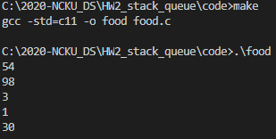

Figure Screenshot of command line

## Program Architecture

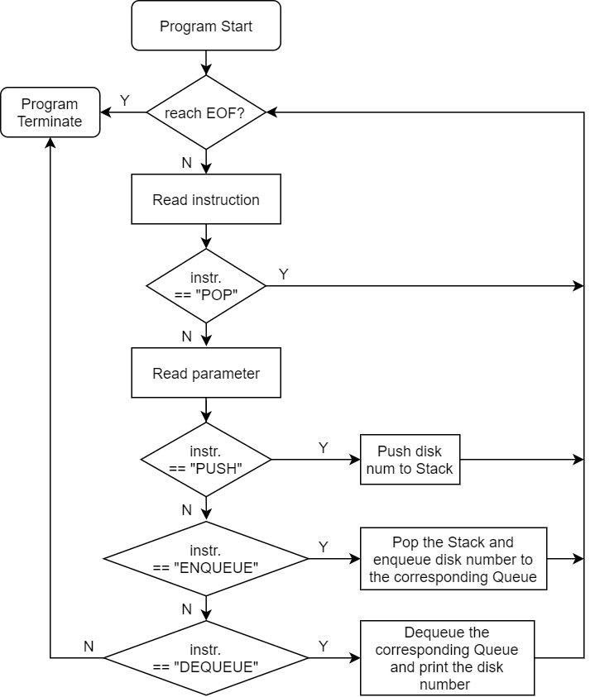

## Program Functions

### 📒 Stack.h



Constructs a new stack.

📐Parameters

None.

↩Return Value

Returns the new pointer of the stack.

* If construction fails, returns NULL.



Removes the element on the top of the stack.

📐Parameters



The pointer of the stack.

↩Return Value

Returns the top element before removal.

* If the stack is empty, program terminates.



Inserts a new element on the top of the stack.

📐Parameters



The pointer of the stack.



The element which you insert.

↩Return Value

None.

### 📒 Queue.h



Constructs a new queue.

📐Parameters

None.

↩Return Value

Returns the new pointer of the queue.

* If construction fails, returns NULL.



Removes the element in front of the queue.

📐Parameters



The pointer of the queue.

↩Return Value

Returns the front element before removal.

* If the queue is empty, program terminates.



Inserts a new element on the rear of the queue.

📐Parameters



The pointer of the queue.



The element which you insert.

↩Return Value

None.

## Program Design

由於本作業需使用一個Stack與兩個Queue，非常適合使用物件的概念來實作，但是受限於C語言並沒有C++物件導向的特性，因此只能折衷的使用struct搭配function來模擬C++中的物件。

為了讓程式敘述更為簡潔，我利用typedef來定義Stack以及Queue。



如此就能讓Compiler識別Stack以及Queue兩組關鍵字，就好像在C++實作class一樣。

另外遇到的問題就是，如何把物件新增的方法做的類似C++，參考了一些網站Ref 1，最後決定用以下方法實作。

C++：



C：



## Reference

* Ref

<https://michaelchen.tech/applied-c-programming/object-oriented-programming-primer/>

## Operating System

Windows 10

## Compiler

(MinGW.org GCC Build-20200227-1) 9.2.0

## Compile

make

## Run

.\food.exe