# Data Structure Assignment 2

|  |  |  |
| --- | --- | --- |
| **ID:** E14066282 | **Name:** 溫梓傑 | **Department:** ME 110 |

## Result Screenshots

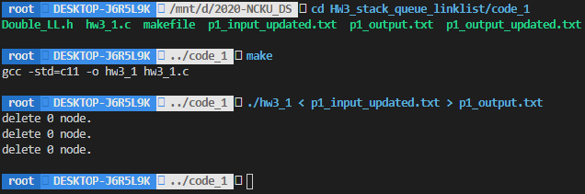

Figure Screenshot of command line (hw3_1)

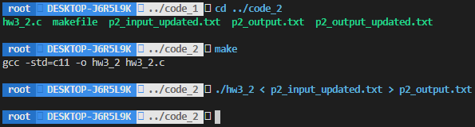

Figure Screenshot of command line (hw3_2)

|  |  |
| --- | --- |
| Figure p1_output.txt | Figure p2_output.txt |

## Program Architecture

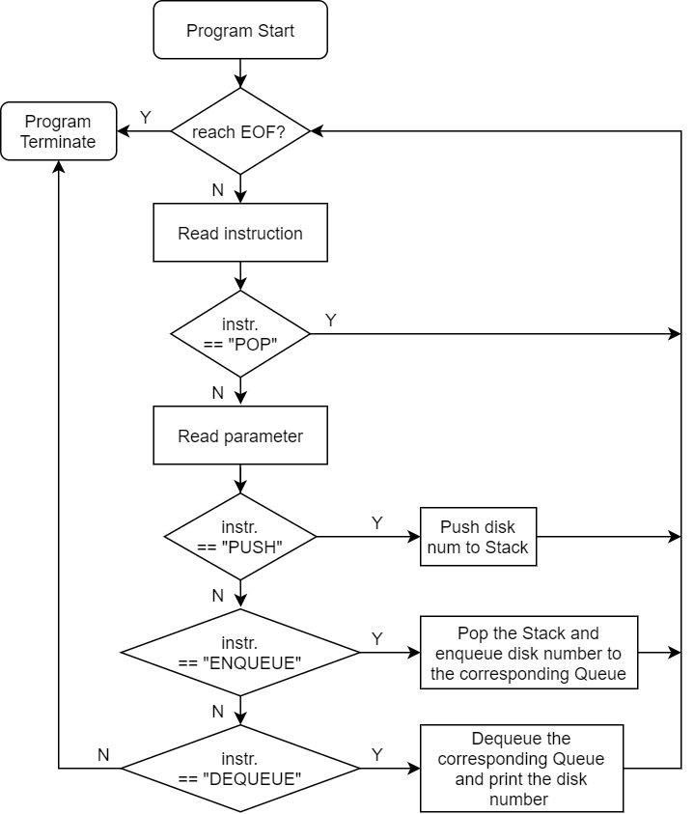

Figure Flow chart of hw3_1

## Program Functions

### 📒 Double_LL.h



Constructs a link list.

📐Parameters

None.

↩Return Value

Returns the new pointer of the link list.

* If construction fails, returns NULL.



Constructs a node.

📐Parameters



The element that would be initialized in the constructed node.

↩Return Value

Returns the new pointer of the node.

* If construction fails, returns NULL.



Inserts a new node on the back of the link list.

📐Parameters



The pointer of the link list.



The pointer of the node.

↩Return Value

None.



Removes the node on the back of the link list.

📐Parameters



The pointer of the link list.

↩Return Value

Returns the back element before removal.

* If the link list is empty, program terminates.

### 📒 Queue.h



Constructs a new queue.

📐Parameters

None.

↩Return Value

Returns the new pointer of the queue.

* If construction fails, returns NULL.



Removes the element in front of the queue.

📐Parameters



The pointer of the queue.

↩Return Value

Returns the front element before removal.

* If the queue is empty, program terminates.



Inserts a new element on the rear of the queue.

📐Parameters



The pointer of the queue.



The element which you insert.

↩Return Value

None.

## Program Design

本作業承接上個作業的精神—物件導向來實作，為了實作doubly link list，我使用兩個 struct來實現，一個是 struct Node另一個是struct LinkList，其宣告細節如下所示：



使用doubly link list的好處是，可以直接存取最後一個Node，節省push以及pop的時間。

## Operating System

Ubuntu 20.04.1 LTS (Focal Fossa)

## Compiler

gcc (Ubuntu 9.3.0-10ubuntu2) 9.3.0

## Compile

make

## Run

### hw3_1

./hw3_1 < input.txt > output.txt

### hw3_2

./hw3_2 < input.txt > output.txt