# Data Structure Assignment 5

|  |  |  |
| --- | --- | --- |
| **ID:** E14066282 | **Name:** 溫梓傑 | **Department:** ME 110 |

## Result Screenshots

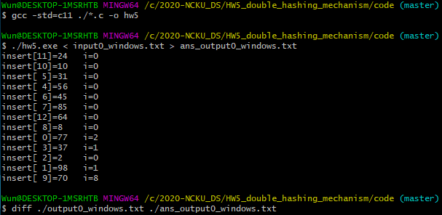

Figure Screenshot of command line

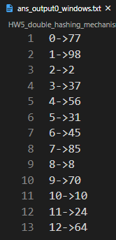

Figure Screenshot of output file

## Program Architecture

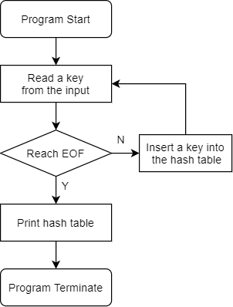

Figure Flow chart of hw5

## Program Functions

**int** hash(**int** key, **int** i)

Returns the hash function value.

### 📐Parameters

key

The key of the input.

i

The counts of the insertion.

### ↩Return Value

Returns the hash function output value.

**void** insert(bucket table[TABLE_SIZE], **int** key)

Inserts the key into the table.

### 📐Parameters

table

The input of the hash table.

key

The key that would be inserted.

### ↩Return Value

None.

## Program Design

首先，將 Hash table 的 bucket 定義如下：

**typedef** **struct** bucket

{

**int** key;

**int** isFull;

} bucket;

為了判斷這個 bucket 是否為空，因此加入 int isFull 來判斷。

當 isFull == 0 代表為空，

而 isFull == 1 代表為滿。

## Operating System

Windows 10

## Compiler

gcc.exe (MinGW.org GCC Build-20200227-1) 9.2.0

## Compile

gcc -std=c11 ./*.c -o hw5

## Run

./hw5.exe < input.txt > output.txt