MODEL COMPARISON FOR EACH PRODUCT
This section has been added to clearly state which model performs better and why, since two models were built.
The table below is the output of the code in R, which shows the result of comparing the models:
print(results)

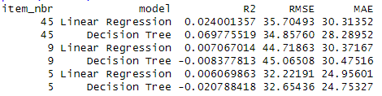
NOTE:
R² (R-squared) - Proportion of variance in units explained by the model. Higher = better (max = 1)
RMSE (Root Mean Squared Error) - Average prediction error (in units sold). Lower = better
MAE (Mean Absolute Error) - Average absolute error. Less sensitive to outliers than RMSE. Lower = better

Product #45
Decision Tree clearly performs better in the following ways:
Higher R² (0.07 vs 0.024) - Explains more than double the variance.
Lower RMSE (34.86 vs 35.70) - More accurate predictions.
Lower MAE (28.28 vs 30.31) - Smaller average error.
Conclusion: Decision Tree is superior for product #45.

Product #9
Linear Regression wins in the following ways:
Positive R² (0.007) vs Negative R² (-0.008) - The Decision Tree performs very badly.
Slightly lower RMSE and MAE – Linear regression is slightly more accurate.
This indicates that Decision Tree overfit the training data and generalizes poorly.

Product #5
Linear Regressions performs better with Positive R² and slightly lower RMSE although Decision Tree has a slightly lower MAE.

VARIABLES IMPACT PER PRODUCT
Let’s summarize how weather impacts sales for each product.
The following is the output of the code in R:
print(impact_summary, n = Inf)

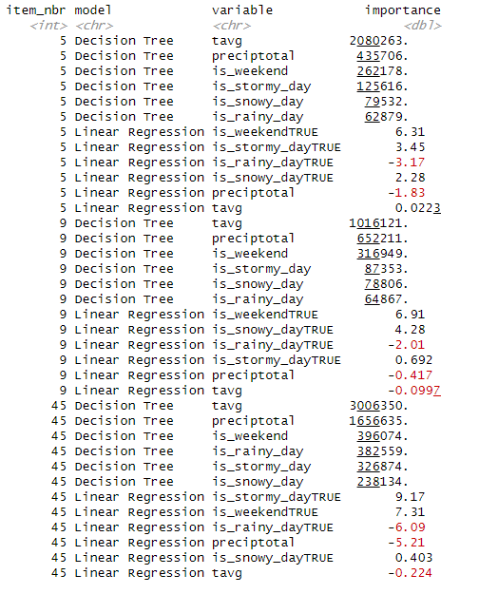

4.3.1. Short paragraph per product
Product #5
For product 5, average temperature (tavg) is the strongest driver of sales according to the decision tree, followed by precipitation and weekends. The regression model suggests weekends have a positive effect (+6.31), while stormy and snowy days also slightly increase sales, though rainy days (–-3.17) and higher precipitation (–1.83) reduce them. Taken together, the evidence suggests that sales for product 5 rise during weekends and stormy conditions, but decline when rainfall is higher, showing that not all weather events have the same influence.

Product #9
For product 9, the decision tree confirms that temperature and precipitation are the most influential weather factors. The tree assigns the highest importance to temperature (1,016,121), while regression shows that weekends (+6.91) and snowy days (+4.28) are positively associated with sales. However, higher temperatures (–0.0997) and rainfall (–2.01) slightly reduce sales, suggesting that colder, snowy periods and weekends encourage demand. This points to product 9 being more popular in cooler, wintry conditions.

Product #45
Product 45 shows the strongest overall sensitivity to weather. The decision tree highlights temperature and precipitation as dominant variables, with extremely high importance scores (3.0M and 1.7M respectively). Regression coefficients support this, with stormy days (+9.17) and weekends (+7.31) driving sales up, while rainy days (–6.09), precipitation (–5.21), and higher temperatures (–0.224) reduce them. This indicates that demand for product 45 peaks during colder, stormy weekends but drops significantly during rainy weather, suggesting weather extremes strongly shape its sales pattern.

4.3.2. VISUALIZATIONS

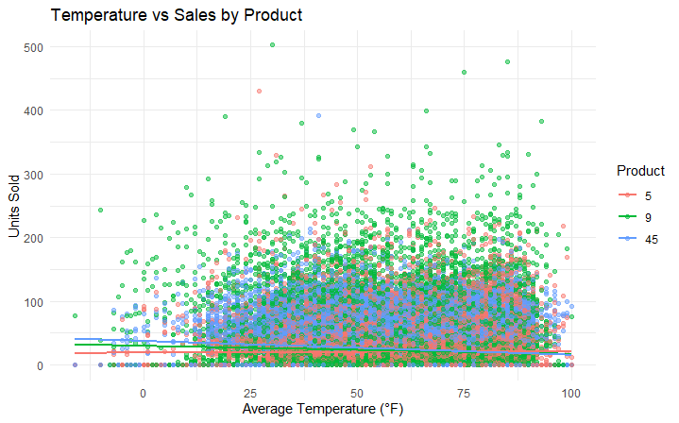

This chart shows how sales relate to average temperature. The regression lines illustrate that product #5 sales marginally increases with temperature, while higher temperatures slightly reduce sales for products #9 and #45.

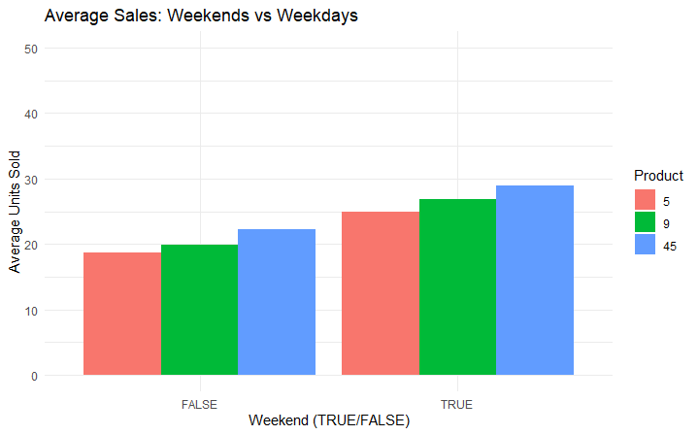

This bar chart compares sales on weekends versus weekdays. It shows that products sell significantly more during weekends, supporting the regression findings.

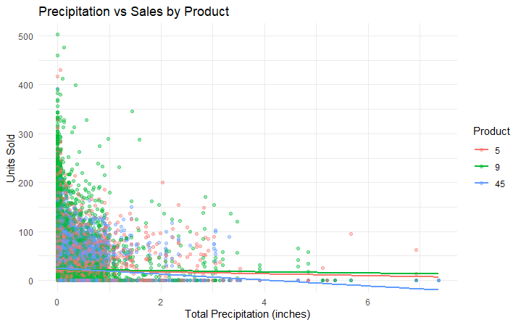

This scatter plot shows how precipitation relates to sales. Negative slopes confirm that higher rainfall tends to reduce demand, especially for product 45.

4.3.3. BUSINESS RECOMMENDATIONS
Here are six product-specific, evidence-based recommendations that tie directly to my model results and visualizations:

Product #5

-Increase stock and promotions during warmer periods, and especially on stormy weekends — Sales of Product 5 rise with higher average temperatures (positive coefficient for tavg). A proactive stocking strategy during warm months can prevent stockouts and capitalize on weather-driven demand.

-Reduce exposure on rainy days — The negative impact of rainfall (preciptotal and is_rainy_day) suggests demand drops during wet weather. The business should avoid running big promotions on rainy weeks and instead focus on indoor-friendly product bundles.

Product #9
- Leverage weekend demand — Product 9 shows a strong positive association with weekends (is_weekendTRUE coefficient +6.96). Marketing campaigns (discounts, targeted ads) should be timed to peak on Fridays and Saturdays to maximize returns.
- Plan for lower demand in hotter weather — Unlike Product 5, Product 9 sales decrease with rising temperature (negative tavg coefficient). Retailers should adjust inventory downward during heatwaves and shift attention to complementary items more suited to warm weather.

Product #45
- Prepare for high sales in colder, stormier periods — Product 45 is strongly influenced by both precipitation and stormy conditions. Demand rises when the weather is harsher, suggesting retailers should boost stock in winter months and during adverse forecasts.
- Mitigate rainy-day demand drops — While storms lift sales, rainfall alone reduces them (negative coefficients for preciptotal and is_rainy_day). To balance this, the business can push online sales or offer weather-resilient delivery options on rainy days.

