MODEL COMPARISON FOR EACH PRODUCT
This section has been added to clearly state which model performs better and why, since two models were built.
The table below is the output of the code in R, which shows the result of comparing the models:
print(results)

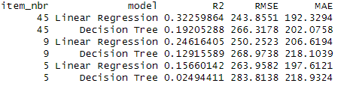
NOTE:
R² (R-squared) - Proportion of variance in units explained by the model. Higher = better (max = 1)
RMSE (Root Mean Squared Error) - Average prediction error (in units sold). Lower = better
MAE (Mean Absolute Error) - Average absolute difference between predicted and actual values. More robust to outliers than RMSE. Lower = better

Product #45
Linear regression (LR) clearly performs better than Decision Tree (DT) on all metrics:
Higher R² (0.323 vs 0.192) - LR explains about 32% of variance vs DT’s 19%.
Lower RMSE (243.86 vs 266.32) - More accurate predictions. LR reduces error by approx. 22 units.
Lower MAE (192.33 vs 202.08) - Smaller average error. LR predictions are approx. 10 units closer on average

Product #9
Linear regression (LR) also dominates across all metrics:
Higher R² (0.246 vs 0.129) - LR explains about 25% of variance vs DT’s 13%.
Lower RMSE (250.25 vs 268.97) - More accurate predictions. LR reduces error by approx. 19 units.
Lower MAE (206.62 vs 218.10) - Smaller average error. LR predictions are approx. 11 units closer on average

Product #5
Linear regression (LR) is clearly superior across all metrics:
Higher R² (0.157 vs 0.025) - DT explains only approx. 2.5% of sales variability, essentially near-random.
Lower RMSE (263.96 vs 283.81) - More accurate predictions. LR reduces error by approx. 20 units.
Lower MAE (197.61 vs 218.93) - Smaller average error. LR predictions are approx. 21 units closer on average.

4.2 Notes on R Programming
- The following points are worthy of note on how I handled special characters & missing weather values:
- preciptotal sometimes arrives as character; "T" means trace precipitation (tiny > 0) so I replaced "T" with a small positive value (0.002 inches) to reflect trace, not 0, and cast to numeric. Empty character strings “ ” are changed to missing values “NA” and all NAs are imputed with station & month-wise median which captures seasonal/local patterns, and if that’s not available, a global median is used as a fallback.
- For tavg, I ensured it is numeric and applied the same imputation logic: missing values are filled with the station–month median, falling back to the global median if necessary.
- The following points are worthy of note on how I handled outliers in ‘units’ (zero inflated):
- I used percentile capping at the 99th percentile per product rather than IQR (because there are many zeros in units). This curbs extreme spikes (maybe due to errors or outliers) without dropping rows. This method is used since it is robust against heavy skewness, and the problem with zero-inflated data is usually extreme positive values, not the zeros themselves.
- Feature Rationale
I created four new features needed for modelling. They are: is_weekend, is_rainy_day, is_snowy_day and is_stormy_day. The reason behind these features are as follows:
- is_weekend: Consumer shopping patterns differ on weekends
- is_rainy_day: Bad weather like rainy days may deter in-store sales but boost online orders
- is_snowy_day: Extreme cold and snowy conditions might reduce mobility, affecting sales
- is_stormy_day: Severe weather like storms can disrupt both supply & demand
Note that preciptotal, meaning precipitation total (rainfall and melted snow) was already part of the original weather variables.
- Train/Validation Split
I split the dataset using random split. Since the dataset was aggregated to a product-day level and does not explicitly depend on sequential or time-series patterns, a random split is appropriate to ensure that model training and testing are fair, unbiased, and representative of the data’s natural variability. To make sure that model performance avoids overfitting, the models are evaluated on a validation (test) set that was held out from training (i.e. training on the first 80% set and validating on the remaining 20%). The metrics table (reporting R², RMSE, and MAE) therefore represents model performance on this out-of-sample validation set rather than on the training data.

VARIABLES IMPACT PER PRODUCT
Let’s summarize how weather impacts sales for each product.
The following is the output of the code in R:
print(impact_summary, n = Inf)
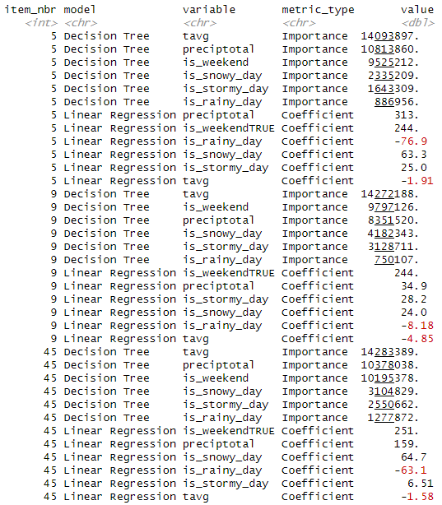

4.3.1. Short paragraph per product to show how variables impact sales

Product #5
-Decision Tree (Feature Importance)
For product #5, the decision tree identifies tavg (average temperature) as the most important variable with an importance score of 14,093,897, indicating it plays the dominant role in splitting the data and predicting sales. Total precipitation (preciptotal) is the second most important variable at 10,813,860, followed closely by weekend at 9,525,212. This suggests that both weather intensity and weekends are critical factors. Other weather flags contribute less but still meaningfully: snowy day (2,335,209), stormy day (1,643,309), and rainy day (886,956). Overall, continuous weather variables (tavg, preciptotal) and weekend status are the primary drivers in the model’s predictions for this product.
-Regression (Size and Direction)
The linear regression reveals specific directional effects on sales. Total precipitation (preciptotal) has the largest positive coefficient of +313, meaning that every inch increase in total precipitation is associated with a substantial increase of approximately 313 units sold. Similarly, 244 more units are sold on weekends. Snowy days also positively impact sales (+63.3 units), while stormy days have a smaller positive effect (+25.0). However, rainy days significantly reduces sales by 76.9 units. Interestingly, average temperature (tavg) has a small negative coefficient (−1.91), suggesting slightly lower sales on warmer days. Thus, while temperature is highly influential in splits (DT), its average linear effect is mildly negative.

Product #9
-Decision Tree (Feature Importance)
For product #9, average temperature (tavg) again ranks as the top predictor with an importance score of 14,272,188, making it the most influential factor in explaining variation in sales. Weekend follows at 9,797,126, and total precipitation (preciptotal) comes third at 8,351,520, showing that both temperature and contextual timing/precipitation levels are key. Snowy day (4,182,343) and stormy day (3,128,711) have moderate importance, whereas rainy day is much less influential at only 750,107. This indicates that snowy and stormy conditions matter more than rainy days in structuring the prediction logic for this product.
-Regression (Size and Direction)
The regression coefficients reveal nuanced behavioral patterns. Weekend has the strongest positive impact (coefficient = +244), meaning weekend sales are 244 units higher on average. Total precipitation (preciptotal) contributes positively but to a lesser extent (+34.9 more units of sale per inch). Snowy (coefficient = +24.0) and stormy (coefficient = +28.2) days both modestly boost sales, while rainy day slightly reduces them (coefficient = −8.18). Notably, tavg has a negative coefficient of −4.85, implying that higher temperatures are linked to lower sales. Despite being the most important split variable in the tree model, temperature's linear relationship with sales is inverse — suggesting optimal sales occur in colder conditions.
Product #45
-Decision Tree (Feature Importance)
For product #45, tavg is once again the most important variable with a very high importance score of 14,283,389, indicating its central role in determining sales outcomes. Total precipitation (10,378,038) and weekend (10,195,378) follow closely behind, all exceeding 10 million in importance — highlighting their comparable significance in the model. Among weather condition flags, snowy days (3,104,829) and stormy days (2,550,662) are notably more impactful than rainy days (1,277,872). This pattern suggests that extreme winter weather conditions play a meaningful role in sales dynamics, particularly when differentiated from general rain.

-Regression (Size and Direction)
From the regression perspective, weekend has the largest positive effect, boosting sales by 251 units — the highest among all three top products. Total precipitations (preciptotal) also strongly increases sales by 159 units, reflecting greater demand during periods of precipitation. Snowy days boost sales by 64.7 units, reinforcing the idea that snow enhances demand, while rainy days decrease sales by 63.1 units — a nearly symmetric counter-effect. In contrast, stormy days have only a minimal positive impact (coefficient = +6.51). On the other hand, tavg exhibits a slight negative coefficient (−1.58), indicating a weak decline in sales as temperatures rise. Hence, despite temperature being the top-splitting variable according to DT, its average marginal effect remains slightly adverse.

4.3.2. VISUALIZATIONS

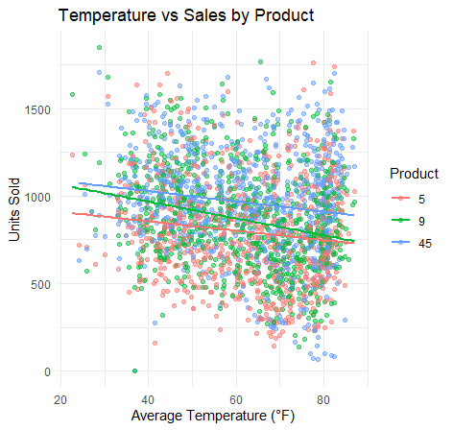

This chart shows how sales relate to average temperature. The regression lines illustrate that for all three products (#5, #9 and #45), higher temperatures are modestly associated with lower sales, corresponding to the negative regression coefficients of -1.91, -4.85 and -1.58 respectively. This is also in line with its importance in the DT model.

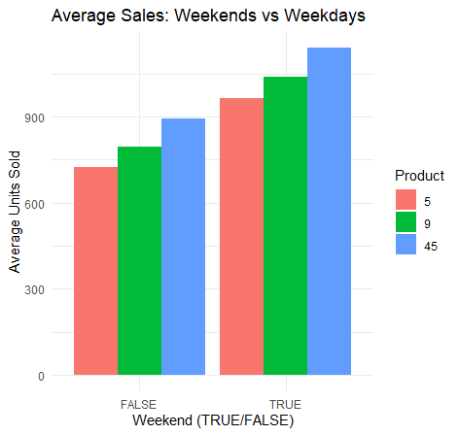

This bar chart compares average sales on weekends versus weekdays. It shows that there are significantly more sales during weekends for products #5, #9 and #45. This is in line with the weekend regression coefficients of +244, +244 and +251 respectively, meaning that during weekends, 244 more units of products #5 and #9 are sold while 251 more units of product #45 are sold compared to weekdays. This is also in line with its highest importance in the DT model.

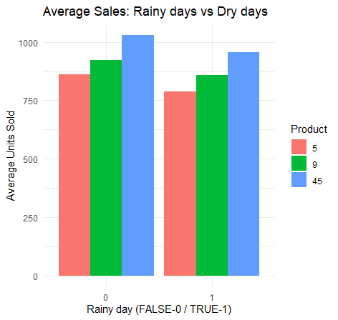

This bar chart shows how rainfall relates to sales. It shows reduced sales during rainy days for products #5, #9 and #45. This supports the is_rainy_day negative regression coefficients of -76.9, -8.18 and -63.1 respectively, meaning that keeping all other variables constant on rainy days, about 77, 8 and 63 less units of products #5 and #9 and #45 respectively are sold compared to dry days (days without rainfall) on the average.

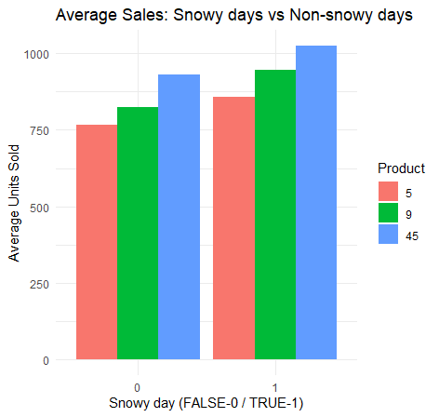

This bar chart shows how snow relates to sales. For products #5, #9 and #45, snowy days consistently increase sales, though the magnitude varies, corresponding to the regression coefficients of +63.3, +24.0 and +64.7 respectively. This means that snowy days increase sales by about 63, 24 and 65 units on the average for products #5, #9 and #45 respectively.

4.3.3. BUSINESS RECOMMENDATIONS
Here are four product-specific, evidence-based recommendations that tie directly to my model results and visualizations:

Product #5
- Increase weekend and winter storm preparedness; prioritize restocking before cold, snowy weekends. This is because linear regression reveals large positive impact of precipitation (rain and melted snow combined) of about 313 more units of sale per inch and weekends (+244 units), with snowy days boosting sales (+63.3 units). Despite high importance of temperature in splits, warmer temps slightly reduce sales (coefficient = −1.91)
- Reduce reliance on rain-based demand; treat rainy days as low-demand periods. Rainy days reduce sales by 76.9 units, even though total precipitation increases demand. Avoid overstocking product #5 during extended rainy periods unless accompanied by cold temperatures or snow forecasts, where demand may rebound.

Product #9
- Leverage weekend demand — Product #9 shows a strong positive association with weekends (is_weekendTRUE coefficient = +244), especially on cold, snowy and stormy weekends. This is because sales rise modestly on snowy (coefficient = +24.0) and stormy (coefficient = +28.2) days and average temperature (tavg) being the most important variable in the decision tree (importance >14M), has negative regression coefficient of −4.85 meaning that warmer days reduce sales. Marketing campaigns (discounts, targeted ads) should be timed to peak on Fridays and Saturdays to maximize returns.

Product #45
- Treat product #45 as a premium weather-responsive product; ensure maximum availability during colder months if precipitation is forecasted, and especially on weekends. Use dynamic pricing or signage like “Perfect for Today’s Weather” when combined cold/rain/snow conditions are predicted. Work with meteorological data providers to distinguish snowfall vs. rainfall forecasts in warehouse dispatch decisions. Prioritize same-day replenishment only when snow or mixed precipitation is expected, not during just prolonged rain. This is because heavy precipitation strongly increases sales (coefficient = +159), but rainy days decrease sales (coefficient = −63.1) while snowy days increase them (coefficient = +64.7) -- showing opposite effects despite similar moisture levels

