MODEL COMPARISON FOR EACH PRODUCT
This section has been added to clearly state which model performs better and why, since two models were built.
The table below is the output of the code in R, which shows the result of comparing the models:
print(results)

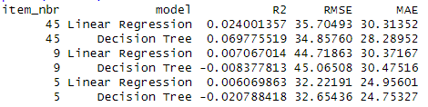
NOTE:
R² (R-squared) - Proportion of variance in units explained by the model. Higher = better (max = 1)
RMSE (Root Mean Squared Error) - Average prediction error (in units sold). Lower = better
MAE (Mean Absolute Error) - Average absolute error. Less sensitive to outliers than RMSE. Lower = better

Product #45
Decision Tree clearly performs better in the following ways:
Higher R² (0.07 vs 0.024) - Explains more than double the variance.
Lower RMSE (34.86 vs 35.70) - More accurate predictions.
Lower MAE (28.28 vs 30.31) - Smaller average error.
Conclusion: Decision Tree is superior for product #45.

Product #9
Linear Regression wins in the following ways:
Positive R² (0.007) vs Negative R² (-0.008) - The Decision Tree performs very badly.
Slightly lower RMSE and MAE – Linear regression is slightly more accurate.
This indicates that Decision Tree overfit the training data and generalizes poorly.

Product #5
Linear Regressions performs better with Positive R² and slightly lower RMSE although Decision Tree has a slightly lower MAE.

VARIABLES IMPACT PER PRODUCT
Let’s summarize how weather impacts sales for each product.
The following is the output of the code in R:
print(impact_summary, n = Inf)

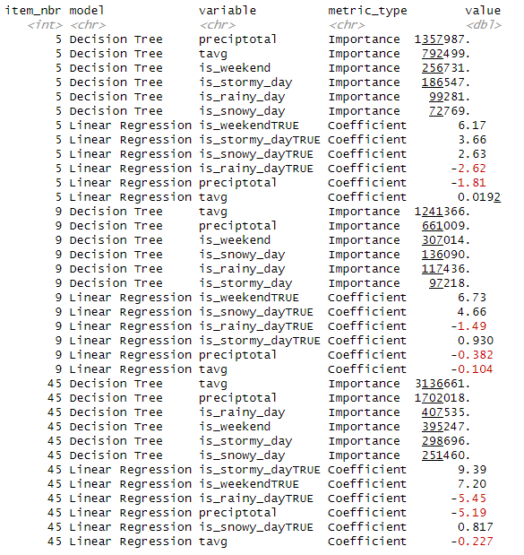

4.3.1. Short paragraph per product to show how variables impact sales
Product #5
-Regression (Size and Direction)
From the regression analysis, weekends emerge as the strongest positive driver of sales, with a coefficient of +6.17, indicating that average sales increase by more than six units on weekends compared to weekdays. Stormy days (+3.66) and snowy days (+2.63) also provide modest boosts, while rainy days (–2.62) and precipitation totals (–1.81) reduce sales. Temperature has only a very small positive effect (+0.019), suggesting warmer weather increases sales slightly but not substantially.
-Decision Tree (Feature Importance)
The decision tree results show that weather dominates in explaining variation in sales. Precipitation has the highest importance score (1,357,987), followed by temperature (792,499) and weekend (256,731). Stormy days (186,547), rainy days (99,281), and snowy days (72,769) are included but play smaller roles relative to overall rainfall and temperature.

Product #9
-Regression (Size and Direction)
Regression results for this product again highlight weekends as a major driver, with a coefficient of +6.73, meaning weekend sales are nearly seven units higher on average. Snowy days also contribute positively (+4.66), while rainy days (–1.49) and precipitation (–0.38) slightly reduce sales. Stormy days provide a small positive boost (+0.93), and temperature has a minor negative effect (–0.104), indicating slightly fewer sales in warmer conditions.
-Decision Tree (Feature Importance)
The decision tree model emphasizes temperature (1,241,366) and precipitation (661,009) as the most important variables, far ahead of other factors. Weekend (307,014) is still influential, while snowy days (136,090), rainy days (117,436), and stormy days (97,218) add smaller contributions. This suggests that, while weather patterns explain most of the variability, weekends consistently push sales upward.

Product #45
-Regression (Size and Direction)
For Product 45, regression coefficients show stormy days (+9.39) and weekends (+7.20) as strong positive drivers of sales. In contrast, rainy days (–5.45) and precipitation totals (–5.19) have large negative effects, substantially lowering demand. Snowy days contribute a small positive effect (+0.82), while temperature has a modest negative coefficient (–0.227), suggesting warmer days are linked to slightly fewer sales.
-Decision Tree (Feature Importance)
The decision tree model highlights weather as overwhelmingly dominant: temperature (3,136,661) and precipitation (1,702,018) outweigh the importance of other variables. Rainy days (407,535), weekends (395,247), stormy days (298,696), and snowy days (251,460) provide additional predictive power but remain secondary compared to the sheer influence of temperature and precipitation.

4.3.2. VISUALIZATIONS

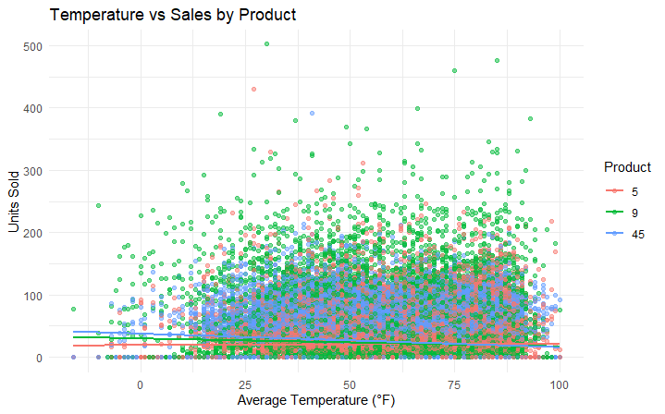

This chart shows how sales relate to average temperature. The regression lines illustrate that product #5 sales marginally increases with temperature, while higher temperatures slightly reduce sales for products #9 and #45.

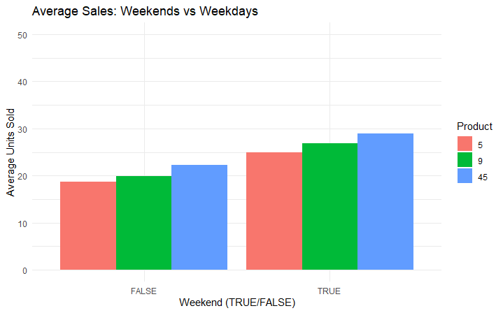

This bar chart compares sales on weekends versus weekdays. It shows that products sell significantly more during weekends, supporting the regression findings.

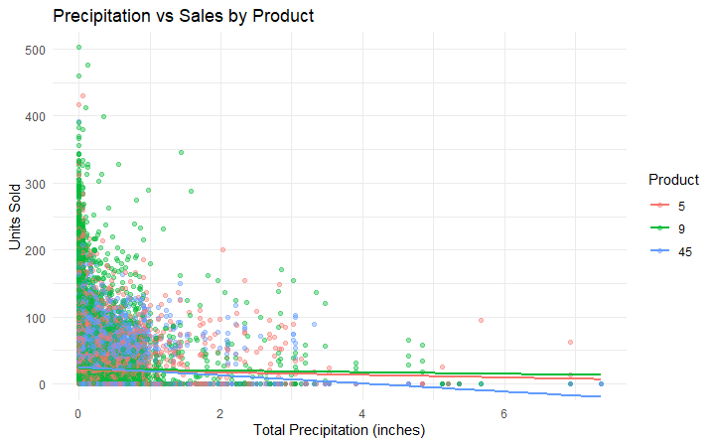

This scatter plot shows how precipitation relates to sales. Negative slopes confirm that higher rainfall tends to reduce demand, especially for product 45.

4.3.3. BUSINESS RECOMMENDATIONS
Here are six product-specific, evidence-based recommendations that tie directly to my model results and visualizations:

Product #5

-Increase stock and promotions during warmer periods, and especially on stormy weekends — Sales of Product 5 rise with higher average temperatures (positive coefficient for tavg). A proactive stocking strategy during warm months can prevent stockouts and capitalize on weather-driven demand.

-Reduce exposure on rainy days — The negative impact of rainfall (preciptotal and is_rainy_day) suggests demand drops during wet weather. The business should avoid running big promotions on rainy weeks and instead focus on indoor-friendly product bundles.

Product #9
- Leverage weekend demand — Product 9 shows a strong positive association with weekends (is_weekendTRUE coefficient +6.96), especially on snowy weekends. Marketing campaigns (discounts, targeted ads) should be timed to peak on Fridays and Saturdays to maximize returns.
- Plan for lower demand in hotter weather, and rainy days as well — Unlike Product 5, Product 9 sales decrease with rising temperature (negative tavg coefficient). Retailers should adjust inventory downward during heatwaves and shift attention to complementary items more suited to warm weather.

Product #45
- Prepare for high sales in colder, stormier periods — Product 45 is strongly influenced by both precipitation and stormy conditions. Demand rises when the weather is harsher, suggesting retailers should boost stock in winter months and during adverse forecasts, including weekends.
- Mitigate rainy-day demand drops — While storms lift sales, rainfall alone reduces them (negative coefficients for preciptotal and is_rainy_day). To balance this, the business can push online sales or offer weather-resilient delivery options on rainy days.

