MODEL COMPARISON FOR EACH PRODUCT
This section has been added to clearly state which model performs better and why, since two models were built.
The table below is the output of the code in R, which shows the result of comparing the models:
print(results)

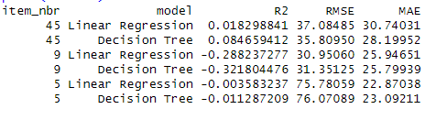
NOTE:
R² (R-squared) - Proportion of variance in units explained by the model. Higher = better (max = 1)
RMSE (Root Mean Squared Error) - Average prediction error (in units sold). Lower = better
MAE (Mean Absolute Error) - Average absolute error. Less sensitive to outliers than RMSE. Lower = better

Product #45
Decision Tree clearly performs better in the following ways:
Higher R² (0.084 vs 0.018) - Explains more than four times the variance.
Lower RMSE (35.81 vs 37.08) - More accurate predictions.
Lower MAE (28.20 vs 30.74) - Smaller average error.
Conclusion: Decision Tree is superior in predicting sales for product #45.

Product #9
Both linear regression and decision tree have negative R² values (-0.29 and -0.32 respectively). For linear regression, this suggests that the regression line is a poor fit, and for the decision tree, it’s an indication that the spits are not very helpful.
Slightly lower RMSE (30.95) than that of decision tree (31.35) indicates that Linear regression is only marginally more accurate in predictions.

Product #5
Linear Regressions performs only marginally better, with slightly lower RMSE and MAE. Both models have negative R² values suggesting poor generalization.

4.2 Notes on R Programming
- The following points are worthy of note on how I handled special characters & missing weather values:
- preciptotal sometimes arrives as character; "T" means trace precipitation (tiny > 0) so I replaced "T" with a small positive value (0.002 inches) to reflect trace, not 0, and cast to numeric. Empty character strings “ ” are changed to missing values “NA” and all NAs are imputed with station & month-wise median which captures seasonal/local patterns, and if that’s not available, a global median is used as a fallback.
- For tavg, I ensured it is numeric and applied the same imputation logic: missing values are filled with the station–month median, falling back to the global median if necessary.
- The following points are worthy of note on how I handled outliers in ‘units’ (zero inflated):
- I used percentile capping at the 99th percentile per product rather than IQR (because there are many zeros in units). This curbs extreme spikes (maybe due to errors or outliers) without dropping rows. This method is used since it is robust against heavy skewness, and the problem with zero-inflated data is usually extreme positive values, not the zeros themselves.
- Feature Rationale
I created four new features needed for modelling. They are: is_weekend, is_rainy_day, is_snowy_day and is_stormy_day. The reason behind these features are as follows:
- is_weekend: Consumer shopping patterns differ on weekends
- is_rainy_day: Bad weather like rainy days may deter in-store sales but boost online orders
- is_snowy_day: Extreme cold and snowy conditions might reduce mobility, affecting sales
- is_stormy_day: Severe weather like storms can disrupt both supply & demand
Note that preciptotal, meaning precipitation total (rainfall and melted snow) was already part of the original weather variables.
- Train/Validation Split
I split the dataset using time-based split. This is more realistic due to the nature of the dataset (time series-like), structured at the product–day level and also includes changing patterns and calendar effects such as weekend. To ensure that model performance avoids overfitting, the models are evaluated on a validation (test) set that was held out from training (i.e. training on the first 80% of dates and validating on the remaining 20%). The metrics table (reporting R², RMSE, and MAE) therefore represents model performance on this out-of-sample validation set rather than on the training data.

VARIABLES IMPACT PER PRODUCT
Let’s summarize how weather impacts sales for each product.
The following is the output of the code in R:
print(impact_summary, n = Inf)

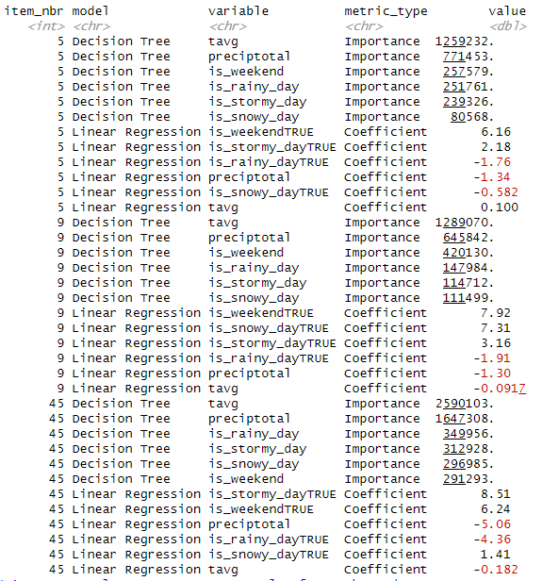

4.3.1. Short paragraph per product to show how variables impact sales
Product #5
-Regression (Size and Direction)
From the regression analysis, weekends emerge as the strongest positive driver of sales, with a coefficient of +6.16, indicating that average sales increase by more than six units on weekends compared to weekdays. Stormy days (+2.18) positive coefficient indicates that stormy conditions increase sales for this product, perhaps because customers stock up before bad weather, or the product is one people use indoors during storms. For preciptotal, the negative coefficient of -1.34 suggests that each additional inch of precipitation (i.e. rainfall and melted snow) is associated with about 1.34 fewer units sold, likely due to reduced customer mobility on wet days. Rainy days (–1.76) and snowy days (-0.582) with negative coefficients also reduce sales. Temperature has only a very small positive effect (+0.10), suggesting warmer weather increases sales slightly but not substantially.
-Decision Tree (Feature Importance)
The decision tree results show that weather dominates in explaining variation in sales. Temperature has the highest importance score (1,259,232), followed by precipitation (771,453), weekend (257,579), rainy days (251,761) and stormy days (239,326). Snowy days (80,568) is included, but play smaller role relative to overall rainfall and temperature.

Product #9
-Regression (Size and Direction)
Regression results for this product again highlight weekends as a major driver of sales, with a coefficient of +7.92, meaning weekend sales are nearly eight units higher on average. Following closely in driving sales is snowy days also contributing very positively (+7.31), while stormy days provide a smaller positive boost (+3.16). Rainy days (–1.91) and precipitation (–1.30) reduce sales, and temperature has a minor negative effect (–0.0917), indicating slightly fewer sales in warmer conditions.
-Decision Tree (Feature Importance)
The decision tree model emphasizes temperature (1,289,070) as the most important variable explaining variation in sales, followed by precipitation (645,842) and weekend (420,130). Rainy days (147,984), stormy days (114,712), and snowy days (111,499) add smaller contributions. This suggests that, while weather patterns explain most of the variability, weekends also consistently push sales upward.
Product #45
-Regression (Size and Direction)
For Product 45, regression coefficients show stormy days (+8.51) and weekends (+6.24) as strong positive drivers of sales. In contrast, precipitation (–5.06) and rainy days (–4.36) have large negative effects, substantially lowering demand. Snowy days contribute a smaller positive effect (+1.41) in increasing demand, while temperature has a smaller negative coefficient (–0.182), suggesting warmer days are linked to slightly fewer sales.
-Decision Tree (Feature Importance)
The decision tree model highlights weather as overwhelmingly dominant: temperature (2,590,103) and precipitation (1,647,308) outweigh the importance of other variables. Rainy days (349,956), stormy days (312,928), snowy days (296,985), and weekends (291,293) provide additional predictive power but remain secondary compared to the sheer influence of temperature and precipitation.
In general, it can be noted that precipitation consistently reduces sales in the regression results and ranks among the top two most important predictors in the decision trees — meaning that both its magnitude and predictive power are substantial. On the other hand, stormy days consistently have positive regression coefficients and moderate-to-high importance in trees, indicating they may trigger behavioral shifts in making more sales.

4.3.2. VISUALIZATIONS

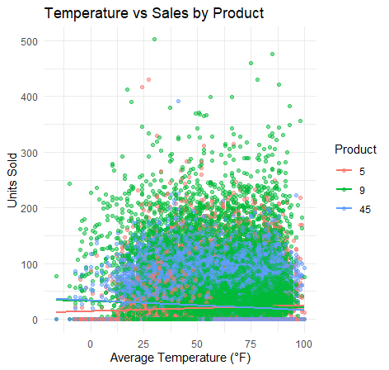

This chart shows how sales relate to average temperature. The regression lines illustrate that product #5 sales marginally increases with temperature, corresponding to the small positive regression coefficient (+0.10), while higher temperatures slightly reduce sales for products #9 and #45, corresponding to the small negative regression coefficients of -0.0917 and -0.182 respectively. This is also in line with its importance in the decision tree model.

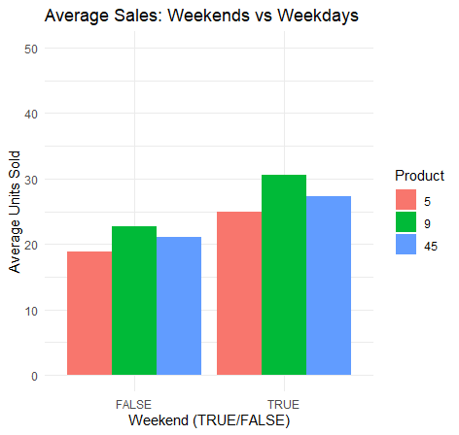

This bar chart compares sales on weekends versus weekdays. It shows that products sell significantly more during weekends for products #5, #9 and #45. This supports the weekend regression coefficients of +6.16, +7.92 and +6.24 respectively, and also its importance in the decision tree model.

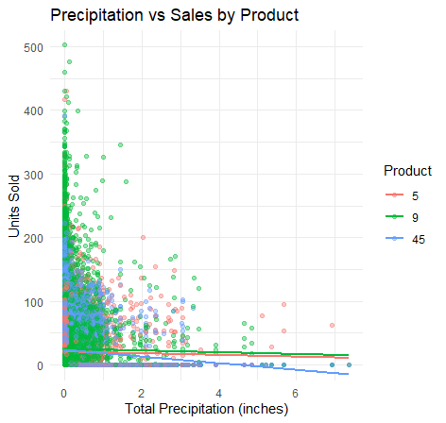
This scatter plot shows how precipitation relates to sales. The negative slopes confirm that higher rainfall tends to reduce demand for products #5, #9, and #45 but especially for product 45. This agrees with the precipitation regression coefficients of -1.34, -1.30 and -5.06 respectively, and also with the high decision tree importance.

4.3.3. BUSINESS RECOMMENDATIONS
Here are six product-specific, evidence-based recommendations that tie directly to my model results and visualizations:

Product #5
-Increase stock and promotions during warmer periods, and especially on stormy weekends — Sales of Product #5 rise with higher average temperatures (positive coefficient for tavg). A proactive stocking strategy during warm months can prevent stockouts and capitalize on weather-driven demand.

-Reduce exposure on rainy and snowy days — The negative impact of rainfall (preciptotal and is_rainy_day) and snow suggests that demand drops during wet and snowy weather. The business should avoid running big promotions on rainy weeks and instead focus on indoor-friendly product bundles.

Product #9
- Leverage weekend demand — Product #9 shows a strong positive association with weekends (is_weekendTRUE coefficient +6.96), especially on snowy and stormy weekends. Marketing campaigns (discounts, targeted ads) should be timed to peak on Fridays and Saturdays to maximize returns.
- Plan for lower demand in hotter weather, and rainy days as well — Unlike Product #5, Product #9 sales decrease with rising temperature (negative tavg coefficient). Retailers should adjust inventory downward during heatwaves and shift attention to complementary items more suited to warm weather.

Product #45
- Prepare for high sales in snowy and stormy periods, especially during stormy weekends — Product #45 is strongly influenced by both precipitation and stormy conditions. Demand rises when the weather is harsher, suggesting retailers should boost stock in winter months and during adverse forecasts, including weekends.
- Mitigate rainy-day demand drops — While storms lift sales, wet weather reduces sales (negative coefficients for preciptotal and is_rainy_day). To balance this, the business can push online sales or offer weather-resilient delivery options on rainy days.

