Competition 1 report — 112062308 蔡佳倩
Code explanation:
Part 1: Import needed functions
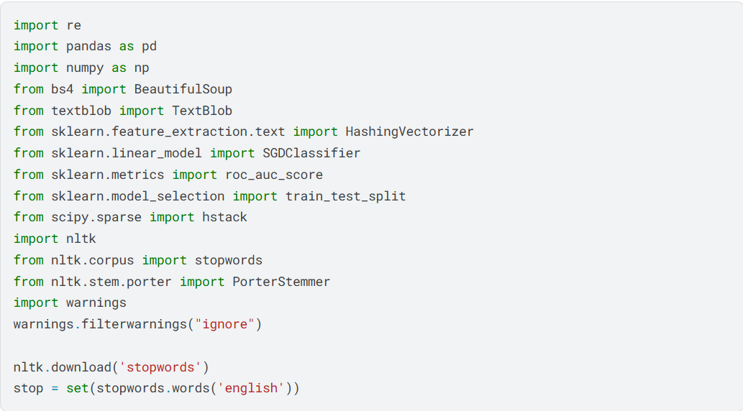
Part 2 : Define the preprocessor
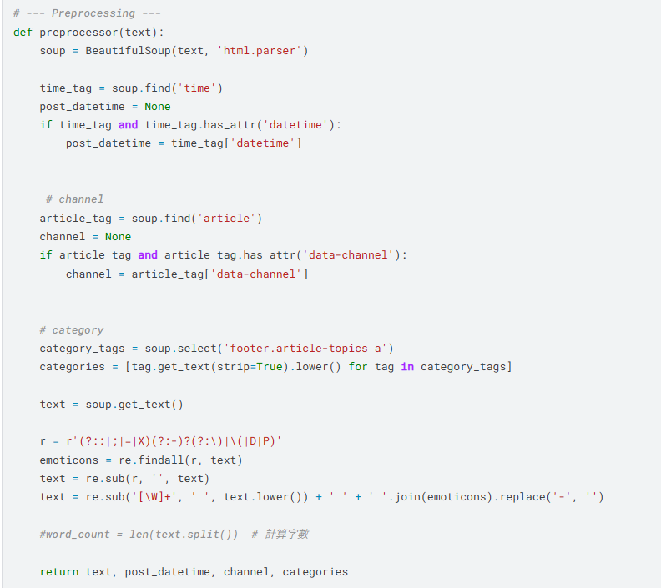


- First, I used BeautifulSoup to parse the input HTML text so I can easily extract specific elements of the html code from ‘soup’ the variance.
- It searches for a <time> tag and retrieves the value of ‘datetime’ attribute. The publication time of the news would be saved in ‘post_datetime’.
- It searches for a <article> tag and reads its ‘data-channel’ attribute. ‘channel’ identifies the news source.
- It gathers all topic tags located within the article footer. Each category names are cleaned, turned as low case, and stored in a list.
- Next is the text cleaning and emoticon handling process: remove hyphen from emoticons and non-alphanumeric characters from the text.
- Last, return the cleaned text, post_datetime, channel, and categories for further use.
Part 3 : Define tokenizer_stem_nostop and extract_sentiment_features
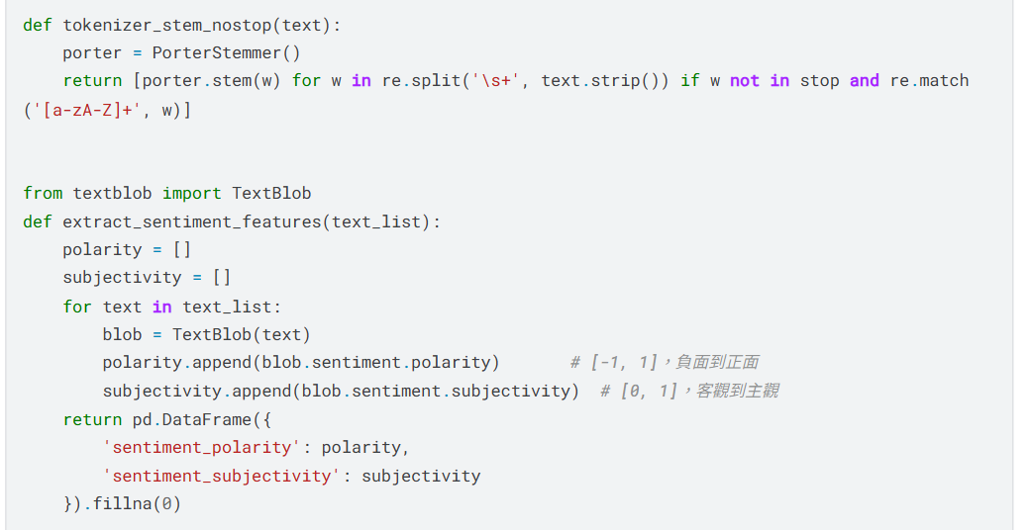
tokenizer_stem_nostop
- Initialize the Stemmer to perform stemming, which makes words transform to their base forms. Then split the text into tokens based on whitespaces.
- It also filters out words that are in the predefined stop word list and non-alphabetical strings. Then, return the result of each stemmed token.
extract_sentiment_features
- Initialize two containers to store the sentiments results. Each word from the ‘text_list’ input would create a ‘TextBlob’ object. Then, it extracts the sentiment scores from negative to positive and from subjective to objective.
- Results would be combined into a pandas DataFrame for structured analysis and any missing values would be filled with zero.

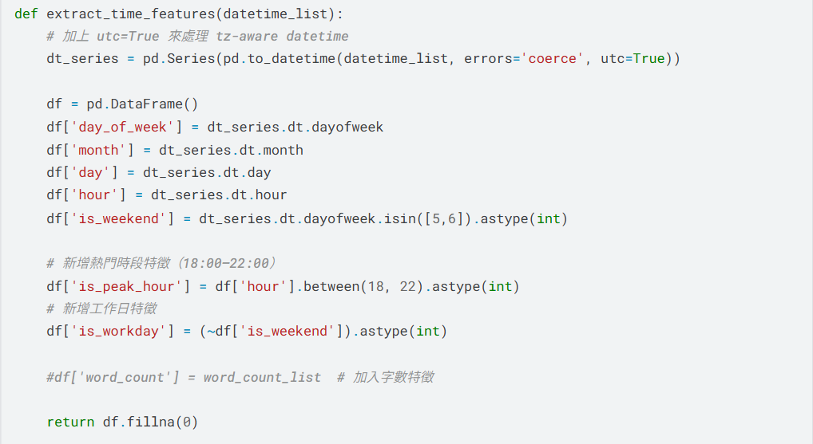
Part 4 : Converts a list of datetime strings into multiple numeric features

- First, convert all datetime strings into pandas and make sure the time zone and context are a proper form of time.
- Next, derive several time-related attributes (day of week, month, day, hour) from each datetime value. This provides a structured representation of each timestamp.
- The weekend indicator uses a binary feature to mark whether the post was published on a weekend. The peak hour indicator also marks whether the post was published when people usually get off work. The workday indicator is just the opposite of the weekend indicator. I think these three indicators may influence the engagement and popularity of news, so I added it in the features.
- At last, the function returns a pandas DataFrame containing all extracted features with any missing values filled with zeros.
Part 5 : Define the classifier and the preprocess of the training data
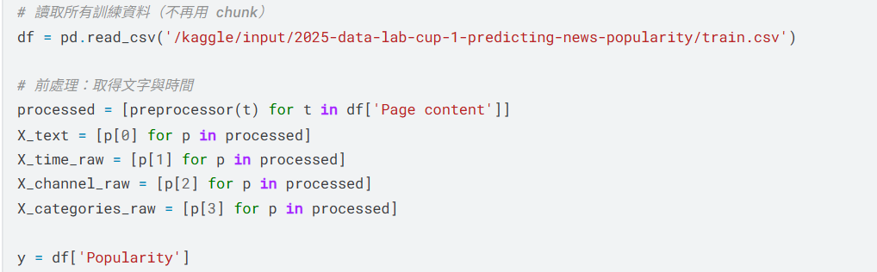
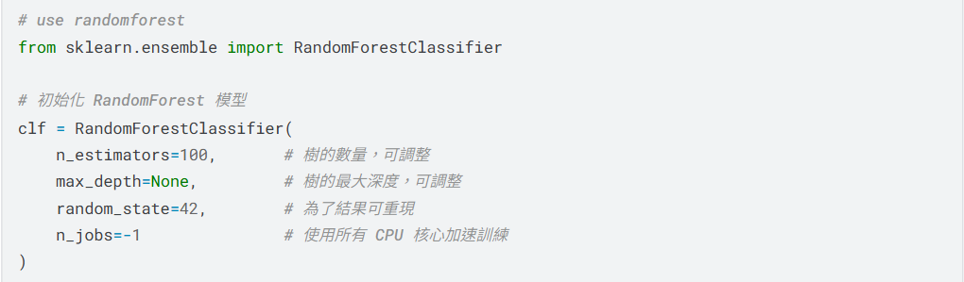
- After different tries, I chose to use a Random Forest Classifier as the main model. First, initializing it with the parameters above. Then, read in the training dataset.
- Before training, multiple feature types are extracted from the dataset by the preprocessor defined above. Get the return values and define y as the known popularity of each article.
Part 6 : Define the text representation, train the model and evaluate it
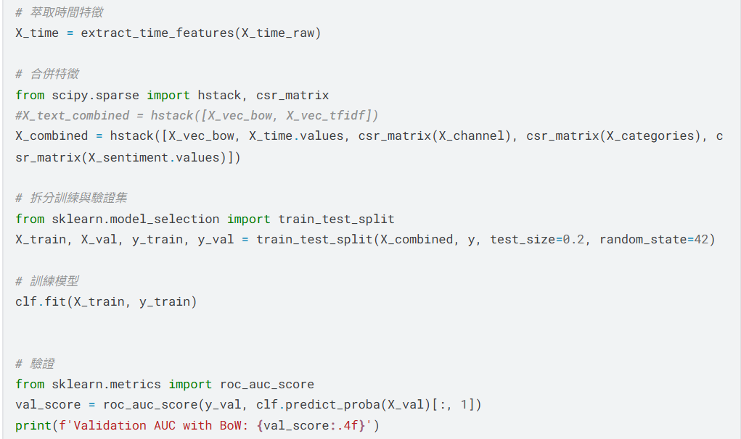
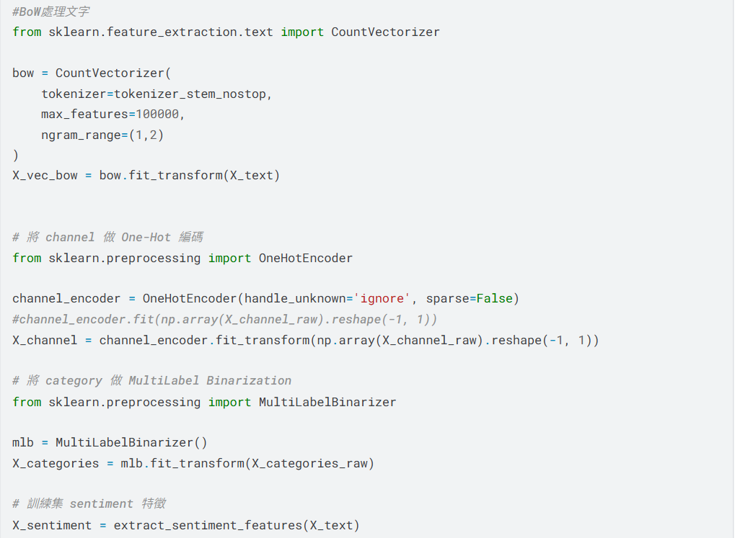
- After different tries, I chose to use the Bag-of-Word model with ‘CountVectorizer’ : including the predefined tokenizer, both unigrams and bigrams, vocabulary limit.
- Encode the channel information using one-hot encoder and convert each channel into a separate binary feature column.
- Since each article can belong to multiple categories, ‘MultiLabelBinarizer’ is used to perform multi-hot encoding generating binary indicators for all category tags.
- Then, use the predefined functions to extract their sentiment analysis and time features. At last, concatenate every extracted feature into one unified feature matrix.
- The training dataset is split into 80% training sets and 20% validation sets to evaluate the model performance. Use the AUC metric to indicate whether the generation of the popularity is precise.
Part 7 : Run the testing dataset and output the prediction in a csv file.
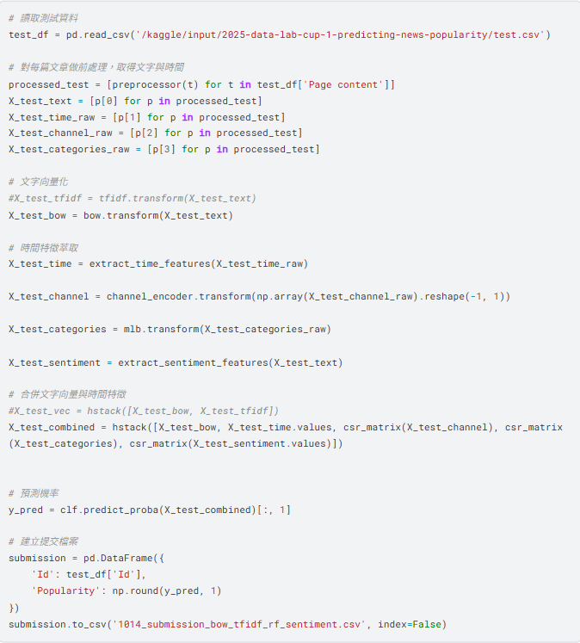
Read the testing dataset and do every preprocess just as the training dataset just did. Save the probability prediction in a panda DataFrame first with ‘Id’ and ‘Popularity’ then turn the results into a csv output file.

Conclusion:
- I tried different models for classifiers and text representation then chose the best performance combination. I observed that some combinations seem to be facing overfitting with a better performance locally but a worse performance at the testing dataset. Below are the other models I tried during the trial session.
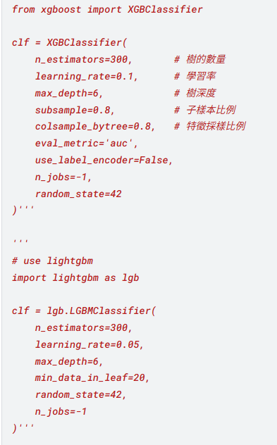
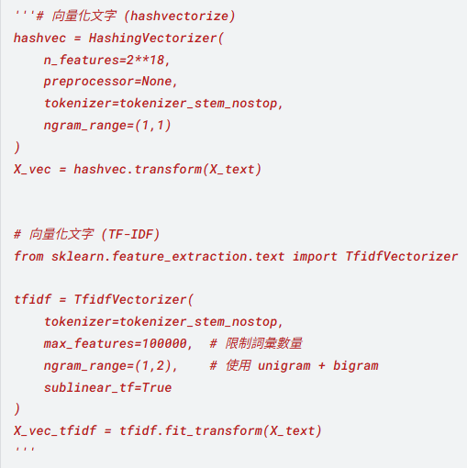

- I faced a pretty big challenge when doing the feature engineering. First, I don’t know what features may be effective to the model training. Sometimes adding too much feature to the training process makes it more complex and doesn’t even lead to a better result. Next, I’m not sure which model suits this kind of training session and this big amount of data, since I’m not familiar with any of these models. Only by trial and error, also Internet sources, can give me the answers. But too bad there are limited submissions a day. Last, after having a basic structure, thinking what other features can be extracted to help enhance the performance is also a big task in this competition. To sum up, I think that maintaining patience and keeping my mind clear about what I’m doing are the most difficult parts, but this is also a learning opportunity for me, a deep learning rookie.

