Huỳnh Văn Chiến

0950080028

Câu 1

Tao bảng  
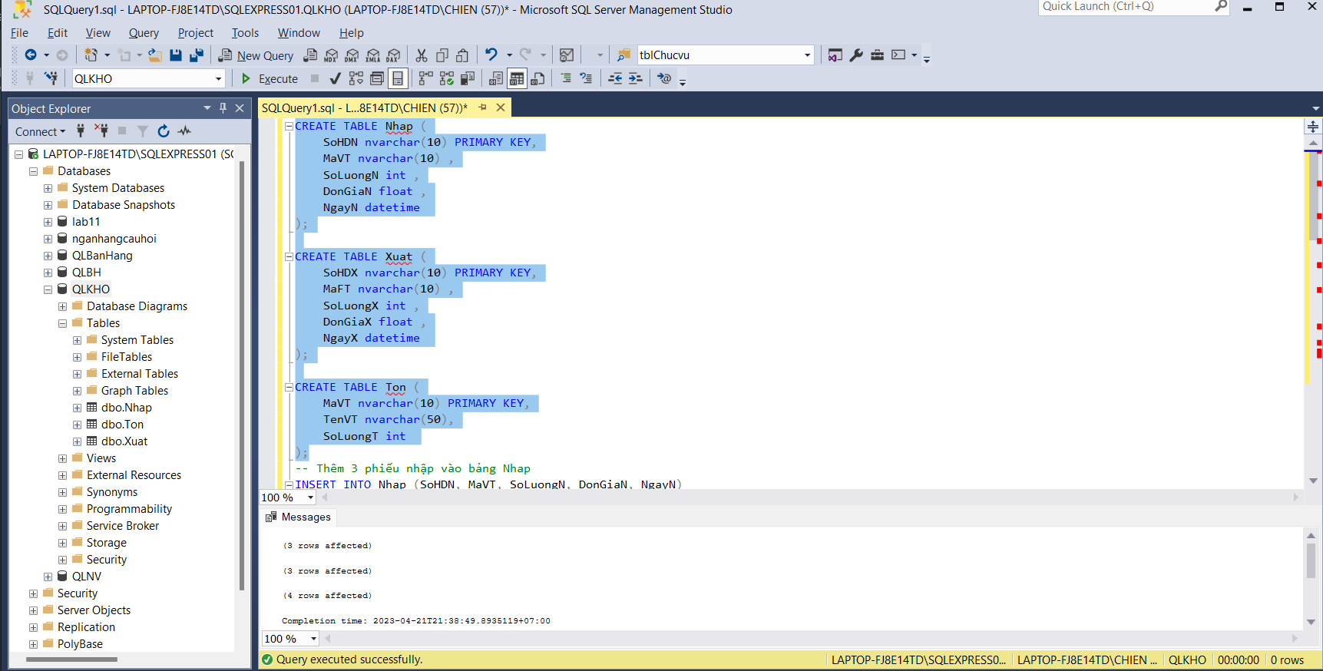

insert

Câu 2

Tạo function

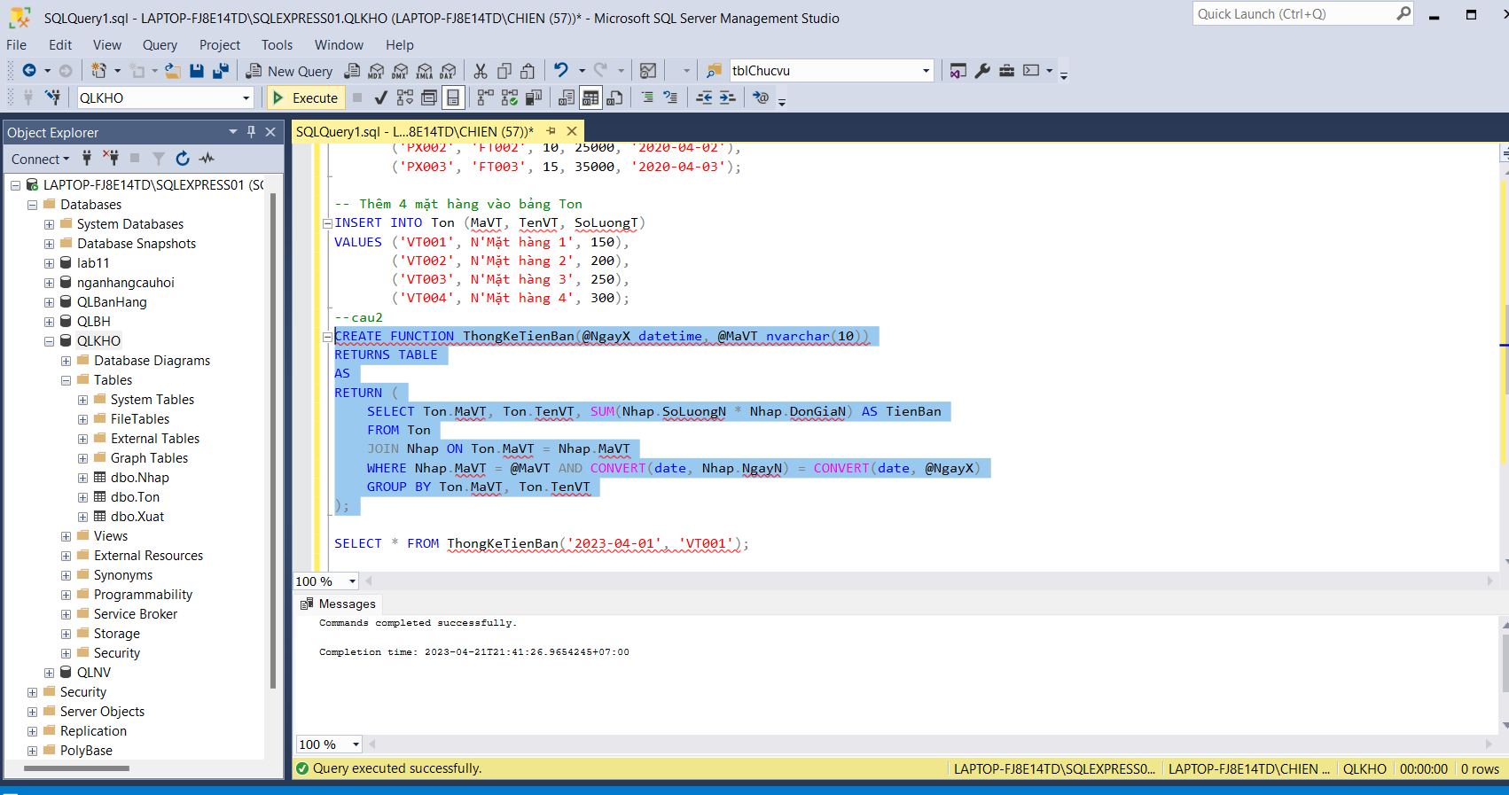

Select

Câu 3

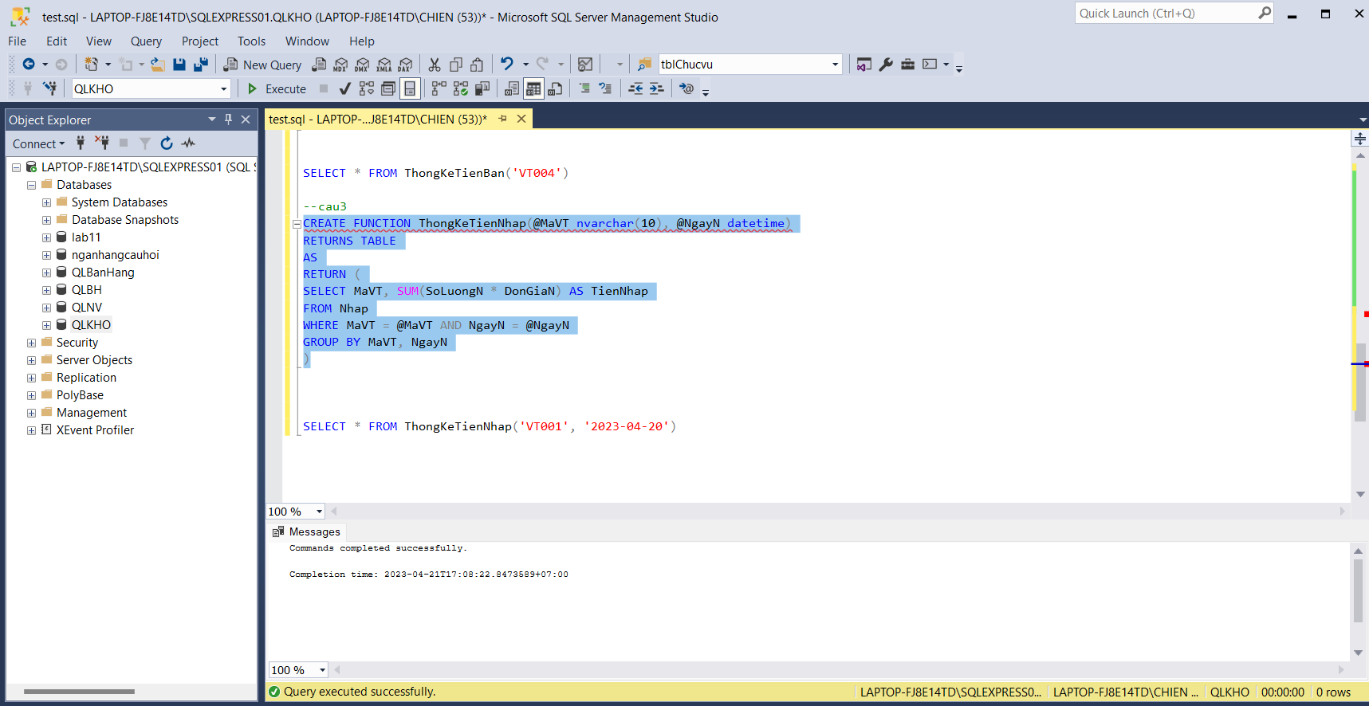

Câu 4

Tao trigger

Thuc thi

