Câu 1:

a.

INSERT INTO NhanVien (manv, tennv, gioitinh, diachi, sodt, email, phong)

VALUES

('NV04', N'Nguyen Van A', 'Nam', 'Ha Noi', '0987654321', 'nva@example.com', N'Kế Tóan')

BACKUP DATABASE QLBanHang TO DISK = 'C:\backup\QLBH.bak'

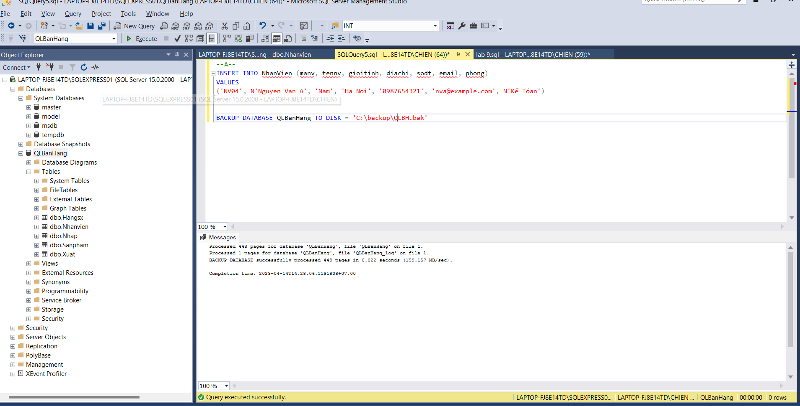

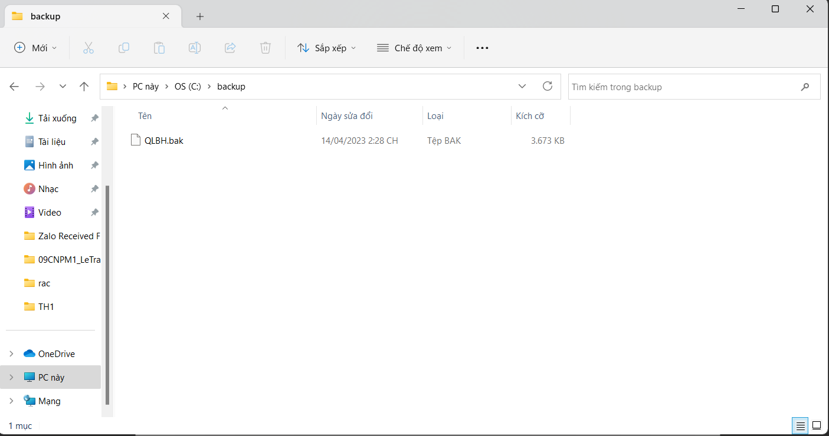

b.

INSERT INTO NhanVien (manv, tennv, gioitinh, diachi, sodt, email, phong)

VALUES

('NV05', N'Nguyen Van A', 'Nam', 'Ha Noi', '0987654321', 'nva@example.com', N'Văn Phòng')

BACKUP DATABASE QLBanHang TO DISK = 'C:\backup\QLBH.bak' with differential

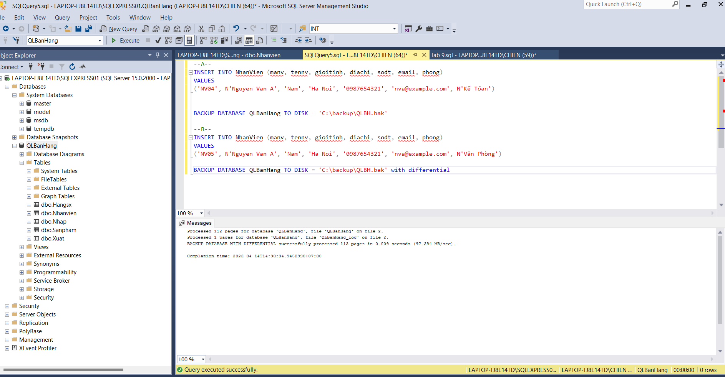

c.

ALTER DATABASE QLBanHang SET RECOVERY FULL

INSERT INTO NhanVien (manv, tennv, gioitinh, diachi, sodt, email, phong)

VALUES

('NV06', N'Nguyen Van A', 'Nam', 'Ha Noi', '0987654321', 'nva@example.com', N'Tài Chính')

Backup database QLBanHang To Disk = 'C:\backup\QLBH.bak';

BACKUP log QLBanHang

TO DISK = 'C:\backup\QLBH_log1.trn' ;

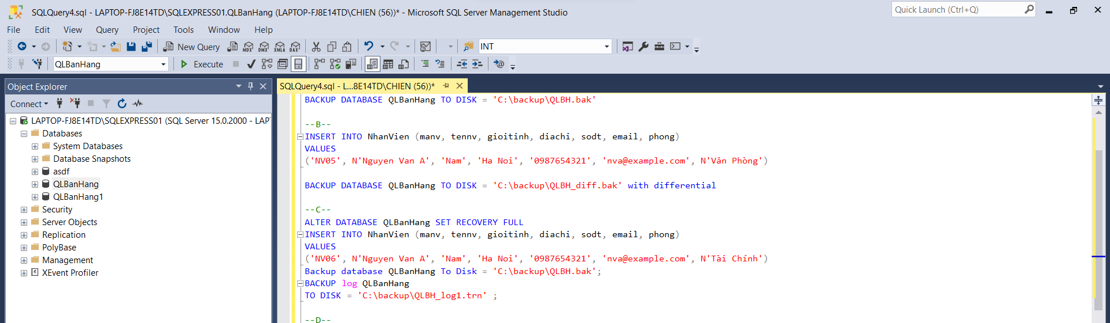

d.

INSERT INTO NhanVien (manv, tennv, gioitinh, diachi, sodt, email, phong)

VALUES

('NV07', N'Nguyen Van B', 'Nam', 'Ha Noi', '0987654321', 'nva@example.com', N'Tài Chính')

BACKUP log QLBanHang

TO DISK = 'C:\backup\QLBH_log1.trn' with init

Câu 2:

b.

restore database QLBanHang from disk ='C:\backup\QLBH.bak'

WITH STANDBY = 'C:\backup\QLBH_undoFile.undo';

