Câu 1:

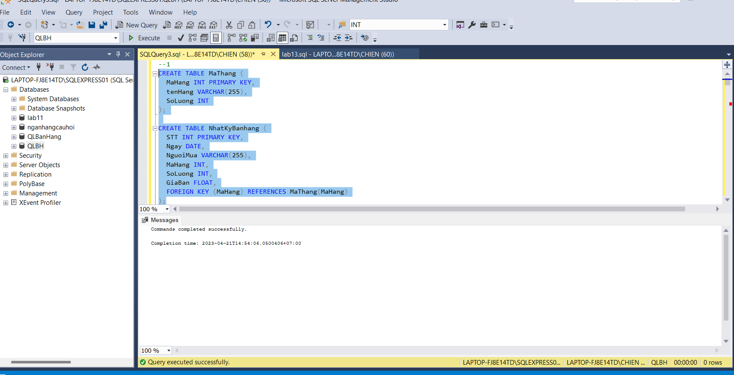

Câu 2:

Câu 3:

a.

b.

c.

d.

e.

f.

g.

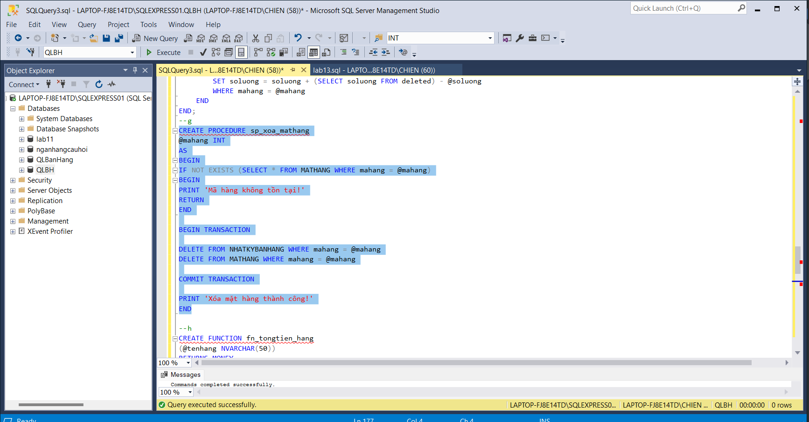

h.

i.

