
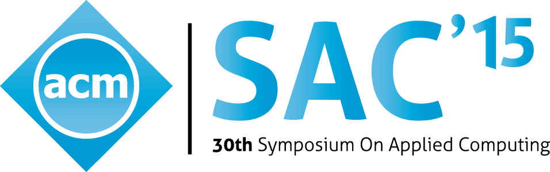

37th ACM/SIGAPP SAC
Symposium on Applied Computing
April 25 – April 29, 2022, Brno, Czech Republic
22ㄋ

Embedded Systems Track - Call for papers

Scope
High performance embedded computing has recently become more and more present in devices used in everyday life. A wide variety of applications, from consumer electronics to biomedical systems, require building powerful yet cheap embedded devices. In this context, embedded software is more and more complex, posing new challenges: the adoption of flexible programming paradigms/architectures is becoming almost mandatory. The development of embedded systems must rely on a tight coupling of hardware and software components and the market pressure calls for the employment of new methodologies for shortening the development time and driving the evolution of products. New efficient solutions to problems can be put into action by a joint effort of academia and industry.
Design of embedded systems must take into account a wide variety of constraints: performance, code size, power consumption, real-time constraints, maintainability, security and possibly scalability: convenient trade-offs must be found, often operating on a large number of parameters. In this scenario, solutions must be found at different levels of abstraction, making use of an assortment of tools and methodologies.
The focus of this conference track is on the application of both novel and well-known techniques to the embedded systems development. Particular attention is paid to solutions that require expertise in different fields (e.g. computer architecture, OS, compilers, security, software engineering, simulation). The track will benefit also from experiences in the employment of embedded devices in application areas. In this setting, researchers and practitioners from academia and industry will get a chance to keep in touch with problems, open issues and future directions in the field of development of embedded applications.
Paper submission and acceptance
Manuscripts must be submitted electronically in PDF format, according to the instructions contained in the main Conference web site. The review process is double blind. Please anonymize the paper submitted for review. The paper length is 8 pages, with the option to add 2 additional pages at extra charge, up to a maximum of 10 pages. Contributions must contain original unpublished work. Papers that have been concurrently submitted to other conferences or journals (double submissions) will be automatically rejected. All papers must be submitted through the SAC main conference web page.
Paper registration is required, allowing the inclusion of the paper/poster in the conference proceedings. An author or a proxy attending ACM SAC MUST present the paper: This is a requirement for the paper/poster to be included in the ACM/IEEE digital library. No-show of scheduled papers and posters will result in excluding them from the ACM/IEEE digital library.
Student Research Competition
Graduate students seeking feedback from the scientific community on their research ideas are invited to submit abstracts of their original unpublished and in-progress research work. Authors of selected abstracts will have the opportunity to give poster presentations of their work and compete for three top winning places. The winners will receive cash awards and SIGAPP recognition certificates. Graduate students are invited to submit abstracts (minimum 2; maximum 4 pages) following the instructions published at SAC web-site.

Topics of Interest (not limited to)
  - Embedded Systems, Cyberphysical Systems (CPS), and Internet-of-Things (IoT):
    - System-level specification, modeling, virtual prototyping and simulation
    - Embedded system synthesis and optimization
    - Many- and multi-core SoC architecture
    - HW/SW co-design, co-simulation and co-verification
    - Energy/power management design and energy harvesting
  - Embedded Software:
    - Kernel, middleware, and virtual machine
    - Energy-efficient embedded software
    - Real-time software and operating systems
    - Software design for multicores, GPUs, and heterogeneous embedded architectures
    - Testing, debugging, profiling and performance analysis of Embedded Systems
  - Memory Architecture and Near/In Memory Computing:
    - Storage system and memory architecture
    - On-chip memory architectures and management: Scratchpads, compiler, controlled memories, etc.
    - Memory and storage hierarchies with emerging memory technologies
    - Near-memory and in-memory computing
    - Memory architecture and management for emerging memory technologies
  - Neural Network and Deep Learning System Designs:
    - AI and machine learning for embedded systems
    - Hardware and devices for neuromorphic and neural network computing
    - Systems for neural computing (including deep neural networks)
    - Neural network acceleration co-design techniques
    - Design techniques for AI of Things

Dates
Submission deadline: October 15, 2021
Notification of acceptance: December 10, 2021
Deadline for final manuscript: December 21, 2021

30th SAC Symposium on Applied Computing
Web site
main:
https://www.sigapp.org/sac/sac2022/
EMBS track:
https://www.cs.ccu.edu.tw/~ccho/sac2022
Track chairs

Jalil Boukhobza - ENSTA-Bretagne, Lab-STICC lab
Hung-Wei Tseng - University of California, Riverside
Chien-Chung Ho - National Cheng Kung University

TPC members (tentative)
Luca Abeni
Università di Trento, Italy
Luis Almeida
Universidade do Porto, Portugal
Sandro Bartolini
Università di Siena, Italy
Joao Cardoso
Universidade do Porto, Portugal
Francisco J. Cazorla
IIIA-CSIC and Barcelona Supercomputing
Center, Spain
Li-Pin Chang
National Chiao Tung University, Taiwan
Tseng-Yi Chen
National Central University, Taiwan
Mingsong Chen
East China Normal University, China
Marco Di Natale
Scuola Superiore S. Anna, Italy
Emmanuel Grolleau
ENSMA, France
Zonghua Gu
Zhejiang University, China
Raphael Guerra
Universid. Federal Fluminense, Brasil
Frank Hannig
Friedrich-Alexander-Universität, Germany
Per Gunnar Kjeldsberg
NTNU, Norway
Chokri Mraidha
CEA List, France
Pierre Olivier
Manchester Univ, UK
Luigi Palopoli
The University of Manchester, UK
Roberto Passerone
Università di Trento, Italy
Keni Qiu
Capital Normal University, China
Christine Rochange
IRIT, France
Martin Schoeberl
Danmark Tekniske Universitet, Denmark
Liang Shi
East China Normal University, China
Ciprian TEODOROV
Lab-STICC, ENSTA Bretagne, France
Hiroyuki Tomiyama
Ritsumeikan University, Japan
Chia-Heng Tu
National Cheng Kung University, Taiwan
April 13 - 17, 2015 Salamanca, Spain

