

**Online Post Office**

**Management System**

|  |  |  |
| --- | --- | --- |
| **Supervisor:** | *TRUONG THANH TRUNG* | |
| **Semester:** | *III* | |
| **Batch No:** | *T1.2206.E1* | |
| **Group No:** | *4* | |
| **Order:** | **Full name** | **Roll No.** |
| *1.* | Pham Quoc Chien | Student1376109 |
| *2.* | Nguyen Phuong Hoa | Student1376108 |
| *3.* | Truong Ngoc Minh Cat | Student1376134 |
| *4.* | Truong Ngo Manh Dan | Student 1341546 |

***Month****: 09* ***Year****:2023*



This is to certify that.

|  |  |
| --- | --- |
| **Mr.** | **PHAM QUOC CHIEN** |
| **Ms.** | **NGUYEN PHUONG HOA** |
| **Mr.** | **TRUONG NGOC MINH CAT** |
| **Mr.** | **TRUONG NGO MANH DAN** |

Have successfully Designed & Developed

|  |  |  |
| --- | --- | --- |
|  |  |  |
| **ONLINE POST OFFICE MANAGEMENT SYSTEM** | | |

Submitted by:

|  |
| --- |
| **Mr. TRUONG THANH TRUNG** |

Date Of Issue:

|  |  |
| --- | --- |
|  | **26/09/2023** |

Authorized Signature:

|  |  |
| --- | --- |
|  |  |
| **Content** | | | |

Content

Acknowledge

Synopsis

Review1 1

Review2 10

Tasksheet 21

|  |
| --- |
| **Acknowledge** |

As we understand that the Project is a step-by- step learning environment that closely simulates the classroom and Lab based learning environment into actual implementation. It is a project implementation at your fingertips!! An electronic, live juncture on the machine that allows you to.

✓ Practice step by step i.e. laddered approach.

✓ Build a larger more robust application.

✓ Usage of certain utilities in applications designed by user.

✓ Single program to unified code leading to a complete application.

✓ Learn implementation of concepts in a phased manner.

✓ Enhance skills and add value.

✓ Work on real life projects.

✓ Give a real-life scenario and help to create applications more complicated and useful.

✓ Mentoring through email support.

We would like to send great thanks to our professor, Mr. Truong Thanh Trung and others student for the adorable support during the time in project. Besides several mistakes we had made in the project, we hope to have more opportunities to widen our knowledge in web-building world.

We also thank you so much for your information and the e-Project from India APTECH to help us get more reality experience in this project. Since we have gained more experience from this project, we will not stop learning anything as much as we can be more successful in the future.

Your Sincerely,

Team Group 4

|  |
| --- |
| **Synopsis** |

The Objective of this program we aim is to give a sample project to work on real.life projects. These applications help us build a larger more robust application.

The objective is not to teach us front-end or back-end technology but to provide us with a real-life scenario and help us create basic applications using the tools.

Hence, we can revise the chapters before we start with the project.This project is meant for students like us who have completed the module ofSemester III, as well as special subjects those are ASP.NET Core 6.0 and ASP.NET Web API. These programs should be done in the Lab sessions with assistance of the faculty if required.

The website (in this project) application is focused on the operation of post office management system of TARS Delivery and giving the best interface for customers so that they can use more services for sending parcels and money orders.

. It is very essential for us that will have a clear understanding of the subject. Wethink we should go through the project and solve the assignments as per requirements.given

**Review 01**

|  |
| --- |
| **Problem Definition** |

## Introduction

TARS Delivery System is a postal service with several branches in various locations that delivers mail using a variety of methods, including money orders, courier services, rapid post, regular post, and VPP. Mail delivery fees were previously determined by the desired service, the weight of the mail, and the distance.

Indeed, with advancement of the technology, numerous companies consisting of TARS would like to develop their own system management with modern tools such as website and mobile apps. TARS have a plan to direct their customers as well as employees to approach the online platform for saving time and using more features from their services.

## Problem Definition

Currently, TARS uses a stand-alone application that stores mail facts such as the delivery number, date of posting, weight, method of delivery selected, destination address, address of the person who posted it, contact information, and so on. The date of reception at the destination place office and the date of delivery to the destination address are recorded as soon as the packet or letter is received. Some of them (businesses, etc...) send many envelopes, couriers, and so on....

The online application included into the system so that the customer may check from his end when the packet or letter is delivered, as most packets or letters posted are primarily for business purposes, such as tenders, application forms, and so on..... Also, instead of maintaining different apps at each site, department personnel can utilize the same application (online) that performs all the responsibilities and tasks of the application that they are using. Giving the best platform for the customer and administrators.

|  |
| --- |
| **Customer Requirements Specifications** |

### 2.1 Functional Requirements

|  |  |  |  |
| --- | --- | --- | --- |
|  | **User** | **Admin** | **Employee** |
| **1.1. Login / Registered page** | R1: allow users to enter the page with registered account or can register new account to access the page. | R1: Login to account. | R1: Login to account. |
| **1.2. Profile page** | R1: Change the password.  R2: Allow to see personal information  R3: Personal information can be edited and updated | R1: Create employee account.  R1: View employee 's information. | R1: Change the password  R2: Allow to see personal information.  R3: Personal information can be edited and updated. |
| **1.3.Order page** | R1: Can see the details of the deliverables that he/she has sent through the Delivery number provided at the time of the submission.  R2: Can choose the services of order  R3: Can search the fee of orders | R1: Can see all user’s orders.  R2: Can update the fee of services  R3: Can update the details of services | R1: Can see and edit the details of the deliverables |
| **1.4. Shipping page** | R1: Can see details of the orders. | R1: Can see tracking history of all employees | R1: Can update the status of orders  R2: History-updates will be recorded |
| **1.5.Statistic page** | R1: Can view all of orders and calculations which are contained in the form of chart or table | R1: Can update the status of services or change the charge of all services |  |
| **1.5.Search page** | R1: Can look up the fee based on the pin codes, type of service, parcel weight  R2: Search the details of services | R1: Search the details of services | R1: Can look up the details of service charges, contact address based on the location, and the pin codes of the locations. |
| **1.6.Money Orders page** | R1: Visit Money Orders page.  R2: create of transferring money to receivers by create new orders and filling the digit which they would like to send as long as meeting the conditions. | R1: Update fee rate of money order service.  R2: See details of all transactions | R1: Update and notify the status of transactions. |
| **1.7. Sitemap** | R1: Can view the page sitemap. | R1: Can view the page sitemap. | None |
| **1.9. Contact us** | R1: Visit Contact Page.  R2: Can view contact information. | R1: Visit Contact Page.  R2: Can edit contact information. |  |

### 2.2. Non-functional Requirement Specifications

**- User-friendly**: The application should be easy to navigate with clear menus and other elements and easy to understand.

**- Operability**: The application should operate in a reliably efficient manner.

**- Performance**: The application should demonstrate high value of performance through speed and throughput. In simple terms, the application should be fast to load and page redirection should be smooth.

**- Scalability**: The application architecture and infrastructure should be designed to handle increasing user traffic, data storage, and feature expansions.

**- Security**: The application should implement adequate security measures such as authentication. For example, only registered users can access certain features.

### 2.3. System Requirement Specifications

2.**3.1 Server Requirement:**

* Hardware:
* Component CPU:
  + Processor type:
  + Pentium IV-compatible processor or faster
  + Processor speed: Recommended: 2.0 GHz or faster
* OS:
  + Microsoft Windows XP or higher with IIS
* Memory (RAM):
  + Minimum: 512MB
  + Recommended: 2GB or more
* Hard Drive:
  + Minimum: 200 MB
  + Recommended: 50 GB or more
  + Maximum: Operating system maximum
* Software:
* ASP.NET Core Version .NET Core 6.0
* RDBMS SQL Server

2.**3.2 Client requirements:**

* Hardware:
* Component CPU:
  + Processor type:
  + Pentium IV-compatible processor or faster
  + Processor speed: Recommended: 2.0 GHz or faster
* OS:
  + Microsoft Windows XP or MacOS …
* Memory (RAM):
  + Minimum: 512MB
  + Recommended: 2GB or more
* Hard Drive:
  + Minimum: 512MB
  + Recommended: 1 GB or more
* Software:
* Web Browser: Microsoft Edge, Mozilla Firefox, Chrome

2.**3.3 Development Software:**

* Microsoft SQL server Management Studio
* Microsoft Visual Studio 2022.
* Microsoft Visual Code

**2.3.4 Technology:**

* ASP.Net Core 6.0

Entity Framework Core 6.0.7

**Review 02**

|  |
| --- |
| **Architecture & Design of the Project** |

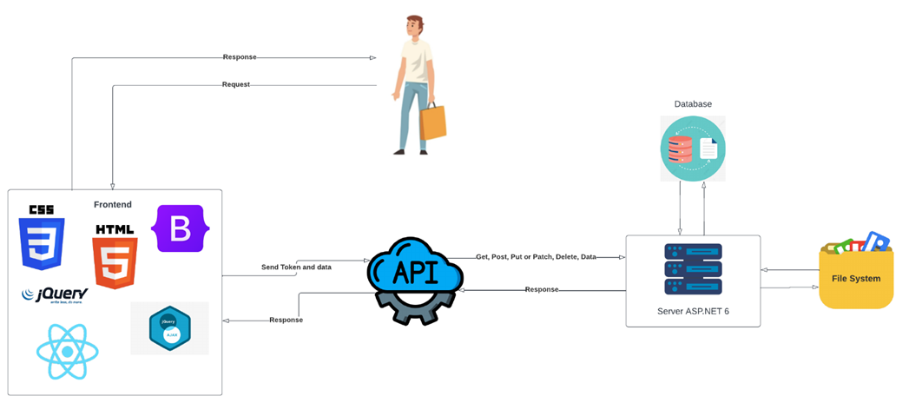

## .Presentation Tier

* + - 1. This is the tier in which the users interact with applications. Presentation Tier contains Model, View, Controller used to receive a request and response to User.
      2. Technology: ASP.NET CORE 6 WEB API MVC, HTML, CSS, JS

## 2.Business Logic Tier

* + - 1. Is mainly working as the bridge between Data Tier and Presentation Tier. All the Data passes through the Business Tier before passing to the Presentation Tier.
      2. Technology: ASP.NET CORE API

## 3.Data Access Tier

* + - 1. This is basically the server which stores all the application’s data. Data tier contents Database Tables, Database Views and other means of storing Application’s data.
      2. Technology: SQL Server

|  |
| --- |
| **Entity Relationship Diagram** |

|  |
| --- |
| **Algorithms – Data Flow Diagram** |

## 2.Logout (all users)

## 3.Profile:

## 4. Parcel Order:

## 5. Money Order:

## 6. Search Pin code:

|  |
| --- |
| **Use Case Diagram** |

## 1. User:

## 2. Admin:

|  |
| --- |
| **SiteMap** |

|  |  |  |  |  |  |  |
| --- | --- | --- | --- | --- | --- | --- |
| **Project Title:**  Online Post Office System | | **Activity Plan**  **Prepared**  **By:** | **Date of Preparation of Activity Plan:** | | | |
| **Sr. No.** | **Task** | **Actual Start**  **Date** | **Actual**  **Days** | **Team**  **Mate**  **Names** | **Status** |
| 1 | Introduce | Pham Quoc Chien | 26 Sep 2023 | 1 | All members | Completed |
| 2 | Problem Definition | 26 Sep 2023 | 1 | All members | Completed |
| 3 | Requirement & Non-functional requirement | 26 Sep 2023 | 1 | All members | Completed |
| 4 | Process Analyst & Task sheet review | 26 Sep 2023 | 1 | All members | Completed |