 

|  |
| --- |
| **FPT-aptech computer education** |
| eProject Document |
| [RECRUITMENT PROCESS SYSTEM] |
|  |
| |  |  | | --- | --- | | **FAT 1 – C1007L – SEM3 – GROUP 6** | | | **Group Member** | Vũ Hoàng Chiến - 4525 | | **Instructor** | Nguyễn Tuân | | **Batch** |  | | **Semester** | SEM 3 | |
|  |

|  |
| --- |
| - Hanoi .10/ 06/2013 - |

# Introduction

*The thirst for learning, upgrading technical skills and applying the concepts in real*

*life environment at a fast pace is what the industry demands from IT professionals*

*today. However busy work schedules, far-flung locations, and unavailability of*

*convenient time-slots pose as major barriers when it comes to applying the concepts*

*into realism. And hence the need to look out for alternative means of*

*implementation in the form of laddered approach.*

*The above truly pose as constraints especially for our students too! With their busy*

*schedules, it is indeed difficult for our students to keep up with the genuine and*

*constant need for integrated application which can be seen live especially so in the*

*field of IT education where technology can change on the spur of a moment. Well,*

*technology does come to our rescue at such times!!*

*Keeping the above in mind and in tune with our constant endeavour to use*

*Technology in our training model, we at Aptech have thought of revolutionizing the*

*way our students learn and implement the concepts using tools themselves by*

*providing a live and synchronous eProject learning environment!*

# Problem Definition

## Problem Abstraction

This project is aimed at developing a web-based and central Recruitment Process System for the HR Group for a company (Mango bussiness). Some features of this system will be creating vacancies, storing Applicants data, Interview process initiation, Scheduling Interviews, Storing Interview results for the applicant and finally Hiring of the applicant. Reports may be required to be generated for the use of HR group.

## The Current System

*Life today to solve the problem of information job and virtual job seeker. Recruitment system We create thorough evaluation of the information security job postings and candidate personal information need not "hunt" candidates introduced earlier for other employers without permission...*

## The Proposed System

• In recent years, the issue of data security and information management effectively before 'whirlwind' internet and the risk of leakage of confidential information outside society is very focused company. The recruitment of personnel responsible for the management of information and now is the time when the most powerful field development.

• A successful recruitment system must meet: Privacy and reduce recruitment costs.

• Development of a web-based Recruitment Process System for the HR group for a company

## Boundaries of the System

To meet the needs of customers, the group has set requirements for the is to build a system so complete. Currently the program offers features to users as follows:

* **Deploy:**
  + Attach database
  + Deploy system
* **Login:**
  + User Name
  + Password
* **HR group:**
  + View, Create, edit, delete vacancy
  + View, Create, edit, delete applicant
  + Search
  + Attach Applicant to Vacancy
  + Schedule or remove interview
* **Interviewer:**
  + View scheduled, applicant, vacancy
  + Change scheduled
  + Update result for interview

## Development Environment

1. Minimum requirements

|  |
| --- |
| *Minimum requirements* |
| PC Pentium III |
| 128 MB RAM |
| 1 GB Hard Drive |

1. Recommended requirements

|  |
| --- |
| Recommended requirements |
| PC Pentium III 1800 MHz |
| 2G RAM |
| 2 GB hard drive |

1. *Software*
   * *ASP.NET 4.0*
   * *Visual studio 2012*
   * *IIS 7*
   * *MS SQL Server 2012*
   * *Window 7 or window 8*
   * *Telerik Q1 2013*

# Requirements and Business Flow

## Customer Requirement Specification

## 

**Applicant:**

* View home page
* Register & Login to website
* Edit individual information
* Look for and view a recruitment vacancy
* Apply for a vacancy

**Admin:**

* View and edit individual information
* Add HR and interview
* Reset password of HR and interview
* Search HR, interview
* View recruited applicant for a vacancy

**HR:**

* View applicant for a position
* Change applicant status
* Create/ delete interview schedule
* Create/ edit recruitment vacancy
* Look for applicant
* Look for recruitment vacancy

**Interviewer:**

* View applicant for a vacancy
* View/edit individual information
* View recruitment vacancy
* View applicant information
* Change the status of interview schedule
* Create interview schedule and result
* Make proposal of changing interview schedule
* Create/ edit recruitment vacancy
* Look for applicant, recruitment vacancy

## Activity Diagram

+ Activity diagram “Applicant apply cv to system” 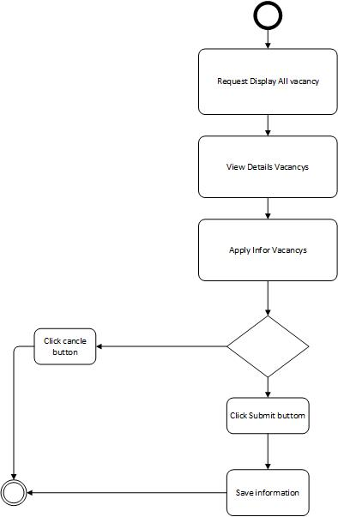

+ Activity diagram “Manager vacancys” 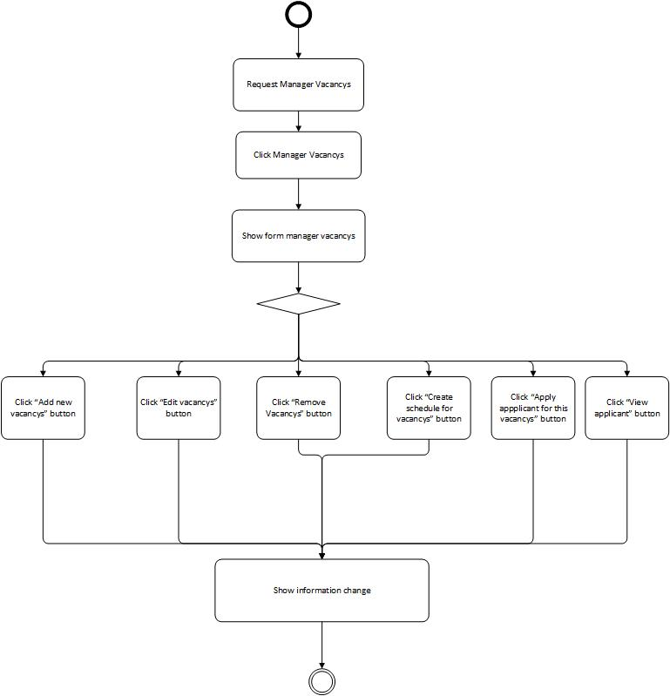

+ Activity diagram “Add new vacancys” 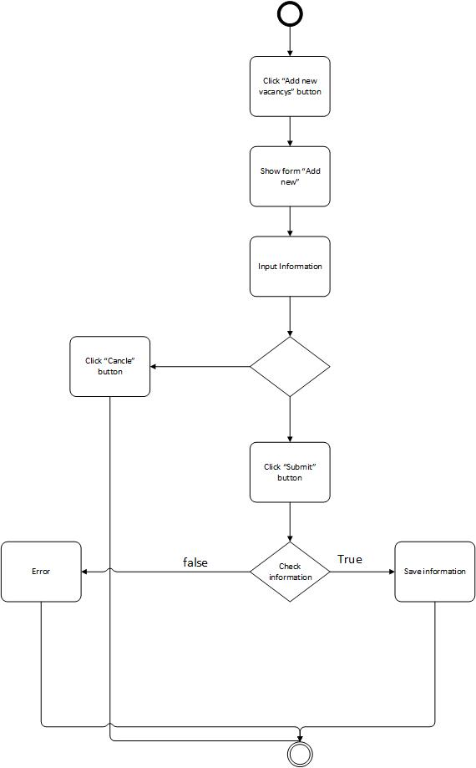

+ Activity diagram “Edit new vacancys” 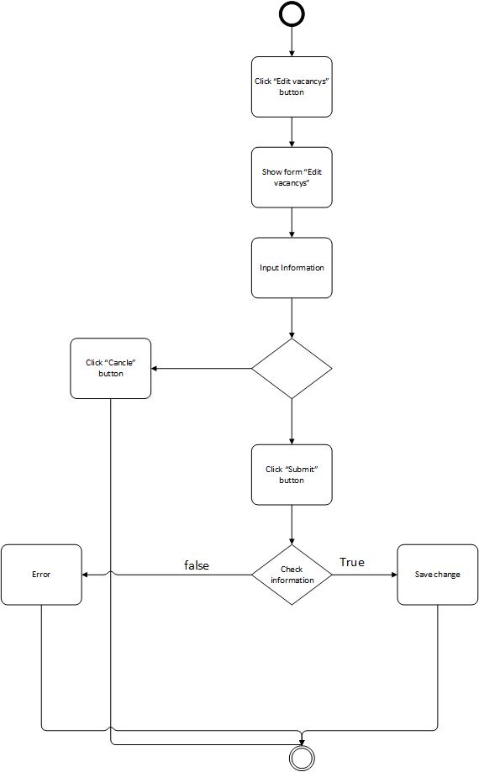

+ Activity diagram “Remove vacancys”

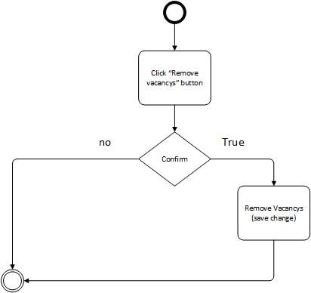

+ Activity diagram “Create schedule for vacancys” 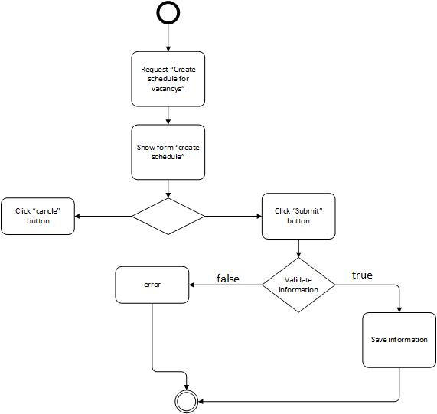

+ Activity diagram “Apply applicant to vacancy”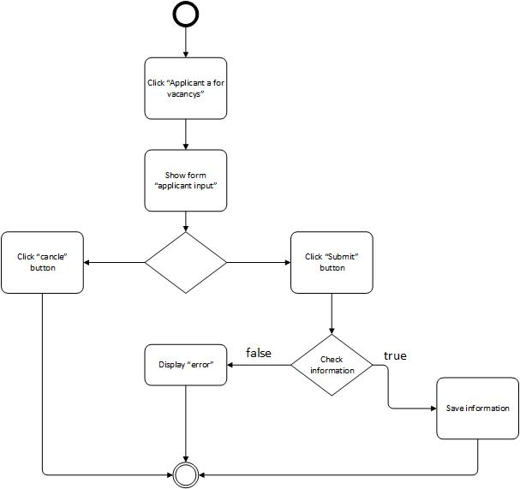

+ Activity diagram “View Applicant”

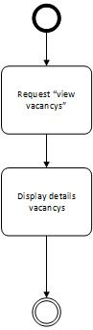

+ Activity diagram “View Schedule interview”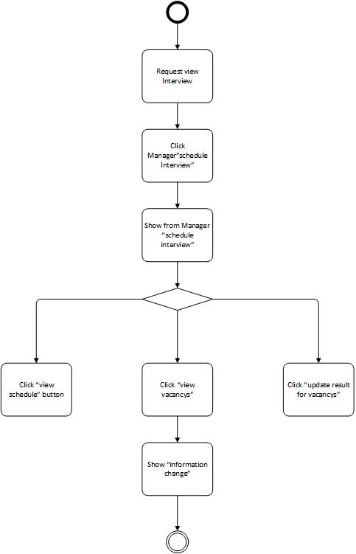

+ Activity diagram “View Schedule”

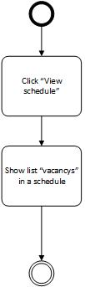

+ Activity diagram “View Schedule details”

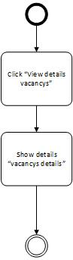

+ Activity diagram “Update result for vacancys”

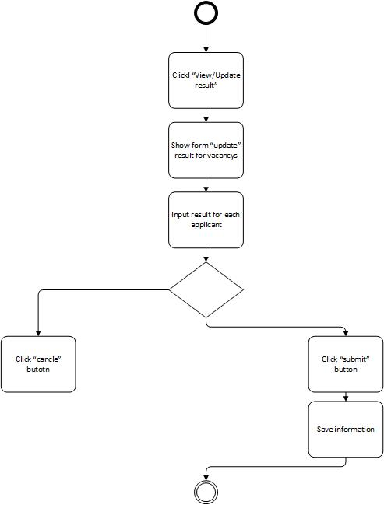

## Use Case Diagram

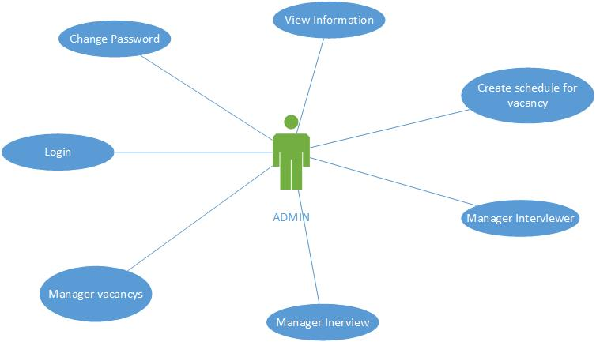

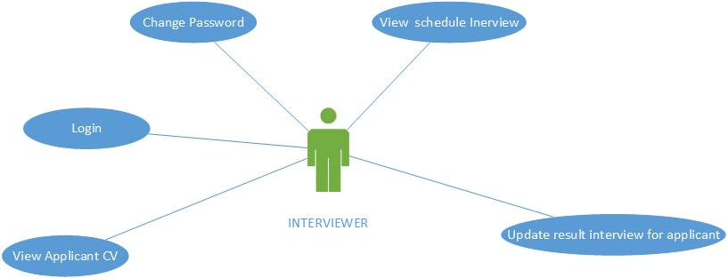

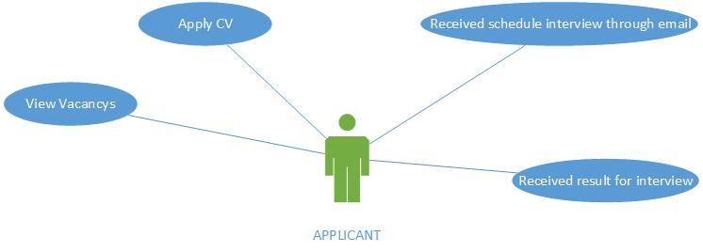

## Use Case Specification

|  |  |  |  |  |
| --- | --- | --- | --- | --- |
| **USE CASE SPECIFICATION** | | | | |
| **Use-case No.** | UC001 | **Use-case Version** | | 1.0 |
| **Use-case Name** | Applicant apply cv to system | | | |
| **Author** | chienvh | | | |
| **Date** | 18/05/2013 | **Priority** | Hight | |
| **Actor:**  Applicant  **Summary:**   * *Use case allows applicant apply cv to system*   **Goal:**  **Triggers**  **Preconditions:**  **Post Conditions:**  **Main Success Scenario:**   * *Applicant find any vacancy on website* * *Applicant cv. Input all information for apply* * *Received schedule interview through email provider*     **Alternative Scenario:**  **Exceptions:**  **Relationships:**  **Business Rules:** | | | | |

|  |  |  |  |  |
| --- | --- | --- | --- | --- |
| **USE CASE SPECIFICATION** | | | | |
| **Use-case No.** | UC002 | **Use-case Version** | | 1.0 |
| **Use-case Name** | Manager vacancy | | | |
| **Author** | chienvh | | | |
| **Date** | 18/05/2013 | **Priority** | Hight | |
| **Actor:**  Admin  **Summary:**   * *Use case allows the admin Manager vacancy:* * *This module will show all vacancy and display number applicant apply to each vacancy. This will show 2 information*   + *Number with background yellow is “pending” confirm*   + *Number with background blue is “has confirm”* * *That will show all number applicant. Include applicant pending and applicant has confirm* * *All feature in this module like*   + *Add new vacancy*   + *Edit vacancy*   + *Remove vacancy*   + *Create schedule for vacancy*   + *Apply applicant to vacancy*   + *View applicant*   **Triggers**  **Preconditions:**   * *The actor must be logged into system before this use case begins.*   **Post Conditions:**  **Main Success Scenario:**   * *Display all vacancy and all action for each vacancy record*   **Alternative Scenario:**  **Exceptions:**  **Relationships:**  **Business Rules:** | | | | |
|  | | | | |

|  |  |  |  |  |
| --- | --- | --- | --- | --- |
| **USE CASE SPECIFICATION** | | | | |
| **Use-case No.** | UC003 | **Use-case Version** | | 1.0 |
| **Use-case Name** | Add new vacancy | | | |
| **Author** | chienvh | | | |
| **Date** | 18/05/2013 | **Priority** | Normal | |
| **Actor:**  admin  **Summary:**   * *Use case allows the admin add new vacancy*   **Goal:**  **Triggers**  **Preconditions:**   * *The actor must be logged into system before this use case begins*   **Post Conditions:**  **Main Success Scenario:**   * *Create new vacancy*   **Alternative Scenario:**  **Exceptions:**  **Relationships:**  **Business Rules:** | | | | |

|  |  |  |  |  |
| --- | --- | --- | --- | --- |
| **USE CASE SPECIFICATION** | | | | |
| **Use-case No.** | UC004 | **Use-case Version** | | 1.0 |
| **Use-case Name** | Edit vacancy | | | |
| **Author** | chienvh | | | |
| **Date** | 20/05/2013 | **Priority** | Normal | |
| **Actor:**  admin  **Summary:**   * *Use case allows the admin edit vacancy* * *Eg. Edit name and details vacancy or description*   **Goal:**  **Triggers**  **Preconditions:**   * *The actor must be logged into system before this use case begins.*   **Post Conditions:**  **Main Success Scenario:**   * *Edit new vacancy*   **Alternative Scenario:**  **Exceptions:**  **Relationships:**  **Business Rules:** | | | | |

|  |  |  |  |  |
| --- | --- | --- | --- | --- |
| **USE CASE SPECIFICATION** | | | | |
| **Use-case No.** | UC005 | **Use-case Version** | | 1.0 |
| **Use-case Name** | Remove vacancy | | | |
| **Author** | chienvh | | | |
| **Date** | 20/05/2013 | **Priority** | Normal | |
| **Actor:**  admin  **Summary:**   * *Will be show confirm for delete this vacancy* * *Use case allows the admin remove vacancy*   **Goal:**  **Triggers**  **Preconditions:**   * *The actor must be logged into system before this use case begins.*   **Post Conditions:**  **Main Success Scenario:**   * *Remove vacancy*   **Alternative Scenario:**  **Exceptions:**  **Relationships:**  **Business Rules:** | | | | |

|  |  |  |  |  |
| --- | --- | --- | --- | --- |
| **USE CASE SPECIFICATION** | | | | |
| **Use-case No.** | UC006 | **Use-case Version** | | 1.0 |
| **Use-case Name** | Create Schedule for vacancy | | | |
| **Author** | chienvh | | | |
| **Date** | 25/05/2013 | **Priority** | Hight | |
| **Actor:**  admin  **Summary:**   * *Use case allows the admin create schedule* * *Set date and time for schedule* * *Send email to all applicant apply to system*   **Goal:**  **Triggers**  **Preconditions:**   * *The actor must be logged into system before this use case begins.*   **Post Conditions:**  **Main Success Scenario:**   * *Create schedule for vacancy* * *Display to frontend site*   **Alternative Scenario:**  **Exceptions:**  **Relationships:**  **Business Rules:** | | | | |

|  |  |  |  |  |
| --- | --- | --- | --- | --- |
| **USE CASE SPECIFICATION** | | | | |
| **Use-case No.** | UC007 | **Use-case Version** | | 1.0 |
| **Use-case Name** | Apptach an applicant to vacancy | | | |
| **Author** | chienvh | | | |
| **Date** | 29/05/2013 | **Priority** | Normal | |
| **Actor:**  admin  **Summary:**   * *Use case allows the create a new applicant apply to vacancy*   **Goal:**  **Triggers**  **Preconditions:**   * *The actor must be logged into system before this use case begins.*   **Post Conditions:**  **Main Success Scenario:**   * *Attach success applicant to vacancy*   **Alternative Scenario:**  **Exceptions:**  **Relationships:**  **Business Rules:** | | | | |

|  |  |  |  |  |
| --- | --- | --- | --- | --- |
| **USE CASE SPECIFICATION** | | | | |
| **Use-case No.** | UC008 | **Use-case Version** | | 1.0 |
| **Use-case Name** | View applicant from vacancy module | | | |
| **Author** | chienvh | | | |
| **Date** | 25/05/2013 | **Priority** | Normal | |
| **Actor:**  admin  **Summary:**   * *Use case allows the admin view applicant* * *This module will show number applicant has confirm and number applicant pending wait to confirm.*   **Goal:**  **Triggers**  **Preconditions:**   * *The actor must be logged into system before this use case begins.*   **Post Conditions:**  **Main Success Scenario:**   * *View and must be confirm the applicant “not confirm” status* * *View details a vacancy*   **Alternative Scenario:**  **Exceptions:**  **Relationships:**  **Business Rules:** | | | | |

|  |  |  |  |  |
| --- | --- | --- | --- | --- |
| **USE CASE SPECIFICATION** | | | | |
| **Use-case No.** | UC009 | **Use-case Version** | | 1.0 |
| **Use-case Name** | View schedule | | | |
| **Author** | chienvh | | | |
| **Date** | 23/05/2013 | **Priority** | Normal | |
| **Actor:**  admin  **Summary:**   * *This feature will show all vacancy in an schedule like “name vacancy”, ”date end”,” number applicant apply to vacancy”*   **Goal:**  **Triggers**  **Preconditions:**   * *The actor must be logged into system before this use case begins.*   **Post Conditions:**  **Main Success Scenario:**   * *View all vacancy current in an schedule*   **Alternative Scenario:**  **Exceptions:**  **Relationships:**  **Business Rules:** | | | | |

|  |  |  |  |  |
| --- | --- | --- | --- | --- |
| **USE CASE SPECIFICATION** | | | | |
| **Use-case No.** | UC010 | **Use-case Version** | | 1.0 |
| **Use-case Name** | View Details vacancy with schedule | | | |
| **Author** | chienvh | | | |
| **Date** | 25/05/2013 | **Priority** | Normal | |
| **Actor:**  admin  **Summary:**   * *Use case allows the admin View details a vacancy in a schedule current*   **Goal:**  **Triggers**  **Preconditions:**   * *The actor must be logged into system before this use case begins.*   **Post Conditions:**  **Main Success Scenario:**   * *View details vacancy with schedule Id*   **Alternative Scenario:**  **Exceptions:**  **Relationships:**  **Business Rules:** | | | | |

|  |  |  |  |  |
| --- | --- | --- | --- | --- |
|  | | | | |
|  |  |  | |  |
|  |  | | | |
|  |  | | | |
|  |  |  |  | |
|  | | | | |

|  |  |  |  |  |
| --- | --- | --- | --- | --- |
| **USE CASE SPECIFICATION** | | | | |
| **Use-case No.** | UC011 | **Use-case Version** | | 1.0 |
| **Use-case Name** | Update result for a vacancy has interview | | | |
| **Author** | chienvh | | | |
| **Date** | 18/05/2013 | **Priority** | Normal | |
| **Actor:**  admin  **Summary:**   * *Use case allows the admin result all applicant in a vacancy* * *Update result for each applicant result as ”Good”,”Normal”,”Bad”*   **Goal:**  **Triggers**  **Preconditions:**   * *The actor must be logged into system before this use case begins.*   **Post Conditions:**  **Main Success Scenario:**   * *Update result all applicant in a vacancy*   **Alternative Scenario:**  **Exceptions:**  **Relationships:**  **Business Rules:** | | | | |

## Other Concerns<Optional>

# Design

## System Architecture

* Admin table

|  |  |  |  |  |
| --- | --- | --- | --- | --- |
| **No** | **Field Name** | **Data Type** | **Constraint** | **Description** |
| 1 | Admin_Id | Int | PK, auto increment, Not null |  |
| 2 | Admin_FullName | Nvarchar(50) |  |  |
| 3 | Admin_Account | Nvarchar(50) |  |  |
| 4 | Admin_Password | Nvarchar(50) |  |  |
| 5 | Admin_Role | Nvarchar(10) |  |  |
| 6 | Admin_Status | bit |  |  |

* Applicant table

|  |  |  |  |  |
| --- | --- | --- | --- | --- |
| **No** | **Field Name** | **Data Type** | **Constraint** | **Description** |
| 1 | Applicant_Id | Int | PK, auto increment, Not null |  |
| 2 | Vacancy_Id | Int | FK with Vacancy table |  |
| 3 | Applicant_FullName | Nvarchar(50) |  |  |
| 4 | Applicant_Email | Nvarchar(50) |  |  |
| 5 | Skill | Ntext |  |  |
| 6 | PositionApply | Nvarchar(50) |  |  |
| 7 | Cetificate | Ntext |  |  |
| 8 | SuggestSalary | Ntext |  |  |
| 9 | Applicant_Address | Nvarchar(50) |  |  |
| 10 | Applicant_IP | Nvarchar(50) |  |  |
| 11 | Applicant_Description | Ntext |  |  |
| 12 | Applicant_DateRegister | Nvarchar(50) |  |  |
| 13 | Applicant_Admin_Accept | Nchar(10) |  |  |
| 14 | Applicant_Result | Nchar(10) |  |  |
| 15 | Applicant_Client_Confirm | Nchar(10) |  |  |

* Interview table

|  |  |  |  |  |
| --- | --- | --- | --- | --- |
| **No** | **Field Name** | **Data Type** | **Constraint** | **Description** |
| 1 | Interviewer_Id | Int | PK, auto increment, Not null |  |
| 2 | Schedule_Id | Int | FK with Schedule table |  |
| 3 | Interviewer_Result | Nvarchar(50) |  |  |
| 4 | Interviewer_Note | Ntext |  |  |

* Schedule table

|  |  |  |  |  |
| --- | --- | --- | --- | --- |
| **No** | **Field Name** | **Data Type** | **Constraint** | **Description** |
| 1 | Schedule_Id | Int | PK, auto increment, Not null |  |
| 2 | DateTime_Create | Nvarchar(50) |  |  |
| 3 | Schedule_Date | Nvarchar(50) |  |  |

* Vacancys table

|  |  |  |  |  |
| --- | --- | --- | --- | --- |
| **No** | **Field Name** | **Data Type** | **Constraint** | **Description** |
| 1 | Vacancy_Id | Int | PK, auto increment, Not null |  |
| 2 | Schedule_Id | Int | FK with schedule table |  |
| 3 | Vacancys_WorkAddress | Nvarchar(200) |  |  |
| 4 | Vacancy_TypeTime | Nchar(10) |  |  |
| 5 | Vacancy_Salary | Nvachar(50) |  |  |
| 6 | Vacancy_Position | Nvarchar(50) |  |  |
| 7 | Vacancy_Numberpeople | Int |  |  |
| 8 | Vacancy_Skill | Nvarchar(200) |  |  |
| 9 | Vacancys_Exp | Nvarchar(50) |  |  |
| 10 | Vacancy_Gender | Nvarchar(50) |  |  |
| 11 | Vacancy_Age | Nvarchar(50) |  |  |
| 12 | Vacancys_Description | Ntext |  |  |
| 13 | Vacancy_DateStart | Nvarchar(50) |  |  |
| 14 | Vacancy_DateEnd | Nvarchar(50) |  |  |
| 15 | Vacancy_DateUp | Nvarchar(50) |  |  |
| 16 | Vacancy_DateInterViewer | Nvarchar(50) |  |  |
| 17 | Vacancy_TimeInterViewer | Nvarchar(50) |  |  |
| 18 | Vacancy_Status | Nvarchar(50) |  |  |
| 19 | Admin_Id | Int | FK with Admin table |  |

## Class Diagram

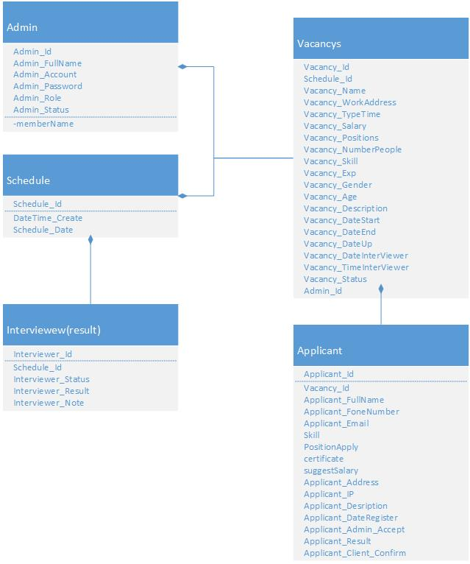

## Class Diagram Explanation

## Sequence Diagram (Optional)

## Collaboration Diagram (Optional)

## State Diagram (Optional)

## Entity Relationship Diagram

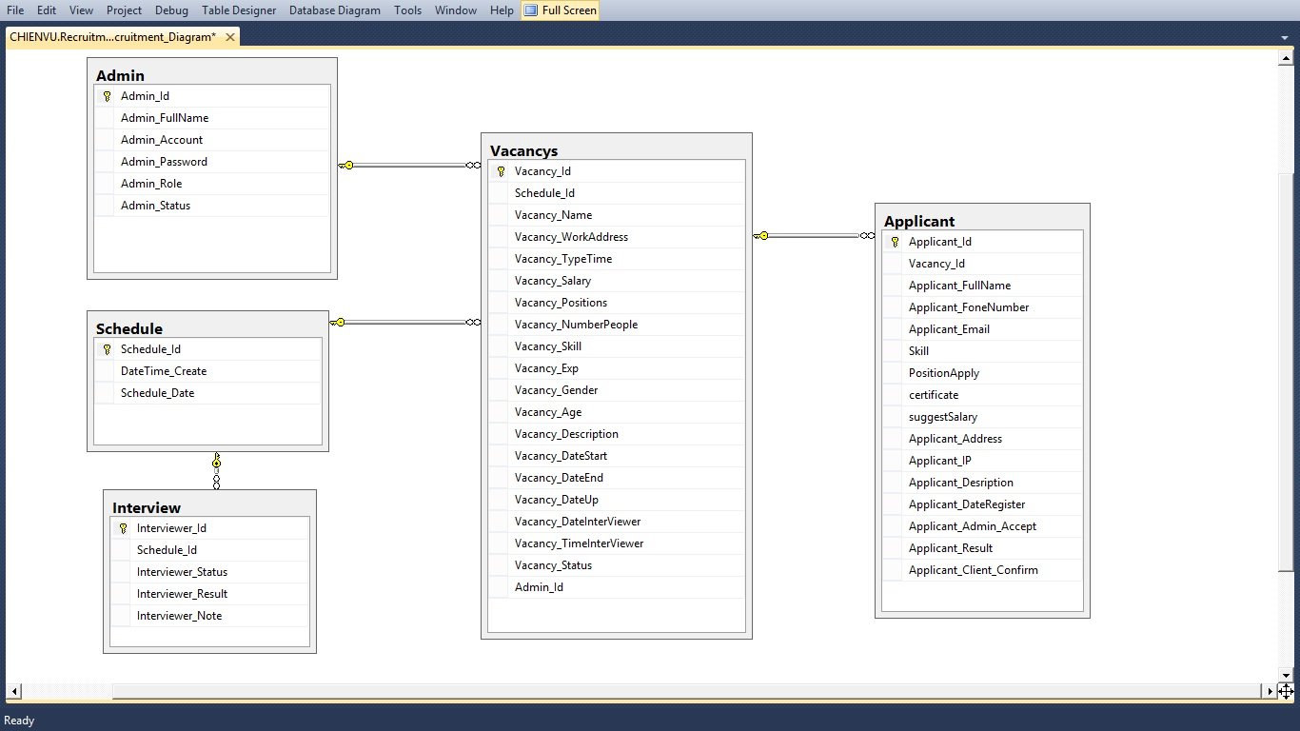

## Database Design

* Admin table

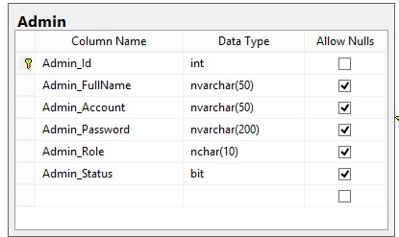

* Schedule table

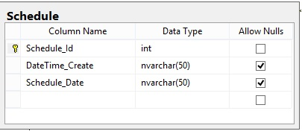

* Interview table

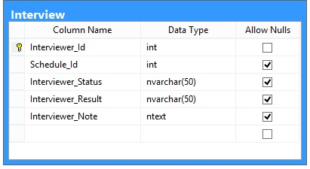

* Vacancys table

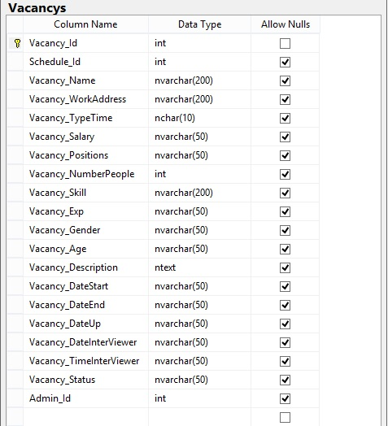

* Applicant table

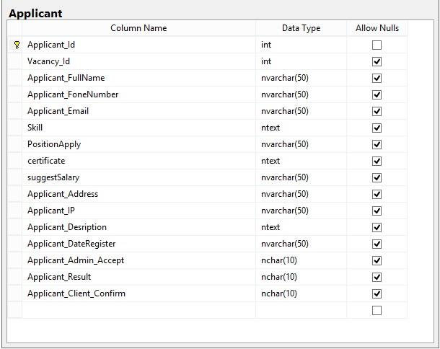

## Algorithms (optional)

## Others (optional)

# System Prototype

# Management and Project Planning

## Management Approach

Our team is half self-managed and half managed by one leader. We plan to become Scrum team. Therefore, we still need one leader to observer the overall project process. The assign task process is self-managed. Each member in Scrum team takes the appropriate task that suitable for him. We plan to do the meeting every day. 4 hours per day. 15 minutes of summarize what each member did, didn’t last meeting and what are they going to do.

## Project Plan

|  |  |  |
| --- | --- | --- |
| **Product Backlog Item** | **Sprint task** | **priority** |
| Design database | Analysis and design database | Hight |
| Manager Interview Module | * + Display all schedule with day   + View all vacancy in a schedule and status   + Update interview result for each vacancy | Hight |
| Manager Vacancy Module | * + Add new vacancy   + Manager number applicant with vacancy   + View details applicant   + Confirm or not applicant   + Add new applicant to any vacancy   + Create schedule for a vacancy   + Edit and remove vacancy | Hight |
| Interviewer module | * + Display schedule interview with user interviewer | Normal |
| Login | * + Login to system | Low |
| Applicant Module site | * + Display all vacancy current   + Apply to any vacancy current   + Received email schedule interview with email and information provider | Hight |

## Task Sheet

|  |  |  |
| --- | --- | --- |
| **Task** | **Member** | **Percent of complete** |
| *Backend and Frontend Design masterpage template* | Chienvu | 100% |
| Backend Module “Manager Vacancys” | Chienvu | 100% |
| Backend Module “Manager Interview” | Chienvu | 100% |
| Frontend site display all vacancys | Chienvu | 100% |
| Frontend site apply cv to vacancys | Chienvu | 100% |
| Reviced schedule interview through email provider | Chienvu | 100% |
|  |  |  |

## Meeting Minutes (Optional)

# Checklists

## Check List of Validation

|  |  |
| --- | --- |
| **Option** | **Validate** |
| *Can applicant recruitment?* |  |
| Can applicant received schedule through email? |  |
| Can interviewer view schedule respective ? |  |
| Can interviewer update result for vacancys? |  |
| Can admin add new vacancys and create new schedule? |  |
| Can interviewer add new vacancys and create new schedule? |  |
|  |  |

## Submission Checklist

|  |  |
| --- | --- |
| **Option** | **Validate** |
| *Can applicant recruitment?* | yes |
| Can applicant received schedule through email? | yes |
| Can interviewer view schedule respective ? | yes |
| Can interviewer update result for vacancys? | yes |
| Can admin add new vacancys and create new schedule? | yes |
| Can interviewer add new vacancys and create new schedule? | no |
|  |  |

# Screenshots

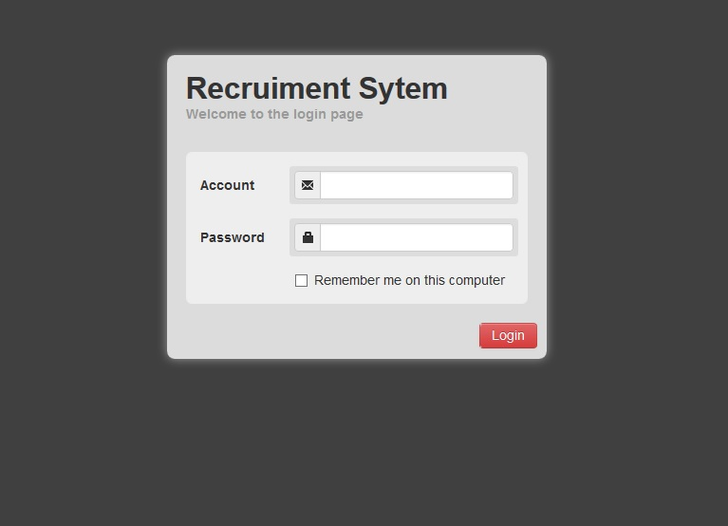

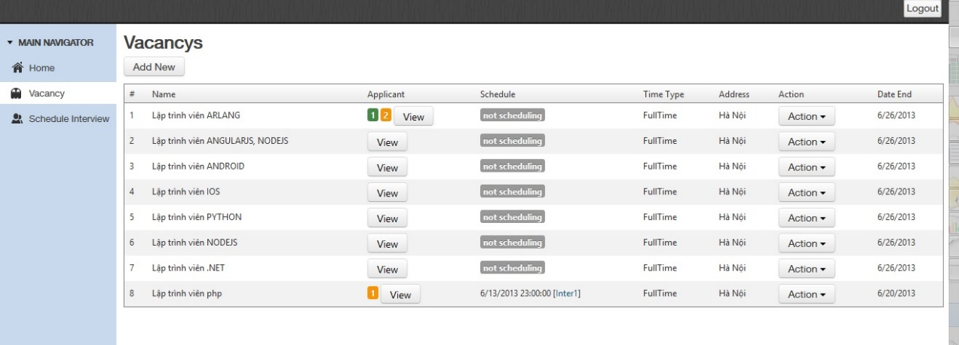

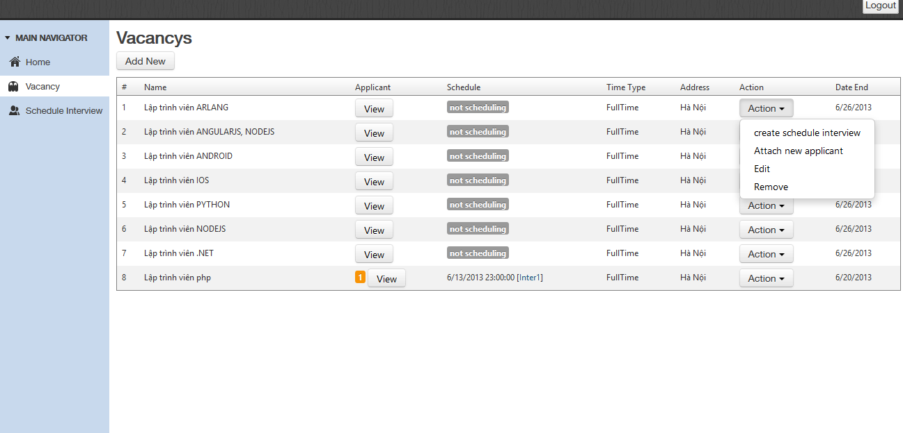

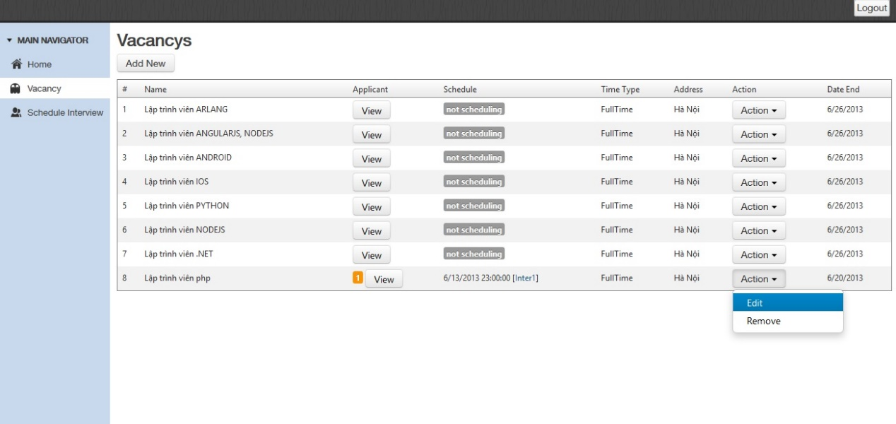

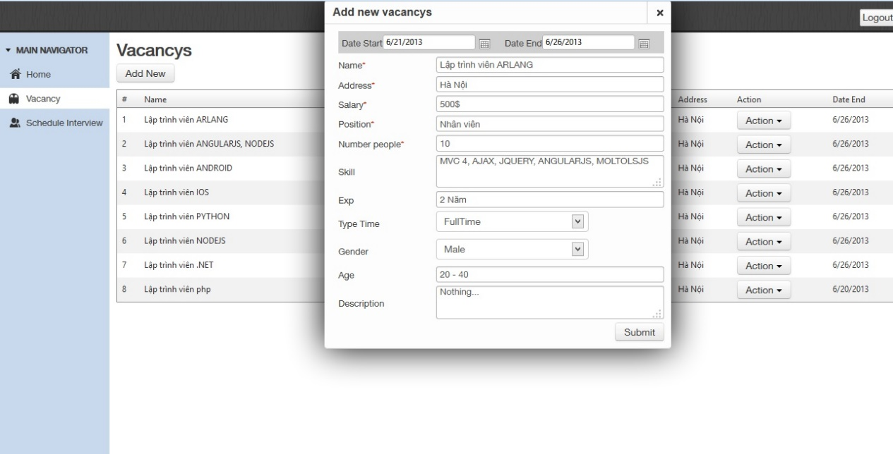

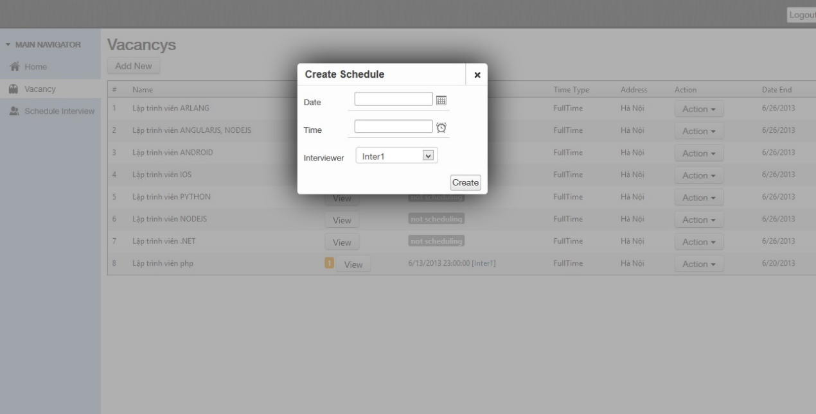

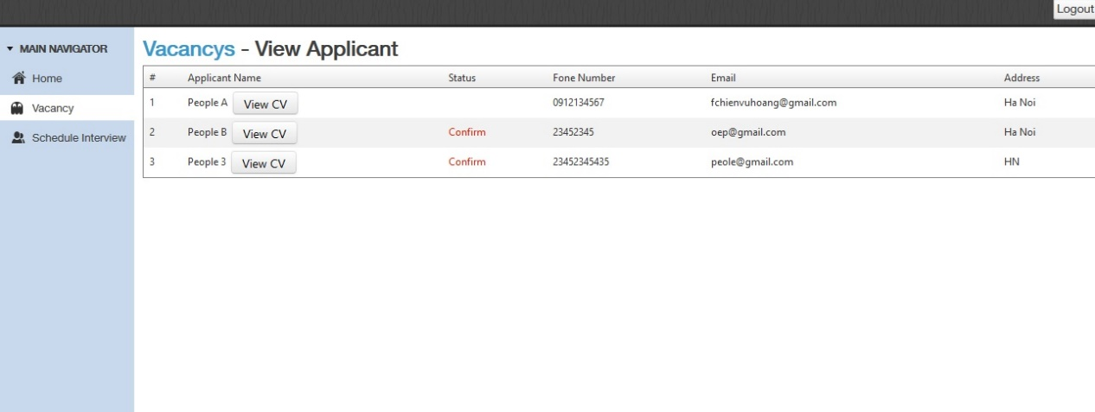

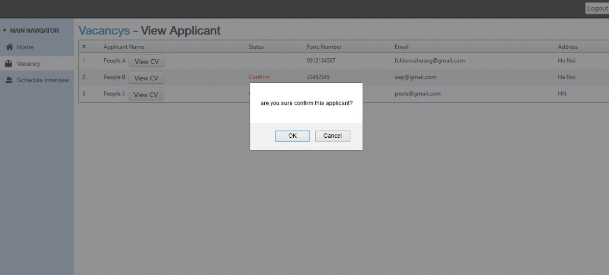

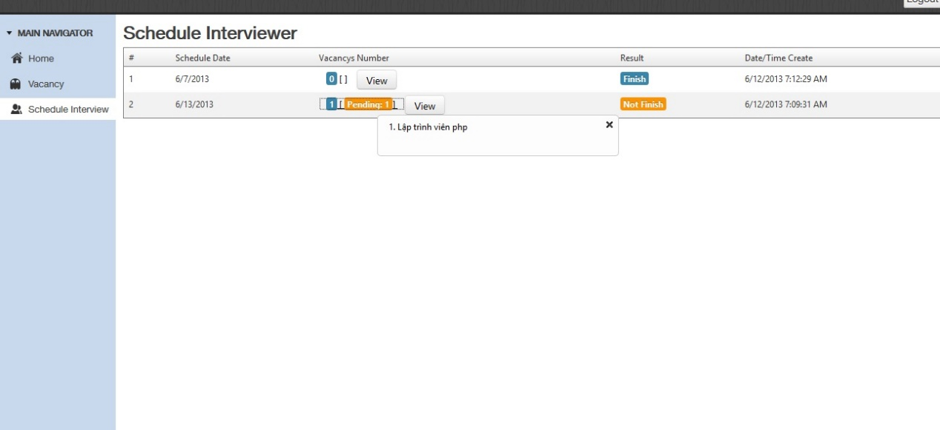

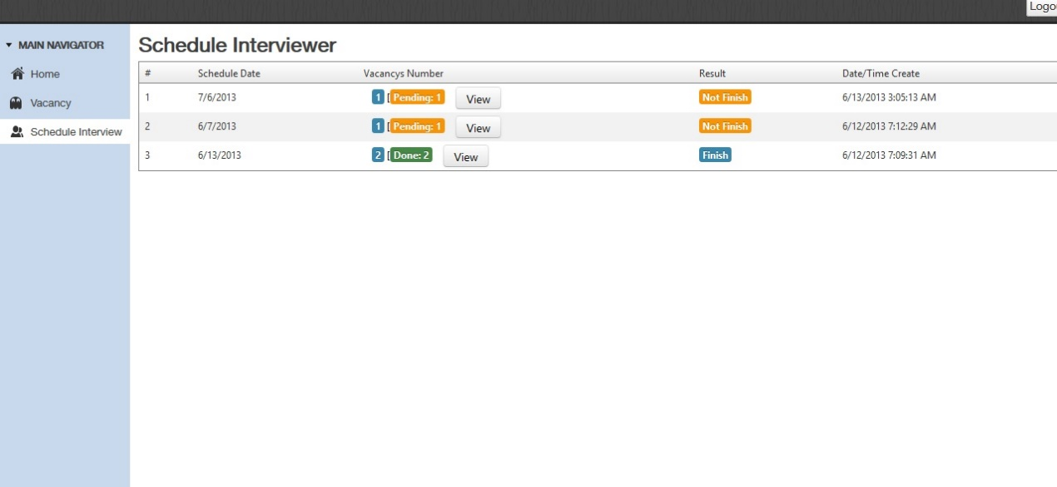

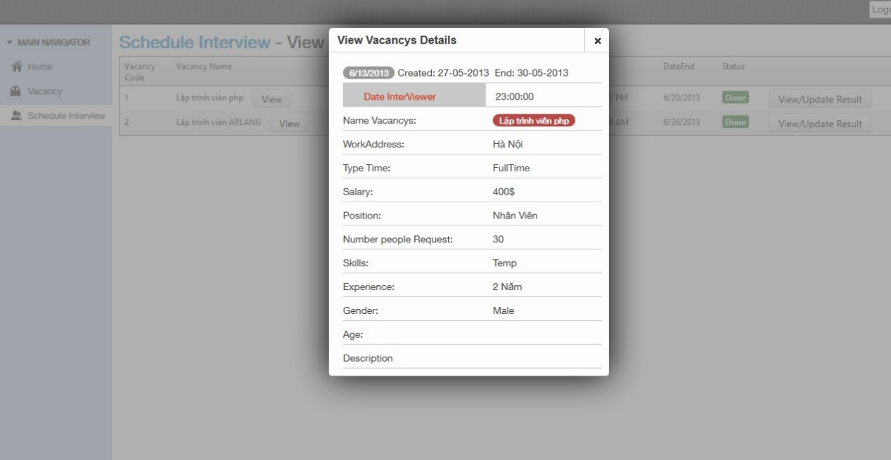

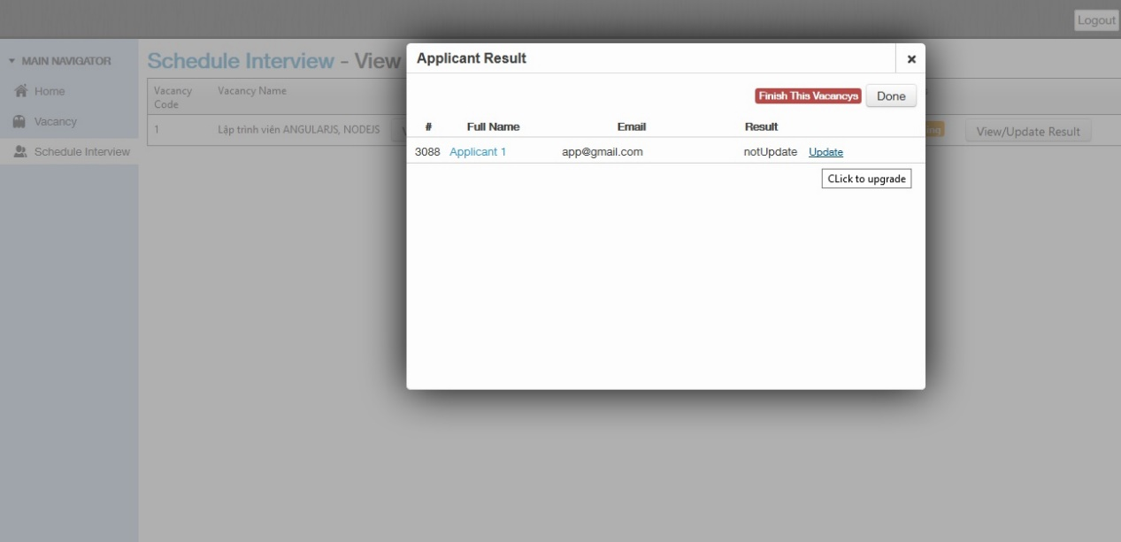

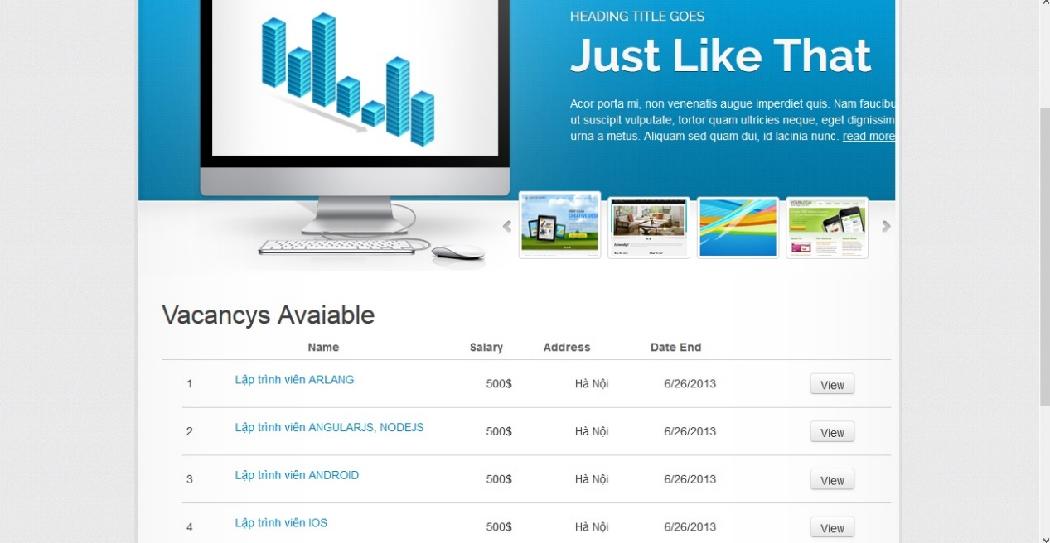

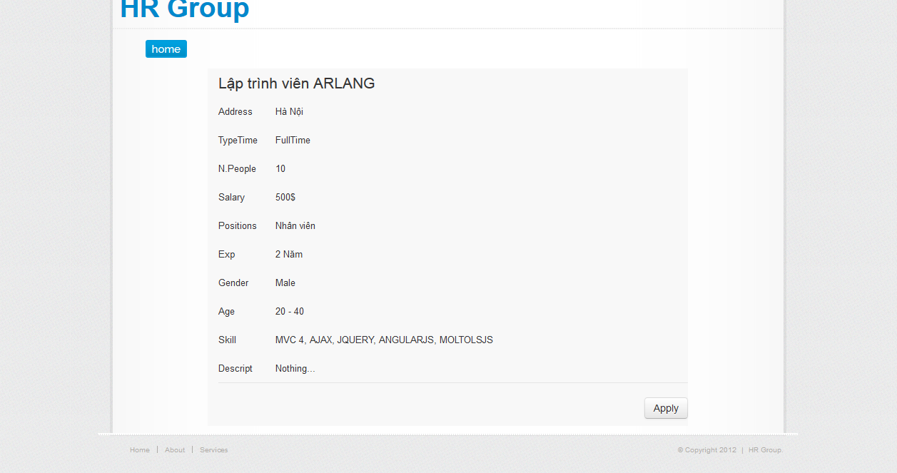

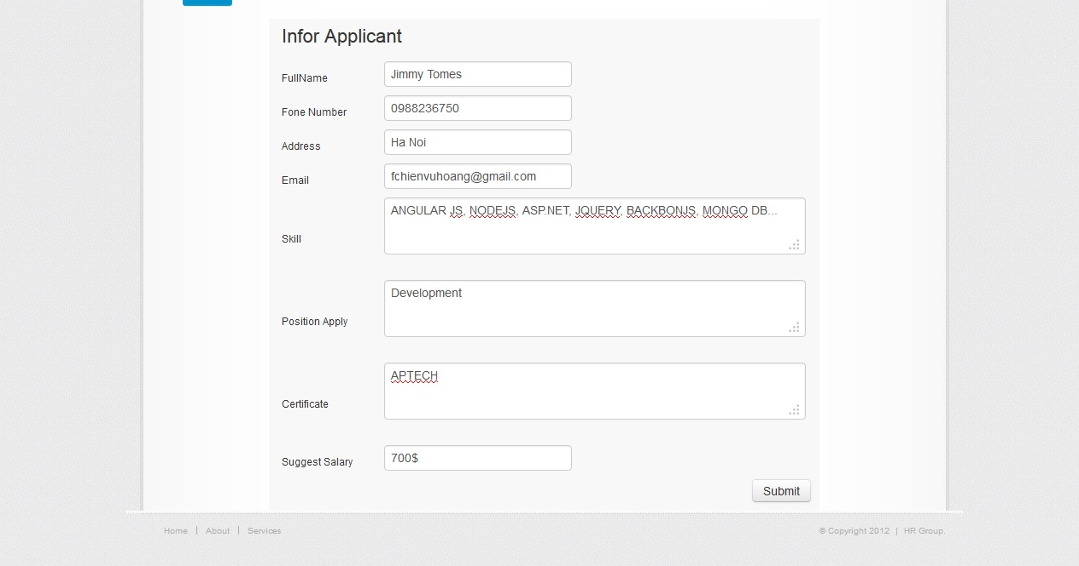

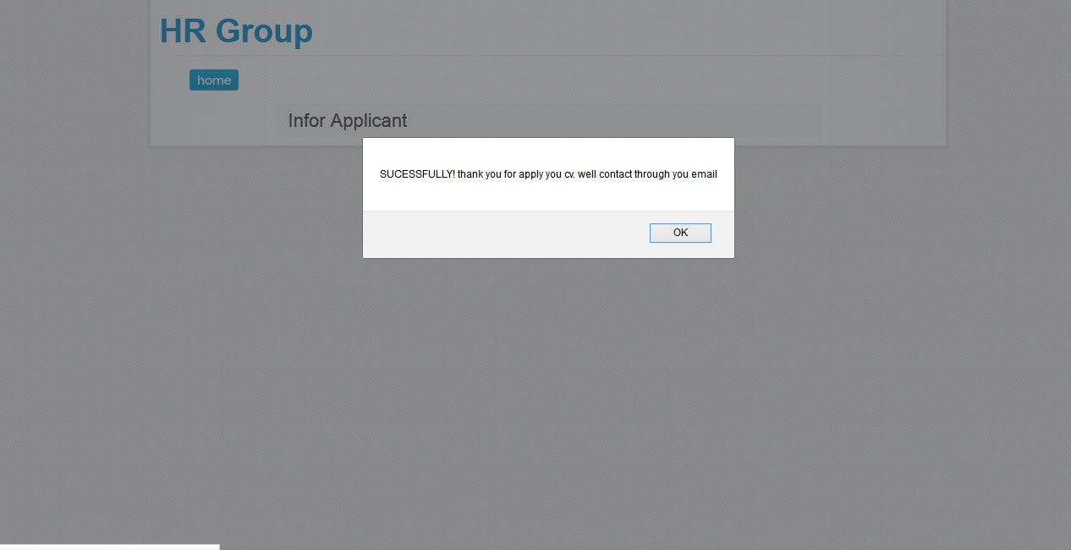

# Coding Convention

* *All name folder and name of page begin with up “uppercase”*
* *All method need have comment*

# Other Concerns<Optional>

# Appendix

## Glossary [Optional]

## References [Optional]

## Others<Optional>