

FPT-Aptech computer education

eProject document
RECRUITMENT PROCESS SYSTEM

FAT 1 – C1007L – SEM 3 – GROUP 6
Members | Vũ Hoàng Chiến
Instructor
Manager | Nguyễn Tuân
Batch | -SEM3

Table of Contents
I. Problem defenition 3
1. Introduction 3
2. The current system 3
3. The proposed system 4
4. Boundaries of the system 4
5. Hardware / software Requirements 5
II. Custommers Requirements Specification 5
1. User of system 5
2. System functions 5
III. Architecture and design 11
1. Database architect: (Database name: Intellibizi) 11
2. Data Flow Diagram 20
3. Entity Relationship Diagram 17
4. Database structure 17
5. Algorithms 23
6. Interface Design Document 26

Problem defenition

Introduction
This project is aimed at developing a web-based and central Recruitment Process System for the HR Group for a company (Mango bussiness). Some features of this system will be creating vacancies, storing Applicants data, Interview process initiation, Scheduling Interviews, Storing Interview results for the applicant and finally Hiring of the applicant. Reports may be required to be generated for the use of HR group.

The current system
Life today to solve the problem of information job and virtual job seeker. Recruitment system We create thorough evaluation of the information security job postings and candidate personal informationneed not "hunt" candidates introduced earlier for other employers without permission...

The proposed system
- In recent years, the issue of data security and information management effectively before 'whirlwind' internet and the risk of leakage of confidential information outside society is very focused company. The recruitment of personnel responsible for the management of information and now is the time when the most powerful field development.
- A successful recruitment system must meet: Privacy and reduce recruitment costs.
- Development of a web-based Recruitment Process System for the HR group for a company.

Boundaries of the system
To meet the needs of customers, the group has set requirements for the is to build a system so complete. Currently the program offers features to users as follows:
- Deploy:
  - Attach database
  - Deploy system
- Login:
  - User Name
  - Password
- Home (Dashboard):
  - View Report
  - Total applicant, vacancy,..
- HR group:
  - View, Create, edit, delete vacancy
  - View, Create, edit, delete applicant
  - Search
  - Attach Applicant to Vacancy
  - Schedule or remove interview
- Interviewer:
  - View scheduled, applicant, vacancy
  - Change scheduled
  - Update result for interview

Hardware / software Requirements

Minimum requirements
Minimum Requirements
PC Pentium III
128 MB RAM
1 GB Hard Drive

Recommended requirements

Recommended requirements
PC Pentium III 1800 MHz
2G RAM
2 GB hard drive

Softsware
- ASP.NET 4.0
- Visual studio 2012
- IIS 7
- MS SQL Sever 2012
- Window 7
- Telerik Q1 2013

Custommers Requirements Specification

User of system
- Adminstrator
- HR group
- Interviewer

System functions
- Administrator
- About
Adminstrator has all information of the employees and adminstartor has all managenement of system.
User will start with the login page in which username and password are
entered. This screen should also provide a functionality to change the
password. To change the password, it should ask for the old password,
new password and confirm new password.
- Login:
Input | Username,Password
Process | Checking account and password
Output | Successful login notification or error messages.
- Forget password
If you forget password, you can input your email on the dialog.We can checked your information and we will sending for you a new password if your information is true.

Data | Insert information in the database
- Add new employee
Input | EmployeeID,Name of Employee….
Process | Checked the existence of the primary key,if not,insert into databse
Output | Display results
Data | Insert information in the database

- HR group
AUTHOR
- Login
Input | Username,Password
Process | Checking account and password
Output | Successful login notification or error messages.

- Forget Password
If you forget password, you can input your email on the dialog.We can checked your information and we will sending for you a new password if your information is true.

VACANCY
- Add new Vacancy
Input | ApplicantId,Name of Vacancy ….
Process | Checked the existence of the primary key,if not,insert into databse
Output | Display results
Data | Insert information in the database

- Edit Vacancy
Input | Choose Vacancy need edit and input information need change.
Process | Check information is true. If true we can update Vacancy.
Output | Display results .
Data | Update information about Applicant in database.

- Delete Vacancy
Input | Choose Vacancy need delete and delete.
Process | Delete from database.
Output | Display results .
Data | Update information in database .

- Search Vacancy
Input | Input keyword from the interface and other options
Process | Find relevant information in the database
Output | Display results .

- View Vacancy detail
Input | Choose Vacancy need view.
Process | Select the Vacancy from database.
Output | Display results .

APPLICANT:
- Add new Applicant
Input | ApplicantId,Name of Applicant ….
Process | Checked the existence of the primary key,if not,insert into databse
Output | Display results
Data | Insert information in the database

- Edit Applicant
Input | Choose Applicant need edit and input information need change.
Process | Check information is true. If true we can update Applicant.
Output | Display results .
Data | Update information about Applicant in database.

- Delete Applicant
Input | Choose Applicant need delete and delete.
Process | Delete from database.
Output | Display results .
Data | Update information in database .

- Search Applicant
Input | Input keyword from the interface and other options
Process | Find relevant information in the database
Output | Display results .

- View Applicant detail
Input | Choose Applicant need view
Process | Get Applicant from database.
Output | Display results .

ATTACH AN APPLICANT TO A VACANCY AND SCHEDULE THE INTERVIEW

- Attach an applicant to a vacancy
Input | ApplicantId,VacancyId, Status, Creation date, ….
Process | Checked the existence of the primary key,if not,insert into databse
Output | Display results
Data | Insert information in the database

- Schedule the interview
Input | Details of the interviewer and date/time, ..
Process | Find relevant information in the database
Output | Display results .
Data | Insert information in the database

OTHER:
- Show and search on Applicant Number and Vacancy Number in User Interface.
- Interviewer
AUTHOR
- Login
Input | Username,Password
Process | Checking account and password
Output | Successful login notification or error messages.

- Forget Password
If you forget password, you can input your email on the dialog.We can checked your information and we will sending for you a new password if your information is true.

- View all interviews scheduled to be taken
Input
Process | Get view all interviews scheduled to be taken from database.
Output | Display results

- View view the details of the applicants details
Input | Applicant Id
Process | Get applicant detail from database.
Output | Display results

- View view the details of the vacancy details
Input | Choose Applicant need view
Process | Get vacancy detail from database.
Output | Display results

- Change the Interview details
Input | Choose product need edit and input information need change.
Process | Check information is true. If true we can update.
Output | Display results .
Data | Update information about interview detail in database.

- Search on Interview Date, Applicant Number and Vacancy Number
Input | Input keyword from the interface and other options
Process | Find relevant information in the database
Output | Display results .

Architecture and design

Database architect: (Database name: Mango)

Admin table
No. | Field name | Data type | Constraint | Description
 | Admin_Id | int | PK, notnull
 | Admin_FullName | nvarchar(50) | notnull
 | Admin_Account | varchar(50) | notnull
 | Admin_Password | nvarchar(200) | notnull
 | Admin_Role | nvarchar(10) | notnull
 | Admin_Status | bit | notnull

Applicant table
No. | Field name | Data type | Constraint | Description
 | Applicant_Id | int | PK, Not null
 | Vacancy_Id | int | FK With Vacancy table
 | Applicant_FullName | nvarchar (50) | Not null
 | Applicant_Email | nvarchar(50) | Not null
 | Skill | ntext | Null
 | PositionApply | nvarchar (50) | Null
- C | Cetificate | ntext | Null
- Sy | SuggestSalary | nvarchar (50) | Null
- A | Applicant_Address | nvarchar (50) | Null
 | Applicant_IP | nvarchar(50) | Null
 | Applicant_Description | ntext | Null
 | Applicant_DateRegister | nvarchar(50) | Null
 | Applicant_Admin_Accept | nchar (10)
 | Applicant_Result | nchar (10)
 | Applicant_Client_Confirm | nchar(10)

Interview table
No. | Field name | Data type | Constraint | Description
 | Interviewer_Id | int | PK, Not null
 | Schedule_Id | int | FK with Schedule table, Not Null
 | Interviewer_Status | nvarchar (50) | Not null
 | Interviewer_Result | nvarchar(50) | Not null
 | Interviewer_Note | ntext

Schedule table
No. | Field name | Data type | Constraint | Description
 | Schedule_Id | int | PK, notnull, autoincrement
 | DateTime_Create | Nvarchar(50) | Not null
 | Schedule_Date | nvarchar(50) | Not null

Vacancys table
No. | Field name | Data type | Constraint | Description
 | Vacancy_Id | int | PK, not null, auto increment
 | Schedule_Id | int | FK with Schedule table
 | Vacancy_WorkAddress | Nvarchar(200) | Not null
 | Vacancy_TypeTime | Nchar(10) | Not null
 | Vacancy_Salary | nvarchar(50) | Not null
 | Vacancy_Position | Nvarchar(50)
 | Vacancy_NumberPeople | int | Not null
 | Vacancy_Skill | Nvarchar(200) | Not null
 | Vacancy_Exp | Nvarchar(50) | Not null
 | Vacancy_Gender | Nvarchar(50) | Not null
 | Vacancy_Age | Nvarchar(50) | Not null
 | Vacancy_Description | Ntext |  | Null
 | Vacancy_DateStart | Nvarchar(50)
 | Vacancy_DateEnd | Nvarchar(50)
 | Vacancy_DateUp | Nvarchar(50)
 | Vacancy_DateInterViewer | Nvarchar(50)
 | Vacancy_TimeInterViewer | Nvarchar(50)
 | Vacancy_Status | Nvarchar(50)
 | Admin_Id | Int | FK with admin table

ApplicantVacancy table

Entity Relationship Diagram
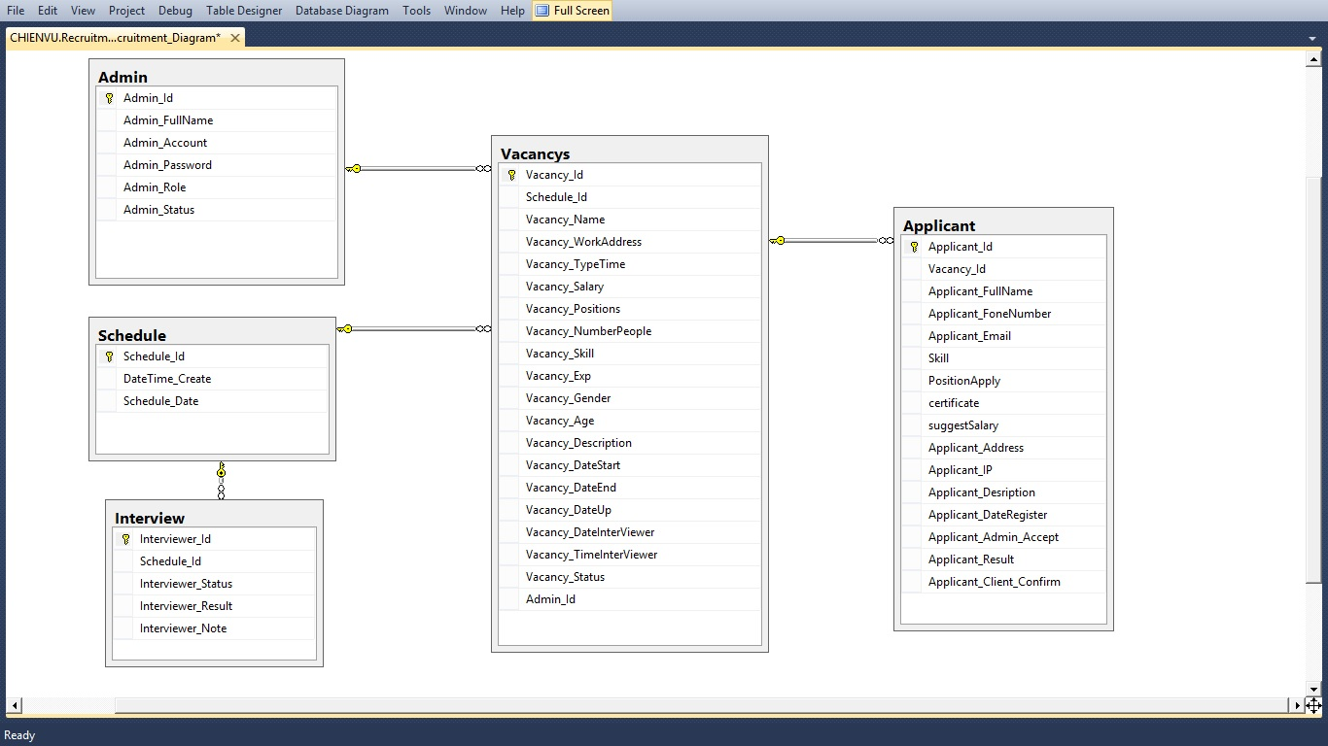

Database structure
- Admin
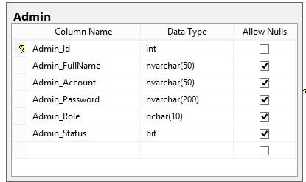
- Schedule
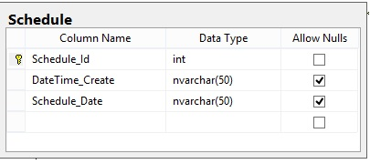

- Interview table
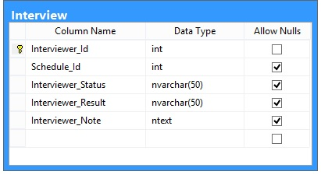
- Vacancy table
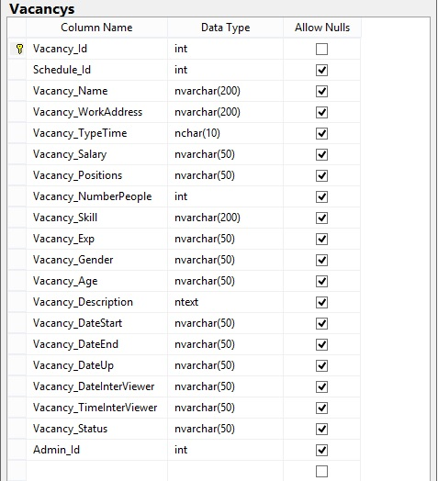
- Applicant table
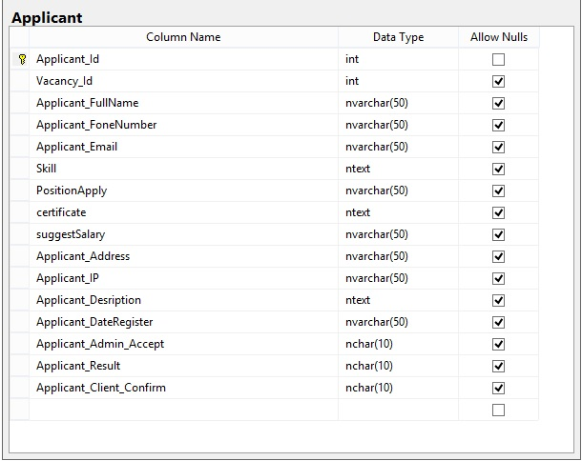

Data Flow Diagram

Symbol using in process
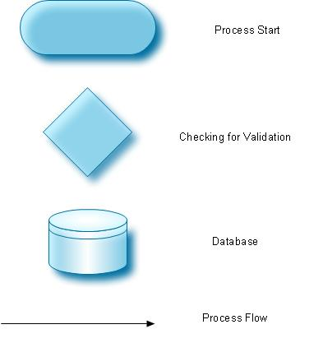

Processing of inserting new Information(Applicant or Vacancy or…)
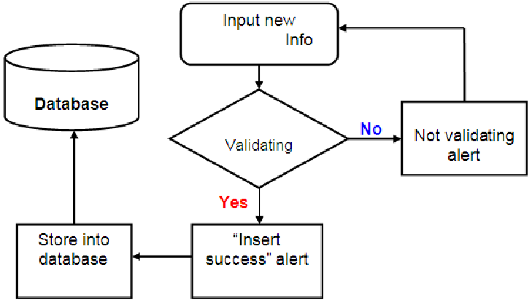
- Input information
  - At first user have to insert information by inputing all neccesary information that required
- Validations checking
  - The validations system check if supplied information is validate or not
    - Not validate informations must by edited by user till validations system accepted
    - Only validate informations are stored in data

Processing of updating Information (Applicant or Vacancy or…)
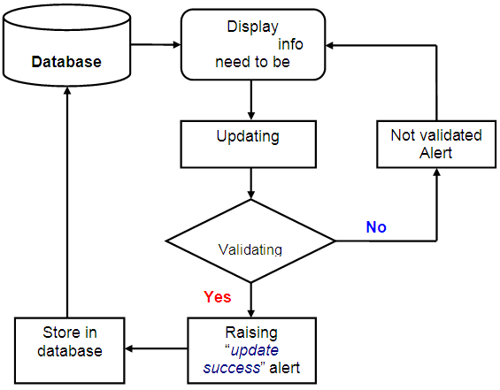
- Select information to update
  - At first user have to select object need to update
  - Then input all neccesary applicant’s information wants to update
- Validations checking
  - The validations system check if supplied information is validate or not
    - Not validate informations must by edited by user till validations system accept
    - Only validate informations are stored in data

Processing of deleting Information(Applicant or Vacancy or…)
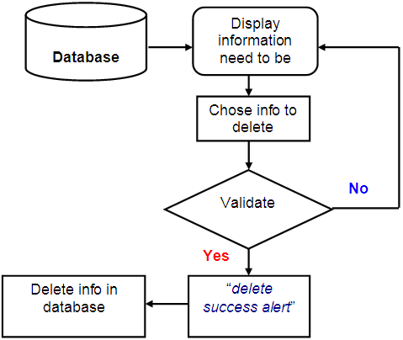
- Select information to delete
  - At first user have to select object need to delete
  - Then click button delete if you wants to delete
- Validations checking
  - The validations system check if supplied information is validate or not
    - Not validate informations must by edited by user till validations system accepte
    - Only validate informations are stored in data

Business processing stream
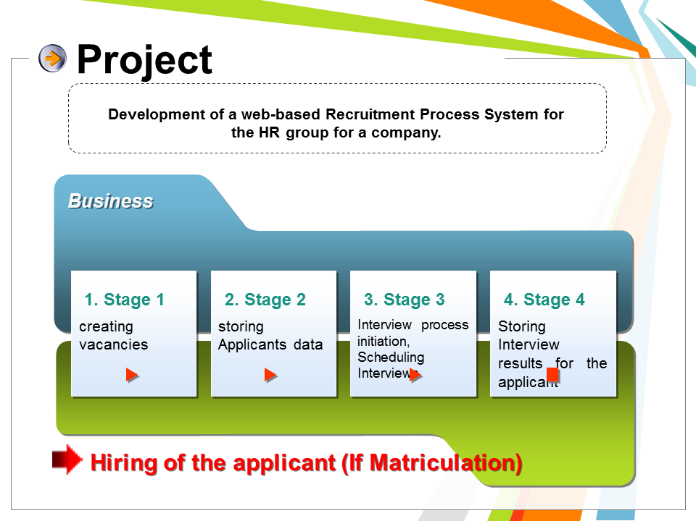

Algorithms

Login
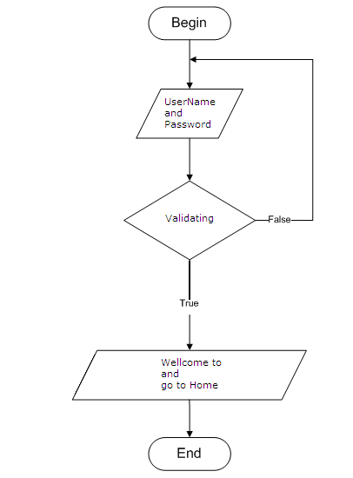

Add
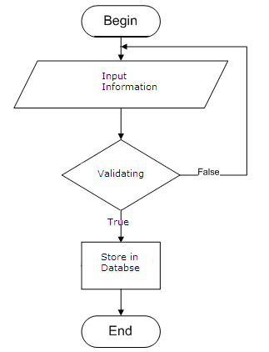

Delete
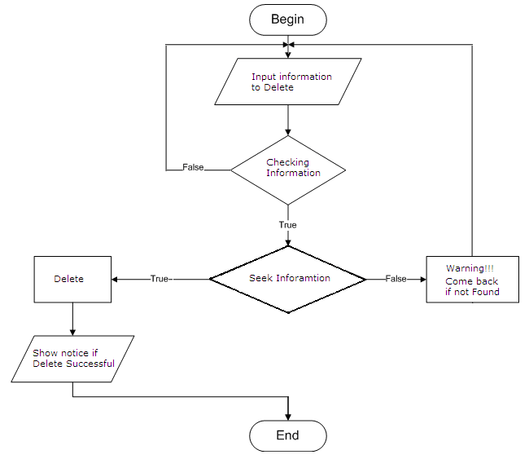

Search
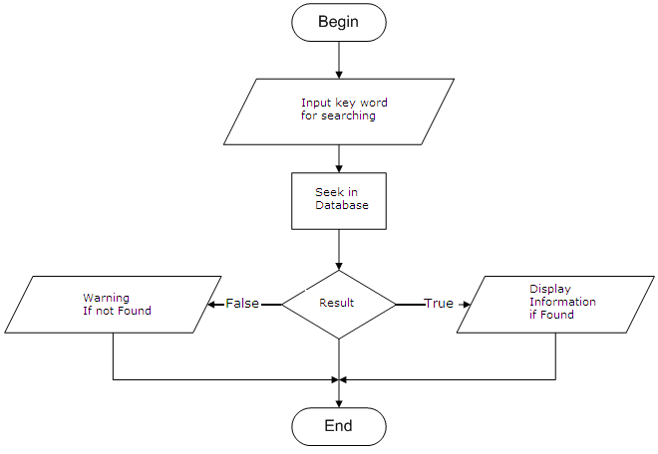

Interface Design Document

Login
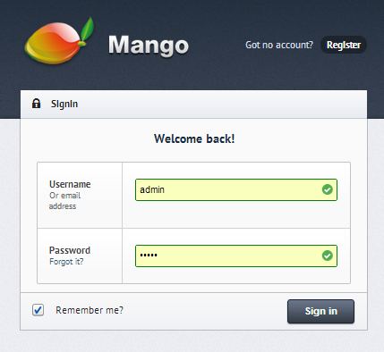

Dashboard
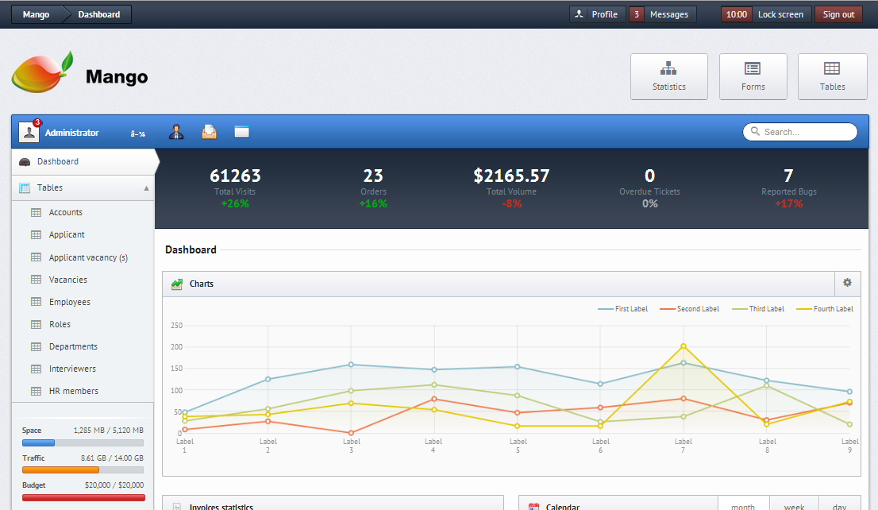

Account setting
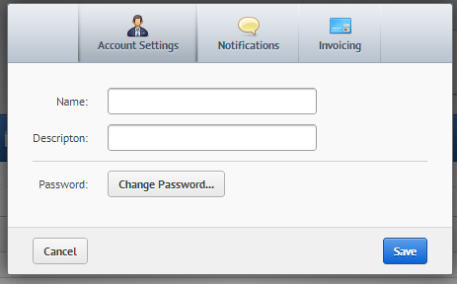

Profile
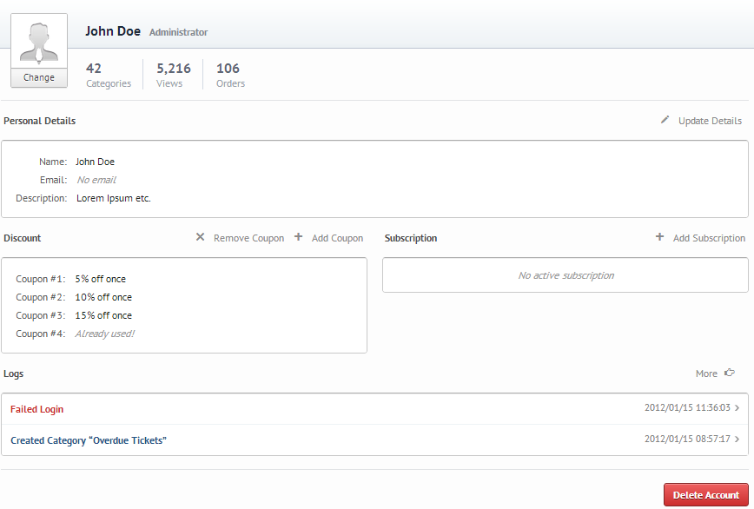

Help
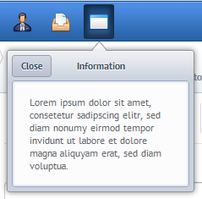

Message
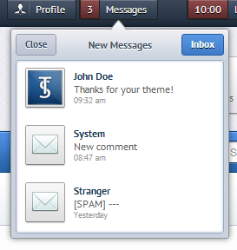

Lock screen
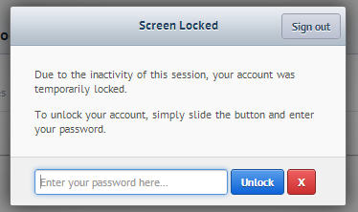

Applicants
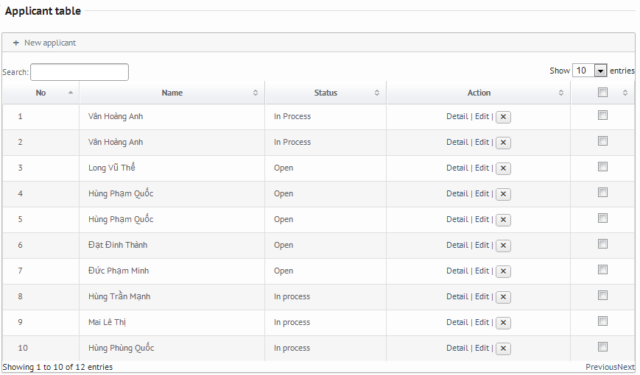

New applicant
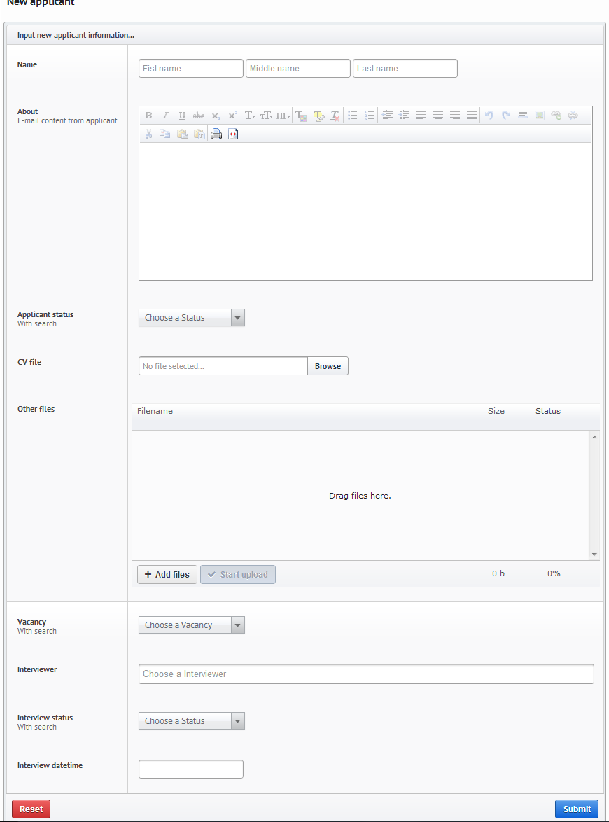

Edit applicant



