Environment Configurations

* MyEclipse Enterprise Workbench Version 2016 CI1
* Maven Integration for Eclipse 1.6.0.me201603172252
* Wildfly 10 Application Server
* Eclipse Web Application Project

1. Deploy WAR to WildFly using Maven Build
   1. Start WildFly server

Start WildFly from Server View in MyEclipse

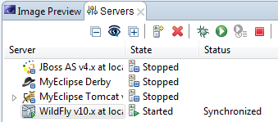

* 1. Declares wildfly-maven-plugin in the pom.xml file

Add the following plugin into yourpom

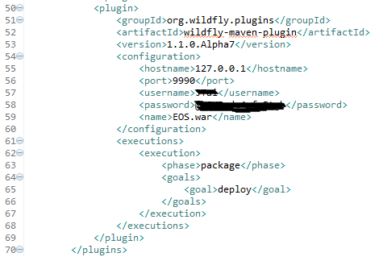

Furthermore, you may specify the war name by putting “fileName” tag to the “Build”

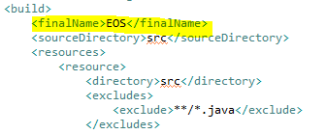

* 1. Build & Package WAR package

Runs Maven Goals:

* Update Maven Project by right click by project>Maven>Update Project…
* Compile
* Package

You will see the WAR file generated under target folder if the build finished successfully

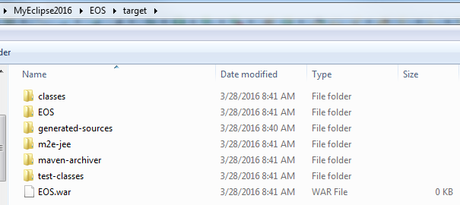

* 1. Deploy with mvn wildfly:deploy

Pointing to the root of your project

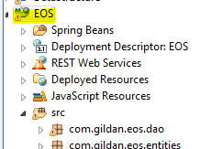

Click triangle next by Run As >Run As> Maven Build…

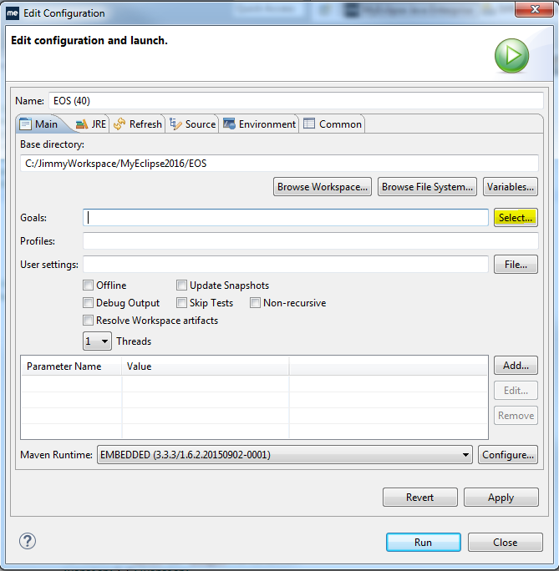

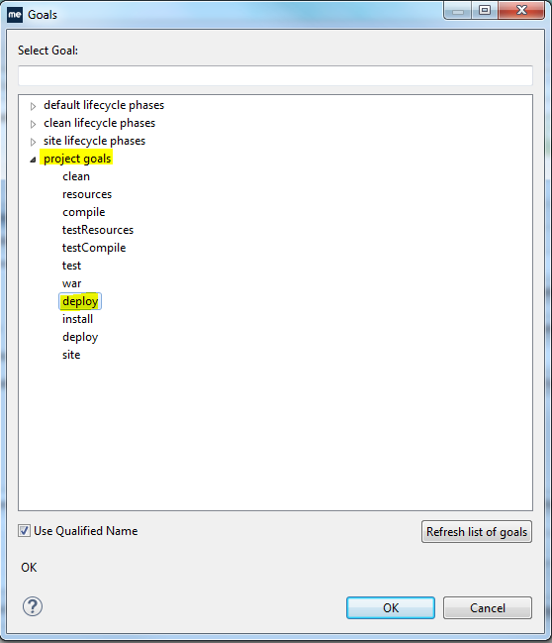

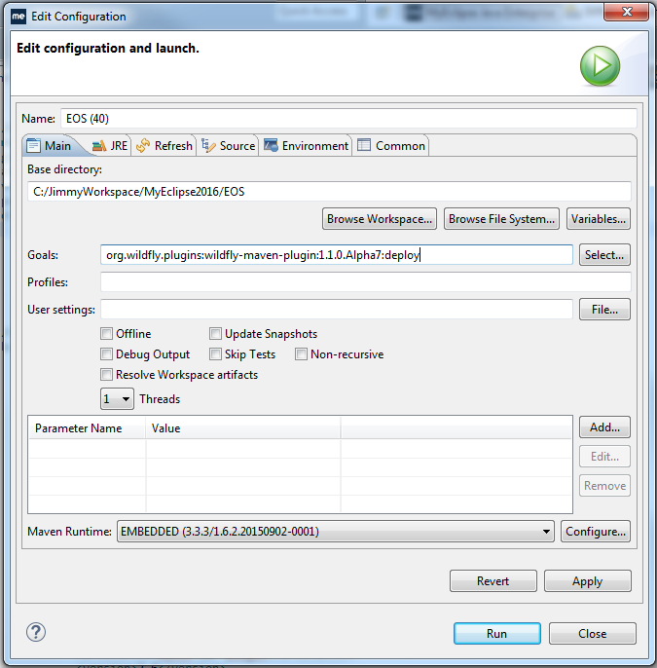

You will see message similar to the following example

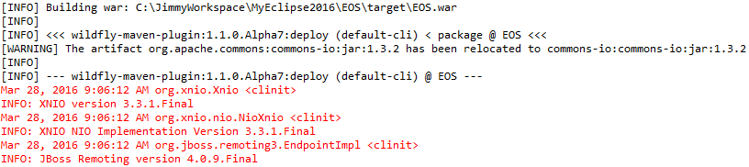

The deployment process will start shortly

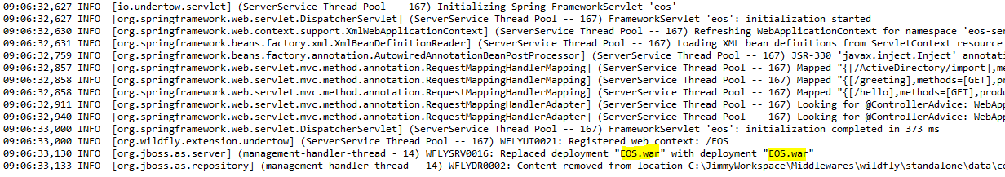

After the deployment finished, you should see “BUILD SUCCESS message”

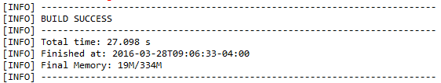

Reference:

<http://www.mkyong.com/maven/maven-deploy-web-application-to-wildfly/>

<https://docs.jboss.org/wildfly/plugins/maven/latest/examples/deployment-example.html>

<https://docs.jboss.org/wildfly/plugins/maven/latest/plugin-info.html>