Пензенский государственный университет
Факультет вычислительной техники
Кафедра «Вычислительная техника»

Отчет
по лабораторной работе №6
по дисциплине «Программирование на языке Java»
на тему «Сетевое взаимодействие в Java»
Вариант № 12
Сделал студент группы 22ВВП1:
Перфилов А.В.

Проверил:
Карамышева Н.С.
Юрова О.В.
Пенза 2025

Цель работы.

Научиться создавать клиент-серверные приложения c использованием стандартных классов Java.
Задание.
Модифицировать приложение из предыдущей лабораторной работы, реализовав клиент-серверную архитектуру, обеспечивающую распределенное вычисление определенного интеграла на нескольких вычислительных узлах (клиентах) при этом каждый узел использует несколько нитей, как в предыдущей работе. Сервер не занимается вычислениями, а лишь реализует взаимодействие с пользователем и агрегацию результатов вычислений от клиентов. Нечетные варианты используют протокол UDP, а четные TCP. Оформление лабораторной работы должно быть выполнено в соответствии с требованиями, приведенными в Приложении 2.
Ход работы.
Переделал функцию кнопки вычисления:
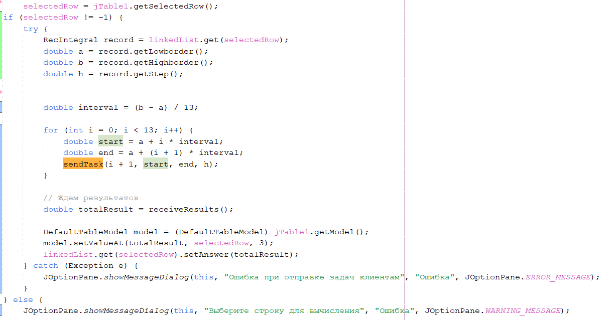

Добавил функцию регистрации клиента:
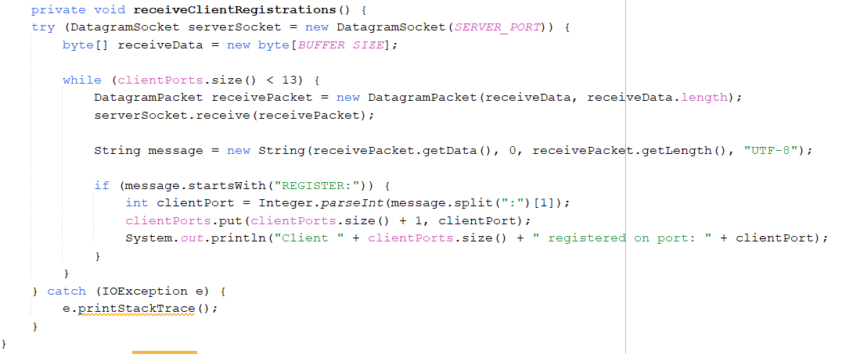
Отправки промежутка клиенту:
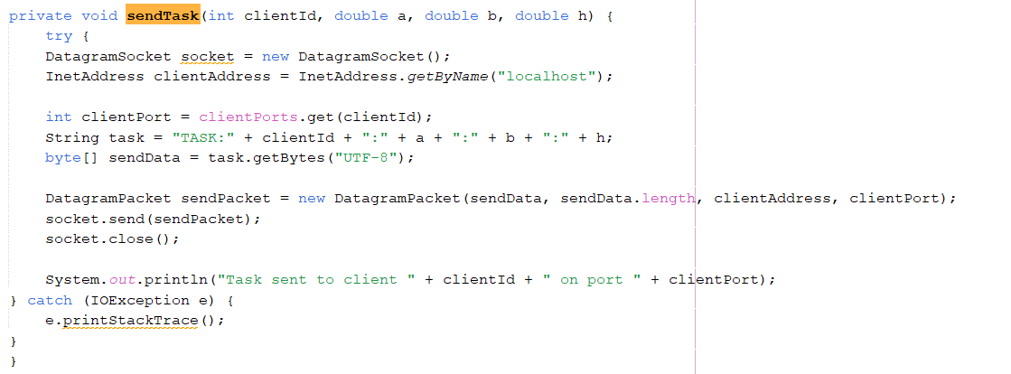И получения посчитанного значения от клиентов:
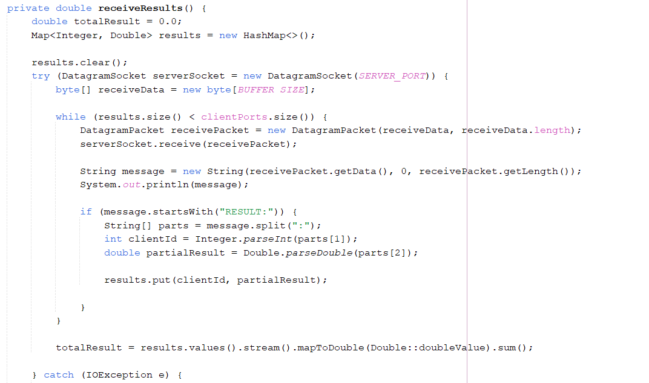
Каждый клиент принимает промежуток и шаг, и считает его, после чего отправляет свой результат на сервер закрывая сокет и завершая поток:
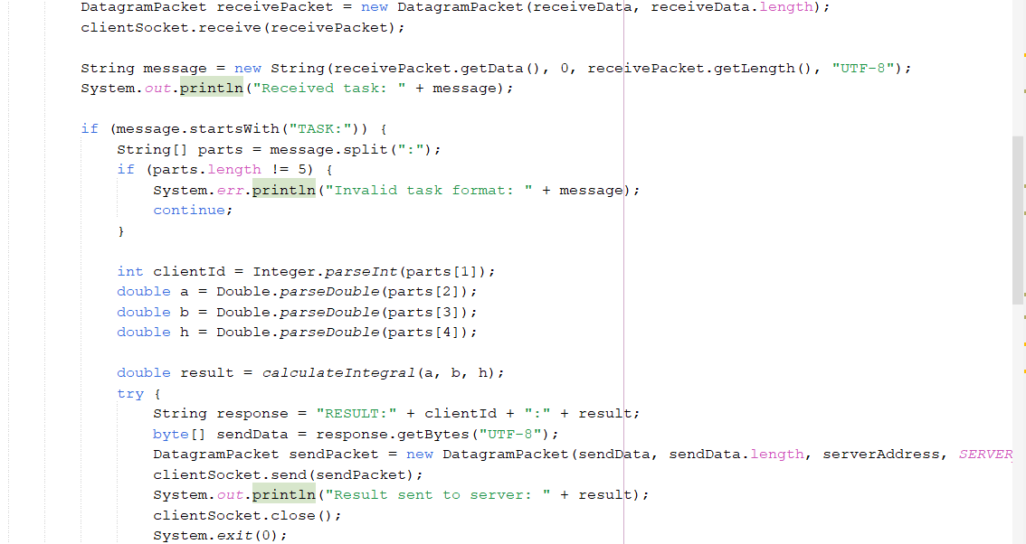

Листинг программы.
Сервер:
package com.mycompany.laba1;
import java.io.BufferedReader;
import java.io.BufferedWriter;
import java.io.File;
import java.io.FileInputStream;
import java.io.FileOutputStream;
import java.io.FileReader;
import java.io.FileWriter;
import java.io.IOException;
import java.io.ObjectInputStream;
import java.io.ObjectOutputStream;
import java.io.Serializable;
import java.net.DatagramPacket;
import java.net.DatagramSocket;
import java.net.InetAddress;
import java.util.ArrayList;
import java.util.HashMap;
import java.util.LinkedList;
import java.util.List;
import java.util.Map;
import javax.swing.JFileChooser;
import javax.swing.JOptionPane;
import javax.swing.SwingUtilities;
import javax.swing.table.DefaultTableModel;

class IntegralTask implements Runnable {
private double lowBorder;
private double highBorder;
private double step;
private int threadIndex;
private int totalThreads;
private double[] results;

public IntegralTask(double lowBorder, double highBorder,
double step, int threadIndex, int totalThreads, double[] results) {
this.lowBorder = lowBorder;
this.highBorder = highBorder;
this.step = step;
this.threadIndex = threadIndex;
this.totalThreads = totalThreads;
this.results = results;
}

@Override
public void run() {
// Расчёт границ для текущего потока
double rangePerThread = (highBorder - lowBorder) / totalThreads;
double start = lowBorder + threadIndex * rangePerThread;
double end = (threadIndex == totalThreads - 1) ? highBorder : start + rangePerThread;

// Вычисление интеграла в пределах границ start и end
double localResult = 0;
for (double currentNumber = start; currentNumber <= end; currentNumber += step) {
if (currentNumber + step <= end) {
localResult += (step / 2) * (Math.sin(currentNumber) + Math.sin(currentNumber + step));
} else {
localResult += (step / 2) * (Math.sin(currentNumber) + Math.sin(end));
}
}

// Сохранение результата в массив
results[threadIndex] = localResult;
}
}

class InvalidRecIntegralValueException extends Exception {
public InvalidRecIntegralValueException(String message) {
super(message);
}
}

class RecIntegral implements Serializable {
private double lowborder;
private double highborder;
private double step;
private double answer;

RecIntegral(double inputLowBorder, double inputHighBorder, double inputStep, double inputAnswer) throws InvalidRecIntegralValueException {
validateValue(inputLowBorder);
validateValue(inputHighBorder);
validateValue(inputStep);

this.lowborder = inputLowBorder;
this.highborder = inputHighBorder;
this.step = inputStep;
this.answer = inputAnswer;
}

private void validateValue(double value) throws InvalidRecIntegralValueException {
if (value < 0.000001 || value > 1000000) {
throw new InvalidRecIntegralValueException("Значение " + value + " должно быть в диапазоне от 0,000001 до 1000000.");
}
}
@Override
public String toString() {
return lowborder + "," + highborder + "," + step + "," + answer;
}

// Геттеры
public double getLowborder() {
return lowborder;
}

public double getHighborder() {
return highborder;
}

public double getStep() {
return step;
}

public double getAnswer() {
return answer;
}

// Сеттеры
public void setLowborder(double lowborder) throws InvalidRecIntegralValueException {
this.lowborder = lowborder;
}

public void setHighborder(double highborder) throws InvalidRecIntegralValueException {
this.highborder = highborder;
}

public void setStep(double step) throws InvalidRecIntegralValueException {
this.step = step;
}

public void setAnswer(double answer) {
this.answer = answer;
}
}

public class laba1 extends javax.swing.JFrame {
private static final int SERVER_PORT = 9876;
private static final int BUFFER_SIZE = 1024;
private ArrayList<RecIntegral> records;

int selectedRow = 0;
LinkedList<RecIntegral> linkedList = new LinkedList<>();

public laba1() {
initComponents();
records = new ArrayList<>();

for (int i = 0; i < 13; i++) {
new Thread(() -> runClient()).start(); // Каждый клиент запускается в отдельном потоке
}
new Thread(this::receiveClientRegistrations).start();
}
@SuppressWarnings("unchecked")
// <editor-fold defaultstate="collapsed" desc="Generated Code">
private void initComponents() {

jLabel1 = new javax.swing.JLabel();
jLabel2 = new javax.swing.JLabel();
jLabel3 = new javax.swing.JLabel();
jButton1 = new javax.swing.JButton();
jButton2 = new javax.swing.JButton();
jButton3 = new javax.swing.JButton();
jScrollPane1 = new javax.swing.JScrollPane();
jTable1 = new javax.swing.JTable();
hbordtextfield = new javax.swing.JTextField();
steptextfield = new javax.swing.JTextField();
lbordtextfield = new javax.swing.JTextField();
jButton4 = new javax.swing.JButton();
jButton5 = new javax.swing.JButton();
jButton6 = new javax.swing.JButton();
jButton7 = new javax.swing.JButton();
jButton8 = new javax.swing.JButton();
jButton9 = new javax.swing.JButton();

setDefaultCloseOperation(javax.swing.WindowConstants.EXIT_ON_CLOSE);

jLabel1.setText("нижняя граница");

jLabel2.setText(" шаг");

jLabel3.setText("верхняя граница");

jButton1.setText("Вычислить");
jButton1.setActionCommand("jButton3");
jButton1.addActionListener(new java.awt.event.ActionListener() {
public void actionPerformed(java.awt.event.ActionEvent evt) {
jButton1ActionPerformed(evt);
}
});

jButton2.setText("Удалить");
jButton2.setActionCommand("jButton2");
jButton2.addActionListener(new java.awt.event.ActionListener() {
public void actionPerformed(java.awt.event.ActionEvent evt) {
jButton2ActionPerformed(evt);
}
});

jButton3.setText("Добавить");
jButton3.addActionListener(new java.awt.event.ActionListener() {
public void actionPerformed(java.awt.event.ActionEvent evt) {
jButton3ActionPerformed(evt);
}
});

jTable1.setModel(new javax.swing.table.DefaultTableModel(
new Object [][] {

},
new String [] {
"Нижняя граница", "Верхняя граница", "Шаг", "Значение"
}
));
jTable1.setCursor(new java.awt.Cursor(java.awt.Cursor.DEFAULT_CURSOR));
jTable1.setShowHorizontalLines(true);
jTable1.setShowVerticalLines(true);
jScrollPane1.setViewportView(jTable1);

hbordtextfield.addActionListener(new java.awt.event.ActionListener() {
public void actionPerformed(java.awt.event.ActionEvent evt) {
hbordtextfieldActionPerformed(evt);
}
});

steptextfield.addActionListener(new java.awt.event.ActionListener() {
public void actionPerformed(java.awt.event.ActionEvent evt) {
steptextfieldActionPerformed(evt);
}
});

lbordtextfield.setName("lbordtextfield"); // NOI18N
lbordtextfield.addActionListener(new java.awt.event.ActionListener() {
public void actionPerformed(java.awt.event.ActionEvent evt) {
lbordtextfieldActionPerformed(evt);
}
});

jButton4.setLabel("Заполнить");
jButton4.addActionListener(new java.awt.event.ActionListener() {
public void actionPerformed(java.awt.event.ActionEvent evt) {
jButton4ActionPerformed(evt);
}
});

jButton5.setLabel("Очистить");
jButton5.addActionListener(new java.awt.event.ActionListener() {
public void actionPerformed(java.awt.event.ActionEvent evt) {
jButton5ActionPerformed(evt);
}
});

jButton6.setText("Загрузить из bin");
jButton6.addActionListener(new java.awt.event.ActionListener() {
public void actionPerformed(java.awt.event.ActionEvent evt) {
jButton6ActionPerformed(evt);
}
});

jButton7.setText("Сохранить в bin");
jButton7.addActionListener(new java.awt.event.ActionListener() {
public void actionPerformed(java.awt.event.ActionEvent evt) {
jButton7ActionPerformed(evt);
}
});

jButton8.setText("Загрузить из text");
jButton8.addActionListener(new java.awt.event.ActionListener() {
public void actionPerformed(java.awt.event.ActionEvent evt) {
jButton8ActionPerformed(evt);
}
});

jButton9.setText("Сохранить в text");
jButton9.addActionListener(new java.awt.event.ActionListener() {
public void actionPerformed(java.awt.event.ActionEvent evt) {
jButton9ActionPerformed(evt);
}
});

javax.swing.GroupLayout layout = new javax.swing.GroupLayout(getContentPane());
getContentPane().setLayout(layout);
layout.setHorizontalGroup(
layout.createParallelGroup(javax.swing.GroupLayout.Alignment.LEADING)
.addGroup(javax.swing.GroupLayout.Alignment.TRAILING, layout.createSequentialGroup()
.addContainerGap()
.addComponent(jScrollPane1)
.addContainerGap())
.addGroup(layout.createSequentialGroup()
.addGap(24, 24, 24)
.addGroup(layout.createParallelGroup(javax.swing.GroupLayout.Alignment.LEADING)
.addGroup(layout.createParallelGroup(javax.swing.GroupLayout.Alignment.TRAILING, false)
.addComponent(jLabel2, javax.swing.GroupLayout.Alignment.LEADING, javax.swing.GroupLayout.DEFAULT_SIZE, javax.swing.GroupLayout.DEFAULT_SIZE, Short.MAX_VALUE)
.addComponent(jLabel3, javax.swing.GroupLayout.Alignment.LEADING, javax.swing.GroupLayout.DEFAULT_SIZE, javax.swing.GroupLayout.DEFAULT_SIZE, Short.MAX_VALUE))
.addComponent(jLabel1)
.addComponent(jButton9))
.addGap(7, 7, 7)
.addGroup(layout.createParallelGroup(javax.swing.GroupLayout.Alignment.LEADING, false)
.addComponent(lbordtextfield)
.addComponent(hbordtextfield)
.addComponent(steptextfield)
.addComponent(jButton8, javax.swing.GroupLayout.DEFAULT_SIZE, javax.swing.GroupLayout.DEFAULT_SIZE, Short.MAX_VALUE))
.addGap(36, 36, 36)
.addGroup(layout.createParallelGroup(javax.swing.GroupLayout.Alignment.LEADING, false)
.addComponent(jButton7, javax.swing.GroupLayout.DEFAULT_SIZE, javax.swing.GroupLayout.DEFAULT_SIZE, Short.MAX_VALUE)
.addComponent(jButton1, javax.swing.GroupLayout.DEFAULT_SIZE, javax.swing.GroupLayout.DEFAULT_SIZE, Short.MAX_VALUE)
.addComponent(jButton2, javax.swing.GroupLayout.DEFAULT_SIZE, javax.swing.GroupLayout.DEFAULT_SIZE, Short.MAX_VALUE)
.addComponent(jButton3, javax.swing.GroupLayout.DEFAULT_SIZE, javax.swing.GroupLayout.DEFAULT_SIZE, Short.MAX_VALUE))
.addGap(35, 35, 35)
.addGroup(layout.createParallelGroup(javax.swing.GroupLayout.Alignment.TRAILING, false)
.addComponent(jButton6, javax.swing.GroupLayout.DEFAULT_SIZE, javax.swing.GroupLayout.DEFAULT_SIZE, Short.MAX_VALUE)
.addComponent(jButton4, javax.swing.GroupLayout.Alignment.LEADING, javax.swing.GroupLayout.DEFAULT_SIZE, javax.swing.GroupLayout.DEFAULT_SIZE, Short.MAX_VALUE)
.addComponent(jButton5, javax.swing.GroupLayout.Alignment.LEADING, javax.swing.GroupLayout.DEFAULT_SIZE, javax.swing.GroupLayout.DEFAULT_SIZE, Short.MAX_VALUE))
.addContainerGap(javax.swing.GroupLayout.DEFAULT_SIZE, Short.MAX_VALUE))
);
layout.setVerticalGroup(
layout.createParallelGroup(javax.swing.GroupLayout.Alignment.LEADING)
.addGroup(layout.createSequentialGroup()
.addGroup(layout.createParallelGroup(javax.swing.GroupLayout.Alignment.LEADING)
.addGroup(layout.createSequentialGroup()
.addGap(32, 32, 32)
.addGroup(layout.createParallelGroup(javax.swing.GroupLayout.Alignment.BASELINE)
.addComponent(jLabel1, javax.swing.GroupLayout.PREFERRED_SIZE, 25, javax.swing.GroupLayout.PREFERRED_SIZE)
.addComponent(jButton3)
.addComponent(lbordtextfield, javax.swing.GroupLayout.PREFERRED_SIZE, javax.swing.GroupLayout.DEFAULT_SIZE, javax.swing.GroupLayout.PREFERRED_SIZE))
.addPreferredGap(javax.swing.LayoutStyle.ComponentPlacement.UNRELATED)
.addGroup(layout.createParallelGroup(javax.swing.GroupLayout.Alignment.BASELINE)
.addComponent(jLabel3, javax.swing.GroupLayout.PREFERRED_SIZE, 25, javax.swing.GroupLayout.PREFERRED_SIZE)
.addComponent(jButton2)
.addComponent(hbordtextfield, javax.swing.GroupLayout.PREFERRED_SIZE, javax.swing.GroupLayout.DEFAULT_SIZE, javax.swing.GroupLayout.PREFERRED_SIZE))
.addPreferredGap(javax.swing.LayoutStyle.ComponentPlacement.UNRELATED)
.addGroup(layout.createParallelGroup(javax.swing.GroupLayout.Alignment.BASELINE)
.addComponent(jLabel2, javax.swing.GroupLayout.PREFERRED_SIZE, 25, javax.swing.GroupLayout.PREFERRED_SIZE)
.addComponent(jButton1)
.addComponent(steptextfield, javax.swing.GroupLayout.PREFERRED_SIZE, javax.swing.GroupLayout.DEFAULT_SIZE, javax.swing.GroupLayout.PREFERRED_SIZE)))
.addGroup(layout.createSequentialGroup()
.addGap(50, 50, 50)
.addComponent(jButton4)
.addPreferredGap(javax.swing.LayoutStyle.ComponentPlacement.UNRELATED)
.addComponent(jButton5)))
.addGroup(layout.createParallelGroup(javax.swing.GroupLayout.Alignment.LEADING)
.addGroup(layout.createSequentialGroup()
.addPreferredGap(javax.swing.LayoutStyle.ComponentPlacement.RELATED, 13, Short.MAX_VALUE)
.addGroup(layout.createParallelGroup(javax.swing.GroupLayout.Alignment.BASELINE)
.addComponent(jButton6)
.addComponent(jButton7))
.addGap(18, 18, 18))
.addGroup(layout.createSequentialGroup()
.addPreferredGap(javax.swing.LayoutStyle.ComponentPlacement.UNRELATED)
.addGroup(layout.createParallelGroup(javax.swing.GroupLayout.Alignment.BASELINE)
.addComponent(jButton8)
.addComponent(jButton9))
.addPreferredGap(javax.swing.LayoutStyle.ComponentPlacement.RELATED, javax.swing.GroupLayout.DEFAULT_SIZE, Short.MAX_VALUE)))
.addComponent(jScrollPane1, javax.swing.GroupLayout.PREFERRED_SIZE, 134, javax.swing.GroupLayout.PREFERRED_SIZE)
.addContainerGap())
);

pack();
}// </editor-fold>
private Map<Integer, Integer> clientPorts = new HashMap<>(); // Список портов клиентов

public static void runClient() {
try {
ProcessBuilder processBuilder = new ProcessBuilder("java", "-cp", "D:/3курс/java/Java_lab1/laba1/target/classes", "com.mycompany.laba1.Client");
processBuilder.inheritIO();
Process process = processBuilder.start();
process.waitFor();
} catch (IOException | InterruptedException e) {
e.printStackTrace();
}
}

private void receiveClientRegistrations() {
try (DatagramSocket serverSocket = new DatagramSocket(SERVER_PORT)) {
byte[] receiveData = new byte[BUFFER_SIZE];

while (clientPorts.size() < 13) {
DatagramPacket receivePacket = new DatagramPacket(receiveData, receiveData.length);
serverSocket.receive(receivePacket);

String message = new String(receivePacket.getData(), 0, receivePacket.getLength(), "UTF-8");

if (message.startsWith("REGISTER:")) {
int clientPort = Integer.parseInt(message.split(":")[1]);
clientPorts.put(clientPorts.size() + 1, clientPort);
System.out.println("Client " + clientPorts.size() + " registered on port: " + clientPort);
}
}
} catch (IOException e) {
e.printStackTrace();
}
}
private void sendTask(int clientId, double a, double b, double h) {
try {
DatagramSocket socket = new DatagramSocket();
InetAddress clientAddress = InetAddress.getByName("localhost");

int clientPort = clientPorts.get(clientId);
String task = "TASK:" + clientId + ":" + a + ":" + b + ":" + h;
byte[] sendData = task.getBytes("UTF-8");

DatagramPacket sendPacket = new DatagramPacket(sendData, sendData.length, clientAddress, clientPort);
socket.send(sendPacket);
socket.close();

System.out.println("Task sent to client " + clientId + " on port " + clientPort);
} catch (IOException e) {
e.printStackTrace();
}
}
private double receiveResults() {
double totalResult = 0.0;
Map<Integer, Double> results = new HashMap<>();

results.clear();
try (DatagramSocket serverSocket = new DatagramSocket(SERVER_PORT)) {
byte[] receiveData = new byte[BUFFER_SIZE];

while (results.size() < clientPorts.size()) {
DatagramPacket receivePacket = new DatagramPacket(receiveData, receiveData.length);
serverSocket.receive(receivePacket);

String message = new String(receivePacket.getData(), 0, receivePacket.getLength());
System.out.println(message);

if (message.startsWith("RESULT:")) {
String[] parts = message.split(":");
int clientId = Integer.parseInt(parts[1]);
double partialResult = Double.parseDouble(parts[2]);

results.put(clientId, partialResult);

}
}

totalResult = results.values().stream().mapToDouble(Double::doubleValue).sum();

} catch (IOException e) {
e.printStackTrace();
}

return totalResult;
}

private static LinkedList<RecIntegral> readRecIntegralsFromTextFile() {
LinkedList<RecIntegral> recIntegrals = new LinkedList<>();
JFileChooser fileChooser = new JFileChooser();
int userSelection = fileChooser.showOpenDialog(null);
if (userSelection == JFileChooser.APPROVE_OPTION) {
File fileToRead = fileChooser.getSelectedFile();
try (BufferedReader reader = new BufferedReader(new FileReader(fileToRead))) {
String line;
while ((line = reader.readLine()) != null) {
String[] parts = line.split(",");
if (parts.length == 4) {
double lowBorder = Double.parseDouble(parts[0].trim());
double highBorder = Double.parseDouble(parts[1].trim());
double step = Double.parseDouble(parts[2].trim());
double answer = Double.parseDouble(parts[3].trim());
recIntegrals.add(new RecIntegral(lowBorder, highBorder, step, answer));
}
}
} catch (IOException | InvalidRecIntegralValueException e) {
System.err.println("Ошибка при чтении из файла: " + e.getMessage());
}
}
return recIntegrals;
}
private static LinkedList<RecIntegral> deserializeAndReadRecIntegrals() {
LinkedList<RecIntegral> recIntegrals = null;
JFileChooser fileChooser = new JFileChooser();
int userSelection = fileChooser.showOpenDialog(null);
if (userSelection == JFileChooser.APPROVE_OPTION) {
File fileToRead = fileChooser.getSelectedFile();
try (FileInputStream fileIn = new FileInputStream(fileToRead);
ObjectInputStream in = new ObjectInputStream(fileIn)) {
recIntegrals = (LinkedList<RecIntegral>) in.readObject();
} catch (IOException | ClassNotFoundException e) {
System.err.println("Ошибка при десериализации: " + e.getMessage());
}
}
return recIntegrals;
}

private static void writeRecIntegralsToFile(List<RecIntegral> recIntegrals) {
JFileChooser fileChooser = new JFileChooser();
int userSelection = fileChooser.showSaveDialog(null);
if (userSelection == JFileChooser.APPROVE_OPTION) {
File fileToSave = fileChooser.getSelectedFile();
try (BufferedWriter writer = new BufferedWriter(new FileWriter(fileToSave))) {
for (RecIntegral recIntegral : recIntegrals) {
writer.write(recIntegral.toString());
writer.newLine();
}
} catch (IOException e) {
System.err.println("Ошибка при записи в файл: " + e.getMessage());
}
}
}
private static void serializeAndWriteRecIntegrals(List<RecIntegral> recIntegrals) {
JFileChooser fileChooser = new JFileChooser();
int userSelection = fileChooser.showSaveDialog(null);
if (userSelection == JFileChooser.APPROVE_OPTION) {
File fileToSave = fileChooser.getSelectedFile();
try (FileOutputStream fileOut = new FileOutputStream(fileToSave);
ObjectOutputStream out = new ObjectOutputStream(fileOut)) {
out.writeObject(recIntegrals);
} catch (IOException e) {
System.err.println("Ошибка при сериализации: " + e.getMessage());
}
}
}

private void jButton2ActionPerformed(java.awt.event.ActionEvent evt) {
javax.swing.table.DefaultTableModel model = (javax.swing.table.DefaultTableModel) jTable1.getModel();
model.removeRow(selectedRow);
linkedList.remove(selectedRow);
}

private void jButton3ActionPerformed(java.awt.event.ActionEvent evt) {
javax.swing.table.DefaultTableModel model = (javax.swing.table.DefaultTableModel) jTable1.getModel();

String lowborder = lbordtextfield.getText();
String highborder = hbordtextfield.getText();
String stepStr = steptextfield.getText();

double dlowborder = Double.parseDouble(lowborder);
double dhighborder = Double.parseDouble(highborder);
double dstep = Double.parseDouble(stepStr);

try {
linkedList.add(new RecIntegral(dlowborder,dhighborder,dstep, 0.0));
model.addRow(new Object[]{lowborder,highborder,stepStr, " "});
} catch (InvalidRecIntegralValueException ex) {
JOptionPane.showMessageDialog(null,ex.getMessage(), "Ошибка!", JOptionPane.ERROR_MESSAGE);
}
}

private void jButton1ActionPerformed(java.awt.event.ActionEvent evt) {
selectedRow = jTable1.getSelectedRow();
if (selectedRow != -1) {
try {
RecIntegral record = linkedList.get(selectedRow);
double a = record.getLowborder();
double b = record.getHighborder();
double h = record.getStep();

double interval = (b - a) / 13;

for (int i = 0; i < 13; i++) {
double start = a + i * interval;
double end = a + (i + 1) * interval;
sendTask(i + 1, start, end, h);
}

// Ждем результатов
double totalResult = receiveResults();

DefaultTableModel model = (DefaultTableModel) jTable1.getModel();
model.setValueAt(totalResult, selectedRow, 3);
linkedList.get(selectedRow).setAnswer(totalResult);
} catch (Exception e) {
JOptionPane.showMessageDialog(this, "Ошибка при отправке задач клиентам", "Ошибка", JOptionPane.ERROR_MESSAGE);
}
} else {
JOptionPane.showMessageDialog(this, "Выберите строку для вычисления", "Ошибка", JOptionPane.WARNING_MESSAGE);
}

}

private double CalculationOfValue(Object low,Object high, Object step){
double dbllow = (Double) low;
double dblhigh = (Double) high;
double dblstep = (Double) step;
double answer = 0;

ArrayList<Double> numbers = new ArrayList<>();

//если шаг равен 0
if (dblstep == 0){
return answer;
}

//подсчет шагов
for (double currentNumber = dbllow; currentNumber <= dblhigh; currentNumber += dblstep) {
numbers.add(currentNumber);
}

//если шаг равен 1
if (numbers.isEmpty()){
answer = (Math.sin(dbllow) + Math.sin(dblhigh)) * (dblstep / 2);
return answer;
}

for (int counter = 0; counter < numbers.size() - 1; counter++) {
double currentElement = numbers.get(counter);
double nextElement = numbers.get(counter + 1);
double stepAnswer = (dblstep / 2) * (Math.sin(currentElement) + Math.sin(nextElement));
answer += stepAnswer;
}

//если есть промежуток меньше шага между последним элементом и верхней границей
if (dblhigh != numbers.get(numbers.size()-1)){
answer += (dblstep / 2) * (Math.sin(numbers.get(numbers.size()-1)) + Math.sin(dblhigh));
}

return answer;
}
private void ShowTheAnswer(double answer) {
SwingUtilities.invokeLater(() -> {
javax.swing.table.DefaultTableModel model = (javax.swing.table.DefaultTableModel) jTable1.getModel();
model.setValueAt(answer, selectedRow, 3);
RecIntegral recIntegral = linkedList.get(selectedRow);
recIntegral.setAnswer(answer);
});
}

private void steptextfieldActionPerformed(java.awt.event.ActionEvent evt) {
// TODO add your handling code here:
}

private void lbordtextfieldActionPerformed(java.awt.event.ActionEvent evt) {
// TODO add your handling code here:
}

private void hbordtextfieldActionPerformed(java.awt.event.ActionEvent evt) {
// TODO add your handling code here:
}

private void jButton4ActionPerformed(java.awt.event.ActionEvent evt) {
javax.swing.table.DefaultTableModel model = (javax.swing.table.DefaultTableModel) jTable1.getModel();

for (RecIntegral ri : linkedList) {
model.addRow(new Object[]{ri.getLowborder(), ri.getHighborder(), ri.getStep(), ri.getAnswer()});
}
}

private void jButton5ActionPerformed(java.awt.event.ActionEvent evt) {
javax.swing.table.DefaultTableModel model = (javax.swing.table.DefaultTableModel) jTable1.getModel();
model.setRowCount(0);
}

private void jButton6ActionPerformed(java.awt.event.ActionEvent evt) {
linkedList = deserializeAndReadRecIntegrals();
javax.swing.table.DefaultTableModel model = (javax.swing.table.DefaultTableModel) jTable1.getModel();
model.setRowCount(0);
for (RecIntegral ri : linkedList) {
model.addRow(new Object[]{ri.getLowborder(), ri.getHighborder(), ri.getStep(), ri.getAnswer()});
}
}

private void jButton7ActionPerformed(java.awt.event.ActionEvent evt) {
serializeAndWriteRecIntegrals(linkedList);
}

private void jButton8ActionPerformed(java.awt.event.ActionEvent evt) {
linkedList = readRecIntegralsFromTextFile();
javax.swing.table.DefaultTableModel model = (javax.swing.table.DefaultTableModel) jTable1.getModel();
model.setRowCount(0);
for (RecIntegral ri : linkedList) {
model.addRow(new Object[]{ri.getLowborder(), ri.getHighborder(), ri.getStep(), ri.getAnswer()});
}
}

private void jButton9ActionPerformed(java.awt.event.ActionEvent evt) {
writeRecIntegralsToFile(linkedList);
}

public static void main(String args[]) {

java.awt.EventQueue.invokeLater(new RunnableImpl());
}

// Variables declaration - do not modify
private javax.swing.JTextField hbordtextfield;
private javax.swing.JButton jButton1;
private javax.swing.JButton jButton2;
private javax.swing.JButton jButton3;
private javax.swing.JButton jButton4;
private javax.swing.JButton jButton5;
private javax.swing.JButton jButton6;
private javax.swing.JButton jButton7;
private javax.swing.JButton jButton8;
private javax.swing.JButton jButton9;
private javax.swing.JLabel jLabel1;
private javax.swing.JLabel jLabel2;
private javax.swing.JLabel jLabel3;
private javax.swing.JScrollPane jScrollPane1;
private javax.swing.JTable jTable1;
private javax.swing.JTextField lbordtextfield;
private javax.swing.JTextField steptextfield;
// End of variables declaration

private static class RunnableImpl implements Runnable {

public RunnableImpl() {
}

@Override
public void run() {
new laba1().setVisible(true);
}
}
}
Клиент:
package com.mycompany.laba1;

import java.io.IOException;
import java.net.DatagramPacket;
import java.net.DatagramSocket;
import java.net.InetAddress;
import java.net.SocketTimeoutException;

public class Client {
private static final int SERVER_PORT = 9876;
private static final int BUFFER_SIZE = 1024;

public static void main(String[] args) {
DatagramSocket clientSocket = null;

try {
clientSocket = new DatagramSocket(); // Автоматически выбирает порт
int clientPort = clientSocket.getLocalPort();

System.out.println("Client started. Listening on port: " + clientPort);

// Отправляем серверу информацию о своём порте
InetAddress serverAddress = InetAddress.getByName("localhost");
String registerMessage = "REGISTER:" + clientPort;
byte[] registerData = registerMessage.getBytes("UTF-8");
DatagramPacket registerPacket = new DatagramPacket(registerData, registerData.length, serverAddress, SERVER_PORT);
clientSocket.send(registerPacket);

byte[] receiveData = new byte[BUFFER_SIZE];

while (true) {
try {
DatagramPacket receivePacket = new DatagramPacket(receiveData, receiveData.length);
clientSocket.receive(receivePacket);

String message = new String(receivePacket.getData(), 0, receivePacket.getLength(), "UTF-8");
System.out.println("Received task: " + message);

if (message.startsWith("TASK:")) {
String[] parts = message.split(":");
if (parts.length != 5) {
System.err.println("Invalid task format: " + message);
continue;
}

int clientId = Integer.parseInt(parts[1]);
double a = Double.parseDouble(parts[2]);
double b = Double.parseDouble(parts[3]);
double h = Double.parseDouble(parts[4]);

double result = calculateIntegral(a, b, h);
try {
String response = "RESULT:" + clientId + ":" + result;
byte[] sendData = response.getBytes("UTF-8");
DatagramPacket sendPacket = new DatagramPacket(sendData, sendData.length, serverAddress, SERVER_PORT);
clientSocket.send(sendPacket);
System.out.println("Result sent to server: " + result);
clientSocket.close();
System.exit(0);
} catch (SocketTimeoutException e) {
System.out.println("Result not sent to server");
}

}
} catch (IOException e) {
e.printStackTrace();
}
}

} catch (IOException e) {
e.printStackTrace();
}
}

private static double calculateIntegral(double a, double b, double h) {
double sum = 0.0;
double x = a;

while (x + h <= b) {
sum += (h / 2.0) * (Math.cos(x) + Math.cos(x + h));
x += h;
}

if (x < b) {
double last_h = b - x;
sum += (last_h / 2.0) * (Math.cos(x) + Math.cos(b));
}

return sum;
}
}

