Пензенский государственный университет
Факультет вычислительной техники
Кафедра «Вычислительная техника»

Отчет
по лабораторной работе №4
по дисциплине «Программирование на языке Java»
на тему «Работа с файлами»
Вариант № 12
Сделал студент группы 22ВВП1:
Перфилов А.В.

Проверил:
Карамышева Н.С.
Юрова О.В.
Пенза 2025

Цель работы.

Изучить работу с файлами и механизмы сериализации данных.
Задание.
Модифицировать приложение из предыдущей лабораторной работы, реализовав сохранение в файл и загрузку данных из файла. Предусмотреть сохранение данных, как в текстовом виде, так и в двоичном (с использованием механизма сериализации). Для этого нужно добавить 4 кнопки для сохранения и загрузки в текстовом и двоичном виде соответственно. Кроме того, в программе нужно предусмотреть использование стандартного диалога открытия файла (JFileChooser). Оформление лабораторной работы должно быть выполнено в соответствии с требованиями, приведенными в Приложении 2.
Ход работы.
Добавил функцию для записи в текстовый файл:
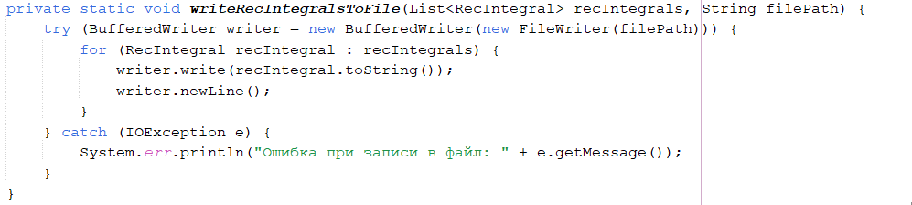
Добавил функцию для записи в бинарный файл:
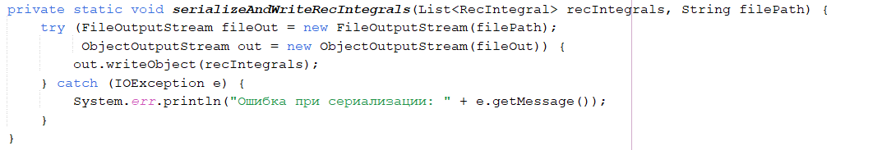
Добавил функцию для чтения из текстового файла:
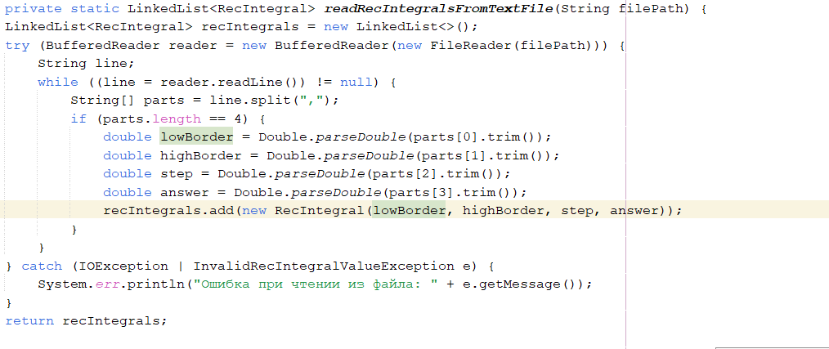
Добавил функцию для десериализации:
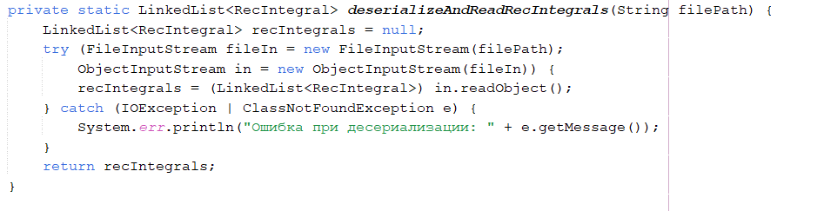

Листинг программы.
package com.mycompany.laba1;
import java.io.BufferedReader;
import java.io.BufferedWriter;
import java.io.FileInputStream;
import java.io.FileOutputStream;
import java.io.FileReader;
import java.io.FileWriter;
import java.io.IOException;
import java.io.ObjectInputStream;
import java.io.ObjectOutputStream;
import java.io.Serializable;
import java.util.LinkedList;
import java.util.List;
import javax.swing.JOptionPane;
import javax.swing.SwingUtilities;

class IntegralTask implements Runnable {
private double lowBorder;
private double highBorder;
private double step;
private int threadIndex;
private int totalThreads;
private double[] results;

public IntegralTask(double lowBorder, double highBorder, double step, int threadIndex, int totalThreads, double[] results) {
this.lowBorder = lowBorder;
this.highBorder = highBorder;
this.step = step;
this.threadIndex = threadIndex;
this.totalThreads = totalThreads;
this.results = results;
}

@Override
public void run() {
// Расчёт границ для текущего потока
double rangePerThread = (highBorder - lowBorder) / totalThreads;
double start = lowBorder + threadIndex * rangePerThread;
double end = (threadIndex == totalThreads - 1) ? highBorder : start + rangePerThread;

// Вычисление интеграла в пределах границ start и end
double localResult = 0;
for (double currentNumber = start; currentNumber <= end; currentNumber += step) {
if (currentNumber + step <= end) {
localResult += (step / 2) * (Math.sin(currentNumber) + Math.sin(currentNumber + step));
} else {
localResult += (step / 2) * (Math.sin(currentNumber) + Math.sin(end));
}
}

// Сохранение результата в массив
results[threadIndex] = localResult;
}
}

class InvalidRecIntegralValueException extends Exception {
public InvalidRecIntegralValueException(String message) {
super(message);
}
}

class RecIntegral implements Serializable {
private double lowborder;
private double highborder;
private double step;
private double answer;

RecIntegral(double inputLowBorder, double inputHighBorder, double inputStep, double inputAnswer) throws InvalidRecIntegralValueException {
validateValue(inputLowBorder);
validateValue(inputHighBorder);
validateValue(inputStep);

this.lowborder = inputLowBorder;
this.highborder = inputHighBorder;
this.step = inputStep;
this.answer = inputAnswer;
}

private void validateValue(double value) throws InvalidRecIntegralValueException {
if (value < 0.000001 || value > 1000000) {
throw new InvalidRecIntegralValueException("Значение " + value + " должно быть в диапазоне от 0,000001 до 1000000.");
}
}
@Override
public String toString() {
return lowborder + "," + highborder + "," + step + "," + answer;
}

// Геттеры
public double getLowborder() {
return lowborder;
}

public double getHighborder() {
return highborder;
}

public double getStep() {
return step;
}

public double getAnswer() {
return answer;
}

// Сеттеры
public void setLowborder(double lowborder) throws InvalidRecIntegralValueException {
validateValue(lowborder);
this.lowborder = lowborder;
}

public void setHighborder(double highborder) throws InvalidRecIntegralValueException {
validateValue(highborder);
this.highborder = highborder;
}

public void setStep(double step) throws InvalidRecIntegralValueException {
validateValue(step);
this.step = step;
}

public void setAnswer(double answer) {
this.answer = answer;
}
}

public class laba1 extends javax.swing.JFrame {
int selectedRow = 0;
String txtFilePath = "D:/3курс/java/text.txt";
String binFilePath = "D:/3курс/java/bin.txt";
LinkedList<RecIntegral> linkedList = new LinkedList<>();

public laba1() {
initComponents();
}
@SuppressWarnings("unchecked")
// <editor-fold defaultstate="collapsed" desc="Generated Code">
private void initComponents() {

jLabel1 = new javax.swing.JLabel();
jLabel2 = new javax.swing.JLabel();
jLabel3 = new javax.swing.JLabel();
jButton1 = new javax.swing.JButton();
jButton2 = new javax.swing.JButton();
jButton3 = new javax.swing.JButton();
jScrollPane1 = new javax.swing.JScrollPane();
jTable1 = new javax.swing.JTable();
hbordtextfield = new javax.swing.JTextField();
steptextfield = new javax.swing.JTextField();
lbordtextfield = new javax.swing.JTextField();
jButton4 = new javax.swing.JButton();
jButton5 = new javax.swing.JButton();
jButton6 = new javax.swing.JButton();
jButton7 = new javax.swing.JButton();
jButton8 = new javax.swing.JButton();
jButton9 = new javax.swing.JButton();

setDefaultCloseOperation(javax.swing.WindowConstants.EXIT_ON_CLOSE);

jLabel1.setText("нижняя граница");

jLabel2.setText(" шаг");

jLabel3.setText("верхняя граница");

jButton1.setText("Вычислить");
jButton1.setActionCommand("jButton3");
jButton1.addActionListener(new java.awt.event.ActionListener() {
public void actionPerformed(java.awt.event.ActionEvent evt) {
jButton1ActionPerformed(evt);
}
});

jButton2.setText("Удалить");
jButton2.setActionCommand("jButton2");
jButton2.addActionListener(new java.awt.event.ActionListener() {
public void actionPerformed(java.awt.event.ActionEvent evt) {
jButton2ActionPerformed(evt);
}
});

jButton3.setText("Добавить");
jButton3.addActionListener(new java.awt.event.ActionListener() {
public void actionPerformed(java.awt.event.ActionEvent evt) {
jButton3ActionPerformed(evt);
}
});

jTable1.setModel(new javax.swing.table.DefaultTableModel(
new Object [][] {

},
new String [] {
"Нижняя граница", "Верхняя граница", "Шаг", "Значение"
}
));
jTable1.setCursor(new java.awt.Cursor(java.awt.Cursor.DEFAULT_CURSOR));
jTable1.setShowHorizontalLines(true);
jTable1.setShowVerticalLines(true);
jScrollPane1.setViewportView(jTable1);

hbordtextfield.addActionListener(new java.awt.event.ActionListener() {
public void actionPerformed(java.awt.event.ActionEvent evt) {
hbordtextfieldActionPerformed(evt);
}
});

steptextfield.addActionListener(new java.awt.event.ActionListener() {
public void actionPerformed(java.awt.event.ActionEvent evt) {
steptextfieldActionPerformed(evt);
}
});

lbordtextfield.setName("lbordtextfield"); // NOI18N
lbordtextfield.addActionListener(new java.awt.event.ActionListener() {
public void actionPerformed(java.awt.event.ActionEvent evt) {
lbordtextfieldActionPerformed(evt);
}
});

jButton4.setLabel("Заполнить");
jButton4.addActionListener(new java.awt.event.ActionListener() {
public void actionPerformed(java.awt.event.ActionEvent evt) {
jButton4ActionPerformed(evt);
}
});

jButton5.setLabel("Очистить");
jButton5.addActionListener(new java.awt.event.ActionListener() {
public void actionPerformed(java.awt.event.ActionEvent evt) {
jButton5ActionPerformed(evt);
}
});

jButton6.setText("Загрузить из bin");
jButton6.addActionListener(new java.awt.event.ActionListener() {
public void actionPerformed(java.awt.event.ActionEvent evt) {
jButton6ActionPerformed(evt);
}
});

jButton7.setText("Сохранить в bin");
jButton7.addActionListener(new java.awt.event.ActionListener() {
public void actionPerformed(java.awt.event.ActionEvent evt) {
jButton7ActionPerformed(evt);
}
});

jButton8.setText("Загрузить из text");
jButton8.addActionListener(new java.awt.event.ActionListener() {
public void actionPerformed(java.awt.event.ActionEvent evt) {
jButton8ActionPerformed(evt);
}
});

jButton9.setText("Сохранить в text");
jButton9.addActionListener(new java.awt.event.ActionListener() {
public void actionPerformed(java.awt.event.ActionEvent evt) {
jButton9ActionPerformed(evt);
}
});

javax.swing.GroupLayout layout = new javax.swing.GroupLayout(getContentPane());
getContentPane().setLayout(layout);
layout.setHorizontalGroup(
layout.createParallelGroup(javax.swing.GroupLayout.Alignment.LEADING)
.addGroup(javax.swing.GroupLayout.Alignment.TRAILING, layout.createSequentialGroup()
.addContainerGap()
.addComponent(jScrollPane1)
.addContainerGap())
.addGroup(layout.createSequentialGroup()
.addGap(24, 24, 24)
.addGroup(layout.createParallelGroup(javax.swing.GroupLayout.Alignment.LEADING)
.addGroup(layout.createParallelGroup(javax.swing.GroupLayout.Alignment.TRAILING, false)
.addComponent(jLabel2, javax.swing.GroupLayout.Alignment.LEADING, javax.swing.GroupLayout.DEFAULT_SIZE, javax.swing.GroupLayout.DEFAULT_SIZE, Short.MAX_VALUE)
.addComponent(jLabel3, javax.swing.GroupLayout.Alignment.LEADING, javax.swing.GroupLayout.DEFAULT_SIZE, javax.swing.GroupLayout.DEFAULT_SIZE, Short.MAX_VALUE))
.addComponent(jLabel1)
.addComponent(jButton9))
.addGap(7, 7, 7)
.addGroup(layout.createParallelGroup(javax.swing.GroupLayout.Alignment.LEADING, false)
.addComponent(lbordtextfield)
.addComponent(hbordtextfield)
.addComponent(steptextfield)
.addComponent(jButton8, javax.swing.GroupLayout.DEFAULT_SIZE, javax.swing.GroupLayout.DEFAULT_SIZE, Short.MAX_VALUE))
.addGap(36, 36, 36)
.addGroup(layout.createParallelGroup(javax.swing.GroupLayout.Alignment.LEADING, false)
.addComponent(jButton7, javax.swing.GroupLayout.DEFAULT_SIZE, javax.swing.GroupLayout.DEFAULT_SIZE, Short.MAX_VALUE)
.addComponent(jButton1, javax.swing.GroupLayout.DEFAULT_SIZE, javax.swing.GroupLayout.DEFAULT_SIZE, Short.MAX_VALUE)
.addComponent(jButton2, javax.swing.GroupLayout.DEFAULT_SIZE, javax.swing.GroupLayout.DEFAULT_SIZE, Short.MAX_VALUE)
.addComponent(jButton3, javax.swing.GroupLayout.DEFAULT_SIZE, javax.swing.GroupLayout.DEFAULT_SIZE, Short.MAX_VALUE))
.addGap(35, 35, 35)
.addGroup(layout.createParallelGroup(javax.swing.GroupLayout.Alignment.TRAILING, false)
.addComponent(jButton6, javax.swing.GroupLayout.DEFAULT_SIZE, javax.swing.GroupLayout.DEFAULT_SIZE, Short.MAX_VALUE)
.addComponent(jButton4, javax.swing.GroupLayout.Alignment.LEADING, javax.swing.GroupLayout.DEFAULT_SIZE, javax.swing.GroupLayout.DEFAULT_SIZE, Short.MAX_VALUE)
.addComponent(jButton5, javax.swing.GroupLayout.Alignment.LEADING, javax.swing.GroupLayout.DEFAULT_SIZE, javax.swing.GroupLayout.DEFAULT_SIZE, Short.MAX_VALUE))
.addContainerGap(javax.swing.GroupLayout.DEFAULT_SIZE, Short.MAX_VALUE))
);
layout.setVerticalGroup(
layout.createParallelGroup(javax.swing.GroupLayout.Alignment.LEADING)
.addGroup(layout.createSequentialGroup()
.addGroup(layout.createParallelGroup(javax.swing.GroupLayout.Alignment.LEADING)
.addGroup(layout.createSequentialGroup()
.addGap(32, 32, 32)
.addGroup(layout.createParallelGroup(javax.swing.GroupLayout.Alignment.BASELINE)
.addComponent(jLabel1, javax.swing.GroupLayout.PREFERRED_SIZE, 25, javax.swing.GroupLayout.PREFERRED_SIZE)
.addComponent(jButton3)
.addComponent(lbordtextfield, javax.swing.GroupLayout.PREFERRED_SIZE, javax.swing.GroupLayout.DEFAULT_SIZE, javax.swing.GroupLayout.PREFERRED_SIZE))
.addPreferredGap(javax.swing.LayoutStyle.ComponentPlacement.UNRELATED)
.addGroup(layout.createParallelGroup(javax.swing.GroupLayout.Alignment.BASELINE)
.addComponent(jLabel3, javax.swing.GroupLayout.PREFERRED_SIZE, 25, javax.swing.GroupLayout.PREFERRED_SIZE)
.addComponent(jButton2)
.addComponent(hbordtextfield, javax.swing.GroupLayout.PREFERRED_SIZE, javax.swing.GroupLayout.DEFAULT_SIZE, javax.swing.GroupLayout.PREFERRED_SIZE))
.addPreferredGap(javax.swing.LayoutStyle.ComponentPlacement.UNRELATED)
.addGroup(layout.createParallelGroup(javax.swing.GroupLayout.Alignment.BASELINE)
.addComponent(jLabel2, javax.swing.GroupLayout.PREFERRED_SIZE, 25, javax.swing.GroupLayout.PREFERRED_SIZE)
.addComponent(jButton1)
.addComponent(steptextfield, javax.swing.GroupLayout.PREFERRED_SIZE, javax.swing.GroupLayout.DEFAULT_SIZE, javax.swing.GroupLayout.PREFERRED_SIZE)))
.addGroup(layout.createSequentialGroup()
.addGap(50, 50, 50)
.addComponent(jButton4)
.addPreferredGap(javax.swing.LayoutStyle.ComponentPlacement.UNRELATED)
.addComponent(jButton5)))
.addGroup(layout.createParallelGroup(javax.swing.GroupLayout.Alignment.LEADING)
.addGroup(layout.createSequentialGroup()
.addPreferredGap(javax.swing.LayoutStyle.ComponentPlacement.RELATED, 13, Short.MAX_VALUE)
.addGroup(layout.createParallelGroup(javax.swing.GroupLayout.Alignment.BASELINE)
.addComponent(jButton6)
.addComponent(jButton7))
.addGap(18, 18, 18))
.addGroup(layout.createSequentialGroup()
.addPreferredGap(javax.swing.LayoutStyle.ComponentPlacement.UNRELATED)
.addGroup(layout.createParallelGroup(javax.swing.GroupLayout.Alignment.BASELINE)
.addComponent(jButton8)
.addComponent(jButton9))
.addPreferredGap(javax.swing.LayoutStyle.ComponentPlacement.RELATED, javax.swing.GroupLayout.DEFAULT_SIZE, Short.MAX_VALUE)))
.addComponent(jScrollPane1, javax.swing.GroupLayout.PREFERRED_SIZE, 134, javax.swing.GroupLayout.PREFERRED_SIZE)
.addContainerGap())
);

pack();
}// </editor-fold>

private static LinkedList<RecIntegral> readRecIntegralsFromTextFile(String filePath) {
LinkedList<RecIntegral> recIntegrals = new LinkedList<>();
try (BufferedReader reader = new BufferedReader(new FileReader(filePath))) {
String line;
while ((line = reader.readLine()) != null) {
String[] parts = line.split(",");
if (parts.length == 4) {
double lowBorder = Double.parseDouble(parts[0].trim());
double highBorder = Double.parseDouble(parts[1].trim());
double step = Double.parseDouble(parts[2].trim());
double answer = Double.parseDouble(parts[3].trim());
recIntegrals.add(new RecIntegral(lowBorder, highBorder, step, answer));
}
}
} catch (IOException | InvalidRecIntegralValueException e) {
System.err.println("Ошибка при чтении из файла: " + e.getMessage());
}
return recIntegrals;
}
private static LinkedList<RecIntegral> deserializeAndReadRecIntegrals(String filePath) {
LinkedList<RecIntegral> recIntegrals = null;
try (FileInputStream fileIn = new FileInputStream(filePath);
ObjectInputStream in = new ObjectInputStream(fileIn)) {
recIntegrals = (LinkedList<RecIntegral>) in.readObject();
} catch (IOException | ClassNotFoundException e) {
System.err.println("Ошибка при десериализации: " + e.getMessage());
}
return recIntegrals;
}

private static void writeRecIntegralsToFile(List<RecIntegral> recIntegrals, String filePath) {
try (BufferedWriter writer = new BufferedWriter(new FileWriter(filePath))) {
for (RecIntegral recIntegral : recIntegrals) {
writer.write(recIntegral.toString());
writer.newLine();
}
} catch (IOException e) {
System.err.println("Ошибка при записи в файл: " + e.getMessage());
}
}
private static void serializeAndWriteRecIntegrals(List<RecIntegral> recIntegrals, String filePath) {
try (FileOutputStream fileOut = new FileOutputStream(filePath);
ObjectOutputStream out = new ObjectOutputStream(fileOut)) {
out.writeObject(recIntegrals);
} catch (IOException e) {
System.err.println("Ошибка при сериализации: " + e.getMessage());
}
}

private void jButton2ActionPerformed(java.awt.event.ActionEvent evt) {
javax.swing.table.DefaultTableModel model = (javax.swing.table.DefaultTableModel) jTable1.getModel();
model.removeRow(selectedRow);
linkedList.remove(selectedRow);
}

private void jButton3ActionPerformed(java.awt.event.ActionEvent evt) {
javax.swing.table.DefaultTableModel model = (javax.swing.table.DefaultTableModel) jTable1.getModel();

String lowborder = lbordtextfield.getText();
String highborder = hbordtextfield.getText();
String stepStr = steptextfield.getText();

double dlowborder = Double.parseDouble(lowborder);
double dhighborder = Double.parseDouble(highborder);
double dstep = Double.parseDouble(stepStr);

try {
linkedList.add(new RecIntegral(dlowborder,dhighborder,dstep, 0.0));
model.addRow(new Object[]{lowborder,highborder,stepStr, " "});
} catch (InvalidRecIntegralValueException ex) {
JOptionPane.showMessageDialog(null,ex.getMessage(), "Ошибка!", JOptionPane.ERROR_MESSAGE);
}
}

private void jButton1ActionPerformed(java.awt.event.ActionEvent evt) {
javax.swing.table.DefaultTableModel model = (javax.swing.table.DefaultTableModel) jTable1.getModel();
selectedRow = jTable1.getSelectedRow();

if (selectedRow != -1) { // Проверка, выбрана ли строка
Object lowBorderObj = model.getValueAt(selectedRow, 0);
Object highBorderObj = model.getValueAt(selectedRow, 1);
Object stepObj = model.getValueAt(selectedRow, 2);

double lowBorder = Double.parseDouble(lowBorderObj.toString());
double highBorder = Double.parseDouble(highBorderObj.toString());
double step = Double.parseDouble(stepObj.toString());

double answer = CalculationOfValue(lowBorder, highBorder, step);
ShowTheAnswer(answer);
} else {
JOptionPane.showMessageDialog(this, "Пожалуйста, выберите строку для вычисления.", "Ошибка", JOptionPane.ERROR_MESSAGE);
}

}

private double CalculationOfValue(double lowBorder, double highBorder, double step) {
int totalThreads = 12; // количество потоков
double[] results = new double[totalThreads];

// Создание и запуск потоков
Thread[] threads = new Thread[totalThreads];
for (int i = 0; i < totalThreads; i++) {
threads[i] = new Thread(new IntegralTask(lowBorder, highBorder, step, i, totalThreads, results));
threads[i].start();
}

// Ожидание завершения всех потоков
try {
for (Thread thread : threads) {
thread.join();
}
} catch (InterruptedException e) {
Thread.currentThread().interrupt();
System.err.println("Поток был прерван: " + e.getMessage());
}

// Суммируем результаты всех потоков
double totalResult = 0;
for (double result : results) {
totalResult += result;
}

return totalResult;
}

private void ShowTheAnswer(double answer) {
SwingUtilities.invokeLater(() -> {
javax.swing.table.DefaultTableModel model = (javax.swing.table.DefaultTableModel) jTable1.getModel();
model.setValueAt(answer, selectedRow, 3);
RecIntegral recIntegral = linkedList.get(selectedRow);
recIntegral.setAnswer(answer);
});
}

private void steptextfieldActionPerformed(java.awt.event.ActionEvent evt) {
// TODO add your handling code here:
}

private void lbordtextfieldActionPerformed(java.awt.event.ActionEvent evt) {
// TODO add your handling code here:
}

private void hbordtextfieldActionPerformed(java.awt.event.ActionEvent evt) {
// TODO add your handling code here:
}

private void jButton4ActionPerformed(java.awt.event.ActionEvent evt) {
javax.swing.table.DefaultTableModel model = (javax.swing.table.DefaultTableModel) jTable1.getModel();

for (RecIntegral ri : linkedList) {
model.addRow(new Object[]{ri.getLowborder(), ri.getHighborder(), ri.getStep(), ri.getAnswer()});
}
}

private void jButton5ActionPerformed(java.awt.event.ActionEvent evt) {
javax.swing.table.DefaultTableModel model = (javax.swing.table.DefaultTableModel) jTable1.getModel();
model.setRowCount(0);
}

private void jButton6ActionPerformed(java.awt.event.ActionEvent evt) {
linkedList = deserializeAndReadRecIntegrals(binFilePath);
javax.swing.table.DefaultTableModel model = (javax.swing.table.DefaultTableModel) jTable1.getModel();
model.setRowCount(0);
for (RecIntegral ri : linkedList) {
model.addRow(new Object[]{ri.getLowborder(), ri.getHighborder(), ri.getStep(), ri.getAnswer()});
}
}

private void jButton7ActionPerformed(java.awt.event.ActionEvent evt) {
serializeAndWriteRecIntegrals(linkedList,binFilePath);
}

private void jButton8ActionPerformed(java.awt.event.ActionEvent evt) {
linkedList = readRecIntegralsFromTextFile(txtFilePath);
javax.swing.table.DefaultTableModel model = (javax.swing.table.DefaultTableModel) jTable1.getModel();
model.setRowCount(0);
for (RecIntegral ri : linkedList) {
model.addRow(new Object[]{ri.getLowborder(), ri.getHighborder(), ri.getStep(), ri.getAnswer()});
}
}

private void jButton9ActionPerformed(java.awt.event.ActionEvent evt) {
writeRecIntegralsToFile(linkedList,txtFilePath);
}

public static void main(String args[]) {

java.awt.EventQueue.invokeLater(new RunnableImpl());
}

// Variables declaration - do not modify
private javax.swing.JTextField hbordtextfield;
private javax.swing.JButton jButton1;
private javax.swing.JButton jButton2;
private javax.swing.JButton jButton3;
private javax.swing.JButton jButton4;
private javax.swing.JButton jButton5;
private javax.swing.JButton jButton6;
private javax.swing.JButton jButton7;
private javax.swing.JButton jButton8;
private javax.swing.JButton jButton9;
private javax.swing.JLabel jLabel1;
private javax.swing.JLabel jLabel2;
private javax.swing.JLabel jLabel3;
private javax.swing.JScrollPane jScrollPane1;
private javax.swing.JTable jTable1;
private javax.swing.JTextField lbordtextfield;
private javax.swing.JTextField steptextfield;
// End of variables declaration

private static class RunnableImpl implements Runnable {

public RunnableImpl() {
}

@Override
public void run() {
new laba1().setVisible(true);
}
}
}

