**Credit Spread Analysis Report**

## Executive Summary

This report investigates the evolution of credit spreads between corporate bonds and government securities over the past decade, using daily data pulled from the FRED database. I focus on Moody’s AAA and BAA corporate bonds and the ICE BofA US High Yield Master II Index. By comparing these with the 10-Year Treasury yield, I aim to assess market perceptions of credit risk and their sensitivity to macroeconomic conditions. The results are visualized through static plots and interactive dashboards, revealing clear trends and risk premiums associated with different credit qualities.

## Methodology

Using Python and the FRED API, I extracted daily yields from 2015 to present for:  
- Government Bonds: DGS1, DGS5, DGS10, DGS30 (Treasury yields)  
- Corporate Bonds: Moody’s AAA (FRED/AAA), BAA (FRED/BAA), and High Yield (FRED/BAMLH0A0HYM2)  
  
Credit spreads were calculated as the difference between corporate bond yields and the 10-year Treasury yield. Missing data were forward-filled to maintain time series continuity. The results were plotted using both Matplotlib and Plotly for exploratory and comparative analysis.

## Visualizations of Credit Spreads

Below are screenshots of the plotted credit spreads over time.

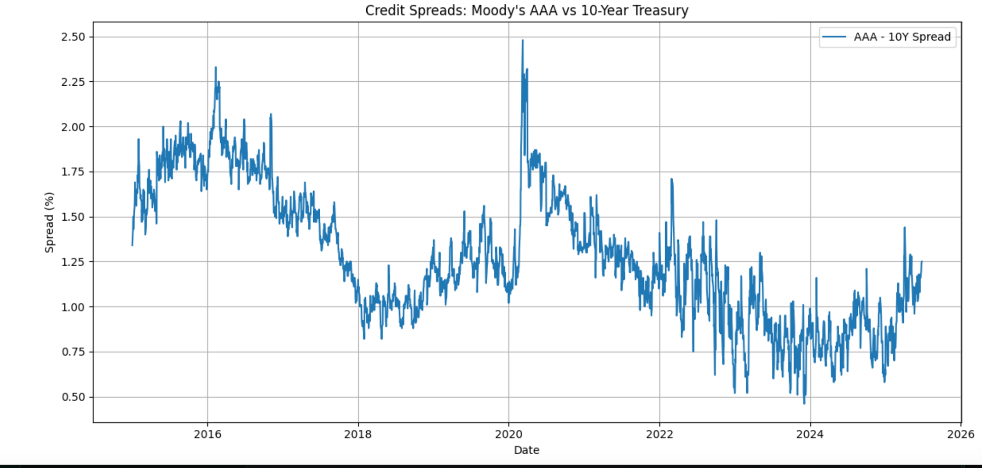

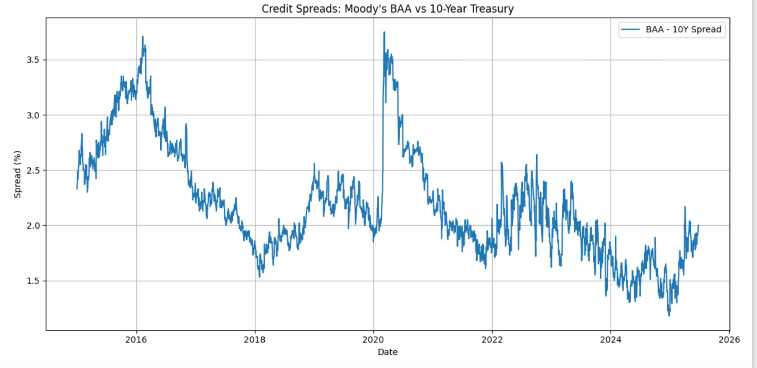

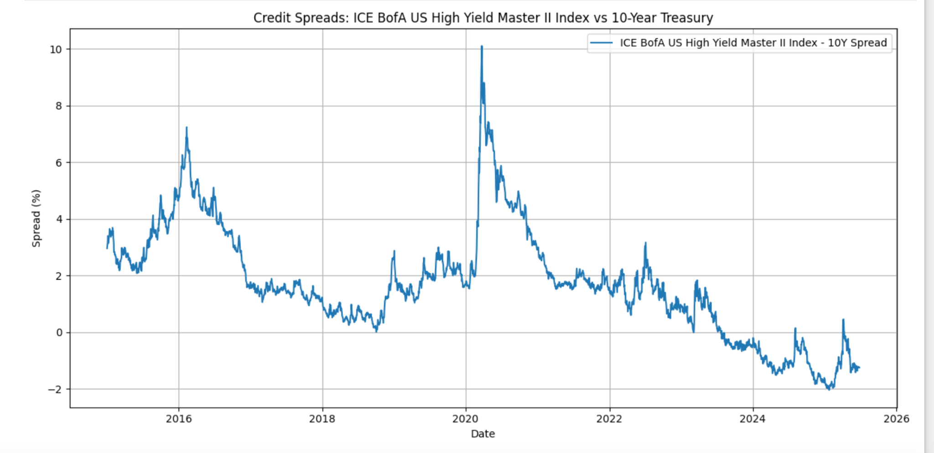

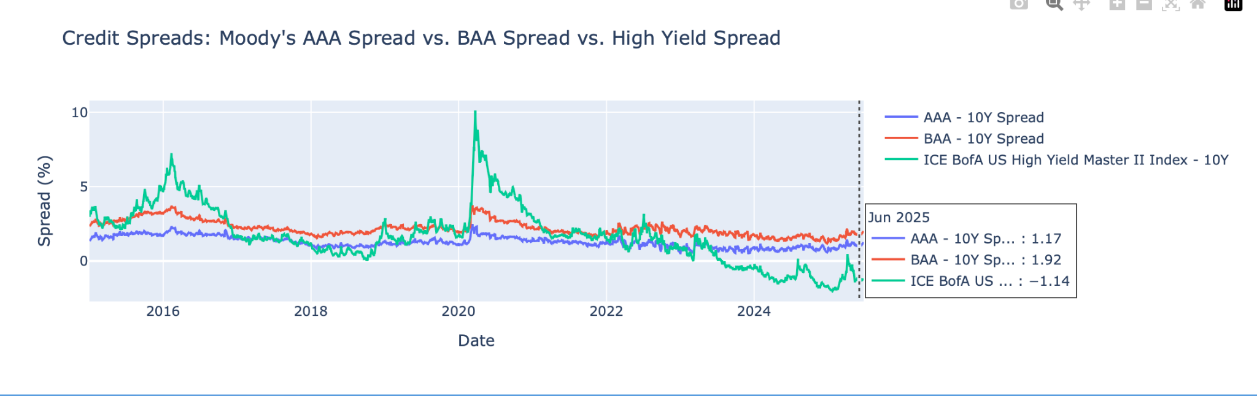

## Analysis of Credit Spreads

The spread between Moody’s AAA-rated corporate bonds and the 10-Year Treasury yield has remained relatively stable, averaging between 1.0% and 2.0%, with noticeable widening during periods of market stress—most notably in early 2020 due to the COVID-19 pandemic. Since then, the AAA spread has gradually narrowed, indicating renewed confidence in investment-grade issuers.  
  
BAA-rated bonds show higher and more volatile spreads, averaging between 1.5% and 3.0%. This reflects increased credit risk and sensitivity to economic downturns. The spread spike in 2020 mirrors the flight-to-safety phenomenon, where investors favored government bonds, sharply increasing the spread.  
  
The ICE BofA High Yield Index exhibits the most volatility, with spreads ranging from 2.5% to above 10%. High yield spreads are strongly influenced by economic expectations, interest rates, and market liquidity. The massive spike in early 2020 indicates extreme market fear and deteriorated credit conditions. However, spreads have compressed significantly since, indicating risk-on sentiment and a search for yield amid low-rate environments.

## Impact of Macroeconomic Factors

Several macroeconomic forces influence credit spreads:  
  
- Federal Reserve Policy: Interest rate hikes and quantitative tightening typically widen credit spreads as borrowing becomes more expensive and risk premiums increase. Conversely, rate cuts and liquidity injections compress spreads.  
- Inflation: Elevated inflation leads to increased uncertainty and can widen spreads, especially for lower-rated bonds.  
- Economic Growth: Strong GDP growth compresses spreads due to reduced default risk, while recessions widen them.  
- Market Volatility: Events such as the COVID-19 pandemic, geopolitical tensions, and banking crises can cause sudden and sharp spread widening.

## Comparative Dashboard Insight

The interactive Plotly dashboard provides a consolidated view of how AAA, BAA, and High Yield spreads evolve concurrently. Key observations include:  
  
- The spread hierarchy (AAA < BAA < HY) holds consistently, reflecting market-assessed credit risk.  
- During periods of crisis, all spreads rise—but the high yield segment reacts disproportionately.  
- Post-2022, spread compression was slower in BAA and HY compared to AAA, indicating residual credit concerns among lower-rated bonds.

## Actionable Insights

- Investors can use widening spreads as a signal to reduce risk exposure, especially in high-yield portfolios.  
- AAA spreads are relatively stable, making them suitable benchmarks for conservative fixed income strategies.  
- Persistent divergence between BAA and AAA spreads may indicate a deteriorating credit outlook.  
- High Yield spreads can be used as an early warning indicator for recession or financial instability.  
- Macro-driven changes (like Fed rate decisions) should be monitored alongside spread dynamics to adjust portfolio risk accordingly.