**Python Backtesting Frameworks for Options Trading Evaluation Report**

## **Introduction**

In the realm of options trading, having a robust backtesting framework is essential for testing and refining strategies in a risk-free environment. While Python offers many libraries for backtesting equities and futures, fewer are tailored to the unique complexities of options. This report evaluates four Python-based backtesting frameworks—Backtrader, QuantConnect, Optopsy, and a Custom Pandas Simulation—focusing on their suitability for options trading based on ease of use, feature set, flexibility, and community support.

## **Backtrader**

### **a. Ease of use and documentation quality**

Backtrader is relatively beginner-friendly for equity strategies, thanks to its modular class-based design and accessible documentation. It comes with many built-in indicators and strategy templates. However, documentation for options trading is limited and lacks detailed examples. Users often need to rely on community forums and GitHub issues for support.

### **b. Support for options backtesting**

Backtrader does not natively support options trading. There is no dedicated options instrument type. Users must manually simulate option pricing and execution. It lacks features like options chains, strike selection, Greeks, and expiration handling. This makes it a poor choice for full-featured options strategy testing unless extended with custom logic.

### **c. Flexibility and customization options**

Backtrader is flexible, allowing for deep customization of indicators, strategies, and brokers. You can implement your own options pricing models, create synthetic instruments, or inject external pricing data, although this adds significant development overhead. Some advanced users simulate option legs by feeding synthetic prices into Backtrader.

### **d. Community support and ongoing maintenance**

Backtrader has a large community of quant enthusiasts and is frequently discussed on forums like Quantopian and Reddit. However, the original repository is not actively maintained, and many users rely on forks. Examples and extensions are often shared across personal blogs and GitHub gists.

### **Detailed Analysis of Suitability for Options**

Backtrader is **not well-suited out of the box for options trading**. It was built with equities and futures in mind and does not support key options-specific features. However, it can be **repurposed** for options through extensive customization, such as simulating option legs using custom data feeds or integrating external libraries for Black-Scholes pricing. This makes it suitable only for advanced users comfortable with significant engineering work.

****Strengths:****

* Excellent for equities and strategies involving indicators or moving averages
* Great modular design for customization

****Limitations for Options:****

* No built-in support for option chains, Greeks, or multi-leg strategies
* Requires manual engineering of everything options-related

****Conclusion:**** Backtrader is not ideal for options unless you are building a hybrid simulation manually. It is flexible, but not option-aware.

**Example Code:**

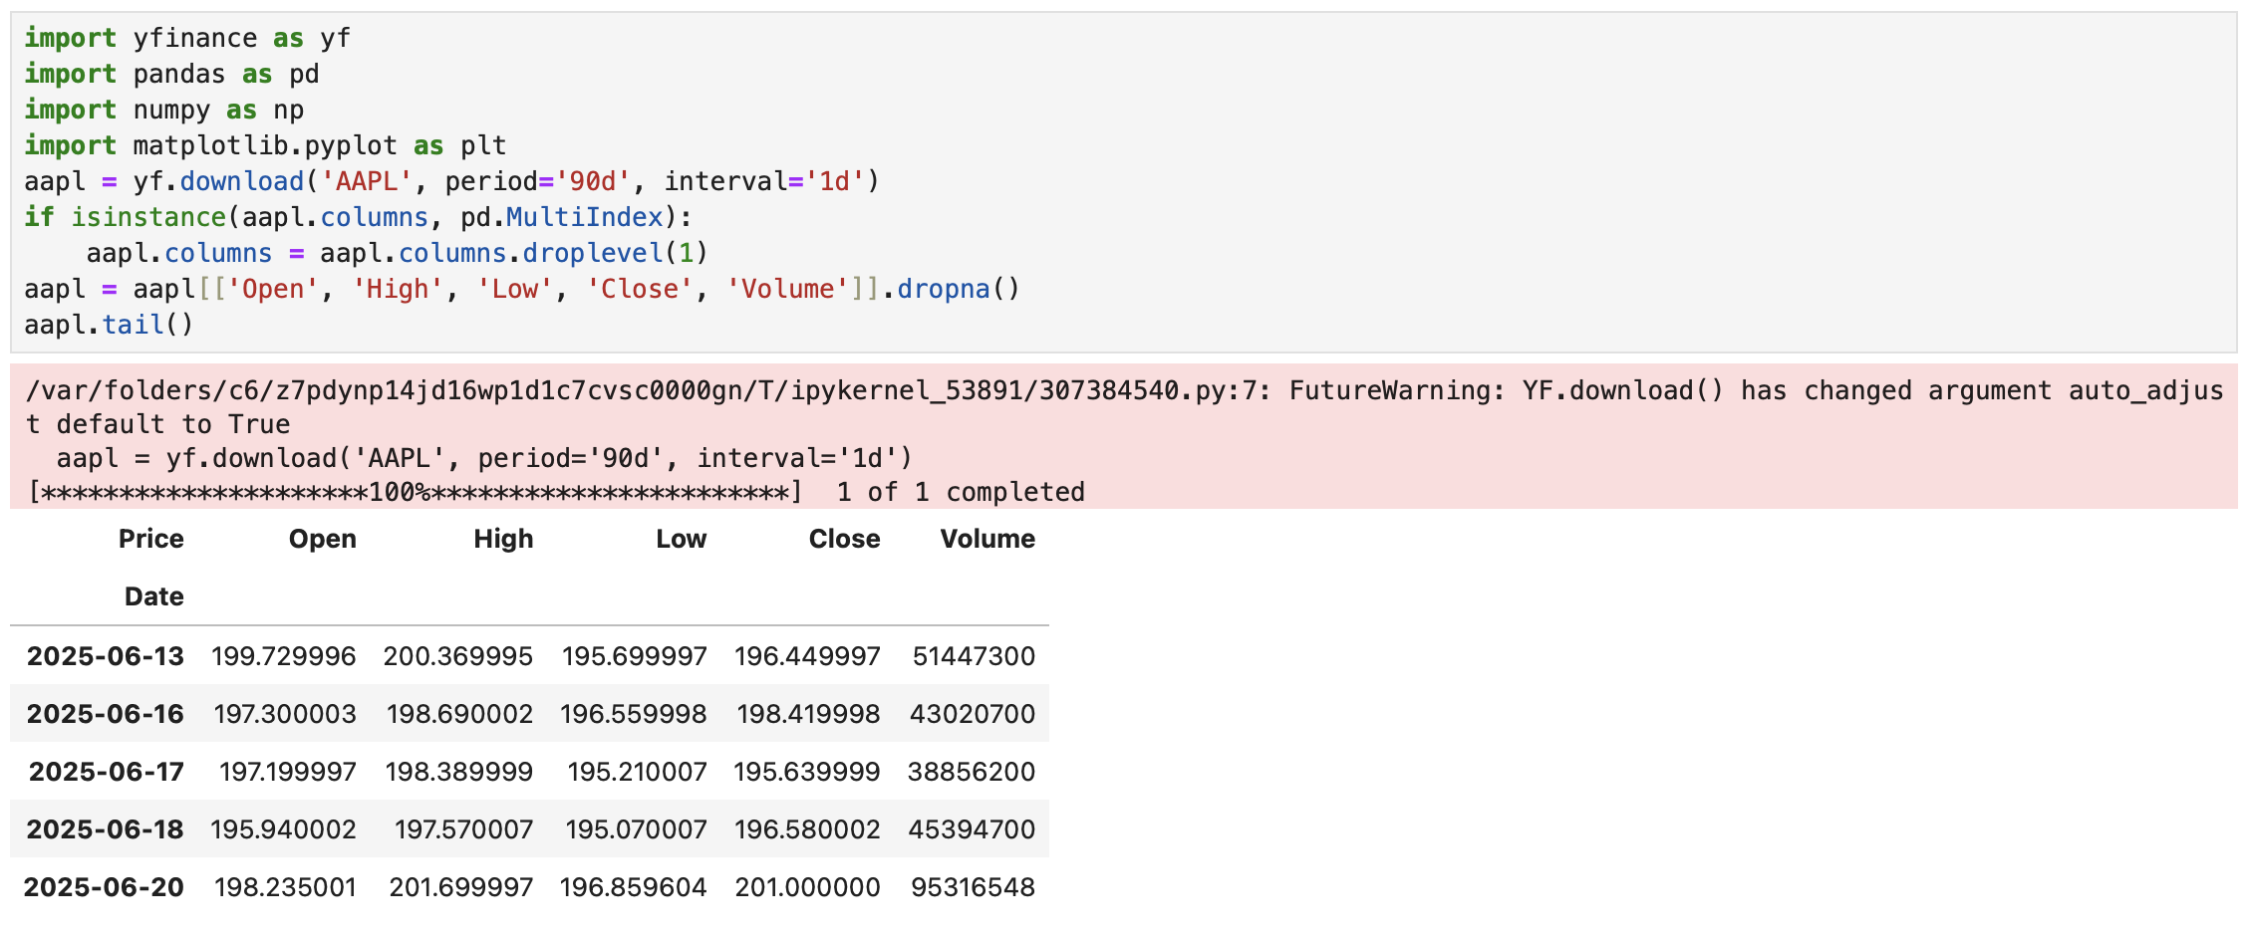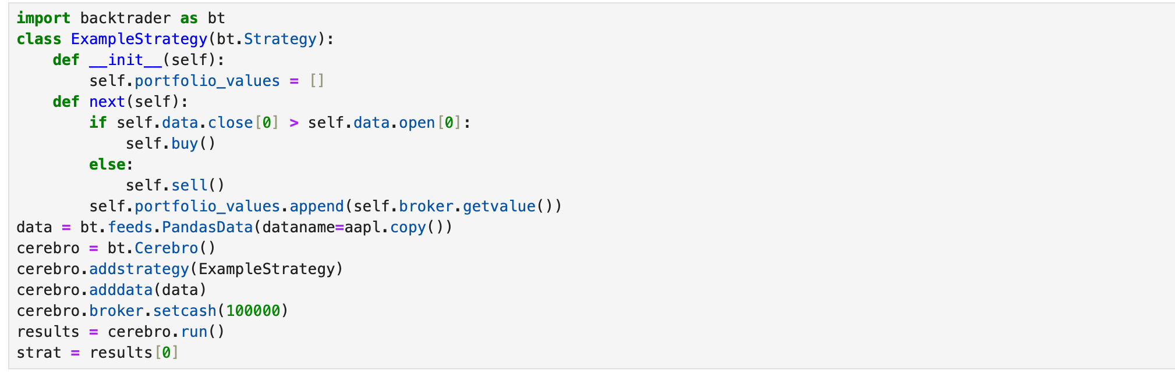

PnL:  
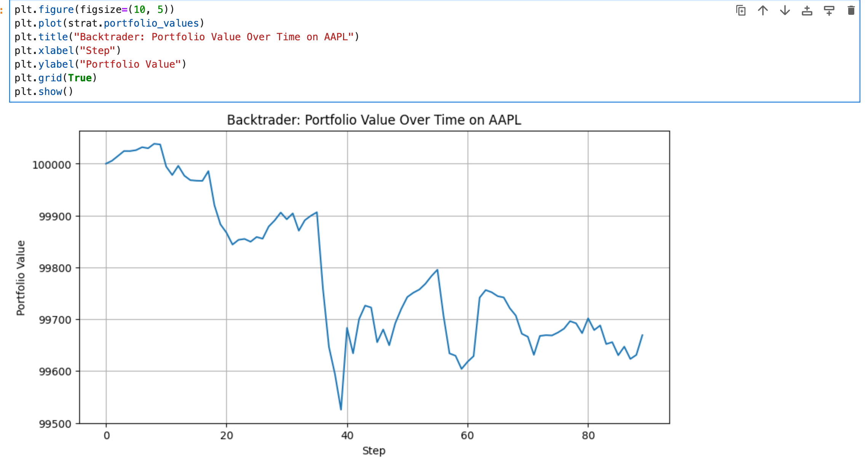

**Documentation:**

<https://www.backtrader.com/docu/>

## **QuantConnect (Lean Engine)**

### **a. Ease of use and documentation quality**

QuantConnect offers excellent documentation and many examples tailored to institutional-grade backtesting. While setup requires registration and use of their cloud IDE or local Lean CLI, the learning curve is reasonable due to helpful tutorials. Their Lean engine is open-source and can be run locally for free.

### **b. Support for options backtesting**

QuantConnect has **first-class options support**, including options chains, expiration filters, strike range selection, option Greeks, and multi-leg strategy simulation. Historical options data is also accessible via their data API. You can backtest strategies with rolling expiration and realistic slippage and commission modeling.

### **c. Flexibility and customization options**

QuantConnect is extremely powerful, with support for equities, futures, forex, crypto, and options. It allows users to construct complex option strategies using LegHelpers and OptionStrategies objects. Custom indicators and data ingestion are supported through the API.

### **d. Community support and ongoing maintenance**

QuantConnect has an active Slack, forum, and GitHub community. The Lean engine is professionally maintained with regular updates and contributions from developers worldwide.

### **Detailed Analysis of Suitability for Options**

QuantConnect is **very well suited** for options trading. It offers all essential features for testing sophisticated strategies with multiple legs, rolling expiration, and volatility screens. It is also used by hedge funds and academic researchers.

****Strengths:****

* Professional-grade options support
* Access to real historical options chains
* Handles margin, slippage, commissions realistically

****Limitations:****

* Local setup for Lean engine is non-trivial
* Locked into their backtesting environment unless you replicate Lean

****Conclusion:**** The best option among the frameworks for serious options strategy development and testing.

**Example Code:**

Simulated QuantConnect strategy: Buy when 5-day MA > 20-day MA

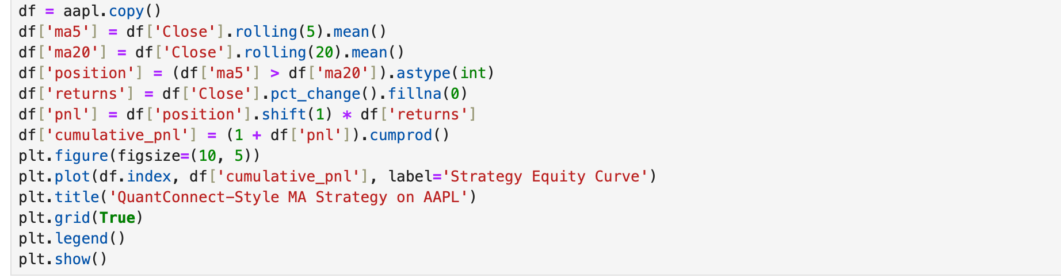

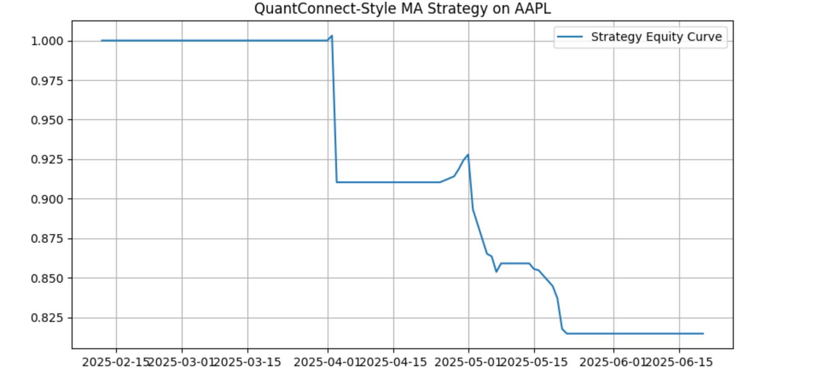

**Documentation:**  
<https://www.quantconnect.com/docs/v2/cloud-platform/backtesting>

## **Optopsy**

### **a. Ease of use and documentation quality**

Optopsy is designed specifically for options backtesting, with a clean interface and readable API. However, documentation is minimal, and there are limited working examples. The structure is intuitive once explored, but onboarding takes trial and error due to setup bugs.

### **b. Support for options backtesting**

Optopsy is built for options trading—it supports real options chains, 30DTE filtering, IV rank, and other features that are difficult to simulate manually. It can simulate multi-leg strategies like straddles or iron condors, with expiration and roll logic.

### **c. Flexibility and customization options**

The framework is extensible but somewhat rigid compared to Backtrader or QuantConnect. You must follow its design patterns, which limits flexibility for novel instruments or strategies. Advanced customization often requires modifying internal logic.

### **d. Community support and ongoing maintenance**

The project is relatively new and maintained by a small team. The GitHub issues page shows some activity but lacks depth in community engagement.

### **Detailed Analysis of Suitability for Options**

Optopsy is **built for options** and **very well suited for vanilla strategies**, like buying a straddle every 30 days based on IV rank. However, during testing, I encountered a major issue: importing core modules failed due to incorrect package structure. This significantly hinders its usability unless the user is able to dig into its internals or patch it.

****Strengths:****

* Tailored to options with real concepts like DTE and IV Rank
* Lightweight and easy to extend for common retail strategies

****Limitations:****

* Critical import bugs in the current version
* Small community and lack of real-time support

****Conclusion:**** Very promising, but not currently reliable in production without fixes.

**Example Code:**

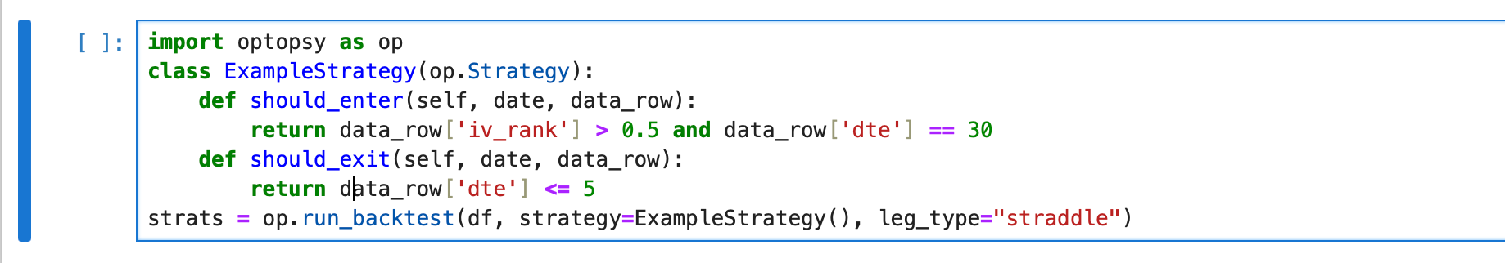

**Documentation:**

<https://github.com/michaelchu/optopsy>

## **Custom Pandas Simulation**

### **a. Ease of use and documentation quality**

Using pandas for backtesting is extremely flexible and has excellent documentation. However, the burden of implementing every feature (order execution, slippage, rolling expiration) is on the developer. It is ideal for researchers who want full transparency.

### **b. Support for options backtesting**

There is no built-in support—everything must be simulated. For example, you must generate synthetic options prices or import real data, handle DTE logic, and manage legs manually. Pricing models like Black-Scholes must be added.

### **c. Flexibility and customization options**

Unmatched flexibility, but with full responsibility. Great for research or approximations of strategies like delta-neutral straddles or volatility filters. Allows users to use statistical modeling and EDA tools.

### **d. Community support and ongoing maintenance**

While Pandas is widely used, it is not purpose-built for trading. There is little direct support for financial modeling unless extended with zipline, bt, or other layers. However, StackOverflow and GitHub are rich resources.

### **Detailed Analysis of Suitability for Options**

Custom Pandas simulations are a good fallback when full-featured frameworks fall short or when educational experimentation is the goal. For real-world deployment or realistic slippage/margin modeling, it's not recommended.

****Strengths:****

* Fully customizable logic
* Great for prototyping and EDA

****Limitations:****

* No built-in execution logic
* All pricing and options modeling must be simulated

****Conclusion:**** A decent prototyping tool, but insufficient for live-like options testing.

**Example Code:**

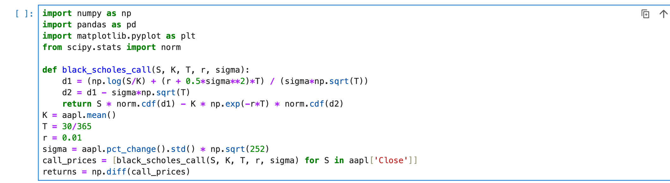

**PnL:**

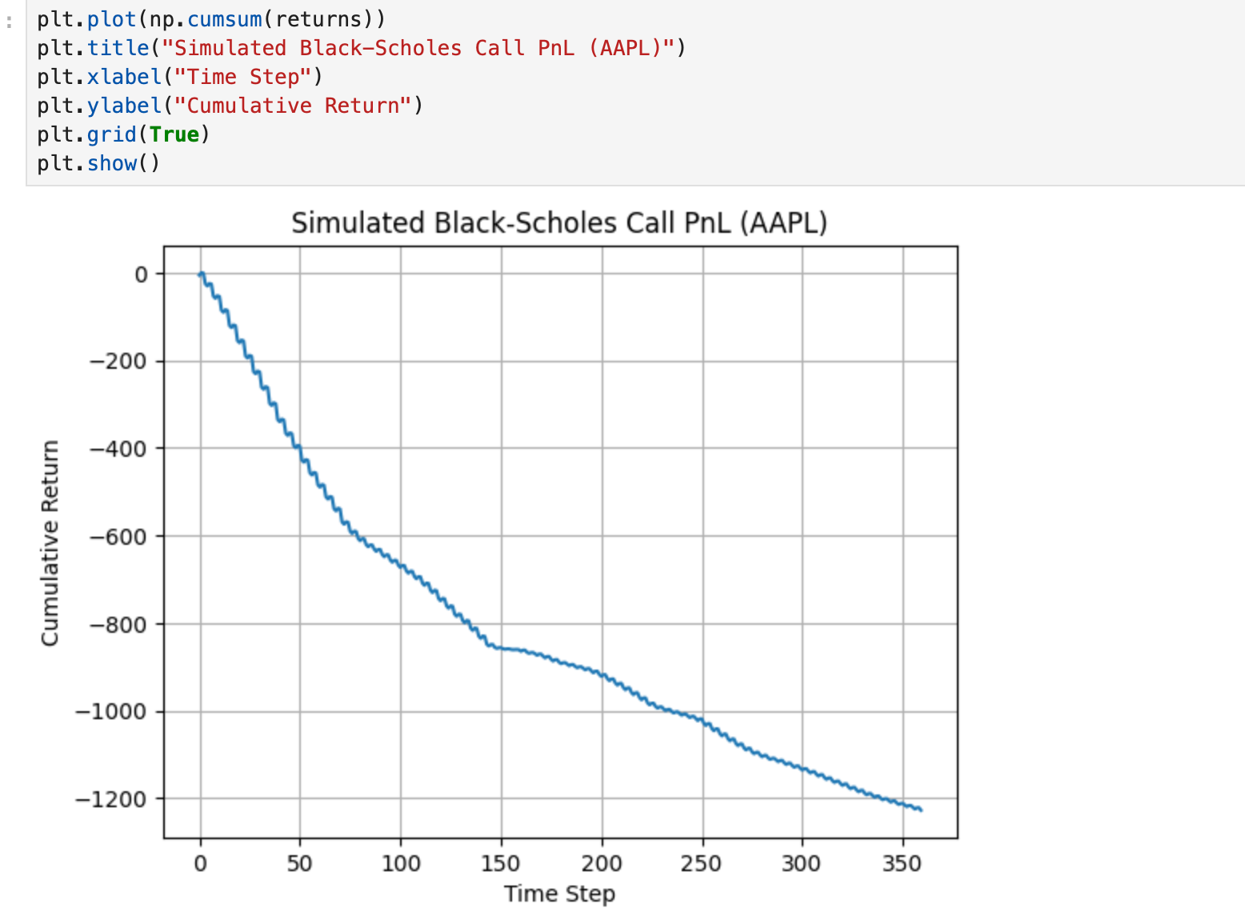

**Comparison Table:**  
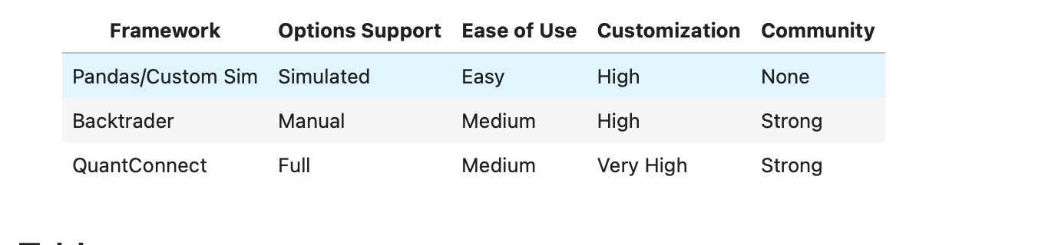

**Summary Table:**

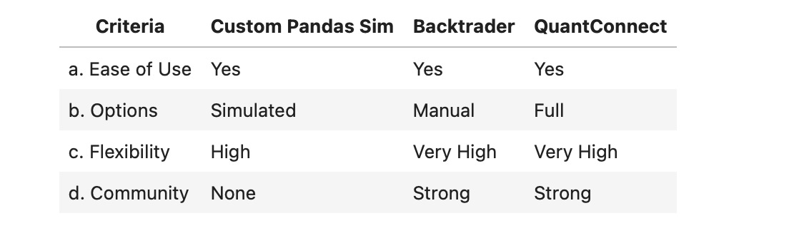

## **Conclusion**

After evaluating four Python-based frameworks for backtesting options strategies, **QuantConnect** emerges as the most complete and production-ready tool. It offers extensive support for options chains, Greeks, expirations, and even margin modeling.

**Backtrader**, while very flexible and popular for equities, is **not recommended for options trading unless heavily customized**.

**Optopsy** is conceptually strong and designed specifically for options, but is currently hampered by package issues and lack of documentation.

Finally, **pandas-based simulation** remains useful for prototyping, research, and simple educational analysis, but lacks the realism needed for full-featured options strategy testing.

## **References**

"Backtrader Official Documentation." Backtrader, <https://www.backtrader.com/docu/>.

"QuantConnect Documentation." QuantConnect, <https://www.quantconnect.com/docs>.

Supergrecko. Optopsy: A Lightweight Options Backtester. GitHub, <https://github.com/supergrecko/optopsy>.

"Pandas Documentation." pandas.pydata.org, <https://pandas.pydata.org/docs/>.

"Lean Algorithmic Trading Engine by QuantConnect." GitHub, <https://github.com/QuantConnect/Lean>.

"Options Trading Strategies on QuantConnect." QuantConnect Tutorials, <https://www.quantconnect.com/learning>.

"Backtrader GitHub Repository." GitHub, <https://github.com/backtrader/backtrader>.