**US Market Sector Analysis**

**The 11 Industry Sectors of the US Market**

The Global Industry Classification Standard (GICS), developed by MSCI and S&P Dow Jones Indices, categorizes the US stock market into 11 primary sectors. These sectors are designed to group companies with similar business activities, allowing investors and analysts to evaluate performance and trends at a granular level.

The 11 GICS sectors are: Information Technology, Health Care, Financials, Consumer Discretionary, Communication Services, Industrials, Consumer Staples, Energy, Utilities, Real Estate, and Materials.

**Most Important Financial Metrics by Sector**

|  |  |  |
| --- | --- | --- |
| Sector | Key Metrics | Why These Metrics Matter |
| Information Technology | PE Ratio, ROE | Technology companies often exhibit rapid growth and high valuations. The PE ratio helps assess whether their earnings justify their price. ROE is crucial because it indicates how effectively a tech firm uses shareholders' equity to generate profits, reflecting management's value creation ability. |
| Health Care | ROE, ROA | Health care companies invest heavily in R&D and have long product cycles. ROE captures shareholder value creation, while ROA measures how efficiently assets are used—especially important in capital-intensive drug development and biotech sectors. |
| Financials | ROE, Debt-to-Equity | Financial institutions generate profits from asset and liability management. ROE measures profitability from equity investments. Debt-to-equity is key for evaluating financial leverage, a critical risk indicator in banking and insurance. |
| Consumer Discretionary | PE, ROA | These firms depend on consumer spending and have volatile revenues. PE assesses market sentiment and earnings strength, while ROA gauges operational efficiency and asset utilization in competitive industries. |
| Communication Services | EBITDA, PE | These companies often require large upfront infrastructure investment. EBITDA reflects operational profitability before financing or tax impacts. PE adds a valuation lens relevant to monetization models in telecom and media. |
| Industrials | ROE, Debt-to-Equity | Efficiency in capital deployment is key in this sector with cyclical demand. ROE tracks return generation from equity while debt-to-equity highlights how companies finance capital-intensive operations. |
| Consumer Staples | Dividend Yield, ROA | These firms generate steady cash flows due to inelastic demand. Dividend yield is critical for income-focused investors. ROA measures how effectively firms convert assets into earnings in this low-margin sector. |
| Energy | ROA, Debt-to-Equity | Given the sector’s exposure to commodity cycles and high capital costs, ROA helps track efficiency of asset utilization. Debt-to-equity reflects financial risk from large infrastructure investments and volatile cash flows. |
| Utilities | Dividend Yield, Debt-to-Equity | Utilities are stable, regulated industries valued for consistent dividends. Dividend yield indicates income potential. Due to heavy capital spending, debt-to-equity is essential to assess long-term solvency. |
| Real Estate | PE, Debt-to-Equity | REITs and real estate firms generate steady rental income. While Funds From Operations (FFO) is ideal, PE serves as a widely accessible proxy for valuation. Debt-to-equity reveals financing structure—a key concern in a sector driven by debt-financed asset acquisition. |
| Materials | PE, ROA | This sector is closely tied to global demand and raw material costs. PE indicates valuation amid volatile earnings. ROA measures how well firms manage resources in production-heavy, commodity-based businesses. |

## Source of Data

All data was sourced using live S&P 500 tickers from Wikipedia and financial metrics from Yahoo Finance via Python’s yfinance API.

## Sector Ranking Visualizations

### Information Technology – Top 5 Companies

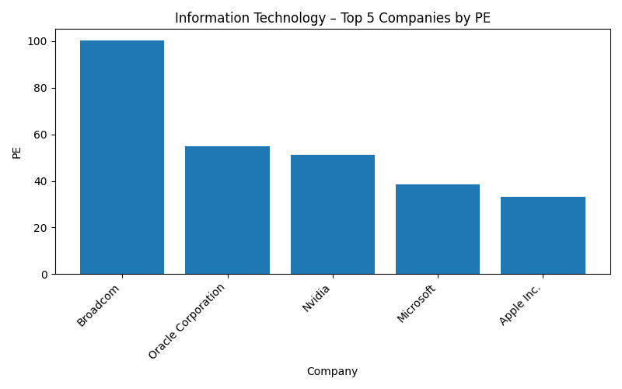

### Health Care – Top 5 Companies

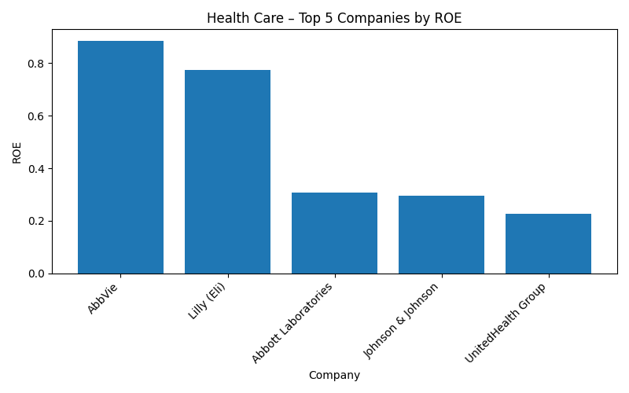

### Financials – Top 5 Companies

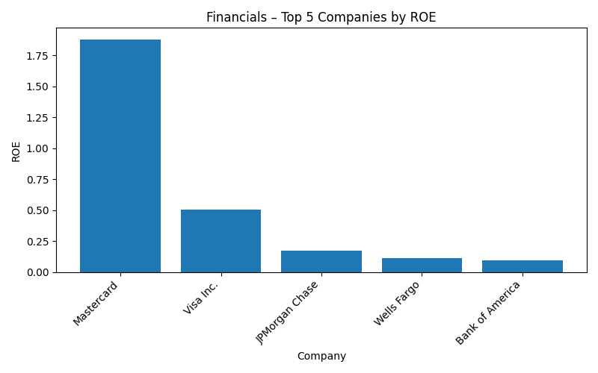

### Consumer Discretionary – Top 5 Companies

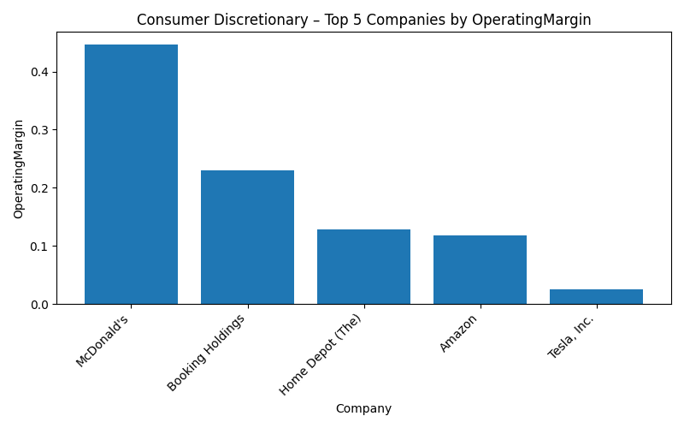

### Communication Services – Top 5 Companies

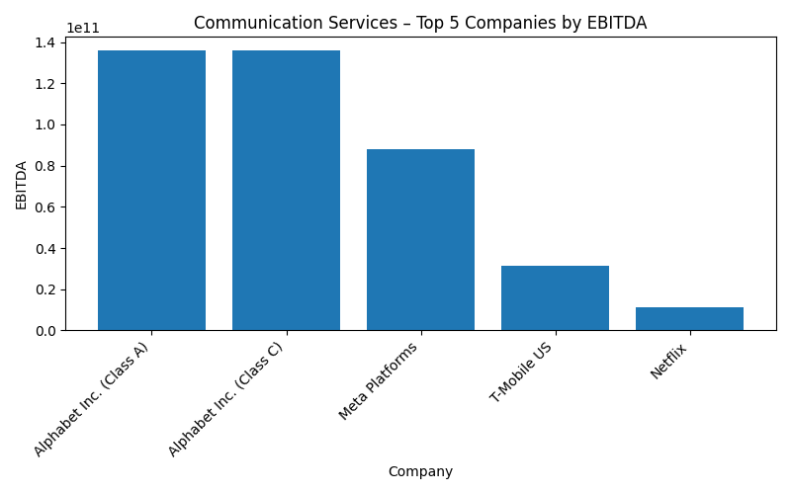

### Industrials – Top 5 Companies

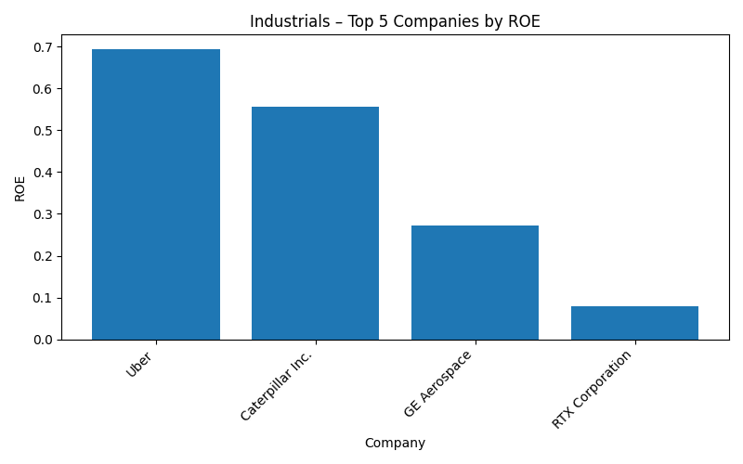

### Consumer Staples – Top 5 Companies

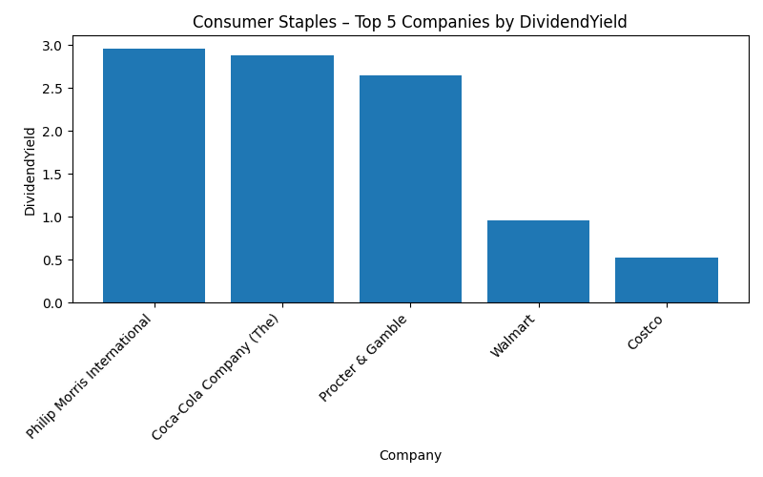

### Energy – Top 5 Companies

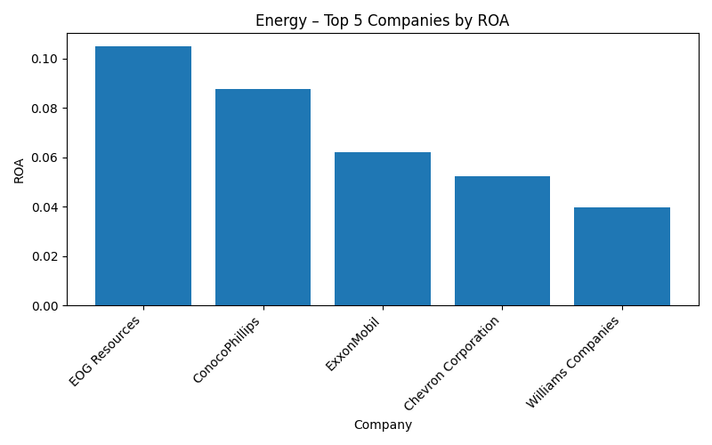

### Utilities – Top 5 Companies

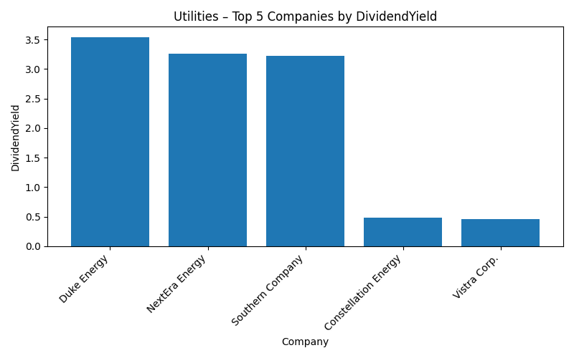

### Real Estate – Top 5 Companies

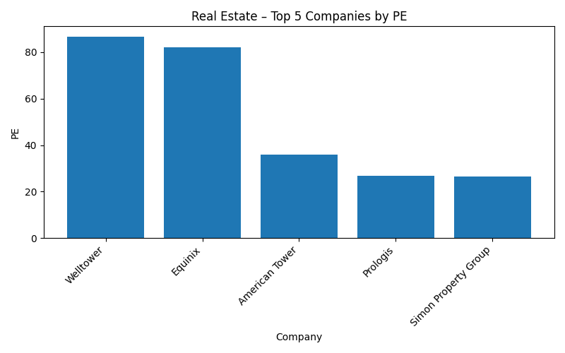

### Materials – Top 5 Companies

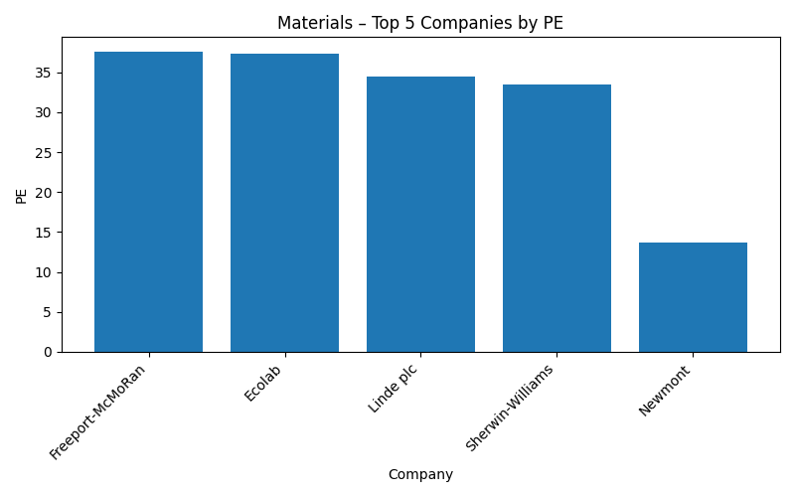

References

Investopedia – Key Financial Ratios: <https://www.investopedia.com/terms/k/keyfinancialratios.asp>

Yahoo Finance: <https://finance.yahoo.com/>

Wikipedia – List of S&P 500 companies: <https://en.wikipedia.org/wiki/List_of_S%26P_500_companies>

MSCI GICS Documentation: <https://www.msci.com/our-solutions/indexes/gics>

S&P Global – Sector Definitions: <https://www.spglobal.com/spdji/en>/