**Task: Asynchronous Requests**

1. Import the following modules at the start of your algorithm

2. Create the following variables:

3. Create a list that contains all 1000 tickers. Hint: the print(len(tickers)) should print 1000

4. Create the event loop and run it using the following code:

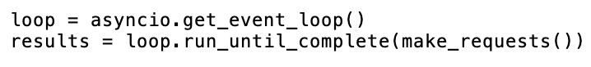

5. Create the asynchronous function “fetch” that makes request to the specified URL using the “aiohttp” library. Ignore rate limiting for this exercise.

6. Create the asynchronous function “make_requests” that makes multiple requests concurrently to the Polygon.io API. Create a context manager that creates and manages an asynchronous HTTP session. Create an empty list of tasks and use a function that creates a list of all the tasks. Use the gather function to concurrently run multiple coroutines.

7. Obtain the opening price for each ticker in “tickers”

8. Print out each stock’s ticker and opening price

9. Save your algorithm as a “.py” file in your documents folder:

10. Run your algorithm from the terminal (change directory to documents before running code)

