**Task: Asynchronous Requests 2 (Part 1)**

1. Import the following modules at the start of your algorithm

2. Create the following variables:

3. Create a list that contains all 1000 tickers. Hint: the print(len(tickers)) should print 1000

4. Create the asynchronous function “fetch”

5. Create the asynchronous function “make_requests” that makes requests to the Polygon.io API

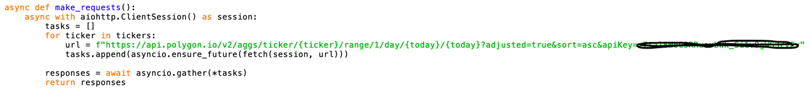

6. Create the event loop and run it using the following code:

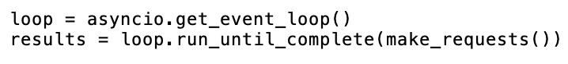

6. For each ticker in “tickers” create an object containing the stock’s ticker, its opening price, and its last trading price

Hint: The last trading price can be found parsing through the returned JSON object by using “c”. Before 4pm, the closing price is equivalent to the last trading price

7. Rank the stock objects from highest to lowest difference

8. Print out the 15 stocks with the highest difference

9. Save your algorithm as a “.py” file in your documents folder:

10. Run your algorithm from the terminal (change directory to documents before running code)

