**Task: Asynchronous Requests 2 (Part 2)**

Overview: Take your list of 15 stocks and simultaneously create 15 candlestick graphs with 5 columns and 3 rows

1. Import the following modules at the start of your algorithm

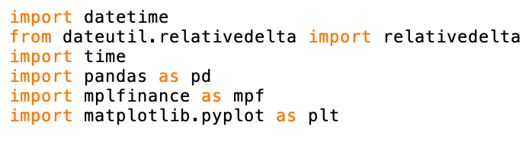

2. Create the “starttime” and “endtime” variables:

3. Obtain the minute by minute data for each stock by making a request to the Polygon.io (<https://polygon.io/docs/stocks/get_v2_aggs_ticker__stocksticker__range__multiplier___timespan___from___to>) and you will get a JSON object as a return value.

Hint: Use an f-string with the two variables from step 3 for the “from” and “to” parameters

4. For each stock create list of it’s minute by minute open price, close price, high price, low price, and volume.

5. For each stock create an empty dataframe using pandas

6. For each stock manipulate the first column in the dataframe so that it displays the time, starting at 9:30am and increasing by one minute each row

7. Create subplots



8. Plot each subplot with mplfinance using the specified parameters



9. Show the subplot



10. Save your algorithm as a “.py” file in your documents folder:

11. Run your algorithm from the terminal (change directory to documents before running code)

