**Task: 3 Month Price Graph using mplfinance**

1. Import the following modules at the start of your algorithm

2. Create the “current_date” and “past_date” variables:

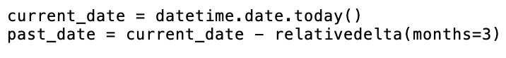

3. Use the input function to specify the ticker you want to obtain news for

4. Obtain the day by day data for the stock you picked by making a request to the Polygon.io (<https://polygon.io/docs/stocks/get_v2_aggs_ticker__stocksticker__range__multiplier___timespan___from___to>) and you will get a JSON object as a return value.

Hint: Use an f-string with the three variables from step 2 and 3 for the “stocksTicker”, “from”, and “to” parameters

5. Create a list of the stock’s day by day open price

6. Create a list of the stock’s day by day close price

7. Create a list of the stock’s day by day high price

8. Create a list of the stock’s day by day low price

9. Create a list of the stock’s day by day volume

10. Create an empty dataframe using pandas

11. Add 5 columns to the data frame (one for each of the following: open, close, high, low, and volume.

12. Manipulate the first column in the dataframe so that it displays the time. It doesn’t matter which time you use since we will be omitting the x-axis labels.

13. Display the dataframe using the following code:

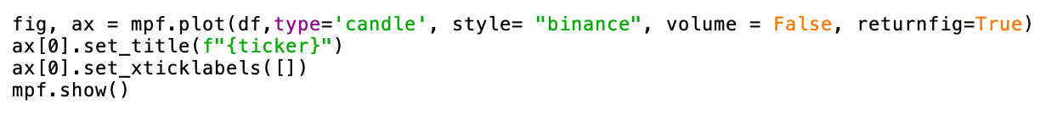

It should end up looking like this:

14. Save your algorithm as a “.py” file in your documents folder:

15. Run your algorithm from the terminal (change directory to documents before running code)

