**Task: Interday swing trading**

1. Import the following modules at the start of your algorithm

2. Create the following variables:

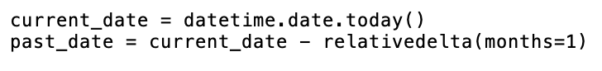

3. Create a list that contains all 1000 tickers. Hint: the print(len(tickers)) should print 1000

4. Obtain the past month’s data for each stock in the list of 1000 tickers by making a request to the Polygon.io (<https://polygon.io/docs/stocks/get_v2_aggs_ticker__stocksticker__range__multiplier___timespan___from___to>) and you will get a JSON object as a return value.

Hint: Use an f-string with the two variables from step 2 for the “from” and “to” parameters

5. Create a new empty list called “trendup”

6. Create a new empty list called “trenddown”

7. Create a function that checks to see if a stock has had an increase in closing price five days in a row. If so, add the ticker to the “trendup” list

8. Create a function that checks to see if a stock has had a decrease in closing price five days in a row, If so, add the ticker to the “trenddown” list

9. Print out the “trendup” and “trenddown” lists

10. Save your algorithm as a “.py” file in your documents folder:

11. Run your algorithm from the terminal (change directory to documents before running code)

