**Task: Object Oriented Programming 2**

1. Import the following modules at the start of your algorithm

2. Create the following variables:

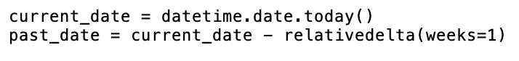

3. Create a class with the following attributes:

4. Create a list that contains all 1000 tickers. Hint: the print(len(tickers)) should print 1000

5. Obtain last week’s closing price and today’s closing price for each stock in “tickers” by making a request to the Polygon.io (<https://polygon.io/docs/stocks/get_v2_aggs_ticker__stocksticker__range__multiplier___timespan___from___to>) and you will get a JSON object as a return value.

6. For each ticker in “tickers” create an object containing the stock’s ticker, last week’s closing price, and today’s closing price

7. Rank the stock objects from highest to lowest difference

8. Print out the 10 stocks with the highest difference

9. Save your algorithm as a “.py” file in your documents folder:

10. Run your algorithm from the terminal (change directory to documents before running code)

