**Task: Visualize Price and Volume Market Data**

1. Import the following modules at the start of your algorithm

2. Create two variables:

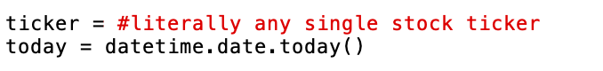

3. Obtain the minute by minute data for the stock you picked by making a request to the Polygon.io (<https://polygon.io/docs/stocks/get_v2_aggs_ticker__stocksticker__range__multiplier___timespan___from___to>) and you will get a JSON object as a return value.

Hint: Use an f-string with the two variables from step 2 for the “stocksTicker”, “from”, and “to” parameters

4. Create a list of the stock’s minute by minute price (name the list “prices”). You can use either the opening or close price. You can parse through the returned JSON object by using either [“o”] or [“c”].

5. Create a list of the stock’s minute by minute volume (name the list “volumes”). You can parse through the returned JSON object by using [“v”].

6. Use the statistics module to find the mean and standard deviation of both the lists

7. Omit any price or volume that is outside of 3 standard deviations from the mean

8. Create a graph of the stock’s minute by minute price and volume

9. Save your algorithm as a “.py” file in your documents folder:

10. Run your algorithm from the terminal (change directory to documents before running code)

