Parallel Computing Lab
Assignment

DFA Membership Test in CUDA

Dhruv Kohli
B.Tech Mathematics & Computing
Pre-final year
120123054

INTRODUCTION

Given a DFA D=(Q, q0, sigma, delta, F) where
- Q = finite set of states
- q0 = starting state
- sigma = finite set of input symbols
- delta = transition function
- F = Set of final states (accepting states)

A string S is said to be a member of the language generated by the DFA D if the state reached after simulating the DFA D with S is an accepting/final state.

The sequential version of the algorithm for the membership test involves simulating the DFA with the given input string.

The parallelized version is a bit complex and is described in the next section.

DFA MEMBERSHIP TEST IN PARALLEL

Given a DFA D, let us denote the number of states by M, the starting state by 1, the number of processors available by P and the length of the input string S by N.

Following is a straightforward approach:
1) Dividing the given input string into P number of equal chunks {c(i), i=1,..p} 2) Simulating the DFA D with chunk c(i) with all the states as starting state (NOTE: We are required to simulate DFA D with state 1 only for chunk c(1))
3) Extracting the ending states for each state as starting state and for each chunk i.e. {e(i,j); where e(i,j) is the state reached on simulating the DFA D with starting state i on chunk c(j)}
4) Finally, since the actual starting state is 1, we find out
E = e( ... e(e(e(e(1, 1), 2), 3), 4), .... p) to get the overall final state reached on simulating the DFA D with starting state 1 on input string S.

Note that step 4 can be performed using reduction in O(lg(P)) time in parallel.

But the above approach is not efficient in the sense that it results in load imbalance among the processors because the 1st processor does M times less work then all other processors and hence the overall time complexity is decided by the time taken by a processor othan than 1st processor which comes out to be O(1) (step 1) + O(M*N/P) (step 2 and 3) + O(log()) (step 4).

BETTER APPROACH:
Instead of equally partitioning the input string S into P equal chunks, we partition S into c(1), c(2), ... c(P) with lengths L(1), ... L(P) where
L(i) = L(1)/M i ~= 1 and
L(1)+L(2)+....+L(P)=N

solving above equations we get:

(M*N)/(M+P-1) if i == 0
L(i) =
L(1)/M if i ~= 0

Using above lengths of chunk and step 2,3 and 4 of above mentioned approach, we'll be able to achieve load balancing and more efficiency.

DFA MEMBERSHIP TEST IN PARALLEL (ALGORITHM)

Basic speculative DFA matching
Input : δ, Q, Σ, P, Str = c(0)c(1) . . . c(P-1)
Output: vector L(i) for each chunk c(i)
1 for i ← 0 to |P| − 1 do in parallel
2 for j ← 0 to |Q| − 1 do
3 L(i)[j] ← j ; // initialize vector Li
4 Start ← StartPos(c(i))
5 End ← EndPos(c(i))
6 if i = 0 then // chunk c0
7 for k ← Start to End do
8 L(0)[0] ← δ(L(0)[0], Str[k])
9 else // chunks c(1) . . . c(P−1)
10 foreach j ∈ Q do
11 for k ← Start to End do
12 L(i)[j] ← δ(L(i)[j], Str[k])

SOURCE: A Speculative Parallel DFA Membership Test for Multicore, SIMD and Cloud Computing Environments;Yousun Ko · Minyoung Jung, Yo-Sub Han, Bernd Burgstaller.

Here,
0 for k = 0
StartPos(c(k)) =
floor(L(0)+(1/M)*(k-1)*L(0)) otherwise

N-1 for k = P-1
EndPos(c(k)) =
floor(L(0)+(1/M)*(k-1)*L(0))-1 otherwise

TIME COMPLEXITY

Sequential algorithm takes O(N) time.
Parallel algorithm takes (O((M*N)/(M+P-1)) + O(lg(P))) ~ O((M*N)/(M+P-1)) time.

Speedup = O(1+(P-1)/M)

CODE
Kernel code
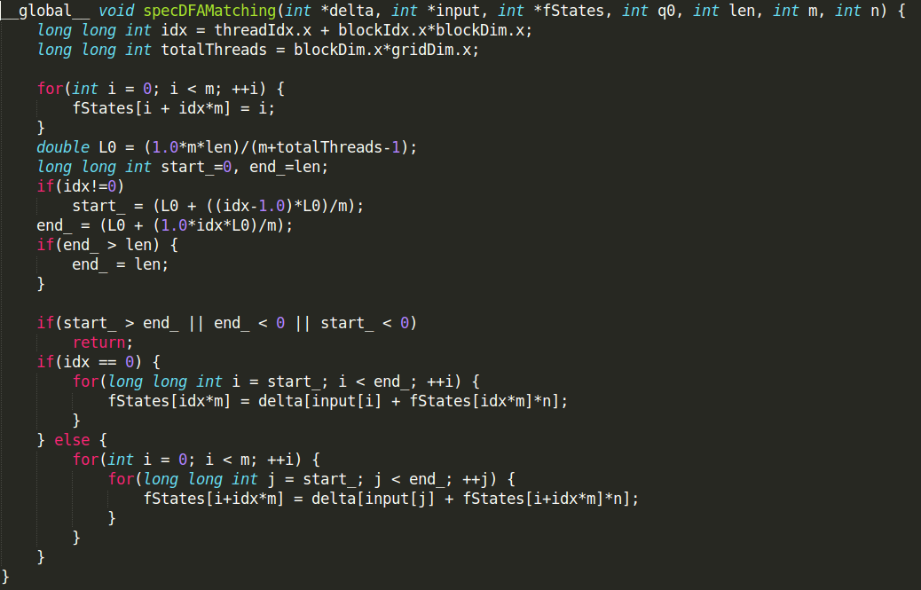
EXPERIMENTAL ANALYSIS AND CONCLUSION
Following graph represents experimental analysis with DFA of 4 states, # threads launched per block = 1024, # blocks launched = 32*1024

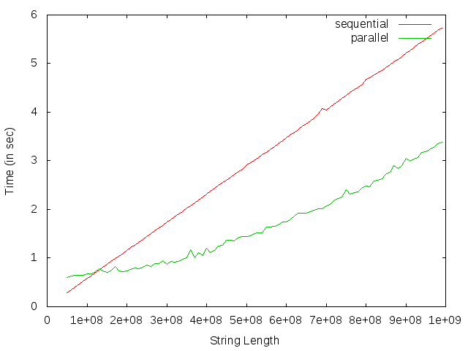

Hence, with an input string of size 10^9 a speedup of approximately 2 times was observed with parallel algorithm.

NOTE: Sorry, I din't get time to implement the reduction operation in my code. I'll do that soon after the endsems.

