A
Project Report
On
"Blockchain Based E-Voting System"
Submitted in partial fulfilment of the requirements
for the course of the degree of Master of Computer Application (MCA)

By

Sanjoy Khoirom
4th Semester
Roll No – 2450036

Under the Supervision of
Dr. Nazrul Hoque

Department of Computer Science,
MANIPUR UNIVERSITY, CANCHIPUR
Imphal West - 795003, India
May, 2026

A
Project Report
On
"Blockchain Based E-Voting System"
Submitted in partial fulfilment of the requirements
for the course of the degree of Master of Computer Application (MCA)

By

Sanjoy Khoirom
4th Semester
Roll No – 2450036

Under the Supervision of
Dr. Nazrul Hoque


Department of Computer Science,
MANIPUR UNIVERSITY, CANCHIPUR
Imphal West - 795003, India
May, 2026


CERTIFICATE
DEPARTMENT OF COMPUTER SCIENCE
MANIPUR UNIVERSITY
CANCHIPUR, IMPHAL - 795003
MANIPUR INDIA

This is to certify that the project titled "Blockchain Based E-Voting System" is a complete work done by Sanjoy Khoirom, a student of MCA in the Department of Computer Science, Manipur University, bearing Roll No. 2450036, under the Guidance of Dr. Nazrul Hoque, Assistant Professor, Department of Computer Science, in partial fulfilment of the requirement for the 4th Semester of Master of Computer Application under Manipur University.
 | (Dr. Dalton Meitei Thounaojam)
 | Head of Department
 | Department Of Computer Science
Date: - | Manipur University
Place: - | Canchipur - 795003
To the best of my knowledge, the project has not been submitted to any University or Institute for the award of any Degree or Diploma. I am happy to recommend the project to the Department of Computer Science, Manipur University, for necessary evaluation.


DEPARTMENT OF COMPUTER SCIENCE
MANIPUR UNIVERSITY
CANCHIPUR, IMPHAL - 795003
MANIPUR INDIA

CERTIFICATE

This is to certify that the project titled "Blockchain Based E-Voting System" is complete work done by Sanjoy Khoirom, MCA student of the Department of Computer Science, Manipur University, with Roll No. 2450036, under my Guidance of Dr. Nazrul Hoque, Assistant Professor, Department of Computer Science in partial fulfilment of the requirement for 4th Semester of Master of Computer Application under Manipur University.
I further certify that he has undertaken the project with sincerity and hard work for the full period prescribed and this report embodies the result of his investigation conducted during the period he worked hard as a student under my supervision. This report has neither been published in any journal nor submitted to any institution before.
 | (Dr. Nazrul Hoque)
 | Assistant Professor
 | Department Of Computer Science
Date: - | Manipur University
Place: - | Canchipur - 795003

Declaration

I do, hereby declare that the project titled "Blockchain Based E-Voting System" is a complete work done by me at Manipur University under the guidance of Dr. Najrul Hoque Professor, Department of Computer Science, Manipur University, submitted as partial fulfilment for the requirements of the 4th Semester of Master of Computer Application, 2024-2025.

I also declare that any or all contents incorporated in this report have not been submitted in any form for the award of any degree or diploma of any other institution or university.
 | Sanjoy Khoirom
 | MCA 4th Sem
 | Roll No. 2450036
Date: - | Department of Computer Science
Place: - | Manipur University

Acknowledgements

I express a deep sense of gratitude, appreciation and my sincere thanks to my guide and mentor Dr. Professor, Department of Computer Science, Manipur University, for his endless guidance and valuable suggestions, without which this project would not have been completed.
I am also thankful to my seniors and friends for helping and sharing their valuable ideas in accomplishing this project work.
I also would like to sincerely thank all other faculty members of the Department of Computer Science, Manipur University, for their support and help in overcoming my problems and giving me the right direction.
I am thankful to a higher power for the grace and blessings that allowed me to successfully complete it.
 | Sanjoy Khoirom
 | MCA 4th Sem
 | Roll No. 2450036
Date: - | Department of Computer Science
Place: - | Manipur University

Abstract
The electoral process is an important part of democratic governance, but traditional voting systems and electronic voting machines face challenges such as vote tampering, lack of transparency, centralized control, and delayed result generation. These issues reduce public trust and create the need for more secure voting systems.
This project presents a Blockchain-Based E-Voting System that uses blockchain technology and smart contracts to improve election security, transparency, and reliability. The system is developed using Ethereum, Solidity, and decentralized transaction processing.
Votes are stored as immutable blockchain transactions, preventing unauthorized modification or deletion. Smart contracts automate election functions such as candidate registration, voter verification, vote casting, duplicate vote prevention, vote counting, and result generation. Blockchain decentralization further improves election integrity and reduces dependence on centralized authorities.
The system also supports transparency and auditability because election transactions can be independently verified on the blockchain without compromising voter privacy. Cryptographic identifiers and blockchain validation mechanisms ensure secure voting operations.
The project is implemented and tested using technologies such as Ethereum, Solidity, Hardhat/Ganache, MetaMask, React, and Ethers.js/Web3.js. Testing results demonstrate secure and reliable electronic voting operations.
Overall, the proposed system provides a strong foundation for secure, transparent, and decentralized digital elections while identifying future improvements such as scalability optimization, biometric authentication, privacy enhancements, and mobile voting support.
Contents

Declaration 5
Acknowledgements 6
Abstract 7

CHAPTER 1 - INTRODUCTION 11
1.1 Introduction 11
1.2 Importance of Elections in Democracy 11
1.3 Evolution of Voting Methods 11
1.4 Limitations of Existing Voting Systems 12
1.5 Objectives of the Project 13
1.6 Scope of the Project 13
1.7 Organization of the Report 14

CHAPTER 2 – LITERATURE SURVEY 16
2.1 Introduction 16
2.2 Review of Existing Voting Systems 16
2.3 Ethereum-Based E-Voting System 17
2.4 Blockchain-Based Voting Recording Systems 18
2.5 Decentralized Voting Platforms 18
2.6 Research Gap 19

CHAPTER 3 – SYSTEM ANALYSIS AND DESIGN 21
3.1 Introduction 21
3.2 System Analysis 21
3.3 Requirement Analysis 22
3.4 Functional Requirements 23
3.5 Non-Functional Requirements 24
3.6 System Requirements 25
Hardware Requirements 25
Software Requirements 25
Blockchain Requirements 25
Network Requirements 26
User Requirements 26
3.7 Model Architecture 26
3.8 System Design 27
3.9 Data Flow Description 28
3.10 Voting Process Flow 28
3.11 Trust Boundary Analysis 29

CHAPTER 4 – TECHNOLOGY USED AND SYSTEM IMPLEMENTATION 31
4.1 Introduction 31
4.2 Blockchain Technology 31
4.3 Ethereum Platform 32
4.4 Smart Contracts 33
4.5 Solidity Programming Language 35
4.6 Development Tools and Environment 35
4.7 Candidate Management 36
4.8 Voter Eligibility Verification 38
4.9 Vote Casting Mechanism 38
4.10 Duplicate Vote Prevention 39
4.11 Blockchain Integration 41
4.12 System Implementation 41

CHAPTER 5 – TESTING AND EXPERIMENTAL ANALYSIS 43
5.1 Introduction 43
5.2 Functional Testing 43
5.3 Security Testing 44
5.4 Vote Integrity Verification 45
5.5 Experimental Analysis 46
5.6 Testing and Results 48
5.7 Comparative Analysis 49

CHAPTER 6 – DISCUSSION, FUTURE SCOPE AND CONCLUSION 50
6.1 Discussion 50
6.2 Future Scope 51
6.3 Conclusion 52

Pseudocode 53
Snapshots 56
REFERENCES 63

CHAPTER 1 - INTRODUCTION

1.1 Introduction
Elections are essential to democracy because they allow citizens to choose their representatives and participate in governance. Traditional paper-based voting systems are simple but face problems such as slow counting, human errors, ballot tampering, and high operational costs. Electronic Voting Machines (EVMs) improved speed and efficiency but raised concerns about transparency, centralized control, and security.
Blockchain technology offers a secure and transparent solution for modern voting systems. It uses a decentralized and immutable ledger, making it difficult to alter or delete recorded votes. Smart contracts can automate election rules, voter verification, vote recording, duplicate vote prevention, and result generation.
This project proposes a Blockchain-Based E-Voting System that aims to improve election security, transparency, and trust. By using decentralization, cryptographic security, and automated smart contracts, the system reduces the risk of manipulation and ensures reliable electronic voting.

1.2 Importance of Elections in Democracy
Elections are a fundamental part of democracy, allowing citizens to choose their representatives and participate in governance. Through free and fair elections, people can influence government decisions and hold leaders accountable for their actions. The credibility of democratic governments depends on transparent and trustworthy electoral processes.
Elections also ensure political equality through the principle of “one person, one vote,” where every citizen’s vote has equal importance. However, unfair or manipulated elections can reduce public trust and create political instability.
In the digital era, ensuring secure and transparent elections has become more challenging due to increasing dependence on technology. These challenges have encouraged the development of advanced electronic voting systems, including blockchain-based voting solutions, which aim to improve election security, transparency, and reliability.

1.3 Evolution of Voting Methods
The method of voting has evolved over time as democratic systems became more advanced. In ancient societies such as Greece and Rome, voting was conducted openly through hand signals, verbal agreements, or physical objects like stones and tablets. Although these methods were simple, they lacked privacy and were unsuitable for large populations.
To improve organization and secrecy, paper-based voting systems were introduced. Voters marked their choices on paper ballots, which provided greater privacy and fairness. However, paper-based systems faced challenges such as slow vote counting, human errors, high operational costs, and risks of ballot tampering or loss.
Electronic Voting Machines (EVMs) were later introduced to automate voting and counting processes. EVMs improved efficiency, reduced manual effort, and provided faster election results. Despite these advantages, concerns remained regarding transparency, centralized control, software reliability, and security vulnerabilities.
With the advancement of internet technology, online and remote voting systems were developed to improve accessibility and convenience. However, these systems introduced cybersecurity risks such as hacking, identity theft, and data manipulation.
Recently, blockchain technology has emerged as a promising solution for secure electronic voting. By using decentralization, cryptographic security, transparency, and immutability, blockchain-based voting systems aim to prevent tampering, improve trust, and ensure reliable election processes.

1.4 Limitations of Existing Voting Systems
Existing voting systems, including paper-based voting and Electronic Voting Machines (EVMs), have several limitations that affect election security, transparency, efficiency, and reliability. These weaknesses can reduce public trust and create opportunities for fraud, manipulation, and operational errors.
Paper-based voting systems depend heavily on manual processes such as ballot distribution, collection, and counting. Although paper ballots provide a physical record, they are vulnerable to ballot tampering, loss, incorrect counting, and ballot stuffing. Manual counting is slow, costly, and prone to human error, especially in large-scale elections.
Electronic Voting Machines were introduced to improve efficiency and speed, but they also created new concerns related to transparency and security. Since voting operations depend on software and hardware, voters cannot directly verify how votes are processed. Centralized control of electronic systems also creates a single point of failure, making them vulnerable to insider threats, technical failures, and cyberattacks.
Existing voting methods also lack strong transparency and auditability, as voters often cannot independently confirm whether their votes were recorded and counted correctly. In addition, large-scale elections require complex infrastructure, while online voting systems introduce cybersecurity risks such as hacking and identity theft.
These limitations highlight the need for a secure, transparent, decentralized, and tamper-resistant voting system. Blockchain technology offers a promising solution by providing cryptographic security, immutability, transparency, and decentralized control for modern electronic voting systems.

1.5 Objectives of the Project
The main objective of this project is to design and implement a secure, transparent, and reliable Blockchain-Based E-Voting System using blockchain technology and smart contracts. The system aims to overcome the limitations of traditional and electronic voting methods by providing a decentralized and tamper-resistant voting platform.
One key objective is to improve election security by ensuring that votes are securely recorded and cannot be altered or deleted after submission. Blockchain and cryptographic techniques help protect voting data from unauthorized access and manipulation.
Another objective is to increase transparency and trust in the electoral process. All voting transactions are stored on a blockchain ledger, allowing authorized participants to verify election activities independently. This transparency helps improve confidence in election results.
The project also aims to enforce the one-person-one-vote principle using smart contracts, which automatically prevent duplicate voting. Maintaining voter privacy and anonymity is another important goal, achieved through the use of cryptographic identifiers instead of storing personal information directly on the blockchain.
In addition, the system reduces dependence on centralized authorities by using a decentralized blockchain network, improving reliability and reducing insider threats. Smart contracts also automate vote counting and result generation, reducing manual errors and improving efficiency.
Finally, the project evaluates the practical use of blockchain technology in electronic voting through the implementation and testing of a prototype system for secure and trustworthy elections.

1.6 Scope of the Project
The scope of this project is limited to the design, development, and evaluation of a Blockchain-Based E-Voting System that demonstrates the use of blockchain technology in secure electronic voting. The project focuses on developing a prototype system that improves transparency, security, and trust through decentralization, cryptographic protection, and smart contracts.
The system includes essential features such as voter verification, candidate registration, secure vote casting, duplicate vote prevention, automatic vote counting, and result generation. Smart contracts automate election rules and ensure fair and consistent voting operations without manual intervention.
The project is implemented using an Ethereum-based blockchain environment in a controlled development and testing setup. A local or test blockchain network is used to simulate blockchain operations such as transaction validation, smart contract execution, and secure vote recording.
The scope is limited to academic and demonstration purposes and does not include real-world deployment or large-scale national elections. Advanced scalability optimization and high-volume transaction handling are outside the current scope.
User interaction is limited to core functions such as voter authentication, candidate selection, vote submission, and result viewing, while administrative tasks include candidate management and election setup.
Advanced features such as biometric authentication, mobile voting, zero-knowledge proofs, integration with government identity systems, and legal compliance are not fully implemented but are considered future enhancements. Overall, the project focuses on demonstrating the practical application of blockchain technology in secure electronic voting systems.

1.7 Organization of the Report
This report is organized into multiple chapters to explain the design, development, implementation, and evaluation of the Blockchain-Based E-Voting System in a structured manner.
Chapter 1 introduces the project, including the importance of elections, evolution of voting methods, limitations of existing systems, project objectives, and scope of the proposed system.
Chapter 2 presents the literature survey and reviews existing research related to electronic voting and blockchain technology. It discusses the advantages, limitations, and research gaps in current voting systems.
Chapter 3 explains the system analysis and design, including requirement analysis, system architecture, data flow, voting workflow, and overall system design.
Chapter 4 focuses on system implementation and technologies used, such as blockchain, Ethereum, Solidity, and smart contracts. It also discusses voter verification, candidate management, vote casting, and blockchain interaction.
Chapter 5 presents testing and evaluation of the system, including functional testing, security testing, vote integrity verification, comparative analysis, and performance observations.
Chapter 6 discusses the results, future scope, and conclusion of the project. It highlights the advantages, limitations, and future enhancements such as biometric authentication, scalability improvements, privacy-preserving techniques, and mobile voting integration.

CHAPTER 2 – LITERATURE SURVEY

2.1 Introduction
A literature survey is an important part of research and development as it helps in understanding existing technologies, methods, and studies related to the proposed system. In electronic voting, researchers have explored various approaches to improve election security, transparency, reliability, and voter trust. The limitations of traditional voting systems and electronic voting machines have encouraged the use of blockchain technology as a potential solution.
Blockchain technology offers features such as decentralization, immutability, transparency, and cryptographic security, making it suitable for secure electronic voting systems. Many researchers have proposed blockchain-based voting models that use smart contracts and distributed ledgers to prevent vote tampering and improve trust in elections.
This chapter reviews existing research papers and systems related to blockchain-based electronic voting. It analyses the technologies used, key features, advantages, and limitations of different approaches while identifying existing challenges and research gaps.
The literature survey also justifies the need for the proposed Blockchain-Based E-Voting System. By studying previous work, the project aims to combine blockchain security, decentralized control, and smart contract automation to create a more transparent, secure, and reliable voting platform.

2.2 Review of Existing Voting Systems
Voting systems have evolved from traditional paper-based methods to electronic and internet-based systems to improve election efficiency and accessibility. However, existing voting methods still face challenges related to security, transparency, trust, and reliability.
Traditional paper-based voting systems use paper ballots that are manually collected and counted. Although they provide a physical record for verification, they are slow, labour-intensive, and vulnerable to ballot tampering, counting errors, and logistical difficulties.
Electronic Voting Machines (EVMs) were introduced to improve speed and reduce manual work. EVMs automate vote recording and counting, allowing faster result declaration. However, concerns remain regarding transparency, centralized control, software reliability, and system security.
Internet-based voting systems further improved accessibility by allowing remote voting through computers or mobile devices. Despite their convenience, these systems face cybersecurity risks such as hacking, malware, phishing attacks, and identity theft.
To overcome these limitations, blockchain-based voting systems were proposed. Blockchain technology provides decentralization, cryptographic security, transparency, and immutable vote storage. Votes stored on the blockchain cannot be modified or deleted, increasing trust in election results. Smart contracts also automate election rules and vote counting processes.
Although blockchain-based systems offer significant advantages, challenges such as scalability, transaction speed, privacy protection, and implementation complexity still require further research and improvement.

2.3 Ethereum-Based E-Voting System
Ethereum-based e-voting systems are widely researched because Ethereum supports decentralized applications and smart contracts. Smart contracts automatically manage election processes such as candidate registration, voter verification, vote recording, duplicate vote prevention, and result generation without requiring intermediaries. Once deployed, these contracts become immutable, ensuring that election rules cannot be changed during voting.
In these systems, votes are stored as blockchain transactions and verified by multiple nodes before being added permanently to the blockchain ledger. This decentralized and immutable structure improves election security, transparency, and auditability while making unauthorized vote modification extremely difficult.
Ethereum-based voting systems also increase transparency because election activities can be independently verified by authorized participants. At the same time, cryptographic techniques help maintain voter anonymity by hiding personal identities through blockchain addresses.
Despite these advantages, Ethereum-based voting systems face several challenges. Public Ethereum networks have limited scalability and transaction processing capacity, which may cause delays in large-scale elections. Another limitation is transaction cost, as smart contract execution and data storage require gas fees.
Privacy protection is also a concern because blockchain transactions are publicly visible. Although voter identities are hidden, transaction metadata may still be analysed. Researchers continue to explore advanced privacy-preserving techniques to improve confidentiality in blockchain voting systems.
Overall, Ethereum-based e-voting systems demonstrate how blockchain technology can improve election security, transparency, and decentralization while also highlighting challenges that require further optimization and research.

2.4 Blockchain-Based Voting Recording Systems
Blockchain-based voting recording systems are designed to securely store and manage votes using distributed ledger technology. In these systems, each vote is recorded as a blockchain transaction, creating a permanent and tamper-resistant record. The main objective is to improve election security, transparency, auditability, and trustworthiness.
Unlike traditional voting systems that rely on centralized databases or physical ballot boxes, blockchain-based systems distribute vote records across multiple nodes in a decentralized network. Each node maintains a synchronized copy of the ledger, making unauthorized modification or data loss extremely difficult.
These systems use cryptographic hashing and consensus mechanisms to secure election data. Votes are verified, grouped into blocks, and added permanently to the blockchain. Once recorded, votes become immutable and cannot be altered or deleted, ensuring election integrity and reducing the risk of manipulation.
Blockchain voting systems also improve transparency because transactions are time-stamped and can be independently audited by authorized participants. This transparency increases public trust and reduces dependence on centralized election authorities. Smart contracts further automate important processes such as voter verification, duplicate vote prevention, and automatic vote counting, reducing manual effort and human error.
Despite these advantages, blockchain-based voting systems still face challenges such as scalability, transaction delays, privacy concerns, and infrastructure requirements. Public blockchain transactions may expose metadata, and reliable internet connectivity is necessary for smooth operation.
Overall, blockchain-based voting recording systems provide a strong foundation for secure and transparent electronic elections while also highlighting areas that require further research and improvement.

2.5 Decentralized Voting Platforms
Decentralized voting platforms are electronic voting systems that operate without relying on a single central authority to manage election processes and data storage. These platforms use blockchain technology and distributed networks to provide secure, transparent, and tamper-resistant elections. Their main goal is to reduce dependence on election authorities and improve trust in the electoral process.
Unlike traditional electronic voting systems that use centralized servers, decentralized voting platforms distribute vote records across multiple blockchain nodes. Each node maintains a copy of the voting ledger, making unauthorized modification or system compromise extremely difficult. This decentralized structure removes single points of failure and improves election security.
Many decentralized voting systems use smart contracts to automate election operations such as voter verification, vote recording, duplicate vote prevention, and result generation. Since smart contracts execute predefined rules automatically, they reduce human intervention and minimize administrative manipulation.
Decentralized voting platforms also improve transparency and auditability. Every vote transaction is recorded on the blockchain and can be independently verified by authorized participants. The immutable nature of blockchain ensures that recorded votes cannot be altered or deleted, increasing trust in election outcomes.
Another major advantage is reliability. Because voting data is distributed across multiple nodes, failure of a single system does not affect the overall election process. Distributed storage also improves fault tolerance and data availability.
However, decentralized voting systems still face challenges such as scalability limitations, privacy concerns, and infrastructure requirements. Blockchain networks may experience delays during large-scale elections, and transaction metadata may expose certain information. In addition, these systems require stable internet connectivity and technical resources for proper operation.
Overall, decentralized voting platforms represent an important advancement in secure digital elections and continue to be a major area of blockchain research and development.

2.6 Research Gap
Although many researchers have proposed blockchain-based e-voting systems, several challenges still remain unresolved. Most existing systems are limited to prototype or experimental implementations and are not fully suitable for large-scale real-world elections.
One major challenge is scalability. Public blockchain platforms such as Ethereum have limited transaction processing capacity, which may cause delays and network congestion during large elections. Efficient handling of millions of vote transactions is still an active research area.
Privacy protection is another important issue. Many systems provide only basic voter anonymity using cryptographic addresses, while advanced privacy techniques such as zero-knowledge proofs and homomorphic encryption are not widely implemented. As a result, some transaction metadata may still expose user activity.
Voter authentication and identity management also remain difficult problems. Most proposed systems depend on external verification methods and lack secure integration with official identity systems or biometric authentication.
Another limitation is usability. Blockchain systems often require technical knowledge for managing wallets, cryptographic keys, and transactions, which may reduce accessibility for general voters.
Legal and regulatory challenges are also not fully addressed in many research works. Real-world deployment requires compliance with election laws, privacy regulations, and government policies.
The proposed Blockchain-Based E-Voting System aims to address some of these issues by providing a secure, transparent, decentralized, and automated voting platform using blockchain and smart contracts. The system focuses on vote integrity, duplicate vote prevention, secure transactions, and transparent auditing while identifying future improvements such as scalability optimization, biometric integration, and advanced privacy protection.

CHAPTER 3 – SYSTEM ANALYSIS AND DESIGN

3.1 Introduction
System analysis and design is an important phase in software development that focuses on understanding system requirements and designing structured solutions. In the Blockchain-Based E-Voting System, this phase aims to create a secure, transparent, reliable, and decentralized voting platform using blockchain technology and smart contracts.
The analysis phase identifies the limitations of traditional voting systems, such as centralized control, vote tampering, duplicate voting, and lack of transparency. These issues highlight the need for a secure and tamper-resistant electronic voting system.
The proposed system uses blockchain as the core infrastructure for storing and managing votes securely. Blockchain provides decentralization, immutability, transparency, and cryptographic security, making it suitable for electronic voting applications. Smart contracts automate important election functions such as voter verification, vote recording, duplicate vote prevention, and result generation.
This chapter explains the requirement analysis, system architecture, voting workflow, data flow, and major system components. It also describes how different users interact with the system and how blockchain technology supports secure election operations.
The overall system design focuses on fairness, reliability, voter privacy, and protection against unauthorized access or manipulation. By combining blockchain infrastructure with smart contract automation, the proposed system provides a strong foundation for secure digital elections.

3.2 System Analysis
System analysis involves studying existing systems, identifying their limitations, and defining requirements for an improved solution. In the Blockchain-Based E-Voting System, the analysis focuses on creating a secure, transparent, and decentralized voting platform using blockchain technology and smart contracts.
Traditional paper-based voting systems face problems such as slow manual counting, human errors, ballot tampering, and high operational costs. Electronic Voting Machines improve efficiency but introduce concerns related to centralized control, lack of transparency, insider threats, and cyberattacks.
To address these issues, the proposed system uses blockchain technology for decentralized and immutable vote storage. Smart contracts automate election processes such as voter verification, vote recording, duplicate vote prevention, and result generation.
The system analysis identifies key functional requirements, including secure voter authentication, vote recording, duplicate vote prevention, voter anonymity, transparent auditing, and accurate result generation. Security requirements include protection against unauthorized access, vote tampering, insider manipulation, and transaction forgery using cryptographic hashing, digital signatures, and decentralized validation.
The analysis also considers practical limitations such as scalability, transaction delays, and blockchain infrastructure requirements. Although the proposed system improves security and transparency, further optimization is needed for large-scale real-world deployment.
Overall, the system analysis shows that blockchain technology can provide a more secure, transparent, and reliable alternative to traditional voting systems.

3.3 Requirement Analysis
Requirement analysis identifies the functional and non-functional requirements needed for the successful operation of the Blockchain-Based E-Voting System. The main focus is on security, transparency, reliability, privacy, and efficient election management.
The system must allow only eligible voters to participate and securely verify voter identity while protecting personal information. It should also support candidate management, where authorized administrators can register candidates before the election begins. Once voting starts, candidate information must remain unchanged.
The system should provide secure vote casting through a blockchain-connected interface. Each vote must be stored permanently as a blockchain transaction. Duplicate vote prevention is another key requirement, ensuring that each voter can vote only once through smart contract validation.
Automatic vote counting and result generation are also required. Smart contracts should securely calculate votes and generate accurate results without manual intervention. The system must also support transparency and auditability, allowing authorized participants to verify election activities independently.
Non-functional requirements mainly focus on security, privacy, reliability, and performance. The system must protect against unauthorized access, tampering, and cyberattacks using cryptographic and blockchain security mechanisms. Voter anonymity must be preserved while maintaining vote integrity.
The system should remain reliable and available throughout the election period, even if some blockchain nodes fail. Performance requirements include efficient vote recording, acceptable transaction speed, and timely result generation despite blockchain transaction delays.
Overall, the requirement analysis defines the essential features and operating conditions needed to develop a secure, transparent, and trustworthy Blockchain-Based E-Voting System.

3.4 Functional Requirements
Functional requirements define the main operations of the Blockchain-Based E-Voting System and describe how users interact with the system during elections.
One important requirement is voter authentication and eligibility verification. The system must ensure that only authorized voters can participate using unique cryptographic identities.
The system must also support candidate registration and management. Administrators should be able to add candidate details before the election begins, and candidate information must remain unchanged once voting starts.
Secure vote casting is another key requirement. Eligible voters should be able to select candidates and cast votes through the voting interface. Each vote must be recorded securely as a blockchain transaction.
The system must prevent duplicate voting by automatically checking whether a voter has already voted. Any repeated voting attempt should be rejected immediately by the smart contract.
Vote recording and storage are also essential functions. All valid votes should be stored permanently on the blockchain in an immutable and tamper-resistant manner.
Automatic vote counting and result generation should be handled by smart contracts without manual intervention. Election results must be accurate and available immediately after voting ends.
Transparency and auditability are additional requirements. Authorized users should be able to verify voting transactions and election results directly from the blockchain ledger while maintaining voter privacy.
The system should also support election management functions such as starting and ending elections, which must be controlled only by authorized administrators.
Finally, voters should receive transaction confirmation after successfully casting their votes, improving transparency and trust in the election process.

3.5 Non-Functional Requirements
Non-functional requirements define the quality and performance characteristics of the Blockchain-Based E-Voting System, including security, reliability, privacy, scalability, and usability.
Security is one of the most important requirements. The system must protect voting data from unauthorized access, tampering, cyberattacks, and insider threats using blockchain technology, cryptographic hashing, digital signatures, and decentralized validation.
Privacy and anonymity are also essential. Voter identities must remain confidential, and votes should not be directly linked to individuals. Cryptographic identifiers are used instead of storing personal data publicly on the blockchain.
Reliability and availability are important for smooth election operation. The system should function correctly without data loss or service interruption, even if some blockchain nodes fail. Decentralized storage improves fault tolerance and system reliability.
Transparency and auditability are key quality requirements. Authorized participants should be able to verify election transactions and results independently through immutable and time-stamped blockchain records.
Performance requirements focus on efficient transaction processing and timely result generation. Although blockchain may introduce some latency, the system should still provide acceptable response times during voting.
Scalability is another important consideration. The system should support increasing numbers of voters and transactions, although further optimization may be required for large-scale elections.
Usability is also necessary to ensure easy voter participation. The interface should be simple and user-friendly, even for users with limited technical knowledge.
Finally, maintainability and flexibility are important for future improvements. The system should be modular and organized so that updates and new features can be added easily.
Overall, these non-functional requirements ensure that the proposed Blockchain-Based E-Voting System operates securely, reliably, and transparently while maintaining voter trust.

3.6 System Requirements
System requirements define the hardware, software, blockchain environment, and supporting tools needed for the successful development and operation of the Blockchain-Based E-Voting System. These requirements ensure that the system can run efficiently and support blockchain-based voting operations securely.

Hardware Requirements
The proposed system can be developed and tested on a standard computer system with moderate hardware specifications. The minimum hardware requirements are:
- Processor: Intel Core i3 or higher
- RAM: 4 GB minimum (8 GB recommended)
- Storage: 100 GB free disk space
- Internet Connection: Stable broadband internet connection
- Input Devices: Keyboard and mouse
- Display: Standard monitor
These hardware resources are sufficient for running the blockchain development environment, smart contract tools, and voting application interface.

Software Requirements
The Blockchain-Based E-Voting System requires several software tools and frameworks for development and testing. The main software requirements include:
- Operating System: Windows, Linux, or macOS
- Programming Languages: Solidity, JavaScript
- Blockchain Platform: Ethereum
- Development Framework: Hardhat or Ganache
- Smart Contract Compiler: Solidity Compiler
- Frontend Framework: React.js
- Backend Runtime: Node.js
- Blockchain Interaction Library: Ethers.js or Web3.js
- Browser Wallet: MetaMask
- Code Editor: Visual Studio Code
These software tools support blockchain network simulation, smart contract deployment, frontend development, and blockchain interaction.

Blockchain Requirements
The proposed system uses an Ethereum-based blockchain network for secure vote storage and smart contract execution. The blockchain requirements include:
- Ethereum Virtual Machine (EVM) support
- Smart contract deployment capability
- Test blockchain accounts
- Gas fee simulation for transactions
- Transaction validation and block generation
A local blockchain development environment such as Ganache or Hardhat Network is used for testing and demonstration purposes.

Network Requirements
Since blockchain operations depend on communication between nodes and applications, stable network connectivity is required. The system requires:
- Reliable internet connection
- Access to blockchain nodes
- Secure communication between frontend and blockchain network

User Requirements
Users interacting with the system should have basic computer knowledge and familiarity with digital interfaces. Voters should be able to:
- Access the voting interface
- Authenticate themselves
- Select candidates
- Submit votes securely
Administrators should be able to manage election setup and candidate registration through authorized system functions.
Overall, these system requirements provide the necessary environment for implementing, testing, and operating the proposed Blockchain-Based E-Voting System successfully.

3.7 Model Architecture
The model architecture of the Blockchain-Based E-Voting System defines how different system components interact to provide security, transparency, decentralization, and automation. The system mainly consists of three layers: the user interface layer, smart contract layer, and blockchain network layer.
The user interface layer allows voters and administrators to interact with the system. Voters can authenticate themselves, view candidates, and cast votes, while administrators can manage candidates and control elections. The interface connects to the blockchain using libraries such as Ethers.js or Web3.js.
The smart contract layer contains the election logic and automatically enforces voting rules. Smart contracts manage candidate registration, voter verification, duplicate vote prevention, vote recording, and result generation. Once deployed, these contracts become immutable and operate without manual intervention.
The blockchain network layer acts as the core infrastructure of the system. Votes are stored as secure and immutable blockchain transactions. The network validates transactions through decentralized consensus mechanisms before permanently adding them to the blockchain ledger.
When a voter submits a vote, the request is sent to the smart contract for verification. If the voter is eligible and has not voted before, the transaction is recorded on the blockchain and confirmed by the network.
The architecture also supports transparency and auditability because all vote transactions can be independently verified. At the same time, voter privacy is protected using cryptographic identifiers instead of storing personal information directly on the blockchain.
Overall, the proposed architecture combines blockchain infrastructure with smart contract automation to create a secure, transparent, and tamper-resistant electronic voting system.

3.8 System Design
System design explains how the components of the Blockchain-Based E-Voting System are organized to perform secure and transparent voting operations. The system is designed using blockchain technology and smart contracts to ensure decentralization, vote integrity, and automated election management.
The system consists of three main components: the administrator module, voter module, and blockchain module.
The administrator module manages election setup and control. The administrator deploys smart contracts, registers candidates, starts elections, and ends voting. Only authorized administrators can access these functions, and election rules cannot be modified once voting begins.
The voter module allows eligible voters to participate through a user interface connected to the blockchain network. After authentication, voters can view candidates and cast votes securely. Each voter uses a unique cryptographic identifier to maintain anonymity and prevent duplicate voting.
The blockchain module acts as the decentralized storage system for voting transactions. Smart contracts automatically verify voter eligibility, validate votes, prevent duplicate voting, and update vote counts. All valid votes are permanently stored on the blockchain, ensuring transparency and immutability.
During the voting process, the voter selects a candidate and submits a vote through the interface. The smart contract verifies election status and voter eligibility before recording the vote on the blockchain.
The system also uses security mechanisms such as cryptographic hashing, digital signatures, decentralized validation, and immutable storage to protect against unauthorized access, vote tampering, and manipulation.

3.9 Data Flow Description
The data flow description explains how information moves between different components of the Blockchain-Based E-Voting System during the election process. The system ensures secure communication, transparency, vote integrity, and voter privacy.
The process begins with voter authentication and eligibility verification. When a voter accesses the voting interface, the system checks whether the voter is authorized to participate. Only eligible voters are allowed to continue.
After authentication, the voter selects a candidate through the voting interface. The vote is prepared as a blockchain transaction request using cryptographic identifiers instead of storing personal voter information directly on the blockchain.
The vote request is then sent to the smart contract on the blockchain network. The smart contract verifies whether the election is active, checks voter eligibility, and ensures that the voter has not already voted. Invalid transactions are rejected automatically.
If validation is successful, the vote is recorded as a blockchain transaction. The blockchain network verifies the transaction using decentralized consensus mechanisms and permanently stores it on the blockchain ledger. Since blockchain records are immutable, votes cannot be modified after confirmation.
After the election ends, the smart contract automatically counts votes and generates results. Authorized users and auditors can independently verify election records and results through the blockchain without revealing voter identities.
The data flow process ensures secure handling of voting information, prevents unauthorized modifications, and maintains transparency, trust, and reliability in the election system.

3.10 Voting Process Flow
The voting process flow describes the sequence of operations in the Blockchain-Based E-Voting System from election setup to result generation. The process ensures security, transparency, fairness, and proper vote validation.
The process begins with election initialization. The administrator deploys the smart contract, registers candidates, and starts the election. Candidate details and election status are stored securely on the blockchain.
After the election starts, eligible voters access the voting interface. The system performs voter authentication and eligibility verification using unique cryptographic identifiers or blockchain addresses. It also checks whether the voter has already voted.
Once verified, the voter selects a candidate through the interface. The selected vote is converted into a blockchain transaction request and sent to the smart contract.
The smart contract validates the request by checking whether the election is active, verifying voter eligibility, and preventing duplicate voting. Invalid requests are rejected automatically.
If validation is successful, the vote is recorded on the blockchain and the candidate’s vote count is updated. The blockchain network verifies the transaction through decentralized consensus before permanently storing it on the ledger.
After successful vote recording, the system marks the voter as having voted and sends transaction confirmation to the voter.
When the election ends, the administrator closes the voting process. The smart contract automatically counts votes and generates the final results. Since all transactions are stored on the blockchain, authorized users can independently verify election results without revealing voter identities.
Overall, the voting process flow ensures secure vote handling, automated rule enforcement, accurate result generation, and transparent election management.

3.11 Trust Boundary Analysis
Trust boundary analysis identifies points in the Blockchain-Based E-Voting System where the level of trust changes between users, applications, and system components. Analysing these boundaries helps improve security and prevent unauthorized access or manipulation.
One major trust boundary exists between the voter and the voting interface. Since user inputs cannot be fully trusted, all vote requests and data must be validated by the smart contract before processing.
Another important trust boundary exists between the voting interface and the blockchain network. The blockchain does not trust external applications directly, so smart contracts verify voter eligibility, election status, and voting rules before accepting transactions.
A further trust boundary exists between the administrator and the smart contract. Administrators can configure elections and register candidates, but once the election begins, they cannot modify votes or change election rules. This reduces insider threats and misuse of authority.
Trust boundaries also exist within the blockchain network itself. No single blockchain node is fully trusted, so transactions are verified collectively using decentralized consensus mechanisms. This distributed trust model prevents manipulation of election records.
Another boundary exists between on-chain and off-chain data. Sensitive voter information may be stored outside the blockchain for privacy reasons, requiring secure communication between external verification systems and blockchain transactions.
Security mechanisms such as cryptographic hashing, digital signatures, decentralized validation, and smart contracts help secure these trust boundaries and maintain election integrity.
Overall, trust boundary analysis helps identify critical security points and ensures that proper controls are applied to maintain transparency, reliability, and voter trust in the election system.

CHAPTER 4 – TECHNOLOGY USED AND SYSTEM IMPLEMENTATION

4.1 Introduction
Technology plays an important role in the implementation of the Blockchain-Based E-Voting System. The system combines blockchain technology, smart contracts, decentralized networks, and web technologies to create a secure and transparent voting platform.
Blockchain technology serves as the core infrastructure by providing decentralized storage, immutable vote recording, cryptographic security, and transparent transaction management. Unlike centralized databases, blockchain stores voting records across multiple nodes, reducing the risk of tampering.
Ethereum is used as the blockchain platform because it supports smart contracts and decentralized applications. Smart contracts automate election functions such as candidate registration, voter verification, vote recording, duplicate vote prevention, and result generation.
Solidity is used to write smart contracts. It allows developers to define election rules and voting logic that run securely on the Ethereum Virtual Machine (EVM).
Development tools such as Hardhat or Ganache are used to create a local blockchain environment for testing and experimentation. These tools simulate blockchain operations and allow contract deployment and transaction testing without real cryptocurrency.
The frontend interface is developed using React, providing a user-friendly environment for voters and administrators. Blockchain interaction libraries such as Ethers.js or Web3.js connect the frontend with deployed smart contracts.
MetaMask is used for blockchain wallet management and secure transaction signing. It enables users to interact safely with the decentralized application.
Overall, these technologies work together to support secure, automated, and transparent blockchain-based electronic voting.

4.2 Blockchain Technology
Blockchain technology is the core foundation of the proposed Blockchain-Based E-Voting System. It provides a decentralized, transparent, secure, and tamper-resistant environment for storing and managing votes. Unlike traditional databases controlled by a central authority, blockchain distributes data across multiple nodes, making unauthorized modification extremely difficult.
A blockchain is a distributed ledger where transactions are stored in blocks linked together using cryptographic hashing. Each block contains transaction data, a timestamp, and the hash of the previous block, ensuring that recorded data cannot be altered without detection.
One major advantage of blockchain is decentralization. Instead of relying on a single authority, voting records are distributed across multiple nodes, reducing the risk of insider manipulation, unauthorized access, and system failure.
Blockchain also improves transparency and auditability. All vote transactions are permanently recorded and can be independently verified by authorized participants. Immutable and time-stamped records support secure auditing and increase trust in election results.
Security is strengthened through cryptographic hashing, digital signatures, and consensus mechanisms. These features ensure that only valid vote transactions are verified and added to the blockchain.
In the proposed system, blockchain is used to securely store votes, maintain vote integrity, prevent unauthorized modifications, and provide transparent election records. Smart contracts further automate election rules and voting operations.
Although blockchain technology offers many advantages, challenges such as scalability, transaction latency, and computational overhead still exist. Despite these limitations, blockchain remains a promising solution for secure and transparent electronic voting systems.

4.3 Ethereum Platform
Ethereum is the blockchain platform used to develop the proposed Blockchain-Based E-Voting System. It is an open-source decentralized platform that supports smart contracts and decentralized applications. Ethereum provides a secure and programmable environment for building applications without centralized control.
One of the main reasons for choosing Ethereum is its strong smart contract support. In the proposed system, smart contracts handle candidate registration, voter verification, vote casting, duplicate vote prevention, and automatic result generation.
Ethereum uses the Ethereum Virtual Machine (EVM) to execute smart contract code securely across all network nodes. Once deployed, smart contracts become immutable, preventing unauthorized changes to election rules and improving transparency.
Ethereum also supports decentralized transaction processing. Each vote is treated as a blockchain transaction and verified by network nodes before being permanently stored on the blockchain ledger. This reduces dependence on central authorities and increases trust in election results.
Another advantage of Ethereum is its large developer ecosystem and available tools. Frameworks such as Hardhat and Ganache simplify smart contract testing and deployment, while libraries like Ethers.js and Web3.js help frontend applications interact with blockchain networks.
For development and testing, the project uses a local Ethereum-based blockchain environment instead of the public network. This allows testing without real cryptocurrency costs while still simulating blockchain operations.
Although Ethereum may face challenges such as scalability issues, transaction delays, and gas fees on public networks, it remains a reliable platform for prototype and academic blockchain voting systems. Overall, Ethereum provides a strong foundation for implementing secure and transparent electronic voting applications.

4.4 Smart Contracts
Smart contracts are one of the most important components of the Blockchain-Based E-Voting System. A smart contract is a self-executing program stored on the blockchain that automatically performs predefined actions when specific conditions are met. It helps enforce election rules securely and transparently without intermediaries.
In the proposed system, smart contracts manage candidate registration, voter verification, vote recording, duplicate vote prevention, and result generation. All election rules are written as program logic and deployed on the blockchain.
One major advantage of smart contracts is automation. Once deployed, voting operations are executed automatically without manual intervention, reducing human errors and administrative manipulation. The contract validates each vote request according to predefined rules.
Smart contracts also improve transparency and trust. Since the contract code is stored on the blockchain, authorized participants can verify its operations independently. Once deployed, the contract becomes immutable, preventing unauthorized changes to election rules.
When a voter casts a vote, the smart contract checks whether the election is active, verifies voter eligibility, and prevents duplicate voting. If validation is successful, the vote is recorded and the candidate’s vote count is updated automatically. Invalid or repeated voting attempts are rejected immediately.
Smart contracts also automate vote counting and result generation. Since vote totals are updated after every valid transaction, final results can be generated quickly and accurately after voting ends.
The proposed system uses Solidity to develop smart contracts for the Ethereum blockchain platform. Solidity allows secure implementation of election logic and blockchain interactions.
Although smart contracts provide many advantages, they must be carefully designed and tested because deployed contracts are difficult to modify. Security vulnerabilities in contract code can create serious risks if not handled properly.
Overall, smart contracts play a central role in automating and securing the Blockchain-Based E-Voting System while improving transparency, reliability, and decentralized election management.

4.5 Solidity Programming Language
Solidity is the programming language used to develop smart contracts for the Blockchain-Based E-Voting System. It is a high-level, contract-oriented language designed specifically for Ethereum blockchain applications.
In the proposed system, Solidity is used to implement election functions such as candidate registration, voter verification, vote casting, duplicate vote prevention, and automatic vote counting. The code runs securely on the Ethereum Virtual Machine (EVM).
One major advantage of Solidity is automated smart contract execution. Once deployed, contracts operate automatically according to predefined rules without centralized control or manual intervention.
Solidity provides important programming features such as functions, mappings, structures, arrays, modifiers, and events. These features help organize election data efficiently. For example, mappings store voter status and candidate details, while structures represent candidate information such as ID, name, and vote count.
Functions in Solidity define system operations like vote submission, election management, and result retrieval. Access control can also be implemented using modifiers to restrict administrative operations to authorized users only.
Another important feature is immutability. Once deployed on the blockchain, smart contract logic cannot be easily modified, ensuring that election rules remain fixed during voting.
Solidity also supports blockchain-based transaction validation and cryptographic security. Vote transactions are verified by the Ethereum network before being permanently stored on the blockchain.
In the proposed system, Solidity contracts are compiled and deployed using tools such as Hardhat or Ganache. However, smart contracts must be carefully tested to avoid vulnerabilities like unauthorized access or coding errors.
Overall, Solidity provides the functionality and security needed to implement reliable smart contracts for the Blockchain-Based E-Voting System.

4.6 Development Tools and Environment
Development tools and environment are important for building, testing, and deploying the Blockchain-Based E-Voting System. The project uses various blockchain frameworks, libraries, and software tools for smart contract development, blockchain simulation, frontend integration, and transaction testing.
Hardhat and Ganache are used to create a local Ethereum blockchain environment for testing smart contracts without real cryptocurrency. These tools simulate blockchain operations such as block generation, transaction validation, and account management.
Hardhat simplifies smart contract compilation, deployment, debugging, and automated testing. Ganache provides a private Ethereum blockchain with test accounts and virtual cryptocurrency for safe experimentation.
The project uses Node.js as the runtime environment for executing JavaScript-based blockchain tools and frontend integration scripts. Visual Studio Code is used as the code editor for writing smart contracts and frontend code.
For frontend development, React is used to create a user-friendly voting interface with dynamic interaction. Blockchain interaction libraries such as Ethers.js and Web3.js connect the frontend application with the Ethereum blockchain.
MetaMask is used as a blockchain wallet and authentication tool for managing accounts and securely signing vote transactions.
The development environment also includes the Solidity compiler, which converts Solidity smart contracts into bytecode executable by the Ethereum Virtual Machine (EVM).
Overall, these tools provide a secure, flexible, and efficient environment for implementing and testing the Blockchain-Based E-Voting System.

4.7 Candidate Management
Candidate management is an important function of the Blockchain-Based E-Voting System because it controls candidate registration and maintenance during elections. Proper management ensures fairness, transparency, and secure handling of candidate information.
In the proposed system, candidate management is handled through smart contracts on the blockchain. The administrator registers candidates before the election begins by assigning each candidate a unique ID and name. This information is securely stored on the blockchain.
The system uses Solidity structures and mappings to organize candidate details such as candidate ID, candidate name, and vote count. Access control mechanisms ensure that only authorized administrators can register candidates.
Once the election starts, candidate information cannot be modified, added, or deleted. This immutability prevents manipulation and maintains election fairness.
Candidate management also supports automatic vote counting. When voters cast votes, the selected candidate’s vote count is updated automatically by the smart contract. Since records are stored on the blockchain, vote counts remain secure and tamper-resistant.
The frontend interface allows voters to view candidate information before voting, improving transparency and helping voters make informed decisions.
Overall, candidate management ensures secure registration, transparent data handling, automated vote counting, and protection against unauthorized modification through blockchain technology and smart contracts.

4.8 Voter Eligibility Verification
Voter eligibility verification is an important security mechanism in the Blockchain-Based E-Voting System. It ensures that only authorized voters can participate in the election, helping prevent unauthorized access, impersonation, and illegal voting activities.
In the proposed system, each voter is associated with a unique cryptographic identifier such as a blockchain address. This acts as the voter’s digital identity while protecting personal information and maintaining voter privacy.
Before voting begins, voters are verified through an authentication process based on predefined election rules or authorized voter databases. Only verified voters can access the voting interface.
When a voter casts a vote, the smart contract automatically checks voter eligibility, election status, and whether the voter has already voted. If any validation fails, the transaction is rejected automatically.
If verification is successful, the voter can submit the vote transaction to the blockchain network. After voting, the voter’s status is updated permanently on the blockchain to enforce the one-person-one-vote principle.
The system maintains privacy by storing only cryptographic identities and voting status on the blockchain, while sensitive personal data remains outside the public network.
Overall, voter eligibility verification combines blockchain security, cryptographic authentication, and smart contract automation to ensure secure, fair, and trustworthy voter participation.

4.9 Vote Casting Mechanism
The vote casting mechanism defines how voters securely submit votes in the Blockchain-Based E-Voting System. It ensures vote integrity, voter anonymity, transparency, and protection against unauthorized or duplicate voting using blockchain technology and smart contracts.
After successful voter authentication, voters access the voting interface and select a preferred candidate. The system then creates a blockchain transaction containing the selected candidate information.
The transaction is digitally signed using the voter’s blockchain credentials through MetaMask or another blockchain wallet. Digital signatures verify voter authenticity and protect transactions from forgery.
The signed transaction is sent to the smart contract on the blockchain network. The smart contract validates the request by checking whether the election is active, verifying voter eligibility, and preventing duplicate voting. Invalid requests are rejected automatically.
If validation is successful, the smart contract updates the selected candidate’s vote count and marks the voter as having voted. The transaction is then verified by blockchain nodes through decentralized consensus and permanently stored on the blockchain ledger.
Blockchain immutability ensures that recorded votes cannot be modified or deleted after confirmation. Each vote is securely time-stamped and linked to previous blockchain records, creating a transparent audit trail.
After successful confirmation, the voter receives notification that the vote has been securely recorded on the blockchain.
Overall, the vote casting mechanism combines cryptographic authentication, decentralized validation, and smart contract automation to provide a secure, transparent, and tamper-resistant voting process.

4.10 Duplicate Vote Prevention
Duplicate vote prevention is an important security feature of the Blockchain-Based E-Voting System. It ensures that each eligible voter can cast only one vote, maintaining fairness, vote integrity, and public trust in election results.
In the proposed system, duplicate vote prevention is implemented using blockchain technology and smart contracts. Each voter is assigned a unique cryptographic identifier such as a blockchain address, which acts as the voter’s digital identity.
The smart contract stores voter participation status using Solidity mappings or similar data structures. Initially, all eligible voters are marked as not voted.
When a voter submits a vote transaction, the smart contract automatically checks the voter’s status. If the voter has not voted before, the vote is accepted and the voter’s status is updated as voted.
If the same voter attempts to vote again, the smart contract detects the existing voting status and rejects the transaction automatically. This process strictly enforces the one-person-one-vote principle.
Blockchain immutability further strengthens security because voter status records cannot be modified or reset without detection. Since blockchain data is distributed across multiple nodes, unauthorized manipulation becomes extremely difficult.
The system also maintains transparency because all voting transactions are stored permanently on the blockchain. Authorized auditors can verify that each voter identifier appears only once without revealing voter identities.
Overall, duplicate vote prevention combines blockchain storage, cryptographic identities, and smart contract validation to ensure fair, secure, and tamper-resistant elections.

4.11 Blockchain Integration
Blockchain integration connects the voting application with the blockchain network to enable secure transaction processing, smart contract execution, and immutable vote storage. It allows the frontend application, smart contracts, and blockchain infrastructure to work together as a decentralized voting platform.
The proposed system integrates the frontend voting interface with the Ethereum blockchain using libraries such as Ethers.js or Web3.js. These libraries allow the application to send transactions, retrieve blockchain data, and interact with smart contracts.
MetaMask is used for authentication and transaction signing. When a voter accesses the system, MetaMask connects the user’s blockchain account and securely signs vote transactions using the voter’s private key.
The integration process begins by loading the deployed smart contract using its contract address and Application Binary Interface (ABI). The frontend application can then access functions such as candidate retrieval, vote casting, election management, and result generation.
When a voter casts a vote, the frontend sends a transaction request to the blockchain through the smart contract. The blockchain network validates the transaction using decentralized consensus mechanisms before permanently storing it on the blockchain ledger.
Blockchain integration also enables real-time access to election data such as candidate details, voting status, transaction confirmations, and results directly from the blockchain. This ensures transparency and data integrity throughout the election process.
Security is strengthened through digital signatures, cryptographic hashing, decentralized validation, and smart contract enforcement of election rules.
Overall, blockchain integration connects the frontend application, smart contracts, and decentralized network into a secure, transparent, and reliable electronic voting system.

4.12 System Implementation
System implementation is the process of converting the Blockchain-Based E-Voting System design into a working application using blockchain technology, smart contracts, and web technologies. The implementation focuses on developing the voting platform, integrating blockchain functionality, and testing election operations.
The implementation begins with smart contract development using Solidity. Smart contracts are created to manage candidate registration, voter verification, vote casting, duplicate vote prevention, and result generation. These contracts automatically enforce election rules.
After development, the smart contracts are compiled and deployed to a local Ethereum blockchain using tools such as Hardhat or Ganache. Deployment generates a unique contract address used for blockchain interaction.
The frontend voting interface is developed using React. The interface provides functionalities for both administrators and voters. Administrators can manage elections and candidates, while voters can authenticate, view candidates, and cast votes securely.
Blockchain interaction libraries such as Ethers.js or Web3.js are integrated into the frontend to communicate with the blockchain network and smart contracts.
MetaMask is used for blockchain account management and secure transaction signing. When a voter submits a vote, MetaMask signs the transaction before sending it to the blockchain network.
The blockchain network validates vote transactions through decentralized consensus mechanisms. Once verified, votes are permanently stored on the blockchain, and smart contracts automatically update vote counts while preventing duplicate voting.
The system also includes transaction confirmation and result retrieval features. Voters receive confirmation after successful voting, and election results can be viewed directly from blockchain records.
Testing is performed throughout implementation to verify voter authentication, duplicate vote prevention, secure vote recording, and accurate result generation.
Overall, the implementation demonstrates how blockchain technology, smart contracts, decentralized validation, and web interfaces can be combined to create a secure and transparent electronic voting system.

CHAPTER 5 – TESTING AND EXPERIMENTAL ANALYSIS

5.1 Introduction
Testing and experimental analysis are important phases in the development of the Blockchain-Based E-Voting System. They help evaluate whether the system functions correctly, securely, and reliably under different conditions. Testing ensures that all components work according to requirements, while experimental analysis measures system performance, transparency, and effectiveness.
Since the system uses blockchain technology, smart contracts, and decentralized transaction processing, careful testing is necessary to ensure secure vote recording, duplicate vote prevention, and tamper-resistant election results.
Several types of testing are performed during evaluation. Functional testing verifies operations such as voter authentication, candidate registration, vote casting, duplicate vote prevention, and automatic result generation. Security testing identifies vulnerabilities related to unauthorized access, transaction manipulation, and smart contract misuse.
Vote integrity verification is also conducted to ensure that recorded votes cannot be modified or deleted after confirmation. Experimental analysis evaluates transaction processing, transparency, auditability, and overall system reliability.
The testing environment uses a local Ethereum blockchain network created using tools such as Hardhat or Ganache. Different voting scenarios are simulated using test blockchain accounts to validate system behaviour and smart contract functionality.
This chapter presents testing methods, security analysis, experimental observations, limitations, and comparative evaluation of the proposed system. The results demonstrate how blockchain technology can improve election security, transparency, and trust compared to traditional voting systems.

5.2 Functional Testing
Functional testing is performed to verify that all features of the Blockchain-Based E-Voting System operate correctly according to the specified requirements. It ensures that the system behaves as expected and produces accurate results for valid inputs.
The testing focuses on major operations such as voter authentication, candidate management, vote casting, duplicate vote prevention, blockchain transaction processing, and result generation. Smart contract functions and frontend interactions are tested individually.
Administrator functions are tested to ensure that only authorized users can register candidates, start elections, and end voting sessions. Unauthorized access attempts are rejected automatically by the smart contract.
Voter authentication and eligibility verification are also tested. Eligible voters can access the system and cast votes successfully, while unauthorized users are denied access.
Vote casting functionality is tested using blockchain test accounts. Voters can select candidates and submit votes through the frontend interface, and valid votes are recorded permanently on the blockchain.
Duplicate vote prevention is verified by attempting multiple votes from the same blockchain account. The smart contract successfully rejects repeated voting attempts, enforcing the one-person-one-vote principle.
Result generation and vote counting are also tested. Smart contracts automatically update vote counts after each valid vote and generate accurate election results at the end of voting.
Blockchain integration testing ensures proper communication between the frontend application, MetaMask, and the blockchain network. Transaction confirmations and blockchain updates are verified successfully.
The testing results show that the proposed Blockchain-Based E-Voting System performs election operations accurately, securely, and reliably using blockchain technology and smart contract automation.

5.3 Security Testing
Security testing is an important phase in evaluating the reliability and trustworthiness of the Blockchain-Based E-Voting System. Since election systems handle sensitive voting data and require high integrity, security testing is performed to identify vulnerabilities and verify protection against unauthorized access, vote manipulation, and fraudulent activities.
The proposed system uses blockchain technology, cryptographic security, and smart contract automation to improve election security. Security testing focuses mainly on smart contract validation, transaction authenticity, voter protection, and blockchain data integrity.
One of the primary areas tested is unauthorized access prevention. Administrative functions such as candidate registration, election setup, and election control are restricted to authorized administrators only. Tests are conducted to verify that unauthorized blockchain accounts cannot access or execute these functions. The smart contract correctly rejects unauthorized requests.
Duplicate voting prevention is another important aspect of security testing. Multiple vote transactions are attempted using the same blockchain account to verify that the system blocks repeated voting attempts automatically. The smart contract successfully detects duplicate voting attempts and rejects them without modifying election data.
Vote integrity and blockchain immutability are also tested. After votes are recorded on the blockchain ledger, attempts are made to modify or delete voting data. The blockchain network prevents unauthorized modification because confirmed transactions become immutable after block validation.
Transaction authentication is verified using digital signatures provided by MetaMask and blockchain wallets. Only transactions signed with valid cryptographic credentials are accepted by the blockchain network. Forged or invalid transactions are rejected automatically.
Input validation testing is also performed to ensure system stability. Invalid candidate IDs, unauthorized transaction requests, and voting attempts outside the active election period are tested. The smart contract handles invalid inputs safely and prevents incorrect state changes.
Smart contract security is analysed to identify possible logical vulnerabilities and improper access controls. Proper validation conditions, restricted administrative access, and transaction checks reduce risks associated with unauthorized manipulation.
Blockchain decentralization further strengthens security by distributing voting records across multiple nodes instead of relying on a centralized server. This reduces the risk of single-point failures and insider attacks.
Overall, security testing demonstrates that the proposed Blockchain-Based E-Voting System provides strong protection against common election threats while maintaining transparency, vote integrity, and secure transaction processing.

5.4 Vote Integrity Verification
Security testing is an important part of evaluating the reliability and trustworthiness of the Blockchain-Based E-Voting System. It helps identify vulnerabilities and ensures protection against unauthorized access, vote manipulation, and fraudulent activities.
The proposed system uses blockchain technology, cryptographic security, and smart contracts to improve election security. Testing mainly focuses on smart contract validation, transaction authenticity, voter protection, and blockchain data integrity.
Unauthorized access prevention is tested by verifying that only authorized administrators can perform functions such as candidate registration, election setup, and election control. Unauthorized requests are rejected automatically by the smart contract.
Duplicate voting prevention is also tested by attempting multiple votes from the same blockchain account. The smart contract successfully detects and rejects repeated voting attempts without affecting election data.
Vote integrity and blockchain immutability are verified by attempting to modify or delete recorded voting data. Since blockchain transactions become immutable after validation, unauthorized changes are prevented.
Transaction authentication is tested using digital signatures through MetaMask and blockchain wallets. Only transactions signed with valid cryptographic credentials are accepted by the blockchain network.
Input validation testing is performed using invalid candidate IDs, unauthorized requests, and voting attempts outside the election period. The smart contract safely rejects invalid operations and prevents incorrect state changes.
Smart contract security analysis is also conducted to identify logical vulnerabilities and improper access controls. Proper validation checks and restricted administrative permissions help reduce security risks.
Blockchain decentralization further improves security by distributing voting records across multiple nodes instead of relying on a centralized server. This reduces the risk of single-point failures and insider attacks.
Overall, security testing demonstrates that the proposed Blockchain-Based E-Voting System provides strong protection against common election threats while maintaining transparency, vote integrity, and secure transaction processing.

5.5 Experimental Analysis
Experimental analysis is performed to evaluate the behaviour, reliability, and performance of the Blockchain-Based E-Voting System under different testing conditions. The analysis focuses on transaction processing, vote recording accuracy, transparency, and overall system functionality.
The experiments are conducted in a local Ethereum blockchain environment using tools such as Hardhat or Ganache. Multiple blockchain accounts are used to simulate administrator and voter activities during election scenarios.
Transaction processing is analysed by submitting vote transactions through the frontend application. The smart contract verifies voter eligibility, election status, and duplicate voting conditions before recording valid votes permanently on the blockchain ledger.
Vote counting and result generation are also evaluated. Smart contracts automatically update candidate vote counts after each successful transaction. The generated results match blockchain transaction records accurately, confirming reliable vote counting behaviour.
Transparency and auditability are verified because all election transactions are stored permanently on the blockchain and can be independently checked by authorized users. Blockchain immutability prevents modification of recorded votes after confirmation.
The duplicate vote prevention mechanism is tested by attempting multiple votes from the same blockchain account. The smart contract successfully rejects duplicate voting attempts without affecting existing records.
Performance analysis shows that the system operates reliably in a prototype-level environment with moderate transaction volumes. However, transaction confirmation time increases slightly as the number of transactions grows, indicating blockchain scalability limitations.
The analysis also confirms successful integration of MetaMask, Ethers.js or Web3.js, and React for frontend-blockchain interaction.
Overall, the experimental analysis demonstrates that the proposed Blockchain-Based E-Voting System provides secure vote recording, transparent transaction handling, accurate result generation, and reliable election management using blockchain technology and smart contracts.

5.6 Testing and Results
Testing and results analysis are performed to evaluate the correctness, reliability, and effectiveness of the Blockchain-Based E-Voting System. Different testing scenarios are conducted to ensure that all functionalities operate correctly and that election data remains secure and tamper-resistant.
The system is tested using a local Ethereum blockchain environment with multiple test accounts representing administrators and voters. Smart contracts are deployed successfully, and election operations are performed through the frontend application connected to the blockchain network.
Candidate registration and election setup tests confirm that only authorized administrators can manage election operations. Unauthorized users are denied access to administrative functions.
Voter authentication and eligibility verification tests show that only authorized voters can access the system and cast votes successfully. Unauthorized or invalid users are prevented from participating.
Vote casting tests confirm that valid vote transactions are recorded correctly on the blockchain ledger. Smart contracts automatically update candidate vote counts after each successful transaction.
Duplicate voting tests demonstrate that the system successfully enforces the one-person-one-vote principle by rejecting repeated voting attempts from the same blockchain account.
Vote integrity verification confirms that recorded votes cannot be modified or deleted after blockchain confirmation. Election results generated by the smart contract match all recorded blockchain transactions accurately.
Security testing also produces positive results. Unauthorized access attempts, invalid transactions, and incorrect candidate inputs are rejected successfully. Digital signatures and blockchain validation mechanisms ensure secure transaction processing.
Performance observations show that the system operates reliably in a prototype-level environment. Transactions are processed correctly, and results are generated automatically after voting ends, although transaction confirmation time increases slightly with higher transaction volume.
Overall, the testing results demonstrate that the proposed Blockchain-Based E-Voting System provides secure vote recording, automated election management, duplicate vote prevention, transparent auditing, and reliable result generation using blockchain technology and smart contracts.

5.7 Comparative Analysis
Testing and results analysis are conducted to evaluate the correctness, reliability, and effectiveness of the Blockchain-Based E-Voting System. Different testing scenarios ensure that all system functionalities operate correctly and that election data remains secure and tamper-resistant.
The system is tested in a local Ethereum blockchain environment using multiple test accounts for administrators and voters. Smart contracts are deployed successfully, and election operations are performed through the frontend application connected to the blockchain network.
Candidate registration and election setup tests confirm that only authorized administrators can manage election operations. Voter authentication tests show that only eligible users can access the system and cast votes successfully.
Vote casting tests verify that valid votes are recorded correctly on the blockchain, and smart contracts automatically update candidate vote counts. Duplicate voting tests confirm that repeated voting attempts from the same blockchain account are rejected successfully.
Vote integrity verification shows that recorded votes cannot be modified or deleted after blockchain confirmation. Election results generated by the smart contract match all recorded blockchain transactions accurately.
Security testing also produces positive results. Unauthorized access attempts, invalid transactions, and incorrect inputs are rejected successfully, while digital signatures and blockchain validation ensure secure transaction processing.
Performance observations indicate that the system operates reliably in a prototype-level environment. Transactions are processed correctly, and results are generated automatically after voting ends, although transaction confirmation time increases slightly with higher transaction volume.
Overall, the testing results demonstrate that the proposed Blockchain-Based E-Voting System provides secure vote recording, automated election management, duplicate vote prevention, transparent auditing, and reliable result generation using blockchain technology and smart contracts.

CHAPTER 6 – DISCUSSION, FUTURE SCOPE AND CONCLUSION

6.1 Discussion
The Blockchain-Based E-Voting System demonstrates how blockchain technology can improve the security, transparency, reliability, and trustworthiness of electronic elections. By combining decentralized blockchain infrastructure with smart contract automation, the system addresses many limitations of traditional and centralized voting systems.
One major advantage is vote integrity. Since votes are stored on an immutable blockchain ledger, unauthorized modification or deletion becomes extremely difficult. This ensures secure and verifiable election results.
The system also improves transparency and auditability. Every valid vote transaction is permanently recorded on the blockchain and can be independently verified by authorized participants, increasing public trust in election outcomes.
Smart contracts automate important election operations such as voter verification, duplicate vote prevention, vote counting, and result generation. Automation reduces manual intervention, minimizes human errors, and prevents administrative manipulation.
Decentralization is another important advantage. Unlike centralized voting systems, blockchain distributes voting records across multiple nodes, reducing risks such as single-point failures, insider attacks, and unauthorized data modification.
The system also successfully enforces the one-person-one-vote principle using blockchain identities and smart contract validation. Duplicate voting attempts are rejected automatically.
However, some limitations were observed during testing. Blockchain transaction processing introduces slight delays because transactions must be verified before confirmation. Scalability is also a challenge for large-scale elections with very high transaction volumes.
Privacy protection remains an area for future improvement. Although the system provides basic anonymity using cryptographic identifiers, advanced privacy techniques such as zero-knowledge proofs and homomorphic encryption are not implemented in the current prototype.
The proposed system is mainly intended for academic and experimental purposes. Real-world deployment would require additional considerations such as legal compliance, advanced authentication methods, scalability improvements, accessibility support, and integration with official identity systems.
Overall, the project demonstrates that blockchain technology provides a strong foundation for secure and transparent electronic voting while also highlighting important challenges and future research opportunities.

6.2 Future Scope
The proposed Blockchain-Based E-Voting System demonstrates the practical use of blockchain technology in secure electronic voting. Although the current system improves transparency, decentralization, and vote integrity, several future enhancements can improve scalability, privacy, accessibility, and real-world applicability.
One important improvement area is scalability optimization. Future systems can use advanced consensus mechanisms or layer-based blockchain solutions to reduce transaction delays and support large-scale elections more efficiently.
Advanced privacy-preserving techniques such as zero-knowledge proofs, homomorphic encryption, and vote anonymization can also be integrated to strengthen voter confidentiality and protect transaction metadata.
Biometric authentication, including fingerprint or facial recognition, can improve voter verification and reduce impersonation risks. Sensitive biometric data can be stored securely outside the blockchain network.
Mobile voting support is another possible enhancement. Secure mobile applications can allow remote voting through smartphones or tablets, increasing accessibility and voter participation.
Future systems may also integrate with national identity management systems and government databases for stronger voter authentication and improved election management.
Real-world deployment would require compliance with election laws, accessibility standards, audit policies, and cybersecurity regulations.
Artificial intelligence and data analytics can further improve election monitoring, suspicious activity detection, and overall election management efficiency.
Additional improvements in smart contract security and blockchain interoperability may allow voting systems to operate across multiple blockchain networks securely.
Overall, blockchain-based electronic voting systems have strong future potential, and continued research can help create more secure, scalable, transparent, and trustworthy digital election platforms for real-world democratic processes.

6.3 Conclusion
The Blockchain-Based E-Voting System presented in this project demonstrates how blockchain technology can improve the security, transparency, reliability, and trustworthiness of electronic elections. Traditional voting systems face challenges such as vote tampering, centralized control, human errors, and lack of transparency. The proposed system addresses these issues using blockchain technology, smart contracts, and decentralized validation.
The project successfully implements a secure voting platform where votes are stored as immutable blockchain transactions. Smart contracts automate important election functions such as candidate management, voter verification, duplicate vote prevention, vote counting, and result generation. This automation reduces manual intervention and minimizes administrative errors.
Blockchain decentralization provides significant advantages over centralized systems. Since voting records are distributed across multiple nodes, unauthorized modifications become extremely difficult. Blockchain immutability ensures that recorded votes cannot be altered or deleted after confirmation, protecting vote integrity and increasing trust in election results.
The system also improves transparency and auditability because election transactions stored on the blockchain can be independently verified by authorized participants without compromising voter privacy. Cryptographic identifiers and blockchain security mechanisms help maintain voter anonymity while ensuring secure transaction processing.
Testing and experimental analysis confirm that the system performs voting operations accurately and securely within a controlled blockchain environment. Functional testing, security testing, duplicate vote prevention, and vote integrity verification demonstrate the effectiveness of the proposed solution.
Although the system provides several advantages, limitations such as scalability challenges, transaction latency, and limited advanced privacy mechanisms were identified. These limitations highlight areas for future improvement and research.
Overall, the proposed Blockchain-Based E-Voting System provides a strong foundation for secure and transparent digital elections. By integrating blockchain technology, smart contracts, and decentralized validation, the system contributes toward the development of more trustworthy electronic voting solutions for future democratic processes.

Pseudocode

// SPDX-License-Identifier: MIT
pragma solidity ^0.8.0;

contract EVoting {
address public admin;
bool public electionActive = false;

struct Candidate {
uint id;
string name;
uint voteCount;
}

mapping(uint => Candidate) public candidates;
mapping(address => bool) public hasVoted;

uint public candidateCount = 0;

// Constructor
constructor() {
admin = msg.sender;
}

// Add Candidate
function addCandidate(string memory _name) public {
require(msg.sender == admin, "Only admin can add candidates");
require(!electionActive, "Election already started");

candidateCount++;
candidates[candidateCount] = Candidate(
candidateCount,
_name,
0
);
}

// Start Election
function startElection() public {
require(msg.sender == admin, "Only admin can start election");

electionActive = true;
}

// End Election
function endElection() public {
require(msg.sender == admin, "Only admin can end election");

electionActive = false;
}

// Vote Function
function vote(uint _candidateId) public {

require(electionActive, "Election is not active");

require(!hasVoted[msg.sender],
"You have already voted");

require(
_candidateId > 0 &&
_candidateId <= candidateCount,
"Invalid candidate"
);

candidates[_candidateId].voteCount++;

hasVoted[msg.sender] = true;
}

// Get Result
function getResult(uint _candidateId)
public
view
returns(uint)
{
return candidates[_candidateId].voteCount;
}

Snapshots

- MetaMask Wallet setup
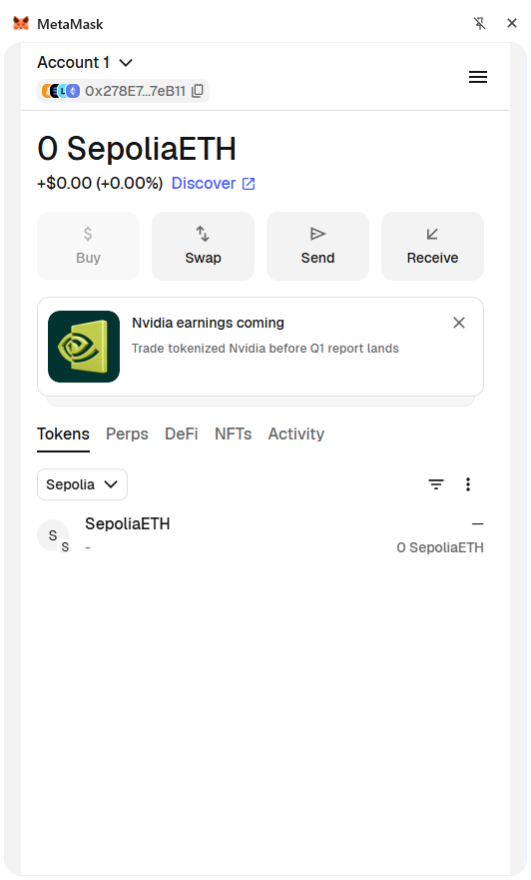
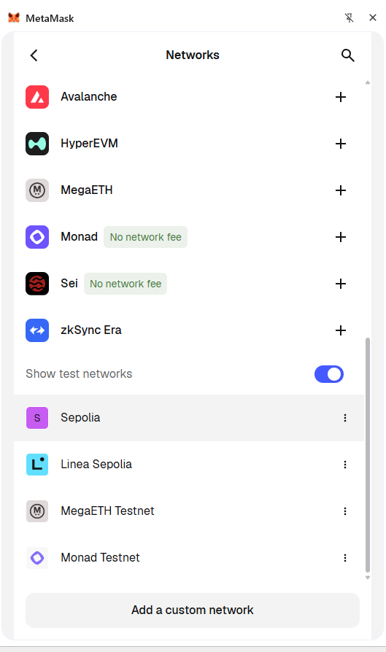
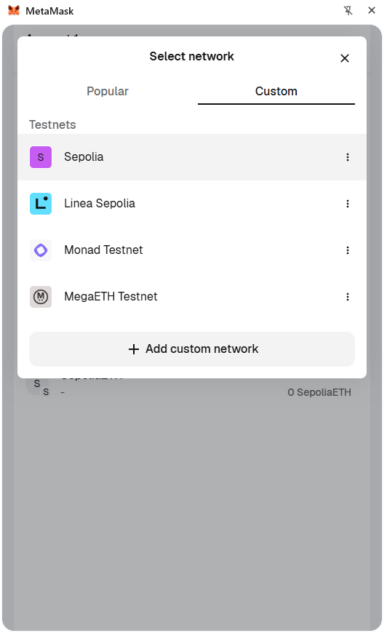
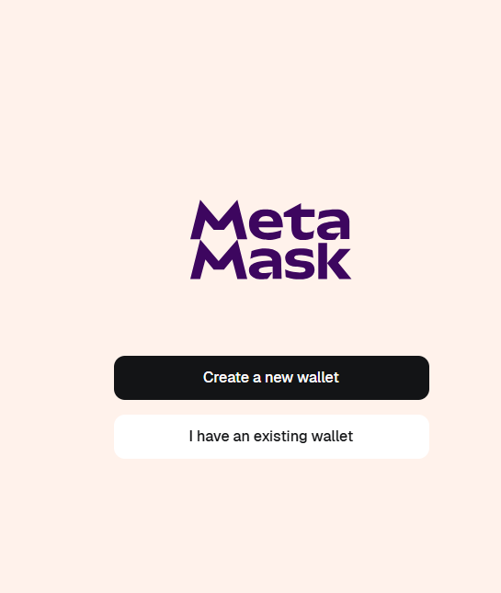
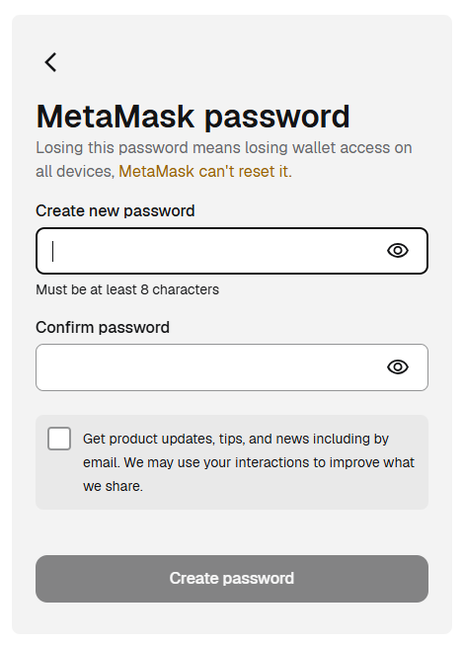
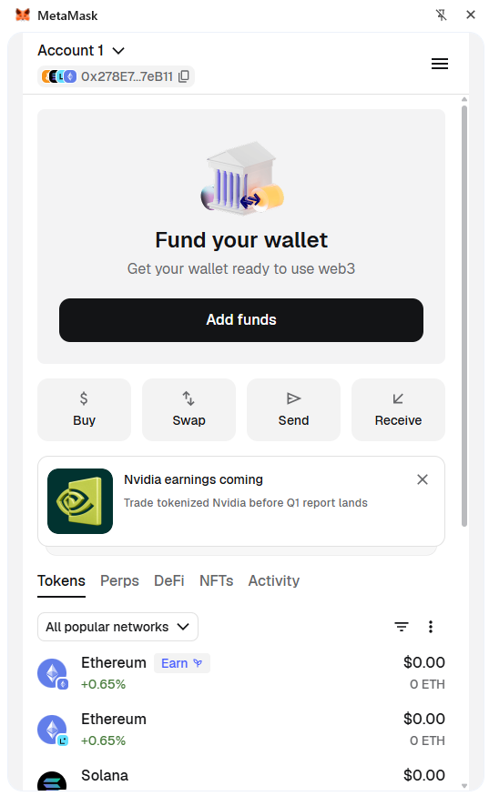
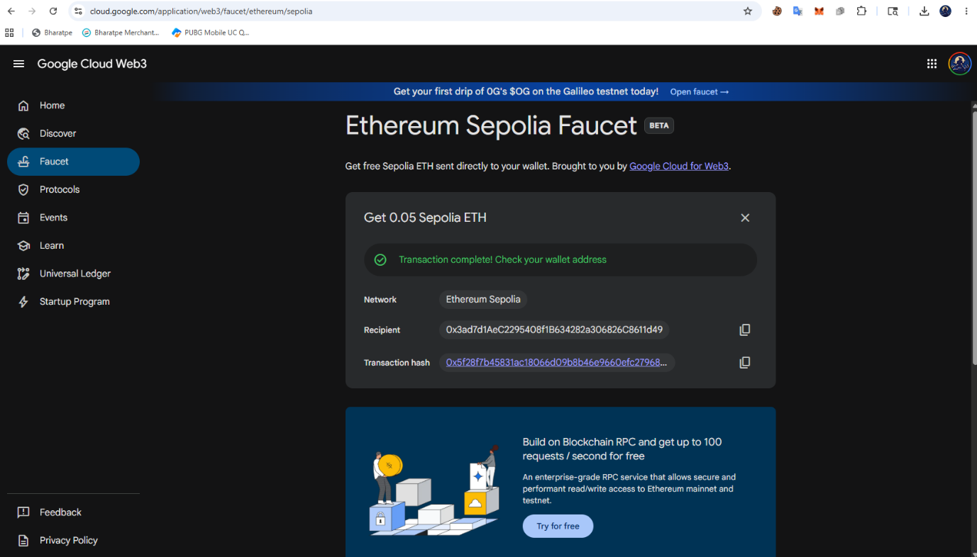
- Get Sepolia ETH from https://cloud.google.com/application/web3/faucet/ethereum/sepolia

- Sepolia RPC Url / Api https://dashboard.alchemy.com
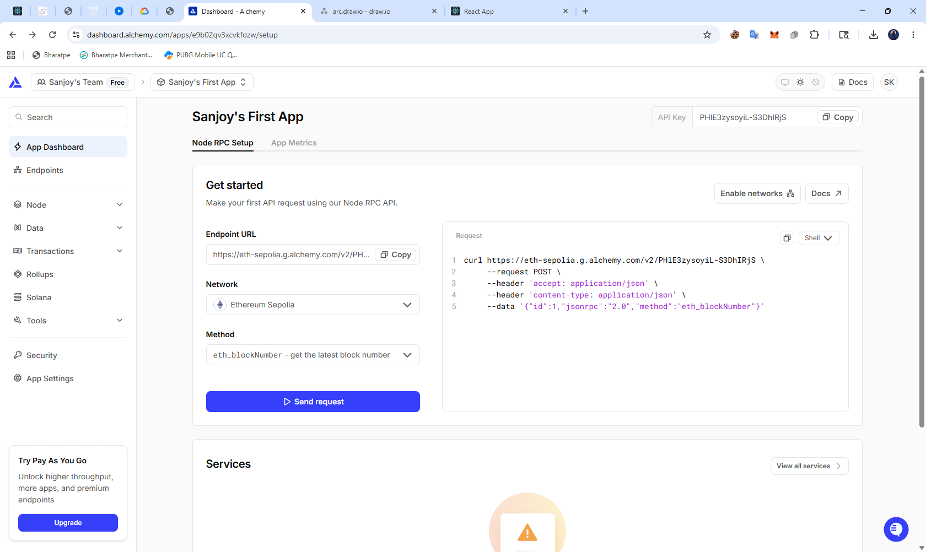

- Smart Contracts Compilation
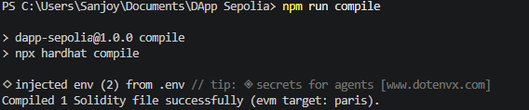
- Deploy Contracts to Blockchain network
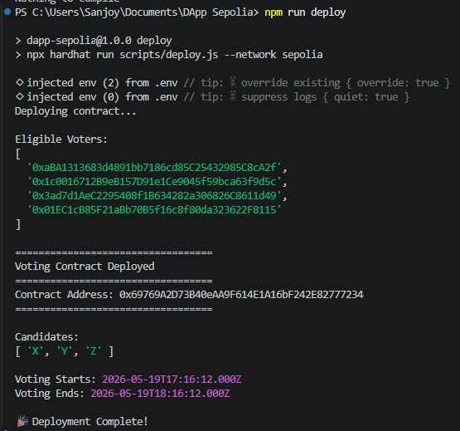

- Frontend Home Pages / Dashboard
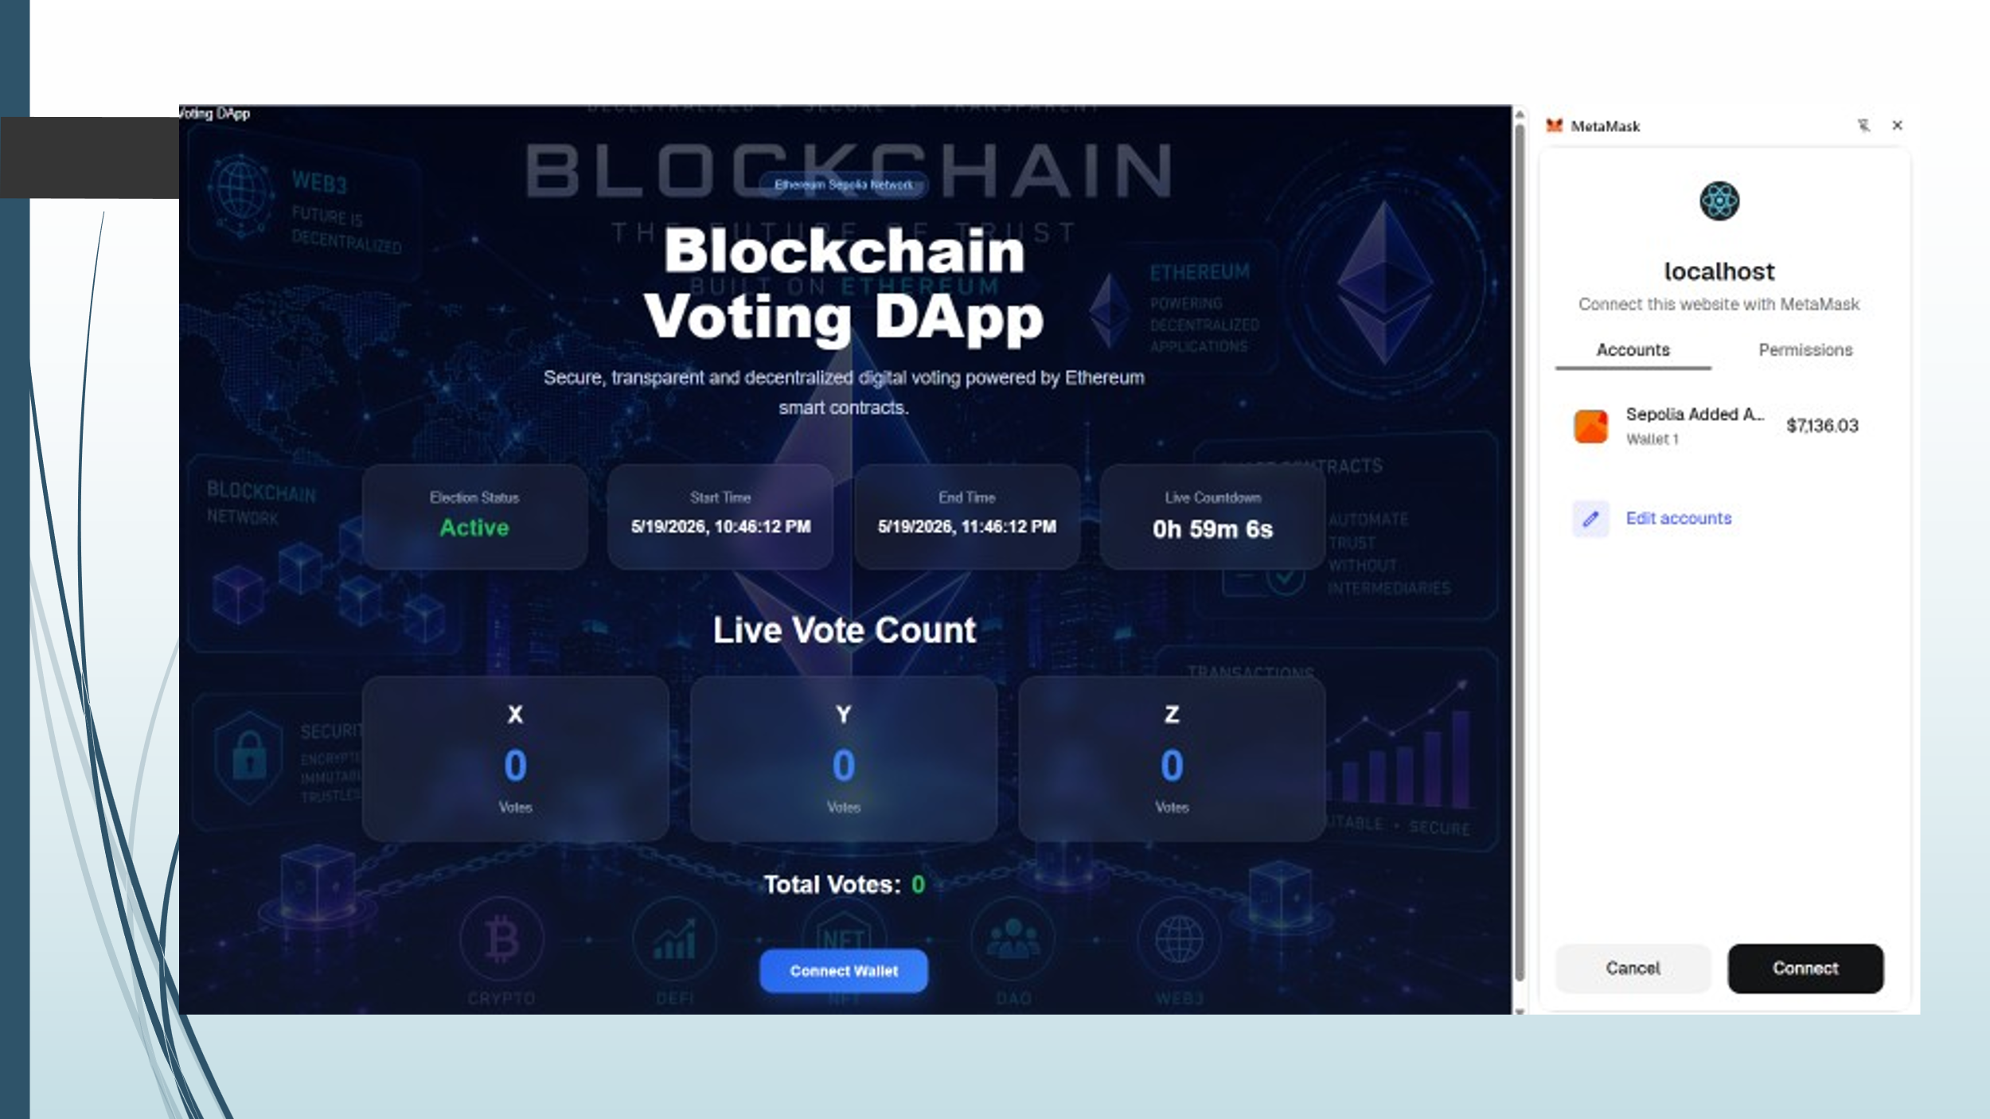

- Wallect Connection Confirmation
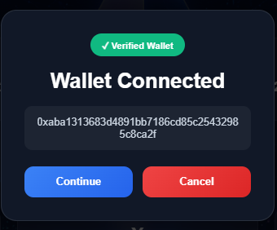

- Voting Page

- Vote confirmation

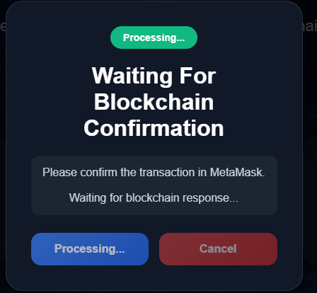

- MetaMask Wallet Confirmation and Vote Confirmation Notification

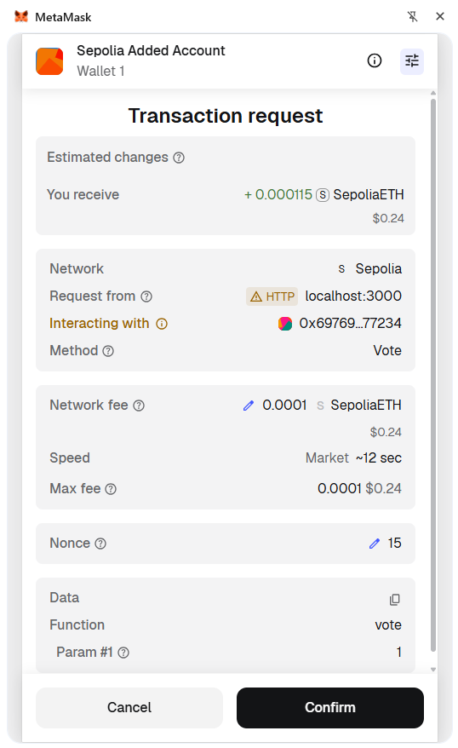

- Vote Transaction Details

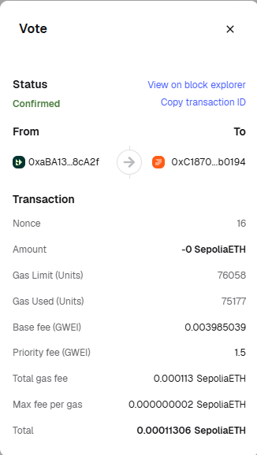
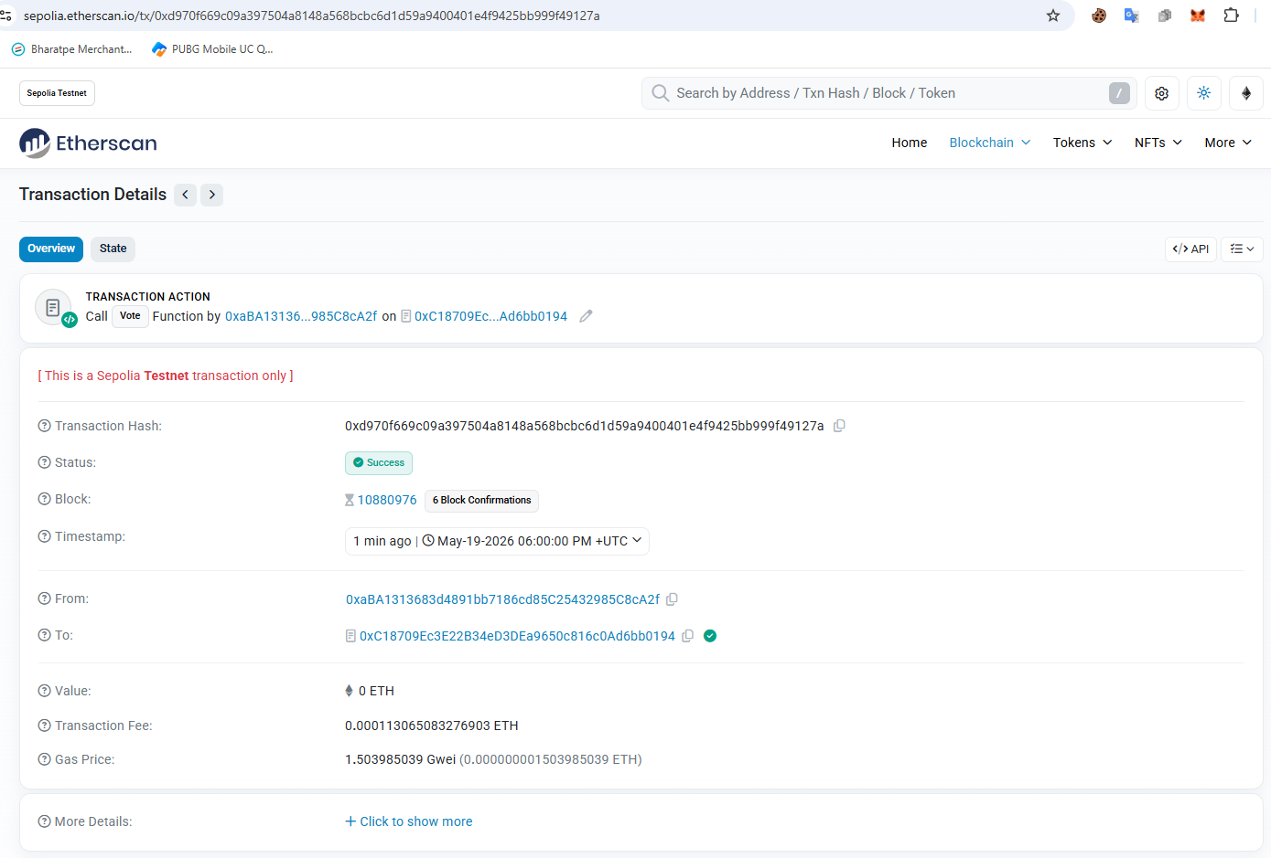

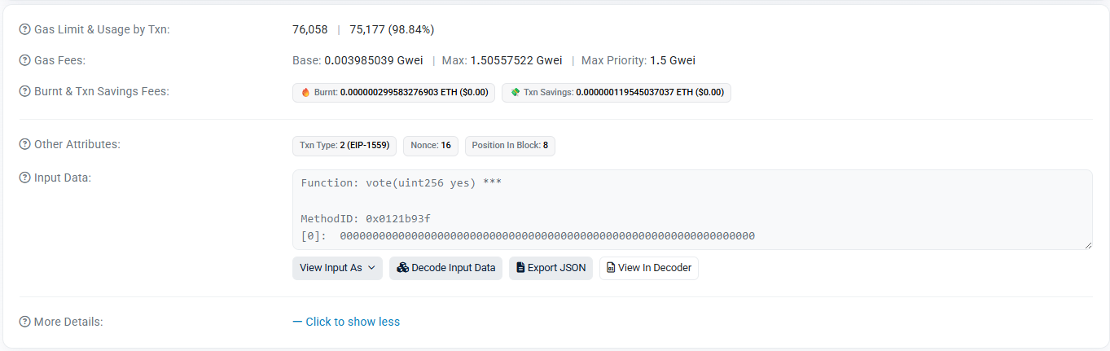

REFERENCES
[1] E. Yavuz, A. K. Koç, U. C. Çabuk, and G. Dalkılıç,
“Towards Secure E-Voting Using Ethereum Blockchain,” 2018.
[2] K. C. Tam,
“Transactions in Ethereum,” 2018.
[3] MetaMask,
“Ethereum Wallet and Web3 Gateway.”
Available: https://metamask.io
[4] D. Khoury, E. F. Kfoury, A. Kassem, and H. Harb,
“Decentralized Voting Platform Based on Ethereum Blockchain,” 2018.
[5] V. Anasune, P. Choudhari, M. Kelapure, P. Shirke, and P. Halgaonkar,
“Online Voting System Using Blockchain,” 2019.
[6] L. Vo-Cao-Thuy, K. Cao-Minh, C. Dang-Le-Bao, and T. A. Nguyen,
“Votereum: An Ethereum-Based E-Voting System,” 2019.
[7] G. Bhavani,
“Survey on Blockchain-Based E-Voting Recording System Design,” 2018.
[8] F. Þ. Hjálmarsson and G. K. Hreiðarsson,
“Blockchain-Based E-Voting System,” 2018.
[9] R. Hanifatunnisa and B. Rahardjo,
“Blockchain-Based E-Voting Recording System Design,” 2017.
[10] S. T. Aras and V. Kulkarni,
“Blockchain and Its Applications – A Detailed Survey,”
International Journal of Computer Applications, 2017.
[11] S. Raju, S. Boddepalli, S. Gampa, Q. Yan, and J. S. Deogun,
“Identity Management Using Blockchain for Cognitive Cellular Networks,”
IEEE International Conference on Communications (ICC), 2017.
[12] H. Choi, H. Kwon, and J. Hur,
“A Secure OTP Algorithm Using a Smartphone Application,”
International Conference on Ubiquitous and Future Networks, 2015.
[13] V. N. Rani, A. S., A. Kumar M., and I. Kumar M. A.,
“Decentralized E-Voting System,”
International Research Journal of Engineering and Technology (IRJET), 2019.
[14] A. Benny, A. A. Kumar, A. Basit, B. Cherian, and A. Kharat,
“Blockchain-Based E-Voting System,”
Department of Computer Engineering, Pillai College of Engineering, Navi Mumbai, India.

