HW05
資工所碩一 吳承翰 0856105
code: https://github.com/chiha8888/NCTU-ML-class/tree/master/HW05

1. Gaussian process
1-1:
Rational Quadratic Kernel alpha,length_scale parameters set to 1
First using kernel() to calculate data points’ similarity, then using predict() to find np.linspace(-60,60,num=500) sampling points’ mean & variance.

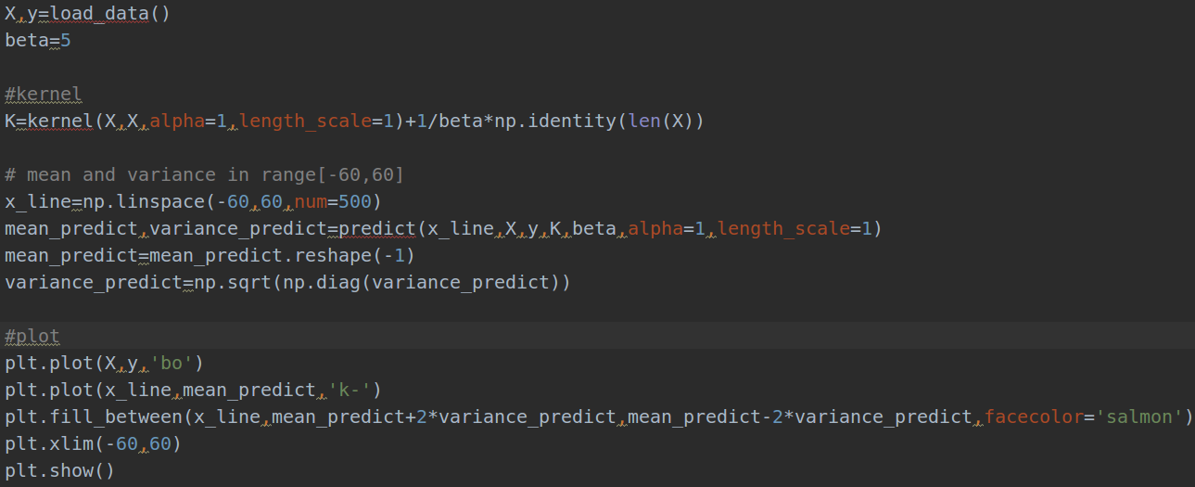
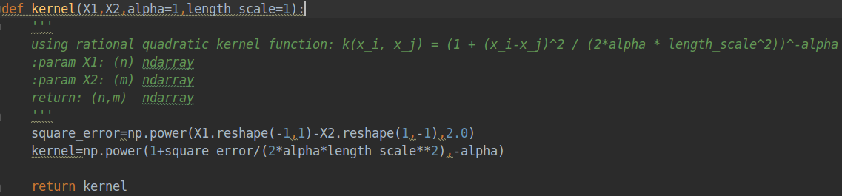
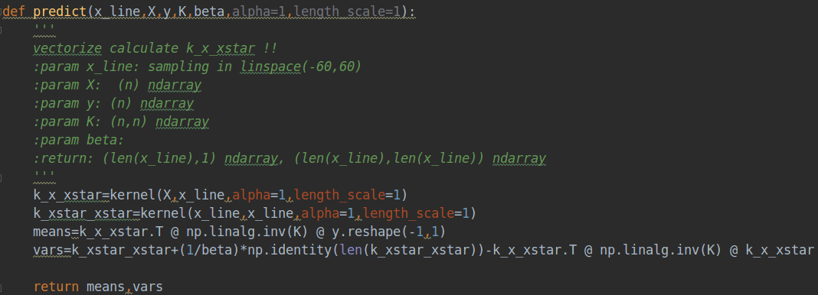

Result：
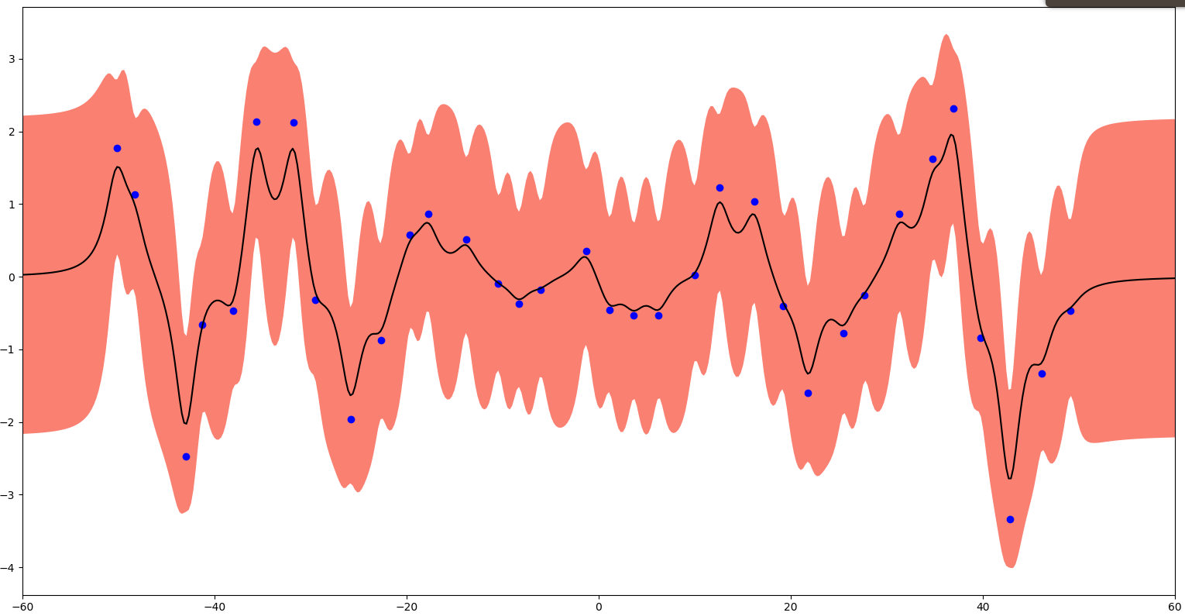
1-2:
using scipy.optimize minimize objective function
Finding optimal alpha & optimal length_scale to minimize negative logp(y|X) ，respectively using [0.01, 0.1, 0, 1, 10, 100] as initial value to run minimize().
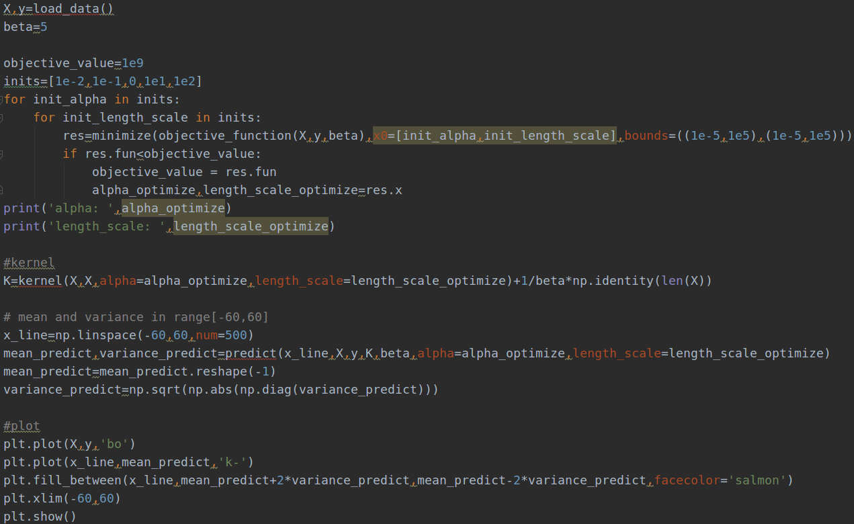
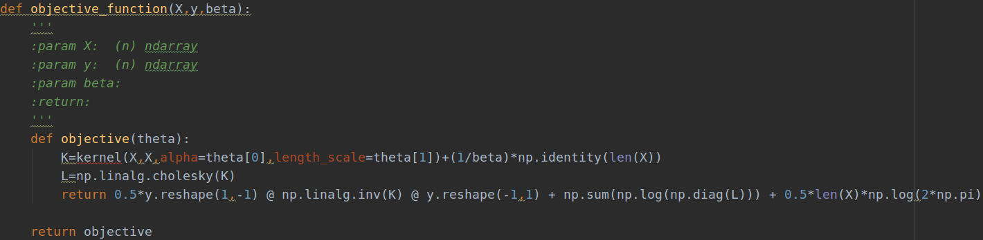
Result：
comparing with alpha=length_scale=1，the variance at the data point is much smaller.
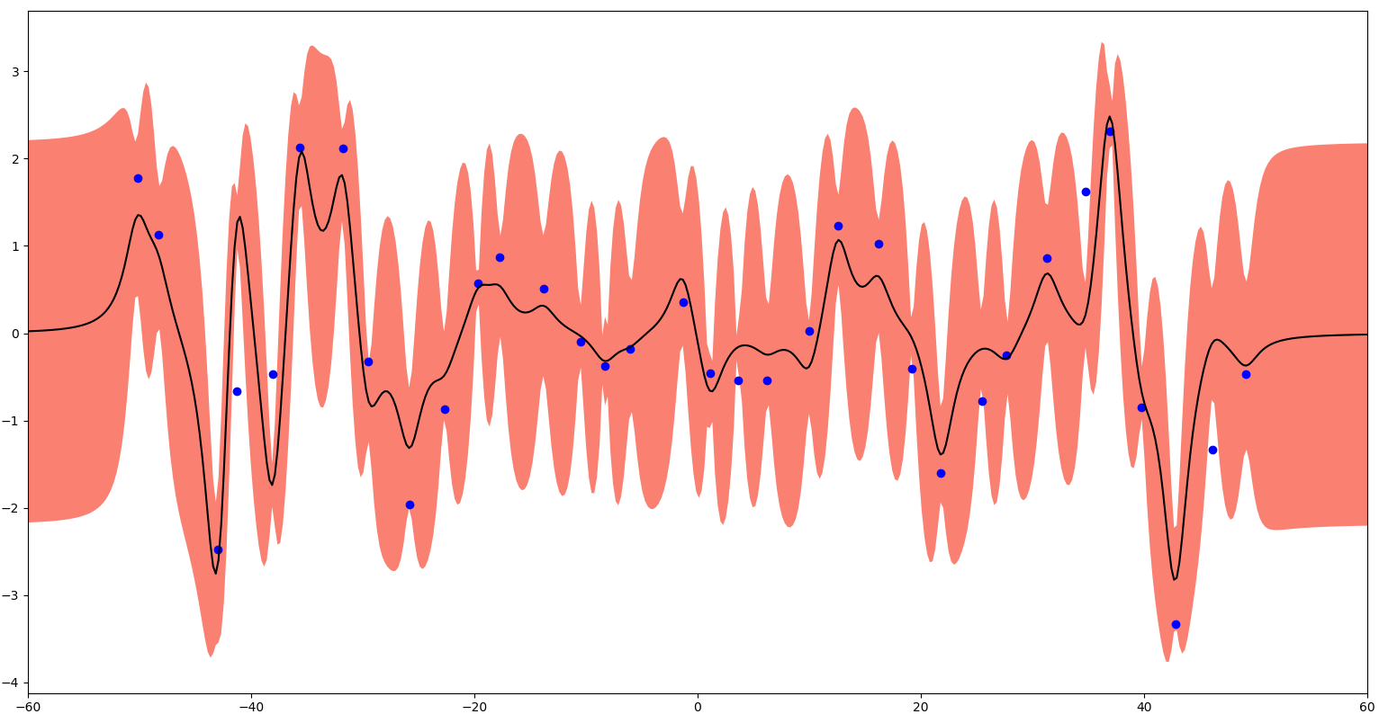

2.SVM on MNIST
2-1：
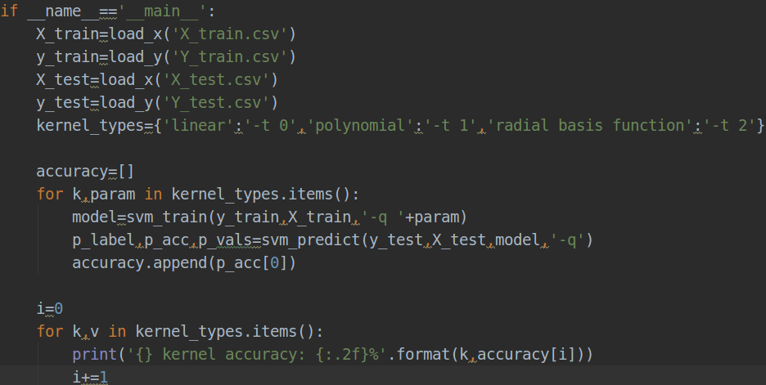
all using default parameters

Result：
linear kernel accuracy: 95.08%
polynomial kernel accuracy: 34.68%
radial basis function kernel accuracy: 95.32%

2-2：
using C and gamma from 2^-4~2^4 to do grid search. If -v is specified, cross validation is conducted and the return of svm_train() is just a scalar.
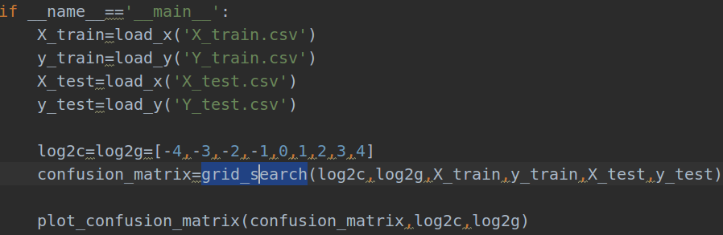
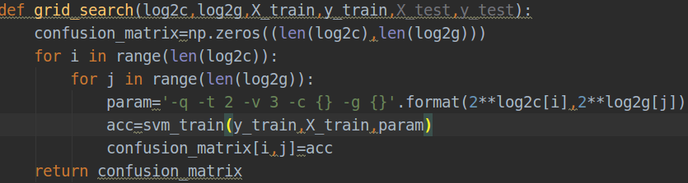
Result:
C=2^4 , gamma=2^-4 has the best validation accuracy 97.78%
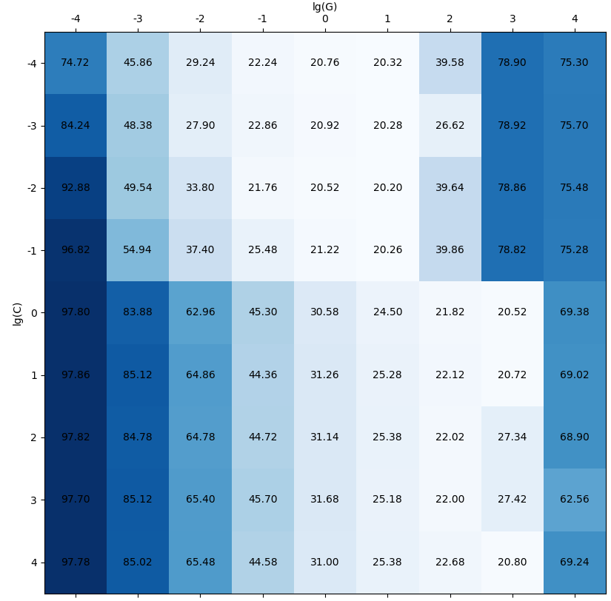

2-3:
using Linear kernel + RBF kernel to get a new kernel, gamma parameter set 2^-4 from 2-2 (which has better predicted result), scipy.spacial.distance.pdist is to calculate the pairwise distance between two data points.
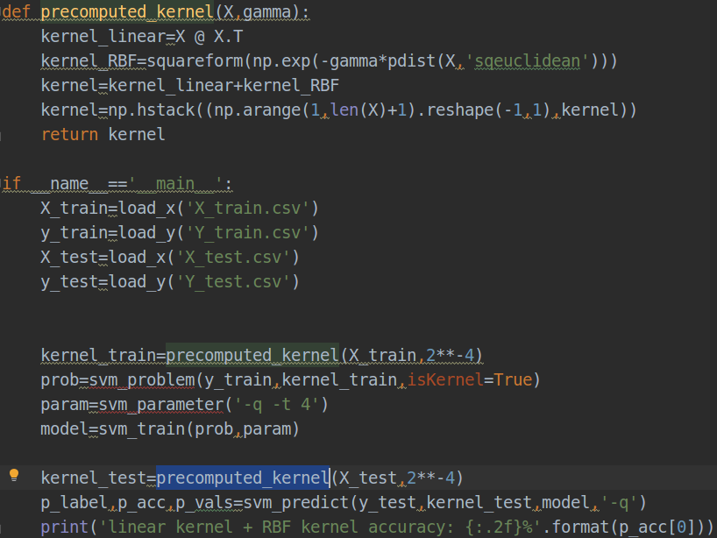
Result:
linear kernel + RBF kernel accuracy: 23.40%

