## Question

A log file is provided which contains 60 lines of strings that are currently organized in chronological order for each individual CPU group number based on their timestamps. The goal is to sort the entire log file in a chronological manner for all the lines of strings in the file regardless of their CPU number.

The following is a sample of a single string line message. The timestamp tick is given in hexadecimal:

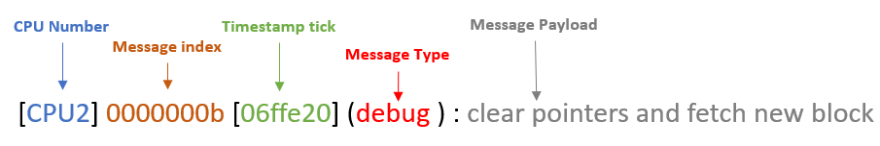

The string message shall be sorted in ascending chronological order (lowest timestamp tick to highest timestamp tick).

**Sample Input**

For example, an unsorted log would look like this:

[CPU0] 00000009 [0002fd3] (debug ) : check capacitor and charge

[CPU1] 00000002 [000071a] (info ) : initialization CPU1

[CPU1] 0000000c [14c2f7f] (info ) : bitmap count 0x7f1db83

[CPU3] 00000004 [0000086] (info ) : opcode 0xd begin init check

**Sample Expected output**

Afterwards, when sorted correctly, the resulting log file should look like this:

[CPU3] 00000004 [0000086] (info ) : opcode 0xd begin init check

[CPU1] 00000002 [000071a] (info ) : initialization CPU1

[CPU0] 00000009 [0002fd3] (debug ) : check capacitor and charge

[CPU1] 0000000c [14c2f7f] (info ) : bitmap count 0x7f1db83

# Instructions

* Write code in C/C++ that reads in the log file, sorts the log messages based on their timestamp ticks in chronological order, and then print the sorted log to standard output.
* You may use any sorting algorithm of your choosing. However, you may not use a built-in sort function (std::sort) as part of any library such as the C++ STL (Standard Template Library).
* **Please include a block comment at the top of your code to describe your design strategy as well as several single-line comments throughout the code to help the reader understand your code.**
* Finally, save your code to a file and return by email to your hiring recruiter.

You may use [www.onlinegdb.com](http://www.onlinegdb.com) to test and write your code as well as upload the provided sample log file. To upload the log file to the server, click on the upload button as circled and shown here:

