COMP4211 Assignment 2 Report

Ng Chi Him

SID 20420921

[chngax@connect.ust.hk](mailto:chngax@connect.ust.hk)

**Results: CNN classifier from scratch**

**Code Screenshot**

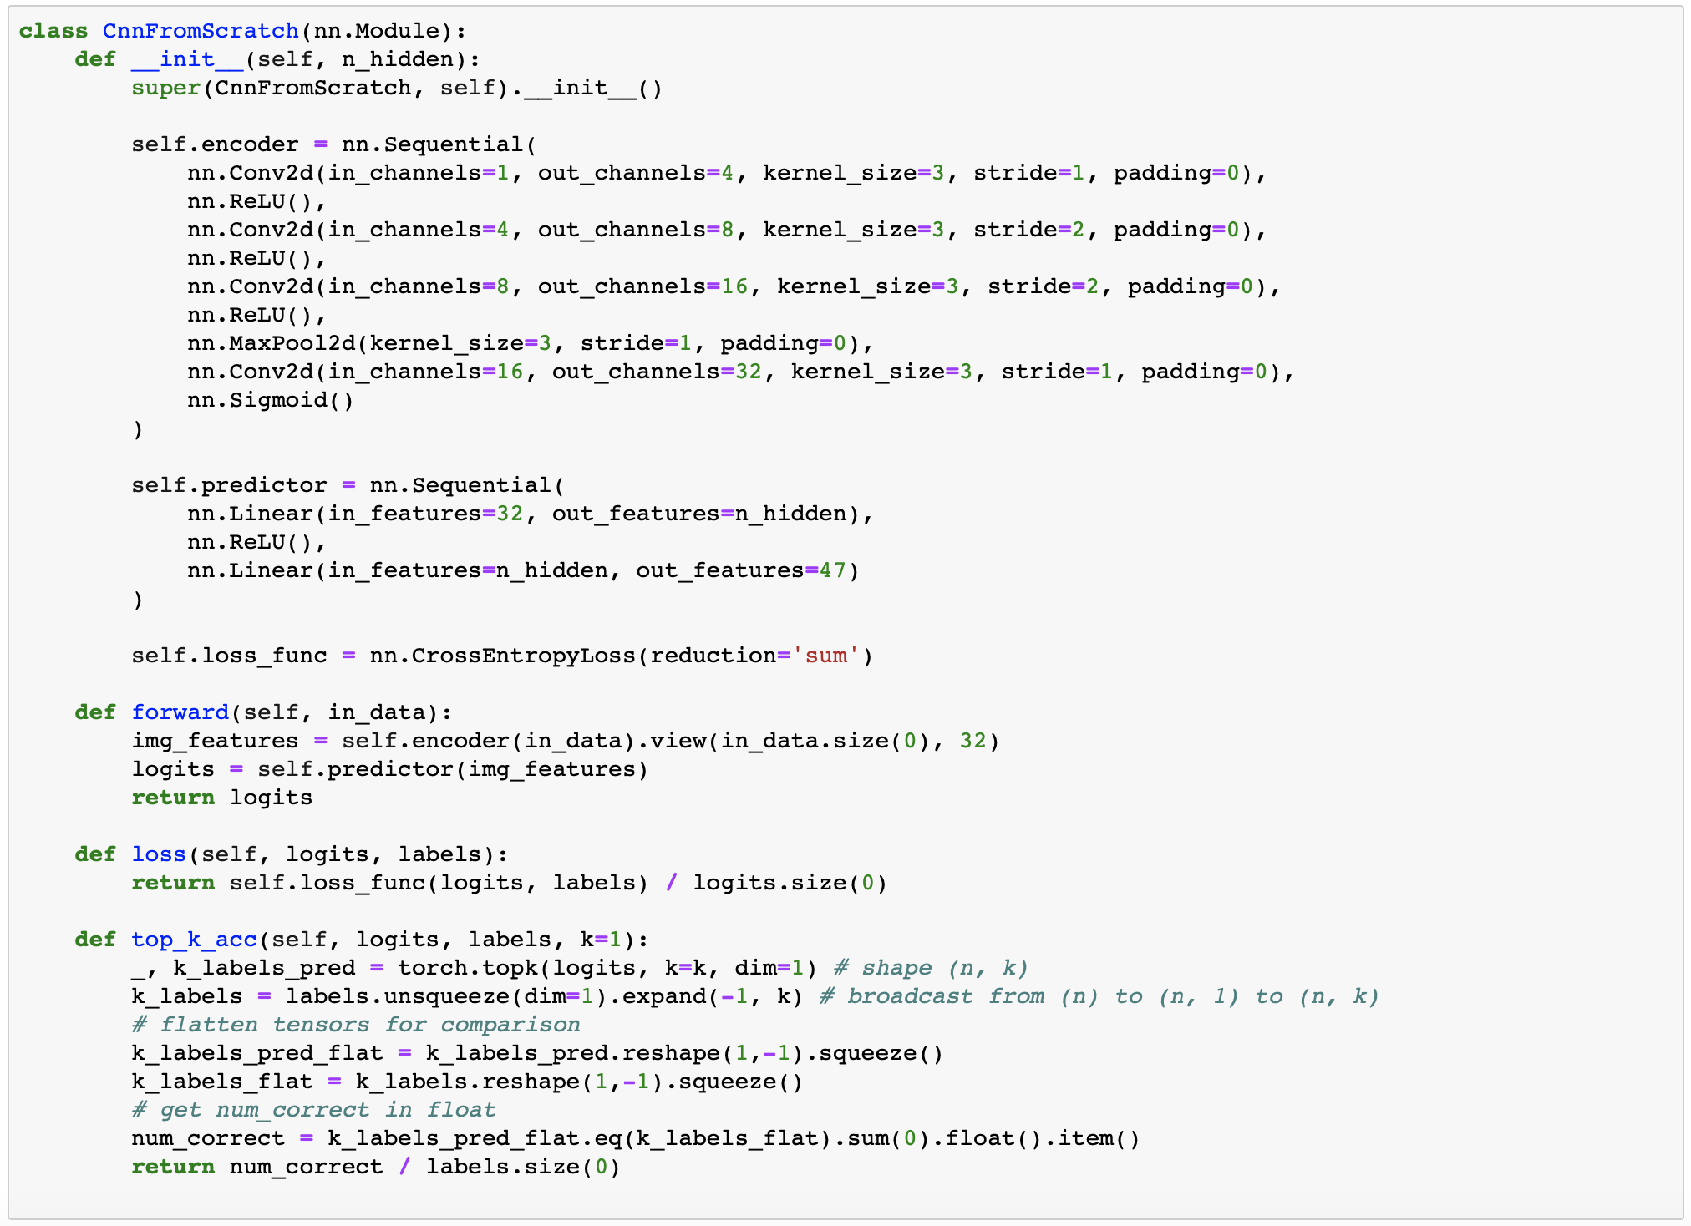

Please refer to code submission for other parts e.g. training/evaluation process.

**Holdout Validation**

Each candidate combination was tested for 10 epochs with batch size 32.

Minimal Validation Set Loss for each candidate combination:

|  |  |  |  |
| --- | --- | --- | --- |
|  | (Adam, 0.001) | (SGD, 0.1) | (SGD, 0.01) |
| H = 32 | 0.836 | 0.8832 | 3.851 |
| H = 64 | 0.6833 | 0.7601 | 3.851 |

Comparing the two hidden layer sizes, H = 64 gave lower loss (~0.7) than H = 32 (~0.8) and was chosen for the final model.

As for optimizers, with reference to the graph on loss over epochs below,

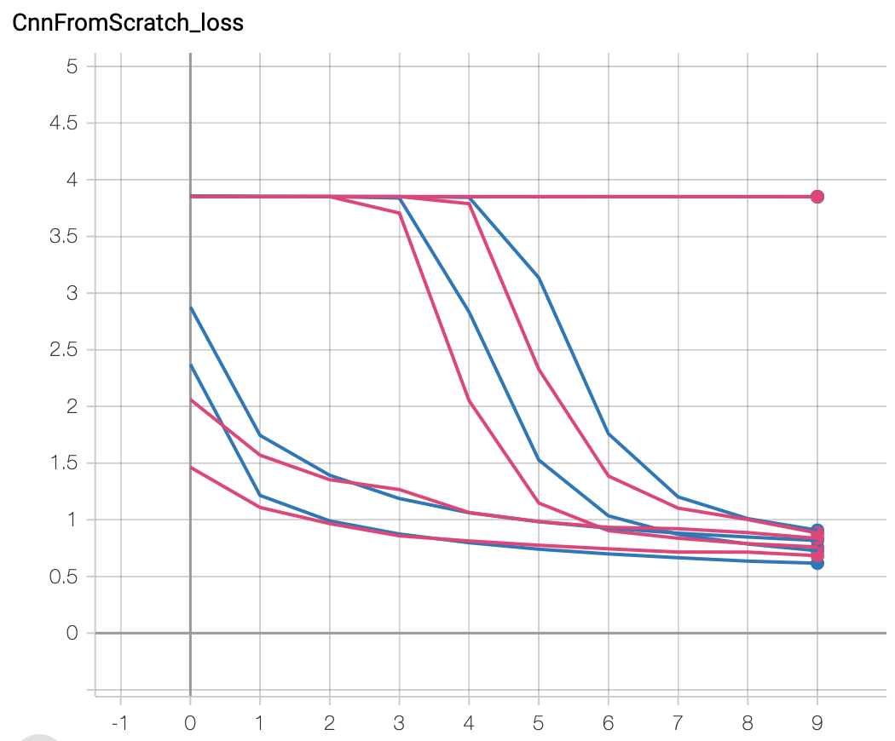

(Adam, 0.001)

(SGD, 0.1)

(SGD, 0.01)

(SGD, 0.01) failed to converge in 10 epochs and was not considered. While both (SGD, 0.01) and (Adam, 0.001) converged, consider that Adam was able to decrease the loss early on and gave lower loss at the end, it was chosen for the final model.

**Final model**

5 runs were executed with configuration below:

Hidden layer size: 64

Optimizer: Adam, learning rate 0.001

Batch size: 32

Number of epochs: 20

Optimal validation metrics recorded:

|  |  |  |  |  |  |  |  |
| --- | --- | --- | --- | --- | --- | --- | --- |
|  | Run 0 | Run 1 | Run 2 | Run 3 | Run 4 | Mean | Std. Dev. |
| epoch 19 | epoch 16 | epoch 18 | epoch 18 | epoch 19 |
| Loss | 0.5804 | 0.6645 | 0.615 | 0.5489 | 0.5796 | 0.5977 | 0.0441 |
| Top-1 Acc. | 0.8117 | 0.7826 | 0.7972 | 0.8159 | 0.8039 | 0.8023 | 0.0131 |
| Top-3 Acc. | 0.9631 | 0.9546 | 0.9593 | 0.966 | 0.9651 | 0.9616 | 0.0047 |

Learning curves: (Run 3 was chosen for showcase)

Loss over epoch

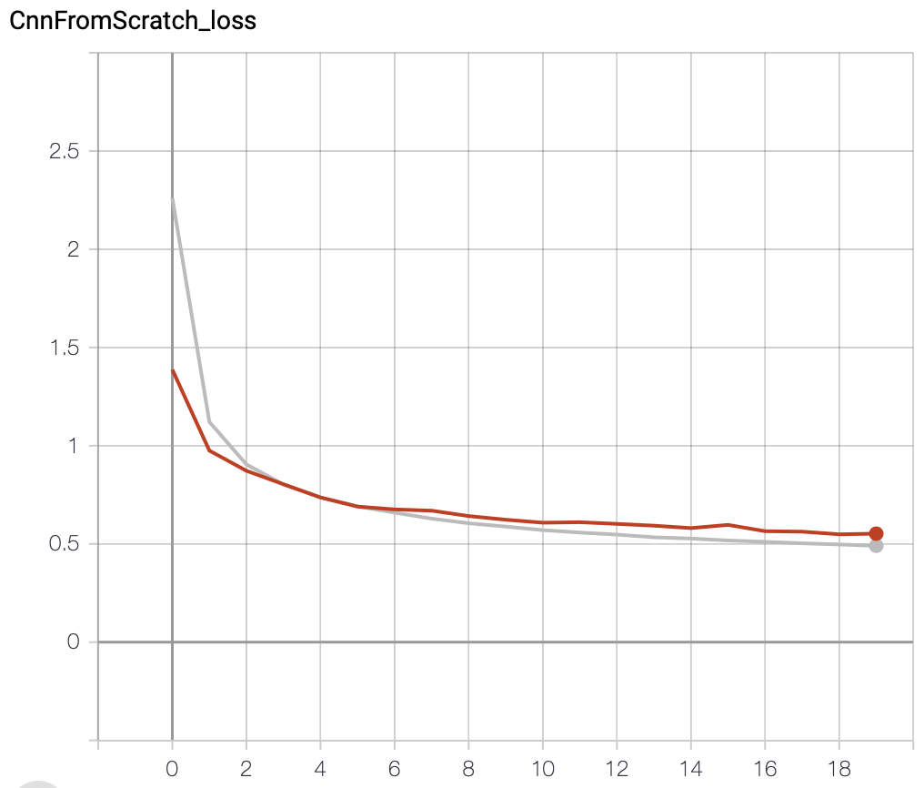

Testing set

Training set

Top-1 Accuracy over epoch

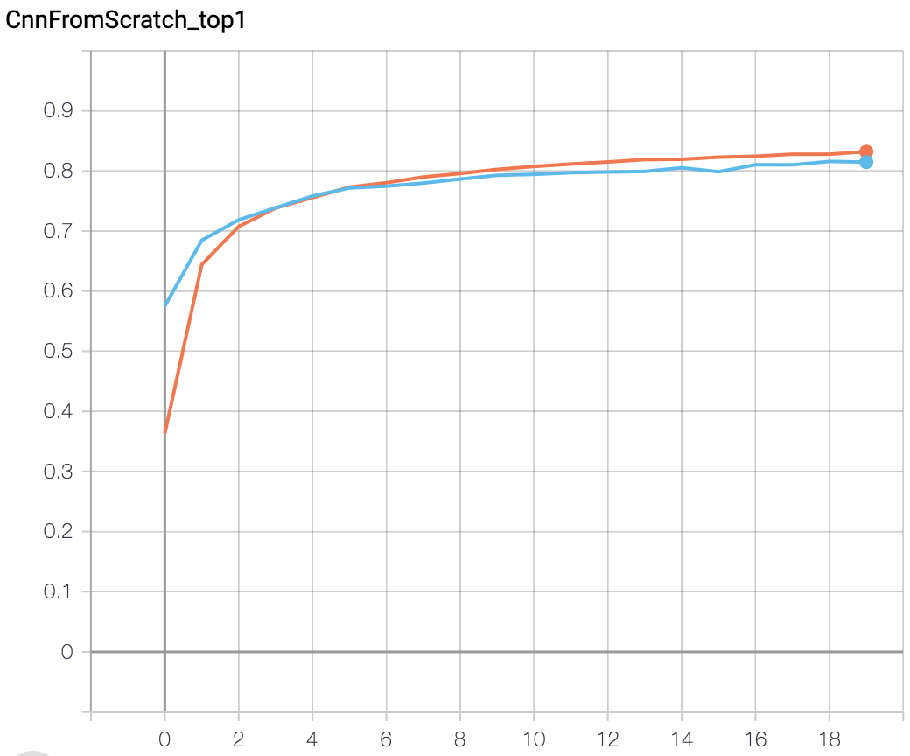

Training set

Testing set

Top-3 Accuracy over epoch

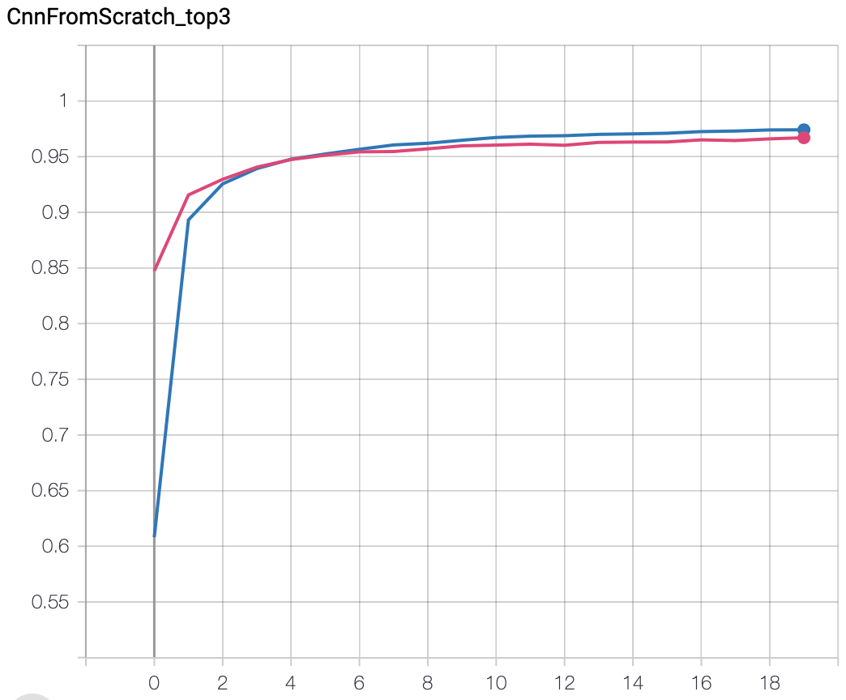

Training set

Testing set

**Results: CNN classifier from Pretrained Encoder**