Question1:

Question2:

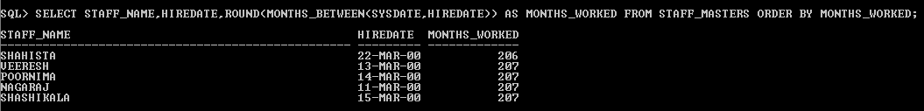

Question3:

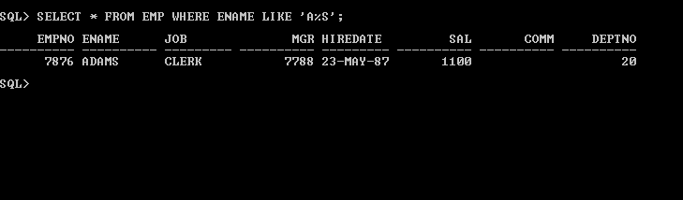

Question4:

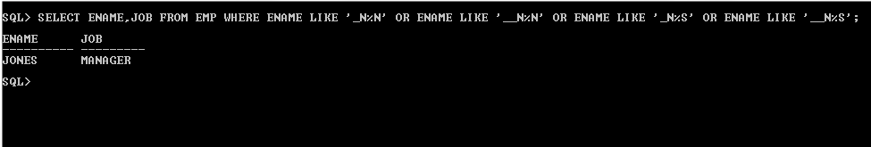

Question5:

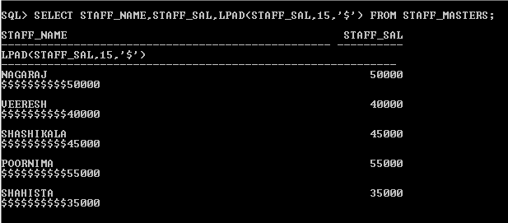

Question6:

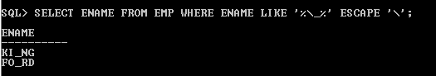

Question7:

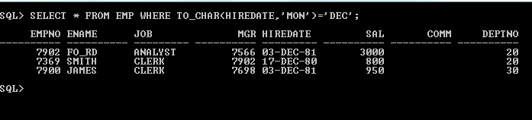

Question8:

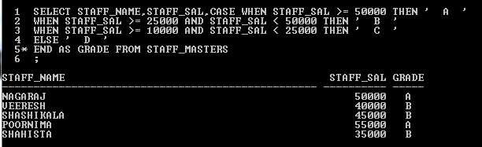

Question9:

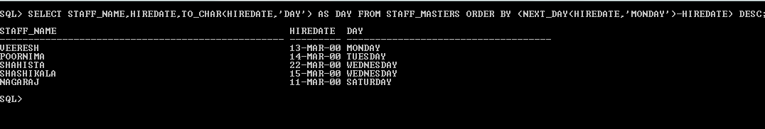

Question10:

