Question1: Retrieve the details (Name, Salary and dept code) of the employees who are working in department 20, 30 and 40.

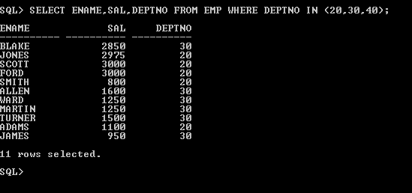

Question2: List the details of the employees with user defined Column headers.

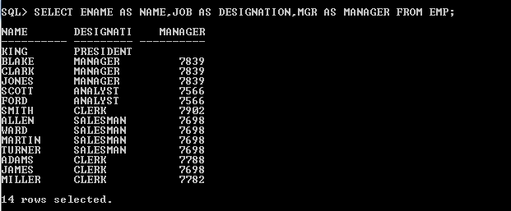

Question3:

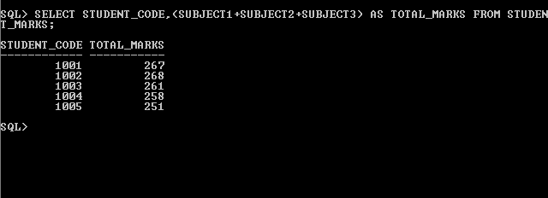

Question4:

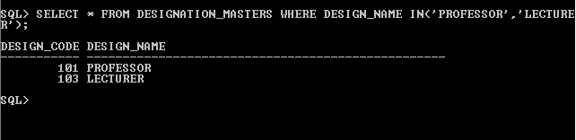

Question5:

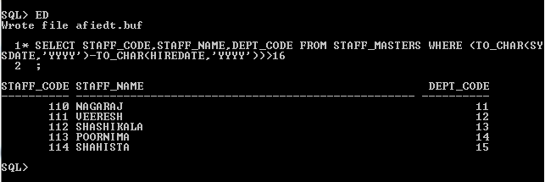

Question6:

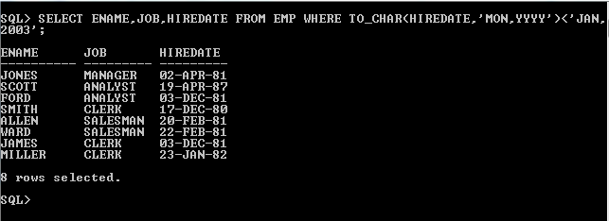

Question7:

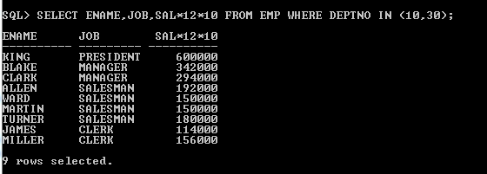

Question8:

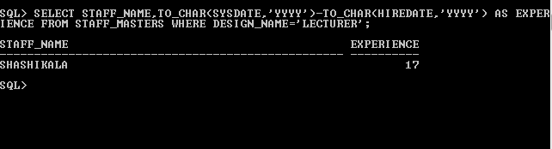

Question9:

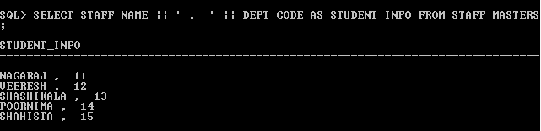

Question10:

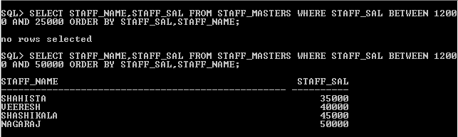

Question11:

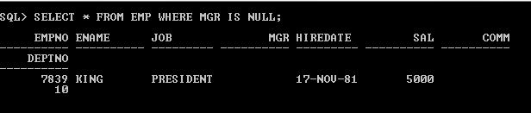

Question12:

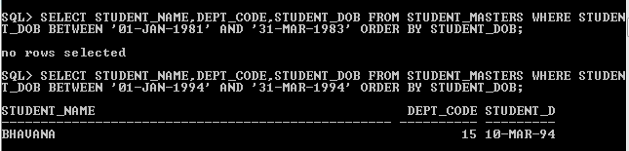

Question13:

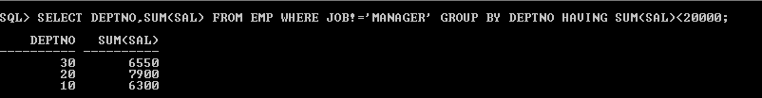

Question14:

Question15:

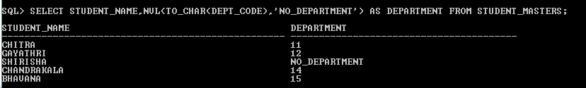

Question16:

