Game Design Document

Game Title: Follow The Light

Team members:
Matěj Minárik
Jan Rybář

Genre
first person 3d casual puzzle and action game

Platform
PC, touchscreen devices later (lowest priority)

Big Idea
Find your way through the immersive space to the mysterious light which will take you to the further levels. The path is not straight and simple though. In this huge space you need not to get crushed by giant and deadly space cubes!

Target Players
Casual players with fondness for 3D puzzles, pathfinding and thrilling situations.
May not be suitable to players suffering from claustrophobia.

Unique Selling Points
- Casual game with 3D world and naturally easy target
- Simple 3D movement through environment

Key Features
- simple, yet enigmatic open 3D world covered in darkness of space (priority 4)
- challenge to find the way around visually giant, deadly and dynamic obstacles – giant rotating space cubes
- simple control of the movement through 3D world (priority 1)
- inspired by space freelancing games like Elite or Descent
- cubes are lit by the target „mysterious“ light, which helps to guess the position of the light (priority 1)
- limited lifes for player (priority 2)
- power-ups like momentary freezing of cubes, short-term disappearance, life-ups, short-term guidance (priority 2)
- auto-generated levels with increasing difficulty (faster cubes, moving target light) (priority 3)

Development plan and priorities
Feature | Priority | Finish date
basic world and mechanics | 1 | 13.10.2015
power-up development and mechanics | 2 | 21.10.2015
level generation | 3 | 1.11.2015
graphics content (lights, glow etc.) | 3 | 8.11.2015
gameplay, controls refinement | 4 | 15.11.2015
menu, HUD | 5 | 22.11.2015
sound, music | 5 | 29.11.2015
further ameliorations | 5 | 13.12.2015
port to Android | 6 | if spare time
Final build | 1 | 21.11.2015

Possible Game Improvements
- control type selection (rotate or yaw)
  - after gameplay research
- cubes with specific features: glowing harmless cubes with no directional enlightment
  - depending on playability and look&feel

Conceptual Images
Only basic concepts! Phong shading shall be featured in the product.
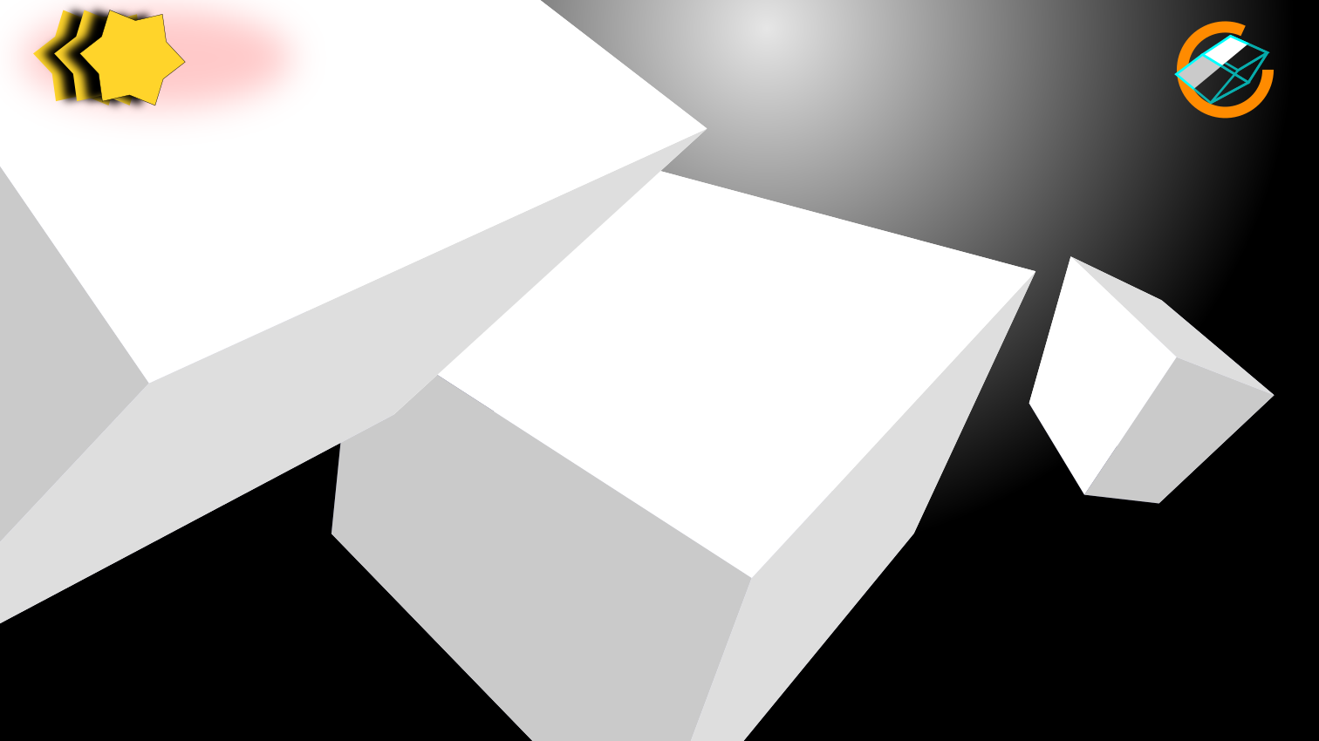
Idea of in-game screen

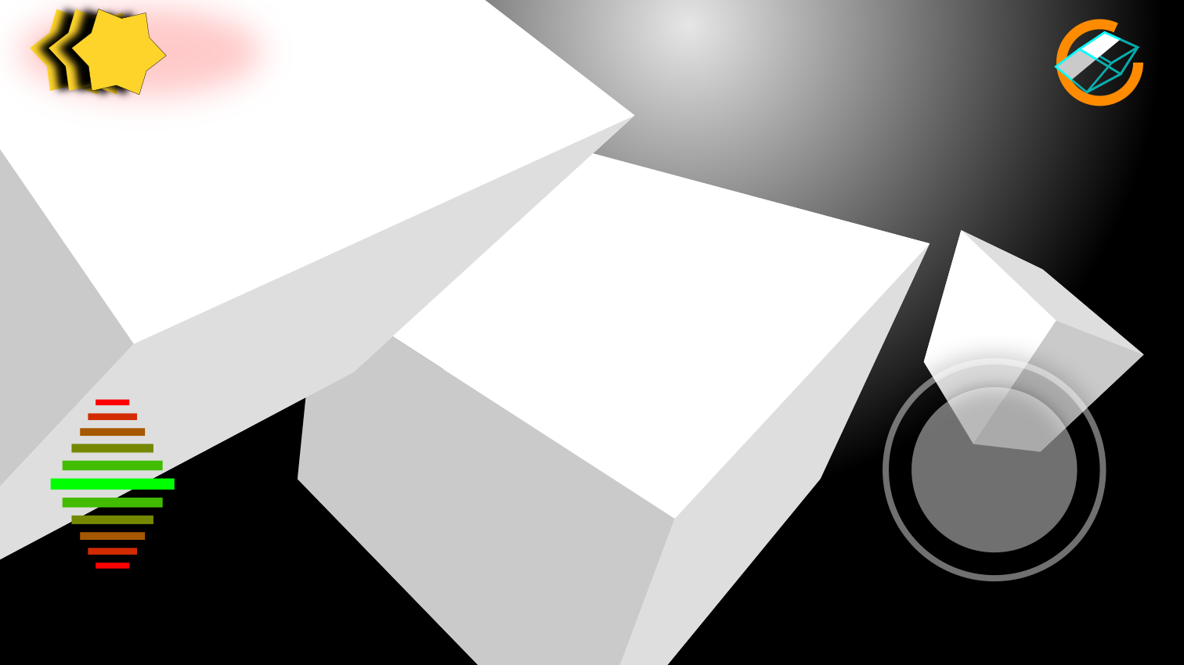
Idea of in-game screen on mobile device

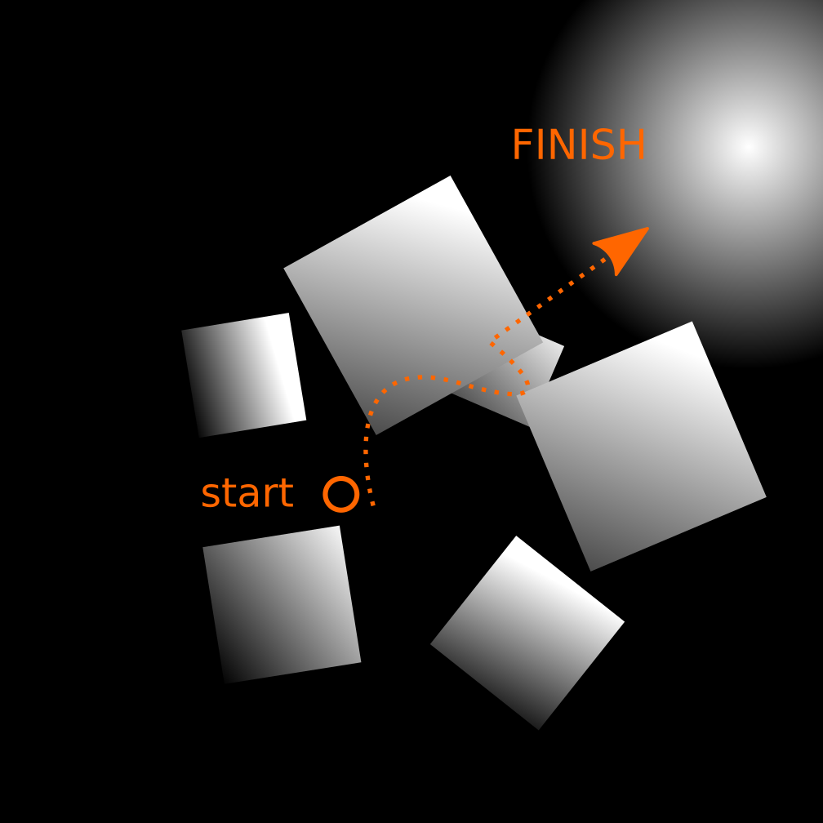
Basic concept

