SERVICE DESK GUIDE
Robocopy Migration Tool
Moving file shares between servers, step by step
For: Level 1 and Level 2 service desk engineers
Tool version: 2.0 (RobocopyMigration-GUI.ps1)
Updated: October 2026
NOTE How to use this guide
If you are new to the tool, read sections 1 to 6 once, in order. They take about 15 minutes.
After that, use section 9 (When a job finishes), section 11 (Troubleshooting) and the Quick reference card on the last page while you work.

Contents
1. What this tool does 3
Who does what 3
2. Before you start 3
3. Starting the tool 4
Closing the tool 5
4. A quick tour of the window 6
Status badges 6
5. Creating a migration job 8
6. Advanced options (Level 2) 10
7. Watching a job and using the queue 12
Reading the latest log lines 12
Running several jobs 13
8. Closing the tool and coming back 14
9. When a job finishes 15
What to do for each result 15
Reading the summary table 16
10. Common tasks 16
A. A standard share migration 16
B. Files failed with "Access is denied" (error 5) 17
C. Files failed because they were in use (error 32) 17
D. A job stopped or was interrupted 17
E. Re-running a finished job 17
11. Troubleshooting 18
When to escalate to Level 2 19
12. What to put in the ticket 19
Files the tool creates 19
Safety rules 19
Quick reference card 21

1. What this tool does
The Robocopy Migration tool copies folders from one server or share to another, with a window instead of a command line. Under the hood it uses robocopy, the copy program built into Windows, so the copies are as reliable as a hand-typed robocopy command, just easier to set up and watch.
Use it to:
- Move a file share to a new file server, keeping NTFS permissions, owners and timestamps.
- Pre-copy ("seed") data days ahead of a cutover, then top it up with quick follow-up passes.
- Re-copy only the files that failed or changed since the last run.
It does not:
- Create the network share itself, or set share permissions.
- Change drive mappings, Group Policy, DFS or user shortcuts.
- Change or delete anything on the source. Only the destination is written to.

Who does what
A suggested split between levels. Always follow your team’s change process if it says otherwise.
Task | Level 1 | Level 2
Run a job that is already planned in the ticket (source, destination and type of copy given) | ✓ | ✓
Watch progress, re-run as Incremental, collect logs for the ticket | ✓ | ✓
Plan a migration and choose the type of copy |  | ✓
Change Advanced options (threads, backup mode, throttling) |  | ✓
Run a Mirror job (it deletes files at the destination) |  | ✓
Investigate "Failed" jobs and repeated "access denied" errors | Collect info, escalate | ✓

2. Before you start
Work through this checklist before every migration. Most failed migrations are caused by a wrong path or missing permission, not by the tool.
☐ The ticket or change is approved, and it states the source and destination paths in full (for example \\FS01\Shares\Finance to \\FS02\D$\Finance).
☐ The customer has confirmed the paths. Read them back if you are unsure. Copying in the wrong direction can overwrite good data.
☐ You know which server to run the tool on. Use a server that can reach both shares, ideally the new (destination) file server.
☐ Your account is a local administrator on that server, can read the source and can write to the destination.
☐ The destination drive has enough free space. Preview (section 5) tells you how much data there is.
☐ You know whether people are still using the source. Files that are open cannot be copied; plan a final pass after hours.
☐ You know which type of copy to use (section 5, step 4). If the ticket doesn’t say, ask Level 2.
IMPORTANT Run it on a server, not your laptop
Copies run on the machine where the tool is open, and they keep running after you close the window. Run the tool on a server that stays on, not on your own workstation or a jump box that gets rebooted.

3. Starting the tool
The tool is one file: RobocopyMigration-GUI.ps1. Nothing needs to be installed.
- Copy the RobocopyMigration folder to the server, for example to D:\Tools\RobocopyMigration. Keep it in the same place for the whole migration: the tool remembers its jobs in a State folder next to the script.
- Right-click RobocopyMigration-GUI.ps1 and choose Run with PowerShell.
- When Windows asks "Do you want to allow this app to make changes?", click Yes. The tool needs administrator rights to copy permissions and owners.
- The Robocopy Migration window opens. The black PowerShell window behind it hides itself; that is normal.

If it doesn’t start
What you see | What to do
Nothing happens, or a red PowerShell error flashes | If the file came from email or a download, right-click it → Properties → tick Unblock → OK, then try again. If it still won’t start, open PowerShell as administrator and run:  powershell.exe -ExecutionPolicy Bypass -File D:\Tools\RobocopyMigration\RobocopyMigration-GUI.ps1
"Robocopy Migration needs to run as administrator…" | You clicked No on the Windows prompt. Start it again and click Yes.
"Robocopy Migration is already open…" | Only one copy of the tool can be open per folder. Someone (possibly another engineer on the same server) already has it open. Find that window and use it.

Closing the tool
Close the window with the X in the corner, like any other program. If copies are still running, the tool asks what to do with them. See section 8.

4. A quick tour of the window
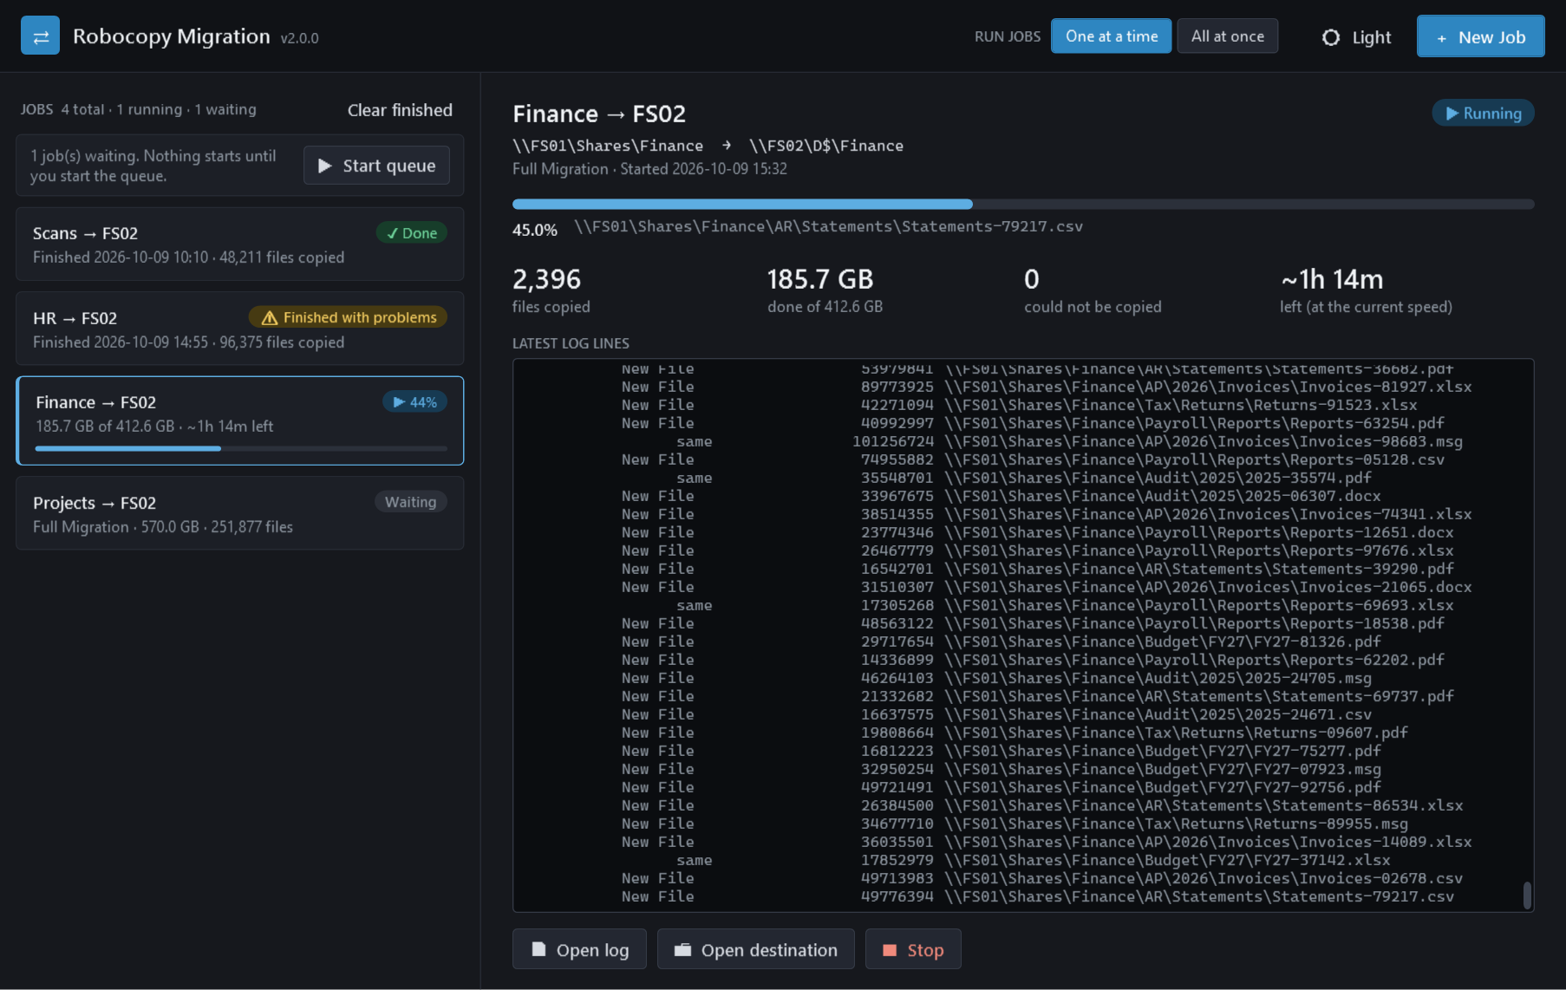
Figure 1. The main window, with one job running and others waiting or finished.
Area | What it shows
Title bar (top) | + New Job to plan a copy. Run jobs: One at a time / All at once controls the queue (section 7). Light / Dark switches the colours.
Jobs list (left) | One card per job. The card shows the job name (source → destination server), a status badge, and a progress bar while it runs. Click a card to see its details.
Queue bar (top of the list) | Appears when jobs are waiting. Start queue starts them; Pause queue stops new ones starting.
Detail pane (right) | Everything about the selected job: full paths, type of copy, progress, numbers, the latest log lines, and the buttons for that job.

Status badges
Badge | Meaning
Waiting | Added but not started yet.
▶ Running / ▶ 45% | Copying now. The % appears when the job was previewed first.
✓ Done | Finished successfully.
⚠ Check | Finished, but robocopy found mismatched files or folders. Look at the log.
⚠ Finished with problems | Finished, but some files could not be copied.
✕ Failed | The copy could not run at all.
■ Stopped | Someone clicked Stop.
Interrupted | The copy ended unexpectedly, for example because the server restarted.
Section 9 explains what to do for each one.

5. Creating a migration job
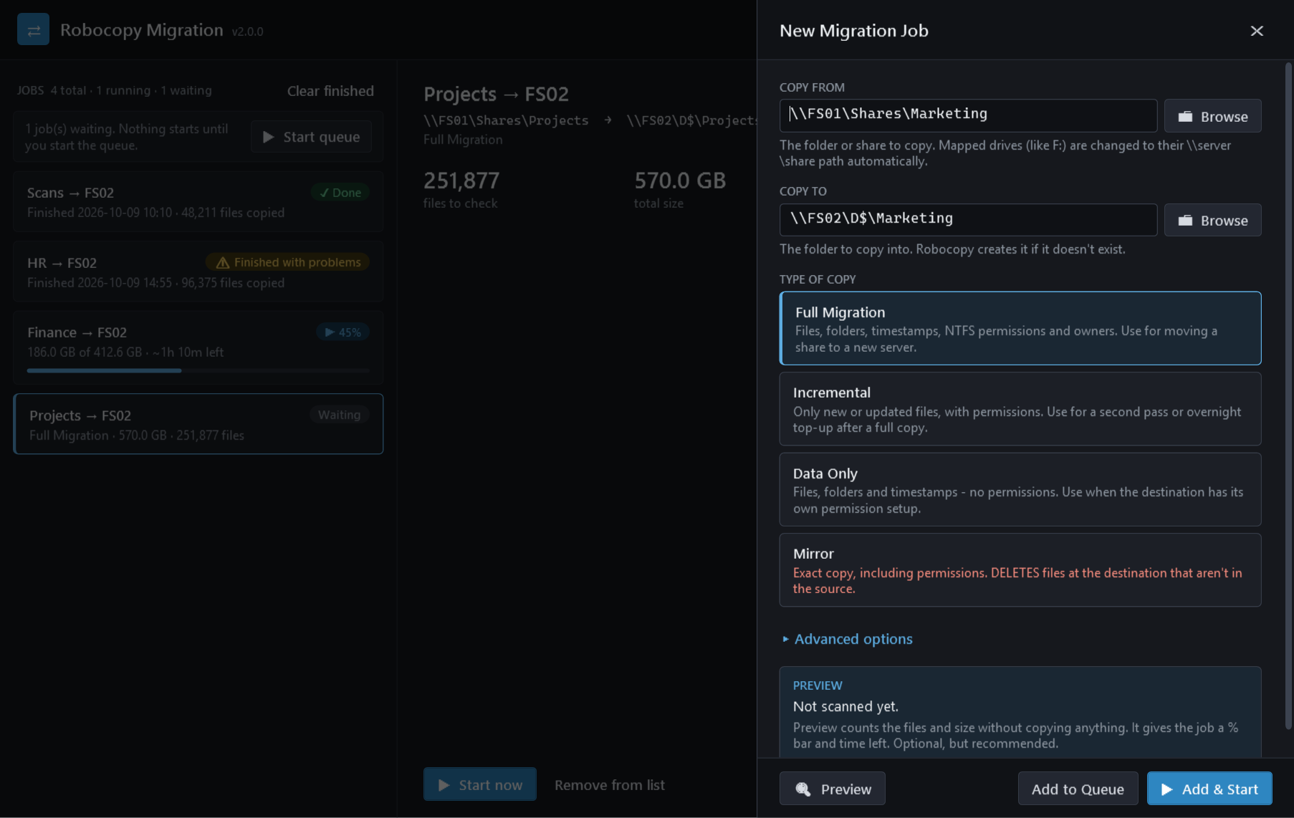
Figure 2. The New Migration Job panel slides in from the right.

Step 1 — Open the panel
Click + New Job in the top-right corner (or press Ctrl+N). Press Esc or click X to close the panel without adding anything.

Step 2 — Copy from
Type or paste the source folder, for example \\FS01\Shares\Finance, or click Browse.
- Use the full \\server\share path where you can. Mapped drive letters (like F:) are converted to their \\server\share path automatically, but an administrator window often can’t see your mapped drives at all.
- Copy from the folder itself. The contents of that folder are copied into the destination folder.

Step 3 — Copy to
Type the destination folder, or click Browse. The destination folder does not need to exist yet: robocopy creates it when the job starts.
To create the folder now, click Browse, select the parent folder, click + New folder, type the name and press Enter. The new folder is selected for you; click Use this folder.
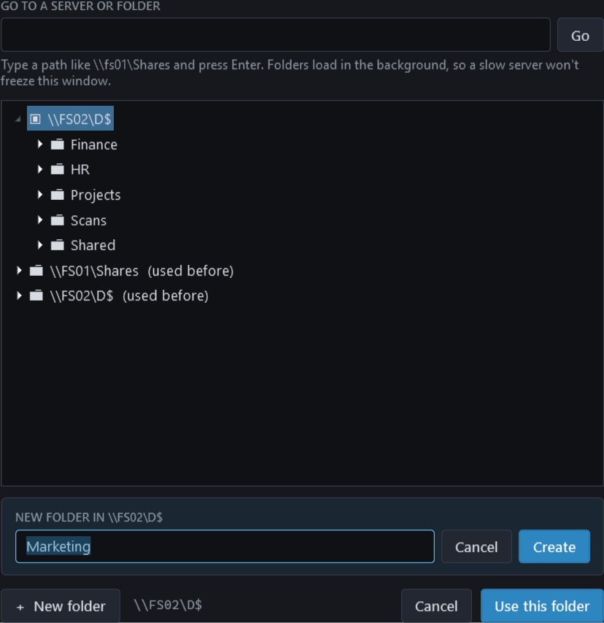
Figure 3. Browsing the destination and creating a new folder.
TIP Browse on a slow server
Folders load in the background, so a slow or offline server shows "Loading…" instead of freezing the window. To jump straight to a server, type \\FS02\D$ in Go to a server or folder and press Enter.

Step 4 — Type of copy
Pick the type the ticket asks for. If it doesn’t say, use this table, or ask Level 2.
Type of copy | What it does | Use it when
Full Migration | Copies all files and folders with timestamps, NTFS permissions and owners. Replaces destination files that are different. | The first copy of a share to a new server.
Incremental | Copies new files and files that changed at the source, with permissions. Never replaces a destination file that is newer than the source copy. | Every pass after the first: nightly top-ups, the final cutover pass, and re-runs after problems.
Data Only | Copies files, folders and timestamps, but no permissions. | The destination already has its own permissions that must be kept, or the source permissions are not wanted.
Mirror (Level 2) | Makes the destination an exact copy, including permissions. Deletes destination files and folders that are not in the source. | Only when the ticket explicitly asks for an exact mirror. The tool asks you to confirm.

WARNING Once users work on the new server, use Incremental only
Full Migration replaces any destination file that differs from the source, even if someone has edited the destination copy since. After cutover, a Full Migration or Mirror from the old server can overwrite users’ new work. Incremental never replaces a newer destination file.

Step 5 — Preview (recommended)
Click Preview. The tool counts the files, folders and total size without copying anything. On a large share this can take a few minutes; you can keep working in the panel, or click Cancel preview.
Preview is optional, but without it the job has no % bar and no time-left estimate. Use the total size to check that the destination has enough free space.

Step 6 — Add the job
Button | What happens
▶ Add & Start | Adds the job and starts it. If One at a time is selected and another job is already running, the job waits and the queue is started, so it runs automatically when its turn comes.
Add to Queue | Adds the job without starting it. Start it later with Start queue or ▶ Start now.

6. Advanced options (Level 2)
Click Advanced options in the New Job panel. The defaults are safe for most migrations; change them only when you have a reason.
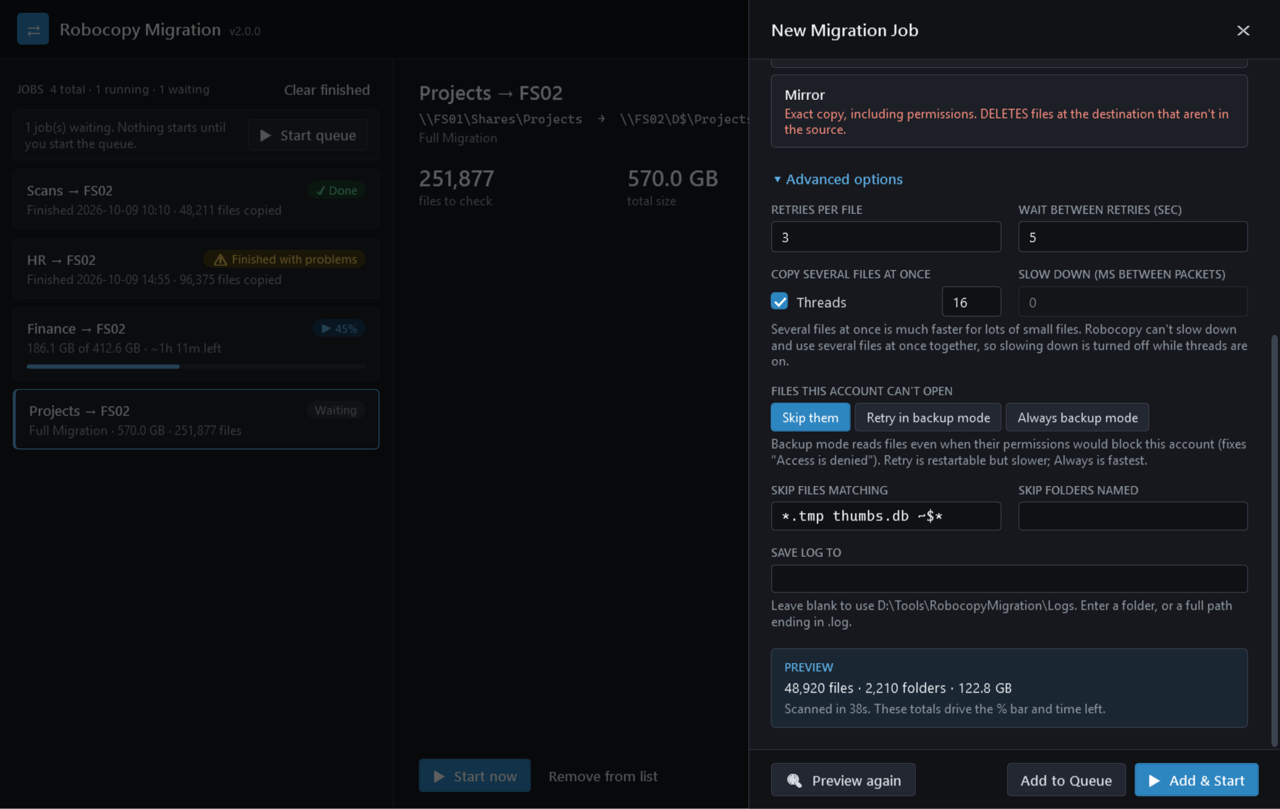
Figure 4. Advanced options and a completed preview.
Option | Default | When to change it
Retries per file | 3 | Lower it (1) when many files are locked and you don’t want each one to hold the job up.
Wait between retries | 5 sec | Raise it when a share drops briefly and needs time to come back.
Copy several files at once (threads) | Off (8 when ticked) | Tick it for shares with many small files; it is often several times faster. 8 to 16 threads suits most servers. It uses more CPU and network.
Slow down (ms between packets) | 0 (full speed) | Copying over a slow WAN link during business hours. Robocopy can’t slow down and use threads together, so this box is greyed out while threads are on.
Files this account can’t open | Skip them | Retry in backup mode or Always backup mode when a previous run failed with "Access is denied" (error 5). Backup mode reads files even when their permissions block your account. Always is faster; Retry can resume interrupted large files.
Skip files matching | (none) | Leave out junk such as *.tmp, thumbs.db or Office lock files (~$*). Separate patterns with spaces.
Skip folders named | (none) | Leave out folders such as Temp or $RECYCLE.BIN.
Save log to | The Logs folder next to the tool | The customer or change process needs the logs somewhere else. Enter a folder, or a full path ending in .log.

7. Watching a job and using the queue
Click a running job in the list. The detail pane updates twice a second.
Number | Meaning
% bar and percentage | How much of the previewed data has been handled so far (copied, already up to date, or failed).
Files copied | Files copied so far in this run.
Done of … | Data handled so far, out of the preview total.
Could not be copied | Files that failed after all retries. Turns red when above zero.
Left (at the current speed) | Estimated time remaining, based on the last minute of copying. It appears after a few seconds and moves as the speed changes.

Reading the latest log lines
The black box shows the last 500 lines of the robocopy log. Common entries:
Log line | Meaning
New File | File copied because it isn’t at the destination yet.
Newer / Older / Changed | The file differs from the destination copy. It is copied, except that Incremental skips Older files (the destination copy is newer).
same | Already identical at the destination; skipped.
*EXTRA File | File exists only at the destination. Left alone, except by Mirror, which deletes it.
ERROR 5 (0x00000005) | Access is denied. See section 11.
ERROR 32 (0x00000020) | The file is open in another program. See section 11.
Waiting 5 seconds... Retrying... | Robocopy is retrying a file that failed. Normal; only the final failure counts.
Buttons: Open log opens the full log in Notepad. Open destination opens the destination folder in Explorer. ■ Stop stops the job; files already copied are kept.

Running several jobs
- Add each share as its own job. Jobs added with Add to Queue show as Waiting.
- Click Start queue to start them. Pause queue stops new jobs starting; running jobs carry on.
- One at a time: the next waiting job starts when the current one finishes. Use this when the jobs share the same source or destination disk.
- All at once: every waiting job starts together. Only use this when the jobs use different servers or disks; otherwise they slow each other down.
- A job that fails doesn’t stop the queue. The next job still starts.
- Clear finished removes finished, stopped and interrupted jobs from the list. Remove from list does the same for one job. Copied files and logs are kept.
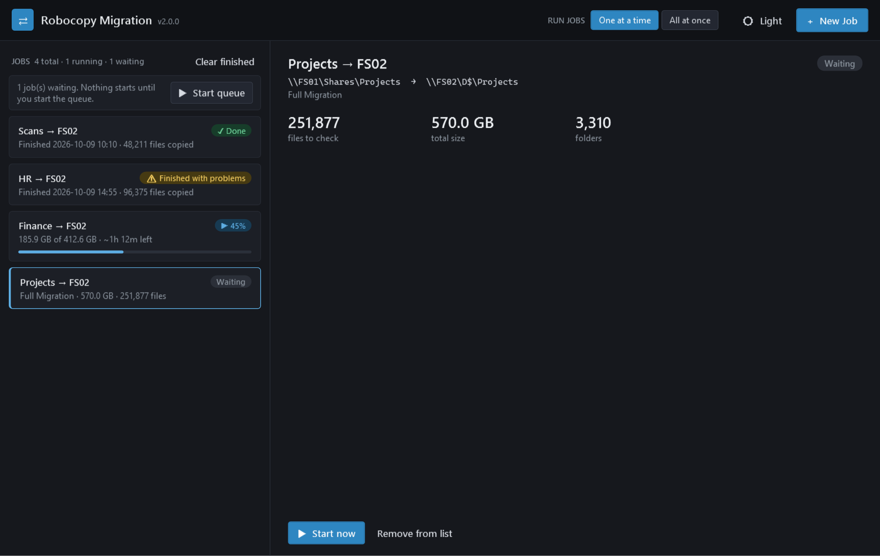
Figure 5. A waiting job shows its preview totals and a Start now button.

8. Closing the tool and coming back
Each copy runs as its own background process, so you don’t have to keep the window open for a long migration.
When you close the window while copies are running, the tool asks:
Answer | What happens
Yes | Copies keep running in the background. Reopen the tool later to check on them. This is the usual choice.
No | All running copies are stopped. Files already copied are kept.
Cancel | Nothing is closed. You go back to the window.

When you reopen the tool, it finds the copies that are still running and shows them as Reattached, with live progress. Jobs that finished while the window was closed show their result. Jobs that were Waiting stay waiting: click Start queue to carry on.
IMPORTANT Disconnect from the server; don’t sign out
Close your Remote Desktop session with Disconnect (or just close the RDP window). Signing out ends every program you started on that server, including the background copies. The jobs would then show as Interrupted.

NOTE If the server restarts
Copies stop when the server restarts. After the restart, open the tool: those jobs show as Interrupted. Select each one and click Run again as Incremental. It skips everything already copied and finishes the rest.

9. When a job finishes
Select the job to see a plain-English summary, robocopy’s own summary table, and any files that could not be copied.
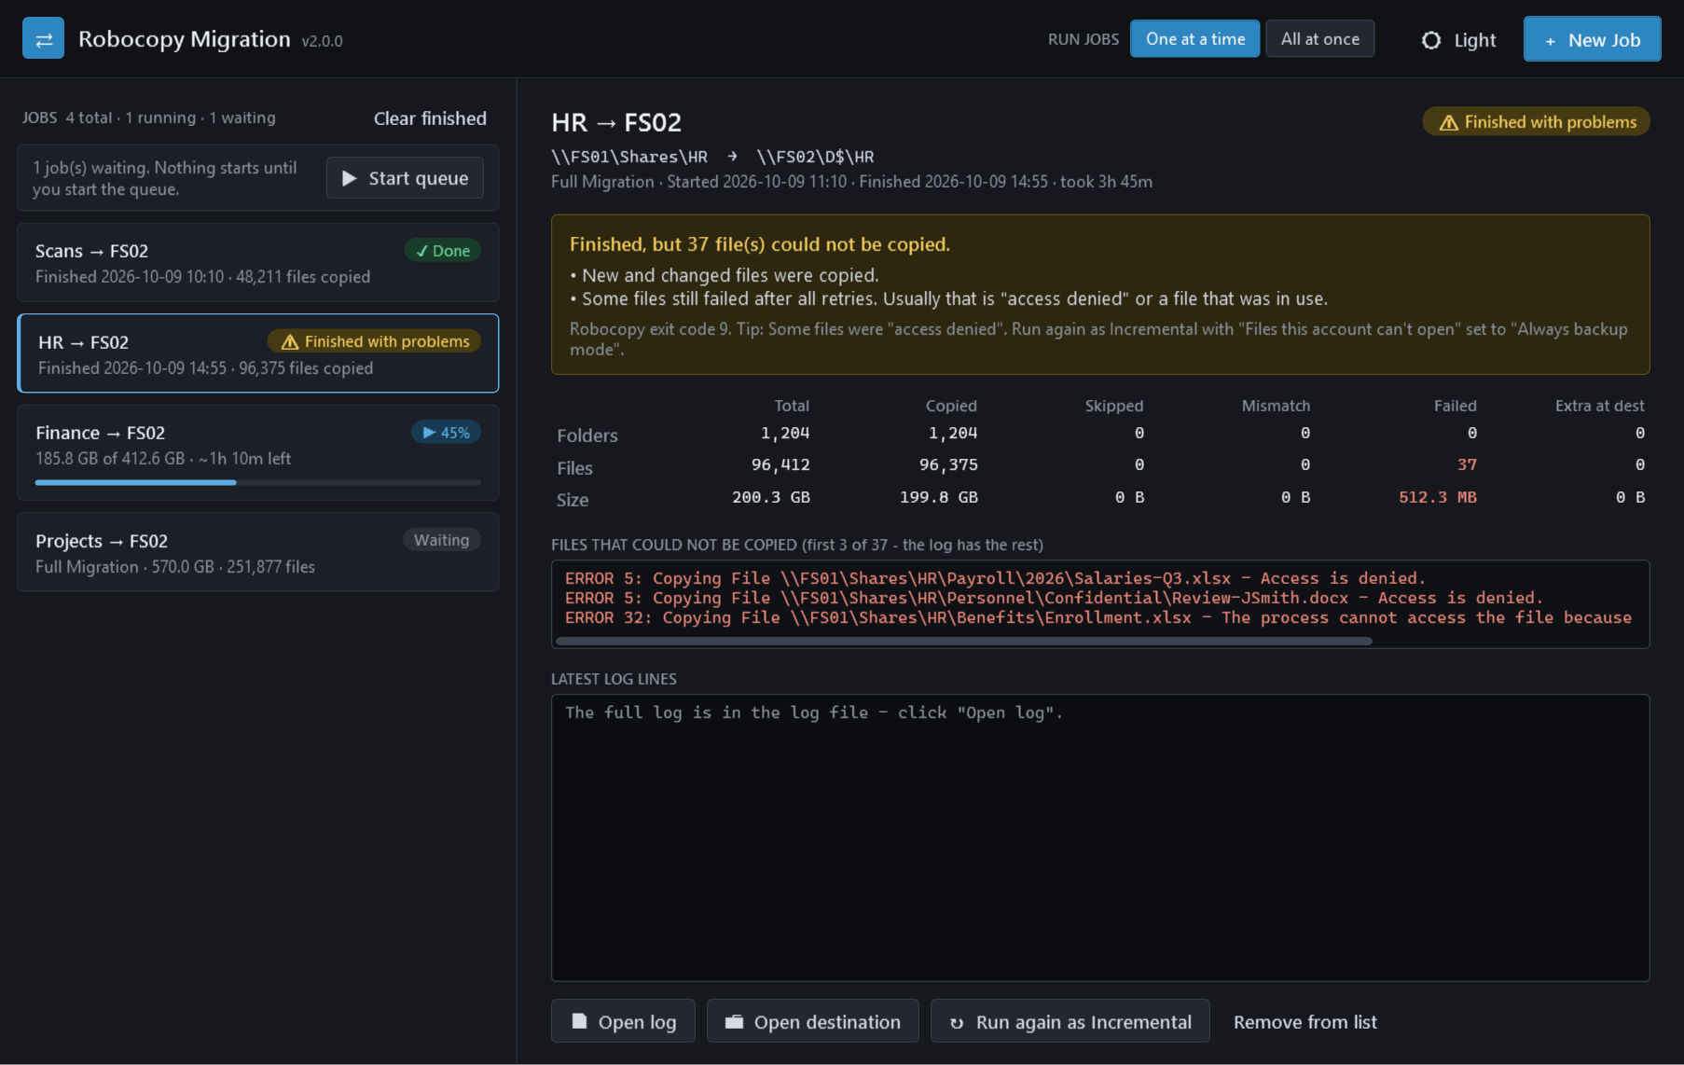
Figure 6. A job that finished with problems: 37 files could not be copied.

What to do for each result
Status | Robocopy exit code | What it means | What you do
✓ Done | 0–3 | Everything that needed copying was copied. Code 0 means nothing needed copying. | Record the result in the ticket. Spot-check a few folders with Open destination.
⚠ Check | 4–7 | Copied, but robocopy found mismatched items (for example a file at the source where the destination has a folder with the same name). | Open the log and search for "Mismatch". Escalate to Level 2 if you’re unsure.
⚠ Finished with problems | 8–15 | Some files failed after all retries. | Read the Files that could not be copied list, then follow section 10 (recipes B and C).
✕ Failed | 16 or higher | Robocopy could not run the copy. Usually the source or destination couldn’t be reached or opened. | Check both paths open in Explorer from this server. Fix and run again. Escalate if they open fine.
■ Stopped | — | Someone clicked Stop. | Run again as Incremental to finish.
Interrupted | — | The copy process ended without a result (restart, sign-out, or ended in Task Manager). | Run again as Incremental to finish.
Exit codes come from Microsoft’s robocopy documentation: values below 8 mean nothing failed; 8 or higher means at least one failure.

Reading the summary table
Column | Meaning
Total | Everything robocopy looked at in the source.
Copied | Copied in this run.
Skipped | Already up to date at the destination, so not copied. High numbers are normal on an Incremental pass.
Mismatch | Items that couldn’t be matched up (for example a file versus a folder with the same name).
Failed | Could not be copied after all retries. Shown in red.
Extra at dest | Only at the destination. Left alone, unless the job was a Mirror (then deleted).

10. Common tasks

A. A standard share migration
The usual pattern for moving a share with little downtime:
- Days before cutover: run a Full Migration of the share, with Preview. This copies the bulk of the data while people keep working.
- Each night until cutover: run Incremental passes. Each one only copies what changed, so they get shorter.
- At cutover: stop users changing the source (the customer or Level 2 arranges this), then run a final Incremental.
- Check the final pass shows Done, or that every file in Files that could not be copied is understood and accepted.
- Hand over to whoever switches drive mappings or DFS. The tool doesn’t do that part.
NOTE Files deleted at the source
Incremental doesn’t delete anything at the destination, so files people deleted from the source after the first copy are still on the new server. If they must go, Level 2 decides whether to run a final Mirror instead.

B. Files failed with "Access is denied" (error 5)
- Select the finished job. The tip under the result says "access denied".
- Level 1: add the job name and the failed-files list to the ticket and escalate to Level 2.
- Level 2: plan a new job with the same paths, type Incremental, and in Advanced options set Files this account can’t open to Always backup mode. Start it.

C. Files failed because they were in use (error 32)
Someone had the file open (often Excel, Outlook PST files, or databases). Run the job again as Incremental outside working hours, or once the customer confirms the files are closed. Files still open at the final cutover pass need the customer’s decision.

D. A job stopped or was interrupted
Select it and click ↻ Run again as Incremental. A new job starts with the same folders and options and skips everything that is already there.

E. Re-running a finished job
Run again as Incremental works on any finished job. Use it to pick up changes since the last run, or to retry files that failed.

11. Troubleshooting
Symptom | Likely cause | What to do
Preview says "Couldn’t scan the source folder" | Wrong path, the server is offline, or your account can’t open the folder. | Open the source path in Explorer on this server. Fix the path or permissions, then preview again.
Job shows Failed within seconds | Source or destination can’t be reached (often error 2, 3, 53 or 67 in the detail). | Same as above, for both paths. Check for typos such as a missing $ in D$.
ERROR 5 — Access is denied | Your account can’t read the file, or can’t write at the destination. | Section 10, recipe B. If whole folders fail at the destination, check your write access there.
ERROR 32 — file in use | The file is open in another program. | Section 10, recipe C.
ERROR 53, 64, 67 or 121 | A network problem: path not found, connection dropped, or a timeout. | Check the servers are reachable, then Run again as Incremental. Escalate if it keeps happening.
ERROR 112 — not enough space on the disk | The destination drive is full. | Stop the job. Free up or add space (Level 2 or the customer), then Run again as Incremental.
ERROR 206 — file name too long | A very deep folder path at the source. | Escalate to Level 2 with the file name from the log.
No % bar or time left | The job wasn’t previewed. | Nothing is wrong. The counts still update. Preview next time.
Job shows Interrupted after I came back | The server restarted, or someone signed out of the session that started it. | Run again as Incremental. Next time use Disconnect, not Sign out (section 8).
Yellow banner: "The saved job list could not be read" | The tool’s job file was damaged. It has been set aside and the list started empty. | Running copies are not affected; their logs are in the Logs folder. Tell Level 2.
Mapped drive (F:) not listed in Browse | Administrator windows often can’t see the drives you mapped as yourself. | Type the full \\server\share path instead.
The tool closes with an error message | An unexpected problem in the tool. | Running copies are not affected. Reopen the tool. Send State\gui-errors.log (next to the tool) to Level 2.
Error code meanings are from Microsoft’s System Error Codes reference.

When to escalate to Level 2
- Any job you are asked to run as Mirror, or where the ticket doesn’t say which type of copy to use.
- A Failed job where both paths open fine in Explorer.
- Repeated "Access is denied" errors, or more than a handful of failed files you can’t explain.
- The destination runs out of space, or the copy is much slower than expected.
- Anything that would mean copying in a different direction or to a different path than the ticket says.

12. What to put in the ticket
When a job finishes (or when you escalate), record:
- Job name, source and destination paths, and type of copy.
- The status and robocopy exit code (both shown in the result box).
- The Files and Size rows of the summary table (Total, Copied, Failed).
- A screenshot of the detail pane.
- The log file path. Click Open log to find it; by default logs are in the Logs folder next to the tool. Logs for large shares can be big, so zip them before attaching.

Files the tool creates
Folder | What’s in it
Logs\ | One robocopy log per job run, named after the source, destination, type and time. Open with Notepad. Never deleted automatically.
State\ | The job list (jobs.json), your theme and queue settings, and gui-errors.log. Don’t edit these by hand.

Safety rules
Do | Don’t
Check the source and destination against the ticket before every Add. | Don’t swap the source and destination, or copy from the new server back to the old one, unless the ticket says so.
Preview first, and check the destination has space. | Don’t run Mirror unless the ticket asks for it and you are Level 2.
Use Incremental for every pass after the first. | Don’t run Full Migration or Mirror after users have started working on the new server.
Disconnect from RDP when copies are running. | Don’t sign out of, or restart, the server while copies are running.

Quick reference card
I want to… | Do this
Start the tool | Right-click RobocopyMigration-GUI.ps1 → Run with PowerShell → Yes
Plan a copy | + New Job (Ctrl+N) → Copy from → Copy to → Type of copy → Preview → Add & Start
Create the destination folder | Copy to → Browse → select parent → + New folder → name → Enter → Use this folder
Start queued jobs | Start queue above the job list
Watch a job | Click its card. Open log for the full log.
Stop a job | Select it → ■ Stop. Copied files are kept.
Finish a stopped or interrupted job | Select it → Run again as Incremental
Leave copies running | Close the window → Yes. Disconnect RDP; don’t sign out.
Check on copies later | Open the tool again. Running jobs show Reattached.

Type of copy | One-line rule
Full Migration | First copy of a share. Keeps permissions.
Incremental | Every pass after the first. Never overwrites newer files.
Data Only | Files without permissions.
Mirror | Level 2 only. Deletes extra files at the destination.

Status | Next step
✓ Done | Update the ticket.
⚠ Check | Search the log for "Mismatch"; escalate if unsure.
⚠ Finished with problems | Read the failed-files list → recipe B (error 5) or C (error 32).
✕ Failed | Check both paths open in Explorer on this server.
■ Stopped / Interrupted | Run again as Incremental.

