ChihYung Wu

4. 5.2016

Assignment 3

The deliverables are:

(1) This *Word* template, including your response where indicated. Name this Word doc <Last Name><First Name>_Assignment1 as in DoeJohn_Assignment1 and

(2) Your source code, zipped.

# Part 1—Overall Project Description:

Provide a paragraph (no more) outlining the Android application you’d like to build for this course. Don’t worry about being overly ambitious or not completely specific to begin with: we hold you only to the specific requirements in Part 3.

# This will be a cool-friend-making application that will allow its users to quickly find and make friends with someone in their proximity. In order to be able to use this application, the user will have to create an account by inputting their username, password, date-of-birth, introduction. The results will display the info of all the users in that user’s proximity.

# Part 2—Screenshot of the directory structure (project or package):

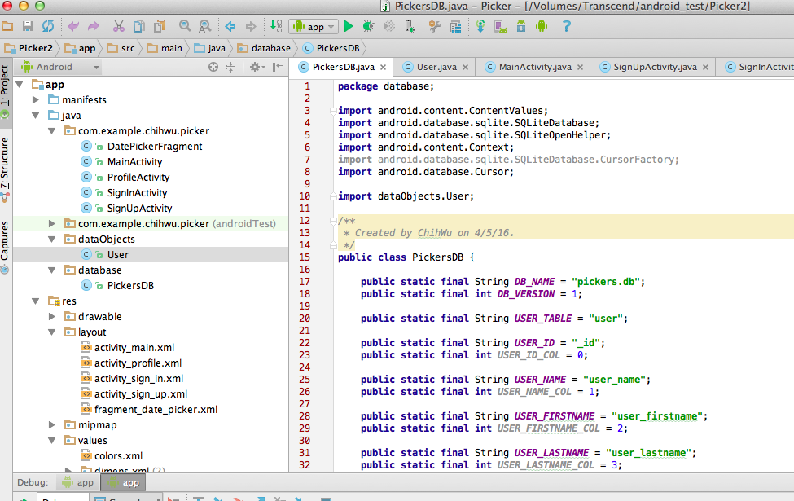

# Part 3—Application Features with output and tests: *(maximum 2 pages of 12-point text, including figures)*

Specify the features of your application that you implemented. The priority is to get practice with as many as possible of the Android constructs covered in Module 1. Number your features 1, 2, 3, … . Each feature must accompanied by output or screen shot that show you accomplished it.

*Example, showing output:*

Feature 19. The list of MSCIS courses to be offered in the next two sessions is on the monitor.

Courses to be Offered in Next Two Sessions:

MET CS 872

MET CS 123

MET CS 822

Application Feature 1:

User can choose to sign up and sign in on the homepage.

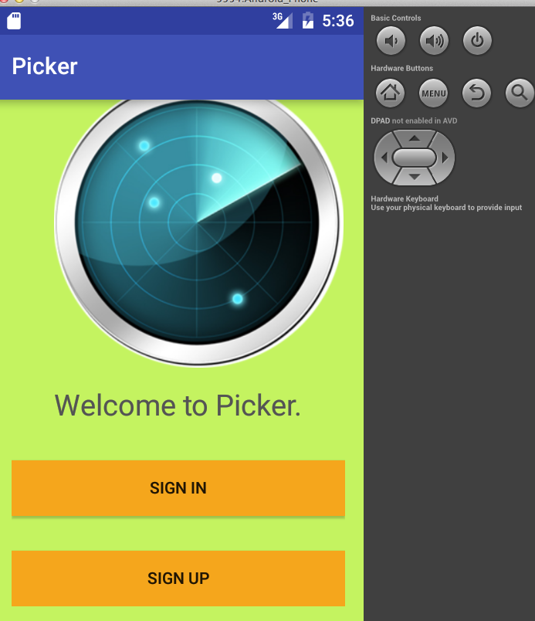

Application Feature 2:

The sign-in page will remember the username user just typed even when moving to another activity.

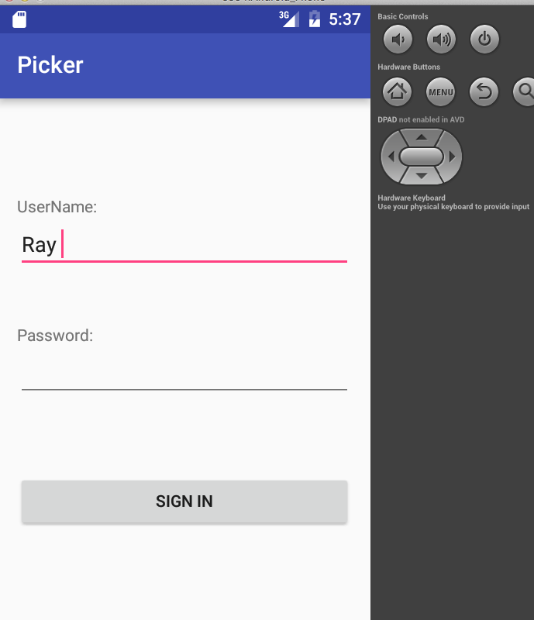

Application Feature 3:

The user can click the signin button to go to the profile page.



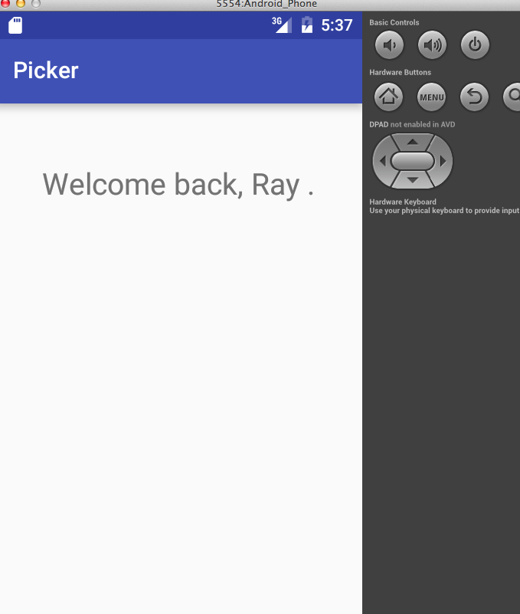

Application Feature 4:

The profile page can know what the username is.

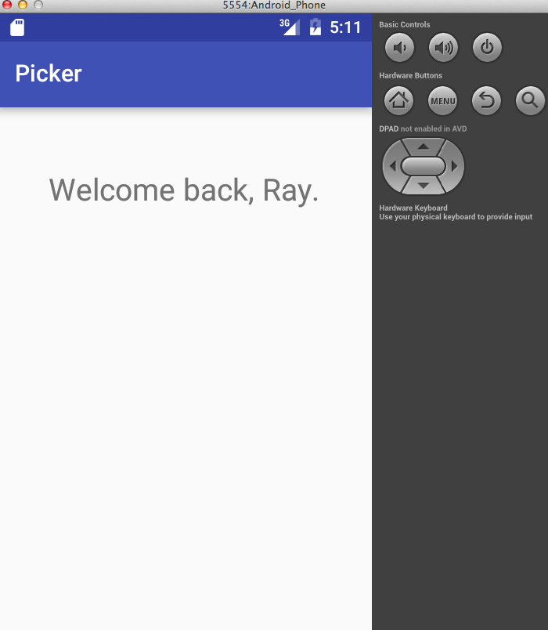

Application Feature 4:

The sign-up page can allows user to enter their personal data.

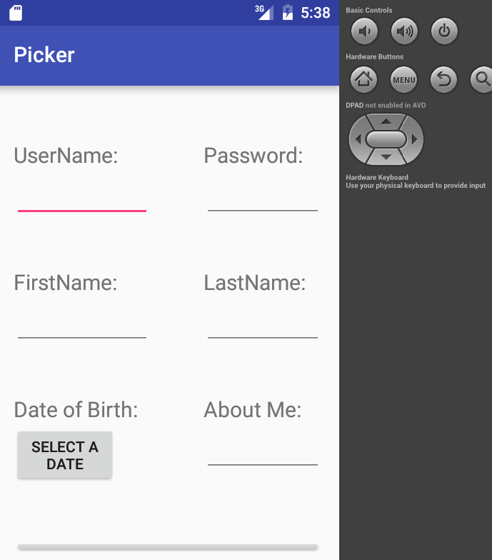

# Part 4—List of Android Elements: *(maximum 1 page of 12-point text)*

Use as many of the Android elements (e.g., built-in keywords, data types or functions) as possible covered in module 1. Provide lines from your code and where they were used once.

Android Feature 1: **(Logging):**

Macintosh HD:Users:ChihWu:Desktop:Screen Shot 2016-03-22 at 5.14.19 AM.png

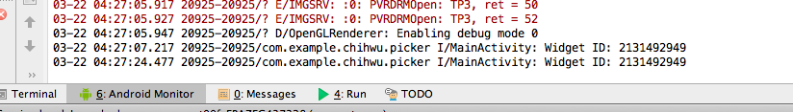

Android Feature 2. **(Saving an Activity States using SharedPreferences):**

Macintosh HD:Users:ChihWu:Desktop:Screen Shot 2016-03-22 at 5.15.10 AM.png

Android Feature 3. **(Relative Layout):**

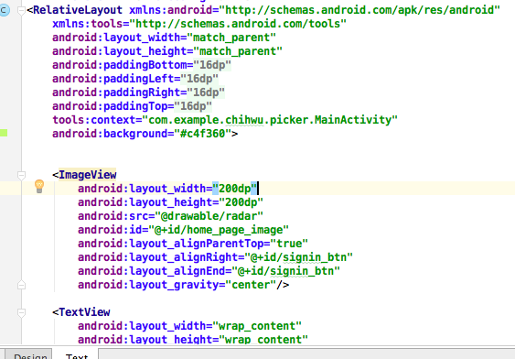

Android Feature 4. **(Use of Refactoring):**

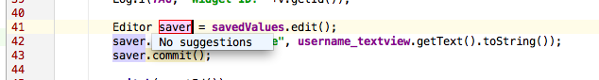

Android Feature 5. **(ImageView):**

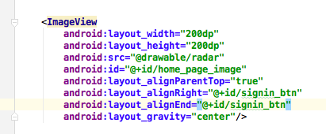

Android Feature 6. **(TextView):**

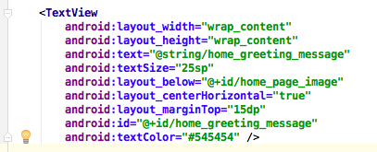

Android Feature 7. **(EditText):**

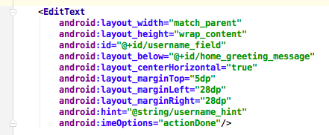

Android Feature 8. **(Button):**

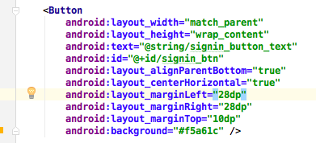

Android Feature 9. **(Use of Intent):**

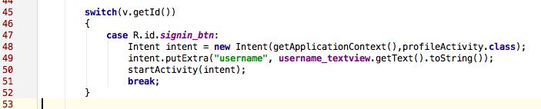

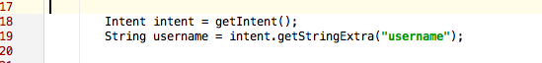

Android Feature 10. **(Use of ClickEventHandler):**

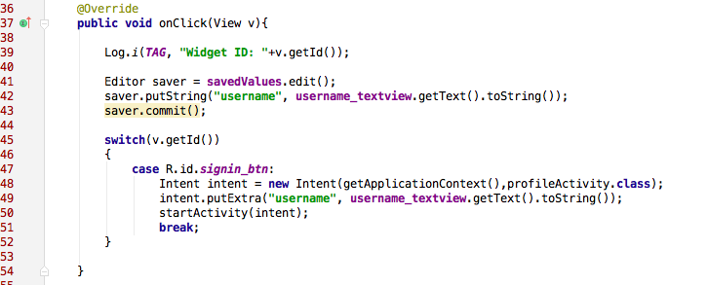

Android Feature 10. **(Use of Scrollview):**

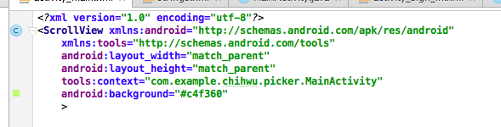

Android Feature 11. **(Use of DatePickerFragment):**

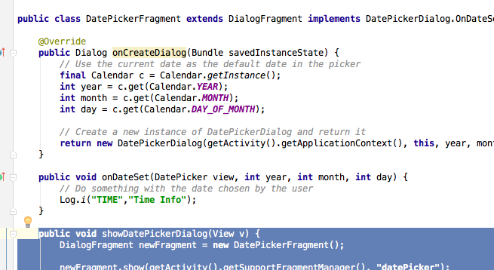

Android Feature 12:(Query data from database)

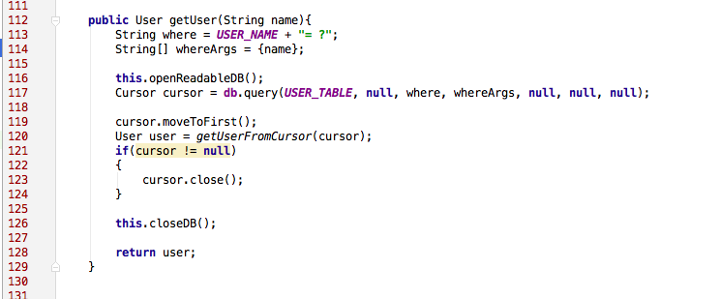

Android Feature 12:(Insert data into database)

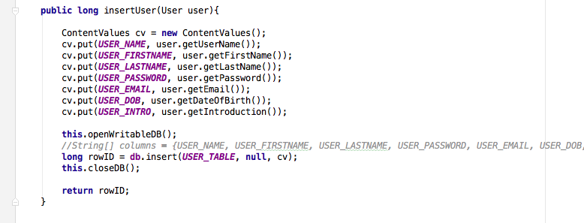

Android Feature 13: (Delete from database)

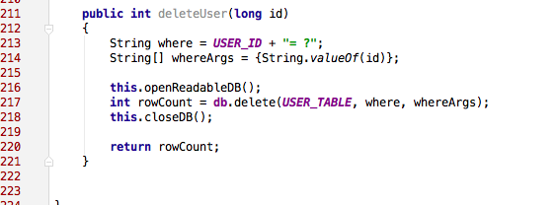

Android Feature 14:(Update data from database)

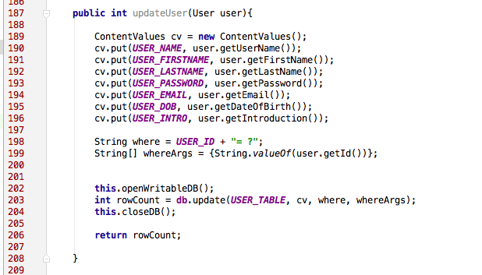

# Part 5—Example Code

Provide a page—in 10-point Ariel Narrow font—of your best (clearly documented)[1] code. You may precede it with a paragraph (not counted in the page limit) explaining where and how it fits with the rest of your project.

Pickers.java

**package** database;  
  
**import** android.content.ContentValues;  
**import** android.database.sqlite.SQLiteDatabase;  
**import** android.database.sqlite.SQLiteOpenHelper;  
**import** android.content.Context;  
**import** android.database.sqlite.SQLiteDatabase.CursorFactory;  
**import** android.database.Cursor;  
  
**import** dataObjects.User;  
  
*/**  
 * Created by ChihWu on 4/5/16.  
 */***public class** PickersDB {  
  
 **public static final** String ***DB_NAME*** = **"pickers.db"**;  
 **public static final int *DB_VERSION*** = 1;  
  
 **public static final** String ***USER_TABLE*** = **"user"**;  
  
 **public static final** String ***USER_ID*** = **"_id"**;  
 **public static final int *USER_ID_COL*** = 0;  
  
 **public static final** String ***USER_NAME*** = **"user_name"**;  
 **public static final int *USER_NAME_COL*** = 1;  
  
 **public static final** String ***USER_FIRSTNAME*** = **"user_firstname"**;  
 **public static final int *USER_FIRSTNAME_COL*** = 2;  
  
 **public static final** String ***USER_LASTNAME*** = **"user_lastname"**;  
 **public static final int *USER_LASTNAME_COL*** = 3;  
  
 **public static final** String ***USER_PASSWORD*** = **"user_password"**;  
 **public static final int *USER_PASSWORD_COL*** = 4;  
  
 **public static final** String ***USER_DOB*** = **"user_dob"**;  
 **public static final int *USER_DOB_COL*** = 5;  
  
 **public static final** String ***USER_EMAIL*** = **"user_email"**;  
 **public static final int *USER_EMAIL_COL*** = 6;  
  
 **public static final** String ***USER_INTRO*** = **"user_intro"**;  
 **public static final int *USER_INTRO_COL*** = 7;  
  
  
 **public static final** String ***CREATE_USER_TABLE*** =  
 **"CREATE TABLE "** + ***USER_TABLE*** + **" ("**+  
 ***USER_ID*** + **" INTEGER PRIMARY KEY AUTOINCREMENT, "** +  
 ***USER_NAME*** + **" TEXT NOT NULL, "**+  
 ***USER_FIRSTNAME*** + **" TEXT, "**+  
 ***USER_LASTNAME*** + **" TEXT, "**+  
 ***USER_EMAIL*** + **"TEXT NOT NULL UNIQUE, "**+  
 ***USER_DOB*** + **"TEXT, "**+  
 ***USER_INTRO*** + **"TEXT);"**;  
  
 **public static final** String ***DROP_USER_TABLE*** =  
 **"DROP TABLE IF EXISTS "**+***USER_TABLE***;  
  
  
 **private static class** DBHelper **extends** SQLiteOpenHelper{  
  
 **public** DBHelper(Context context) {  
 **super**(context, ***DB_NAME***, **null**, ***DB_VERSION***);  
 }  
  
  
 @Override  
 **public void** onCreate(SQLiteDatabase db){  
 db.execSQL(***CREATE_USER_TABLE***);  
  
 db.execSQL(**"INSERT INTO user VALUES(1,'Raymond','Ray','Wu','chihwu@bu.edu','11/23/1990','Hi, this is Ray.')"**);  
 }  
  
  
 @Override  
 **public void** onUpgrade(SQLiteDatabase db, **int** oldVersion, **int** newVersion)  
 {  
 db.execSQL(***DROP_USER_TABLE***);  
 onCreate(db);  
 }  
  
 }  
  
  
 **private** SQLiteDatabase **db**;  
 **private** DBHelper **dbHelper**;  
  
 **public** PickersDB(Context context)  
 {  
 **dbHelper** = **new** DBHelper(context);  
 }  
  
 **private void** openReadableDB(){  
 **db** = **dbHelper**.getReadableDatabase();  
 }  
  
 **private void** openWritableDB()  
 {  
 **db** = **dbHelper**.getWritableDatabase();  
 }  
  
 **private void** closeDB()  
 {  
 **if**(**db** != **null**)  
 {  
 **db**.close();  
 }  
 }  
  
  
 **public** User getUser(String name){  
 String where = ***USER_NAME*** + **"= ?"**;  
 String[] whereArgs = {name};  
  
 **this**.openReadableDB();  
 Cursor cursor = **db**.query(***USER_TABLE***, **null**, where, whereArgs, **null**, **null**, **null**);  
  
 cursor.moveToFirst();  
 User user = *getUserFromCursor*(cursor);  
 **if**(cursor != **null**)  
 {  
 cursor.close();  
 }  
  
 **this**.closeDB();  
  
 **return** user;  
 }  
  
  
 **private static** User getUserFromCursor(Cursor cursor){  
  
*// if(cursor == null || cursor.getCount() == 0)  
// {  
// return null;  
// }  
// else  
// {  
// try{  
//// return new User(  
//// cursor.getInt(USER_ID_COL),  
//// cursor.getString(USER_NAME_COL),  
//// cursor.getString(USER_FIRSTNAME_COL),  
//// cursor.getString(USER_LASTNAME_COL),  
//// cursor.getString(USER_PASSWORD_COL),  
//// cursor.getString(USER_EMAIL_COL),  
//// cursor.getString(USER_DOB_COL),  
//// cursor.getString(USER_INTRO_COL)  
//// );  
//  
//  
//  
//  
// }  
// catch(Exception e)  
// {  
// return null;  
// }  
// }* **return new** User(1,**"Raymond"**,**"Chih"**,**"Wu"**,**"1234"**,**""**,**""**,**""**);  
  
 }  
  
  
 **public long** insertUser(User user){  
  
 ContentValues cv = **new** ContentValues();  
 cv.put(***USER_NAME***, user.getUserName());  
 cv.put(***USER_FIRSTNAME***, user.getFirstName());  
 cv.put(***USER_LASTNAME***, user.getLastName());  
 cv.put(***USER_PASSWORD***, user.getPassword());  
 cv.put(***USER_EMAIL***, user.getEmail());  
 cv.put(***USER_DOB***, user.getDateOfBirth());  
 cv.put(***USER_INTRO***, user.getIntroduction());  
  
 **this**.openWritableDB();  
 *//String[] columns = {USER_NAME, USER_FIRSTNAME, USER_LASTNAME, USER_PASSWORD, USER_EMAIL, USER_DOB, USER_INTRO};* **long** rowID = **db**.insert(***USER_TABLE***, **null**, cv);  
 **this**.closeDB();  
  
 **return** rowID;  
 }  
  
  
 **public int** updateUser(User user){  
  
 ContentValues cv = **new** ContentValues();  
 cv.put(***USER_NAME***, user.getUserName());  
 cv.put(***USER_FIRSTNAME***, user.getFirstName());  
 cv.put(***USER_LASTNAME***, user.getLastName());  
 cv.put(***USER_PASSWORD***, user.getPassword());  
 cv.put(***USER_EMAIL***, user.getEmail());  
 cv.put(***USER_DOB***, user.getDateOfBirth());  
 cv.put(***USER_INTRO***, user.getIntroduction());  
  
 String where = ***USER_ID*** + **"= ?"**;  
 String[] whereArgs = {String.*valueOf*(user.getId())};  
  
  
 **this**.openWritableDB();  
 **int** rowCount = **db**.update(***USER_TABLE***, cv, where, whereArgs);  
 **this**.closeDB();  
  
 **return** rowCount;  
  
 }  
  
  
 **public int** deleteUser(**long** id)  
 {  
 String where = ***USER_ID*** + **"= ?"**;  
 String[] whereArgs = {String.*valueOf*(id)};  
  
 **this**.openReadableDB();  
 **int** rowCount = **db**.delete(***USER_TABLE***, where, whereArgs);  
 **this**.closeDB();  
  
 **return** rowCount;  
 }  
  
  
}

MainActivity.java

(The MainActivity.java is the java code for the home page of my application.)

**package** com.example.chihwu.picker;  
  
**import** android.content.SharedPreferences;  
**import** android.support.v4.app.DialogFragment;  
**import** android.support.v7.app.AppCompatActivity;  
**import** android.os.Bundle;  
**import** android.view.View;  
**import** android.widget.Button;  
**import** android.view.View.OnClickListener;  
**import** android.content.Intent;  
**import** android.util.Log;  
**import** android.content.SharedPreferences;  
**import** android.content.SharedPreferences.Editor;  
**import** android.widget.TextView;  
  
**public class** MainActivity **extends** AppCompatActivity **implements** OnClickListener{  
  
 **private** Button **signin_button**;  
 **private** Button **signup_button**;  
 **private static final** String ***TAG*** = **"MainActivity"**;  
  
  
 @Override  
 **protected void** onCreate(Bundle savedInstanceState) {  
 **super**.onCreate(savedInstanceState);  
 setContentView(R.layout.***activity_main***);  
  
 **signin_button** = (Button)findViewById(R.id.***signin_btn***);  
 **signin_button**.setOnClickListener(**this**);  
  
 **signup_button** = (Button)findViewById(R.id.***signup_btn***);  
 **signup_button**.setOnClickListener(**this**);  
  
 }  
  
 @Override  
 **public void** onClick(View v){  
  
 Log.*i*(***TAG***, **"Widget ID: "** + v.getId());  
  
  
 **switch**(v.getId())  
 {  
 **case** R.id.***signin_btn***:  
 Intent intent1 = **new** Intent(getApplicationContext(),SignInActivity.**class**);  
 startActivity(intent1);  
 **break**;  
 **case** R.id.***signup_btn***:  
 Intent intent2 = **new** Intent(getApplicationContext(), SignUpActivity.**class**);  
 startActivity(intent2);  
 **break**;  
 }  
  
 }  
  
 @Override  
 **public void** onResume()  
 {  
 **super**.onResume();  
  
  
 }  
  
 **public void** showDatePickerDialog(View v) {  
 DialogFragment newFragment = **new** DatePickerFragment();  
  
 newFragment.show(getSupportFragmentManager(), **"datePicker"**);  
 }  
}

ProfileActivity.java

(The ProfileActivity.java is the java code for the user profile page after users sign in.)

**package** com.example.chihwu.picker;  
  
**import** android.support.v7.app.AppCompatActivity;  
**import** android.os.Bundle;  
**import** android.widget.TextView;  
**import** android.content.Intent;  
  
**public class** ProfileActivity **extends** AppCompatActivity {  
  
 **private** TextView **username_textview**;  
 **private** TextView **profile_greeting_textview**;  
  
 @Override  
 **protected void** onCreate(Bundle savedInstanceState) {  
 **super**.onCreate(savedInstanceState);  
 setContentView(R.layout.***activity_profile***);  
  
 Intent intent = getIntent();  
 *// retrieve the username from the intent just passed from the MainActivity* String username = intent.getStringExtra(**"username"**);  
  
  
 **profile_greeting_textview** = (TextView)findViewById(R.id.***profile_greeting_msg***);  
  
 **profile_greeting_textview**.setText(**"Welcome back, "** + username + **"."**);  
  
 }  
}

SignInActivity.java

**package** com.example.chihwu.picker;  
  
**import** android.content.Intent;  
**import** android.content.SharedPreferences;  
**import** android.support.v7.app.AppCompatActivity;  
**import** android.os.Bundle;  
**import** android.view.View;  
**import** android.widget.TextView;  
**import** android.view.View.OnClickListener;  
**import** android.widget.Button;  
  
**public class** SignInActivity **extends** AppCompatActivity **implements** OnClickListener{  
  
 **private** SharedPreferences **savedValues**;  
 **private** TextView **username_textview**;  
 **private** Button **signinBtn**;  
  
 @Override  
 **protected void** onCreate(Bundle savedInstanceState) {  
 **super**.onCreate(savedInstanceState);  
 setContentView(R.layout.***activity_sign_in***);  
  
 **username_textview** = (TextView)findViewById(R.id.***username_editTxt***);  
  
 *// create a SharedPreferences instance to save user input when coming back to this activity* **savedValues** = getSharedPreferences(**"SavedUsername"**, ***MODE_PRIVATE***);  
  
 **signinBtn** = (Button)findViewById(R.id.***signin_btn***);  
 **signinBtn**.setOnClickListener(**this**);  
 }  
  
  
  
 @Override  
 **public void** onClick(View v){  
  
 SharedPreferences.Editor saver = **savedValues**.edit();  
 saver.putString(**"username"**, **username_textview**.getText().toString());  
 saver.commit();  
  
 **switch**(v.getId()) {  
 **case** R.id.***signin_btn***:  
 Intent intent = **new** Intent(getApplicationContext(),ProfileActivity.**class**);  
 *// save the username just input by the user in the intent object so that the value can be passed to the next activity* intent.putExtra(**"username"**, **username_textview**.getText().toString());  
 startActivity(intent);  
 **break**;  
  
 }  
  
 }  
  
 @Override  
 **public void** onResume()  
 {  
 **super**.onResume();  
  
 *// when this activity is back onto the foreground, make sure the username can be printed again in the username_textview widget* String stored_username = **savedValues**.getString(**"username"**, **""**);  
 **username_textview**.setText(stored_username);  
 }  
}

SignUpActivity.java

**package** com.example.chihwu.picker;  
  
**import** android.support.v4.app.DialogFragment;  
**import** android.support.v7.app.AppCompatActivity;  
**import** android.os.Bundle;  
**import** android.view.View;  
**import** android.widget.Button;  
**import** android.view.View.OnClickListener;  
  
**public class** SignUpActivity **extends** AppCompatActivity **implements** OnClickListener {  
  
 **private** Button **dob_btn**;  
  
 @Override  
 **protected void** onCreate(Bundle savedInstanceState) {  
 **super**.onCreate(savedInstanceState);  
 setContentView(R.layout.***activity_sign_up***);  
  
 **dob_btn** = (Button)findViewById(R.id.***dob_btn***);  
 **dob_btn**.setOnClickListener(**this**);  
 }  
  
 @Override  
 **public void** onClick(View v){  
  
 **switch** (v.getId())  
 {  
 **case** R.id.***dob_btn***:  
  
 **break**;  
 }  
  
 }  
  
 **public void** showDatePickerDialog(View v) {  
 DialogFragment newFragment = **new** DatePickerFragment();  
  
 newFragment.show(getSupportFragmentManager(), **"datePicker"**);  
 }  
}

DatePickerFragment.java

**package** com.example.chihwu.picker;  
  
  
**import** android.content.Context;  
**import** android.net.Uri;  
**import** android.os.Bundle;  
**import** android.support.v4.app.Fragment;  
**import** android.view.LayoutInflater;  
**import** android.view.View;  
**import** android.view.ViewGroup;  
**import** android.app.DatePickerDialog;  
**import** android.support.v4.app.DialogFragment;  
**import** android.widget.DatePicker;  
**import** android.app.Dialog;  
**import** java.util.Calendar;  
**import** android.util.Log;  
  
  
**public class** DatePickerFragment **extends** DialogFragment **implements** DatePickerDialog.OnDateSetListener{  
  
 @Override  
 **public** Dialog onCreateDialog(Bundle savedInstanceState) {  
 *// Use the current date as the default date in the picker* **final** Calendar c = Calendar.*getInstance*();  
 **int** year = c.get(Calendar.***YEAR***);  
 **int** month = c.get(Calendar.***MONTH***);  
 **int** day = c.get(Calendar.***DAY_OF_MONTH***);  
  
 *// Create a new instance of DatePickerDialog and return it* **return new** DatePickerDialog(getActivity().getApplicationContext(), **this**, year, month, day);  
 }  
  
 **public void** onDateSet(DatePicker view, **int** year, **int** month, **int** day) {  
 *// Do something with the date chosen by the user* Log.*i*(**"TIME"**,**"Time Info"**);  
 }  
  
 **public void** showDatePickerDialog(View v) {  
 DialogFragment newFragment = **new** DatePickerFragment();  
  
 newFragment.show(getActivity().getSupportFragmentManager(), **"datePicker"**);  
 }  
  
  
  
}

# Below is the matrix that will be used to evaluate your response:



A regular A translates as 95, A-=93, B+=87, B=85, B-=83, C+=77, C=75, C-=73, D+=67, F=0 etc. To get an A grade for the course, your weighted average should be >93. A-:>=90. B+:>=87. B:>83. B-:>=80. C+:>=77. C:>73. C-:>=70 etc.

1. Document intentions—don’t paraphrase code. Nontrivial functions should have (an informal) *Intent* statement*,* (precise) *Preconditions* (if any), *Returns* (if any),and *Postconditions* (always). Each block of code should be preceded by its intended objectives.